`Śrī Śrī Guru-Gaurāṅgau Jayataḥ

Śrī Mādhava-tithi
(Glories of Śrī Ekādaśī-vrata)

Collected from the instructions, lectures and books of our Guru-pāda-padma Tridaṇḍi-svāmī Śrī Śrīmad Bhaktivedānta Nārāyaṇa Gosvāmī Mahārāja and other important Ācāryas

Śrī Bhakti-prajñāna Gauḍīya Vedānta
University Publication
Publisher: | Tridaṇḍi-svāmī Bhaktivedānta Daṇḍī Mahārāja  B.Sc. (Hons), B.E. (IISc. Bangalore).  M.S. (IIT Chennai) D. Sc. (Washington University)

Our preaching centers in South India
- Śrī Ranganātha Gauḍīya Maṭha, Hesarghatta, Bangalore. (Karnataka). Pin: 560088. Telephone: (080) 28466760 Mobile: 9379447895, 7829378386. Email: visnudaivata@gmail.com, bdandi@gmail.com
- Śrī Bālājī Gauḍīya Maṭha, Śrī Gajānana Śrī Śrī Rādhā-Madana-mohana Mandira, Satya-nārāyaṇa Puram Circle, Tirupati. (A.P.) Pin: 517501 Mobile: 801943668 Email: selams9@yahoo.com
- Śrī Gaura-nārāyaṇa Gauḍīya Maṭha, R. C. Colony-3, Sindhanur, District: Raichur. Pin: 584143 (Karnataka). Mobile: 7676308925. 9019265296.

Websites:

http://www.purebhakti.com
http://www.purebhakti.tv
http://www.bhaktiprojects.org/project/sri-ranganatha-gaudiya-matha-gurukula/

Printer: O. S. Prints, 48/Y, 59th Cross, 14th Main, 3rd Block, Near Bhasyam Circle, Rajajinagar, Bangalore-560010. (Karnataka) Mobile: 9845320921 Telefax: 41731313 Email: osprints@gmail.com

The wonderful picture on the front page is by Śrīmatī Bakulā dīdī. We thank Śrīmatī Jānakī dīdī, Śrī Oṁ Prakāśa Brajavāsī “Sahitya-ratna”, Śrī Keśava Dāsa (USA), Śrīpāda Bhaktivedānta Tridaṇḍī Mahārāja, Śrīpāda Bhaktivedānta Viṣṇudaivata Mahārāja, Śrīmatī Bakulā dīdī, the editorial team of the Hindi Ekādaśī book published from Śrī Caitanya Gauḍīya Maṭha, Śrīmatī Śyāmarāṇī dīdī, the editorial team of Bhaktivedānta Book Trust, Śrīla Gaura Govinda Svāmī Archives, Śrī Phanindra Mankale, Śrīmatī Harshala Rajesh and Śrī Avadhūta Dāsa for their valuable help in publishing this book. We give our special thanks to the persons whose art, photographs, articles, transliterations and translations are used in this book.

Important quotes about ekādaśī
- It is mentioned in the Purāṇas that the beloved day of ekādaśī can fulfill all of the desires of every human being.
- Anyone who observes the vow of ekādaśī with devotion, whether a brāhmaṇa, kṣatriya, vaiṣya, śudra, woman, or man, will attain liberation and association with Bhagavān.
- If a wife observes the vow of ekādaśī for the benefit of her husband, she is entitled to one-hundred-times more pious merit.
- Ekādaśī has appeared for the protection of all living entities, just like a mother protects her babies, and like medicine protects a sick person.
- One can become free from this distressful material world by fasting on ekādaśī and worshiping Janārdana.
- Ekādaśī mixed with daśamī is considered to be contaminated with all of the sins of the three worlds.
- One day Śrī Gaurasundara offered obeisances at the feet of Mother Śacī and requested, “Mother, please grant Me a wish.” Mother Śacī replied, “I will give You just what You ask for.” The Lord said, “Mother, do not eat grains on ekādaśī.”
- “For Śrī Kṛṣṇa, the day of ekādaśī is superior to even Janmāṣtamī. The Supreme Lord Śrī Kṛṣṇa, the embodiment of all auspiciousness, manifests in this world in the form of Mādhava-tithi or ekādaśī. The potency of Viṣṇu, which takes innumerable forms, has appeared as the most auspicious day of ekādaśī in order to bestow all types of auspiciousness on the living entities.” (from a lecture by Oṁ Viṣṇupāda Śrīmad-Bhaktivedānta Nārāyaṇa Gosvāmī Mahārāja)
- Śrī Vyāsadeva told Jaiminī that he should certainly know ekādaśī to be a manifestation of Viṣṇu, and that ekādaśī is the best among all pious activities and vows.
- Lord Caitanya said, “By neglecting ekādaśī, which is a limb of devotional service, one is totally ruined. One should worship mahā-prasāda on the day of ekādaśī and accept it the next day.”
- If the daśamī even slightly overlaps ekādaśī during the period of aruṇodaya (dawn, or one hour and thirty six minutes before sunrise), that ekādaśī is known as viddhā.
- The body of a human being is like a machine. If we take food three times a day, this machine does not get any rest. If one does not take food on ekādaśī, one’s body can rest and one has more time to engage in nāma-bhajana (devotional service rendered through the chanting of the holy names). Thus, one’s devotion is nourished and can increase. (Śrīla Bhaktivedānta Nārāyaṇa Gosvāmī Mahārāja, Hawaii, 13 May 2000)
- The most important reason to follow ekādaśī is that ekādaśī is Kṛṣṇa Himself. Kṛṣṇa has become ekādaśī. He descends to this world on ekādaśī day, looks after all the people who are observing its vows, and gives special mercy to them. So we must observe ekādaśī.
- Not following ekādaśī will be harmful to us. On ekādaśī the moon comes closer to the Earth, and therefore it attracts water from everywhere–from the seas, rivers, our bodies, and so on. If one takes any grains on this day, the grains become like blotting paper. If you drink water, the water will very soon pass from the body. However, if you take grains and water together, the grains become like blotting paper or cotton and hold the water. Even if you squeeze the cotton, some water will remain.
- For us fallen, conditioned souls, Kṛṣṇa has personally become ekādaśī. Ekādaśī has no consideration of caste or creed. For example, it is not that ekādaśī will give its fruit only to someone who is initiated by Śrīla Bhaktisiddhānta Sarasvatī Ṭhākura.
- We are not realizing the fact of how gainful it is to follow ekādaśī. Ekādaśī is the mother of bhakti. If anyone observes ekādaśī in the right way, bhakti will come automatically.
- Preparations made from grains, wheat, rice, corn, and dāla are like cotton in our stomach. The moon attracts the water in them and diseases increase. Many people die in hospitals from ekādaśī to the full moon and ekādaśī to the new moon. It is essential to follow ekādaśī to control our diseases.
- If one observes ekādaśī without taking water, but does not take pāraṇa in time, the fruits from ekādaśī go away.
- Devotee: On ekādaśī, can we offer the Deity grains?
Śrīla Prabhupāda: Yes, but not to guru. Ekādaśī is observed by jīva-tattva, not by Viṣṇu-tattva. We are fasting for clearing our material disease, but Rādhā-Kṛṣṇa, Caitanya Mahāprabhu... Caitanya Mahāprabhu also may not be offered grains because He is playing the part of a devotee. Only Rādhā-Kṛṣṇa and Jagannātha can be offered grains. Otherwise, Guru-Gaurāṅga - no. The prasādam should not be taken by anyone; it should be saved for the next day. [Śrīla Prabhupāda Room Conversation, Tokyo, April 22, 1972]
- Śrīla Ācāryadeva displayed the ideal standards for observing fasting days. On Śrī Janmāṣṭamī, Śrī Ekādaśī, Śrī Gaura Jayantī, Śrī Rāma navamī, Śrī Nṛsiṁha Caturdaśī, Śrī Advaita Saptamī, Śrī Nityānanda Trayodaśī, and other fast days, he firmly rejected fasting on days which overlapped with the previous day. He gave the fullest protection to the observance of Cāturmāsya and ūrjā-vrata in Śrī Vedānta Samiti, completely following the rules practiced and preached by Śrīla Sarasvatī Prabhupāda, Śrīla Bhaktivinoda Ṭhākura, and Śrīman Mahāprabhu. He never supported reluctance to follow the Cāturmāsya vow or laxity in honoring ūrjā-vrata. [Ācārya Kesarī Śrī Śrīmad Bhakti Prajñāna Keśava Gosvāmī–His Life and Teachings]
- According to the University’s rules and regulations, every college must observe Saturday as a half-day and Sunday as a full-day holiday. However, in the school in Śrīdhāma Māyāpura, the holidays were observed on ekādaśī and pañcamī. This is contrary to the University rules. When local Christians and Muslims opposed this, the departmental inspector of the University came and issued an order against me, which I refused to accept. As a result, the aid given by the University was stopped. In spite of this, the Ṭhākura Bhaktivinoda Institute in Śrīdhāma Māyāpura is still running today, and is still recognized by the government. [Ācārya Kesarī Śrī Śrīmad Bhakti Prajñāna Keśava Gosvāmī–His Life and Teachings]
- Sārasājola is a well-known and prosperous village in the Dumkā district. Śrīla Gurudeva stayed in Śrī Madhusūdana Vidyānidhi’s home in Sārasājola and preached śuddha-bhakti there for seven days. All the leading villagers there accepted vaiṣṇava-dharma along with their families. Sārasājola became like Kulīna-grāma, whose inhabitants were all great Vaiṣṇava bhaktas during Śrīman Mahāprabhu’s time. In those days, there were only Vaiṣṇavas in the village of Kulīna-grāma; even the village dogs were bhaktas who observed ekādaśī and other vratas. Śrīla Gurupādapadma’s auspicious arrival in Sārasājola was also very blessed. [Ācārya Kesarī Śrī Śrīmad Bhakti Prajñāna Keśava Gosvāmī–His Life and Teachings]
- At the present time, some people observe fasts which are not recommended in śāstra out of selfish or political interests. The provision for fasts given in the śāstra is only for the purpose of attaining the transcendental goal, and not for political or social purposes. On ekādaśī, there is a provision to fast from everything, even from water (nirjala-vrata), and to remain awake performing hari-kīrtana throughout the night (rātri-jāgaraṇa). Nowadays, people perform rātri-jāgaraṇa by eating flesh, drinking wine, and singing vulgar, contemptible songs. In this way, they violate the rules of śāstra. Such rātri-jāgaraṇa is not included within the three types of śraddhā, and is miserable. These fasts and jāgaraṇas do not benefit anyone. In fact, such activities are performed out of the pride and ego born from excessive attachment to material desires and sense enjoyment. They also cause unnecessary pain to the body and disturb one’s inner peace as well as the peace of others. Sometimes persons even die from performing these fanatical austerities and fasts. While wandering repeatedly in the āsurika species of life, they receive only misery. [Śrīla Gurudeva in Sārārtha-Varṣiṇī Prakāśikā-Vṛtti on Śrīmad Bhagavad-gītā (Chapter 17, Verses 5-6)]

- Śrī-ekādaśī-vrata: Observing the vow of ekādaśī
The name of śuddhā ekādaśī is Hari-vāsara, the day of Lord Hari. Śuddhā ekādaśī means pure ekādaśī. This refers to a circumstance in which there is no overlapping or mixture of tithis, lunar days. When the ekādaśī tithi begins one aruṇodaya period, or at least ninety-six minutes before sunrise on a particular day, and continues until sunrise of the following day with no overlapping of tithis, this is known as śuddhā ekādaśī or pūrṇā ekādaśī.
If, however, the daśamī tithi extends even one second within the aruṇodaya period before sunrise, the tithis are said to overlap and this is called pūrva-viddhā ekādaśī. The term pūrva-viddhā ekādaśī means that the overlapping takes place at the beginning of ekādaśī, or in other words with the daśamī tithi. One should not observe the ekādaśī-vrata on pūrva-viddhā ekādaśī. In such a case the dvādaśī tithi that follows will be known as Mahā-dvādaśī. The ekādaśī-vrata should then be observed on Mahā-dvādaśī instead of on the ekādaśī tithi.
When, however, the overlapping occurs any time before sunrise of the following day, or in other words with the dvādaśī tithi, this is known as para-viddhā ekādaśī. The term para-viddhā ekādaśī means that the overlapping occurs at the conclusion of ekādaśī. This does not present any problem and the ekādaśī-vrata should still be observed on the ekādaśī tithi.
To honor the day of Lord Hari properly, one should observe celibacy the day before. Then on Hari-vāsara, one should fast even from water and remain awake throughout the night, performing continuous bhajana. On the next day, one should maintain celibacy and break the fast at the appropriate time. Fasting from water (nirambu-upavāsa) means that one must also refrain from taking any mahā-prasāda. Without doing so, one cannot be said to be observing nirambu-upavāsa.
For those who are incapable of observing complete fasting throughout the day, an alternative arrangement has been given in Hari-bhakti-vilāsa (12.97), quoting from the Vāyu Purāṇa. There the statement naktaṁ haviṣyānnam is found. The word naktam means ‘by night’, and the word haviṣyānnam means ‘sacrificial food that is suitable to be taken on certain religious festival days’. By this statement, it is understood that those who are incapable of observing complete fasting may accept suitable eatables such as fruits in the evening.
A similar statement has been given in Hari-bhakti-vilāsa (12.82), also quoted from the Vāyu Purāṇa, regarding the method of observing fasting by appointing a representative. This is stated in the following words:
upavāse tv aśaktasya āhitāgner athāpi vā
putrān vā kārayed anyān brāhmaṇān vāpi kārayet

If a brāhmaṇa who is maintaining a sacrificial fire is incapable of observing fasting, he may appoint a son or another brāhmaṇa to observe the fast in his place.
The complete statement of Hari-bhakti-vilāsa (12.97) regarding the method of fasting by accepting suitable eatables (haviṣyānna), as cited from the Vāyu Purāṇa, is as follows:
naktaṁ haviṣyānnam anodanaṁ vā
phalam tilāḥ kṣīram athāmbu cājyaṁ
yat pañca-gavyaṁ yadi vāpi vāyuḥ
praśastam atrottaram uttaraṁ ca
In other words, one may accept suitable foods (haviṣyānna) at night. All types of grains are unacceptable. Foods that are considered suitable include fruits, milk, water, clarified butter, the five articles derived from the cow (milk, yoghurt, ghee, cow urine, and cow dung) or simply air. Each of these is considered progressively better than the one preceding it. According to the Mahābhārata (Udyoga-parva), there are eight items by which one’s vow is not spoiled: water, roots, fruits, milk, ghee, the desires of a brāhmaṇa, the order of the spiritual master, and medicine. The verse, cited in Hari-bhakti-vilāsa (12.100), is as follows:
aṣṭaitāny avrata-ghnāny āpo mūlaṁ phalaṁ payaḥ
havir brāhmaṇa-kāmyā ca guror vacanam auṣadham
The word ‘Hari-vāsara’ implies not only that one should observe ekādaśī, but other Vaiṣṇava holy days such as Janmāṣṭamī, Rāma-navamī, Nṛsiṁha-caturdaśī, and Gaura-pūrṇimā. The prescription to follow ekādaśī that is given in Hari-bhakti-vilāsa is meant for all men and women of all four varṇas and āśramas. All women, whether they be married or widowed, are meant to follow ekādaśī. Eating grains on ekādaśī is equated with the sin of eating cow flesh. One should observe methodically the two ekādaśīs that occur every month (one during the dark phase and one during the light phase of the moon). In Hari-bhakti-vilāsa (12.47), quoting from the Viṣṇu-dharmottara, it is said:
saputraś ca sabhāryaś ca svajanair bhakti-samyutaḥ
ekādaśyām upavaset pakṣayor ubhayor api
One should observe fasting on both ekādaśīs of the month along with one’s wife, sons, and other family members in a mood of great devotion.
In the above verse, the word svabhārya refers to one’s wife. By this statement, it has been prescribed that women who have husbands should also observe the vow of ekādaśī. The ekādaśī-vrata is invariable. To neglect the vow of ekādaśī is a great transgression. There are fasts originating from other desires which are forbidden for married women, but not the ekādaśī-vrata. In Hari-bhakti-vilāsa (12.3) it is stated:
atra vrata-stha-nityatvād avaśyaṁ tat samācaret
sarva-pāpāpahaṁ sarvārthadaṁ śrī-kṛṣṇa-toṣaṇam
Because the ekādaśī- or dvādaśī-vrata is invariable, it must certainly be followed. By doing so all sins are eradicated, all purposes are fulfilled, and Śrī Kṛṣṇa is pleased. [Śrīla Gurudeva’s Śrī Bindu-vikāśinī-vṛtti on Śrī Bhakti-rasāmṛta-sindhu-bindu]
- Śrī Rūpa Gosvāmī, who is an eternal associate of Caitanya Mahāprabhu, serves Śrī Rādhā-Kṛṣṇa as Śrī Rūpa Mañjarī in kṛṣṇa-līlā. Śrī Rūpa Mañjarī, appearing as Śrīla Rūpa Gosvāmī with the attitude of a sādhaka, weeps again and again and prays anxiously to obtain the service of Śrī Yugala. Sometimes, while praying in this way, he would become so deeply immersed in the emotional trance of Rūpa Mañjarī that he would taste the happiness of direct service. Therefore, rāgānuga-sādhakas must certainly follow Śrī Rūpa-Sanātana and other gosvāmīs. Opposed to this are those who vainly consider themselves as rasika-sādhakas, but who do not adopt the limbs of bhakti, such as guru-padāśraya and ekādaśī-vrata. They can never obtain the service of Śrī Yugala. [Śrīla Gurudeva’s Śrī Bindu-vikāśinī-vṛtti on Śrī Bhakti-rasāmṛta-sindhu-bindu]
- The bodily urges are also of three types: the vehemence of the tongue, the urge of the belly, and the agitation of the genitals. Vehemence of the tongue appears when the desire to enjoy any of the six distinct tastes impels one to eat prohibited foods and to take intoxicants. A bhakti-sādhaka must never indulge in these things. One should carefully keep the urge of the tongue at bay by taking the remnants of Bhagavān and the devotees. The urge of the belly will also be pacified by taking bhagavat-prasāda as needed, by regularly observing ekādaśī, and by serving Kṛṣṇa.

It is possible to fall into varieties of bad behavior and bad association just to satisfy the desires of the tongue. Śrī Caitanya-caritāmṛta (Antya-līlā 6.227) states: jīhvāra lālase yei iti uti dhāya, śiśnodara-parāyaṇa kṛṣṇa nāhi pāya - “One who runs here and there trying to satisfy his tongue and who is always devoted to the desires of the genitals and belly cannot attain Kṛṣṇa.” Also, Antya-līlā 6.236 states: bhāla nā khāibe āra bhāla nā paribe - “Do not eat delicious food and do not dress opulently.” Many troubles come from overeating. A person who eats too much becomes a servant of his agitated genitals. In other words, he becomes devoid of good character. The agitation of the genitals, or the desire to meet with the opposite sex, drags the mind towards material sense objects and therefore renders one incapable of cultivating pure bhakti.
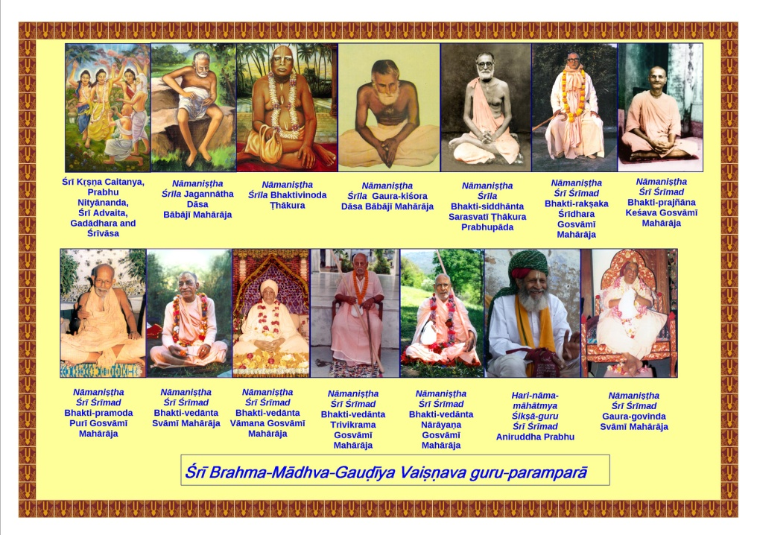

Table of Contents
Our preaching centers in South India 3
Important quotes about ekādaśī 5
Table of Contents 14
Preface 18
Importance of ekādaśī 20
Ekādaśī-kathā (ekādaśī story) 23
Story of Ambarīṣa Mahārāja 25
Story of King Rukmāṅgada 28
Ekādaśī Tattva 31
List of the days of ekādaśī 32
Mahā-dvādaśī 33
Proper process for following ekādaśī 38
More details of ekādaśī 39
Foodstuffs that are suitable on ekādaśī 39
Rules for breaking the ekādaśī fast 40
Ekādaśī Kīrtana 40
List of the lectures delivered by Śrīla Gurudeva in India and foreign countries on the topic of ekādaśī 45
The scientific reason behind not taking grains on ekādaśī 45
The vow of ekādaśī 46
The powers of an ekādaśī family 49
It is not a day–it is Kṛṣṇa 56
Ekādaśī can fulfill all desires………………………………………63
Anu-kalpa 72
Restricted foods on ekādaśī: 72
Foods that can be taken on ekādaśī 73
Important letter about ekādaśī 73
Stories and anecdotes about ekādaśī 76
Deliverance of a brahma-rākṣasa 76
Spiritual lottery 77
An old lady and her husband 77
Safe delivery 78
Remote relief 78
Two Muslim brothers 79
Ekādaśī Māhātmya 81
Introduction 81
The Purāṇic glories of ekādaśī 88
Utpannā Ekādaśī 88
Mokṣadā Ekādaśī 91
Saphalā Ekādaśī 93
Putradā Ekādaśī 95
Ṣaṭ-tilā Ekādaśī 97
Jayā Ekādaśī 100
Significance 100
Significance of bathing in a river in the month of Māgha 100
Vijayā Ekādaśī 104
Āmalakī Ekādaśī 107
Pāpamocanī Ekādaśī 110
Kāmadā Ekādaśī 113
Varuthinī Ekādaśī 115
Mohinī Ekādaśī 117
Aparā Ekādaśī 121
Nirjalā Ekādaśī 126
Yoginī Ekādaśī 129
Śayana Ekādaśī 131
Kāmikā Ekādaśī 136
Pavitrā Ekādaśī 138
Annadā Ekādaśī
Pārśva Ekādaśī
Indirā Ekādaśī
Pāśāṅkuśā or Pāpāṅkuśā Ekādaśī
Significance
Quotes from scriptures
Ramā Ekādaśī
Utthāna Ekādaśī
Padminī Ekādaśī
Parama Ekādaśī
The glories of ekādaśī in Garga Saṁhitā
Eight Mahā-dvādaśīs
Important information
One should not perform śrāddha on ekādaśī
All women must fast on ekādaśī
Nanda Mahārāja observed ekādaśī
Important scriptural injunctions
Keeping the ekādaśī vow
The Spiritual Master follows ekādaśī
The day of ekādaśī is superior to even Janmāṣtamī
One must not pluck Tulasī leaves on dvādaśī day
Śrīla Bhaktivedānta Svāmī Mahārāja’s teachings about ekādaśī
Śrīla Gaura Govinda Svāmī’s teachings about ekādaśī
Life is meant for Tapasyā
Giving pleasure to Śrī Kṛṣṇa
Ekādaśī Vrata is an Aṅga of Bhakti
Quotes from Kṛṣṇa-amṛta-mahā-arṇava
Hari-bhakti-vilāsa–ekādaśī-tattva
Hari-bhakti-vilāsa–Fifteenth Vilāsa
The science behind the ekādaśī fast
Scientific explanation of ekādaśī benefits……………………….
Scientific importance of observing a fast on ekādaśī
Health benefits
Ekādaśī Kathā by Śrīla Bhakti Rakṣaka Śrīdhara Mahārāja
Ekādaśī Kathā by Śrīla Bhakti-ballabha Tīrtha Gosvāmī Mahārāja
Saṅkalpa Mantras for ekādaśī fast
Ekādaśī-kathā by Śrīla Nārāyaṇa Gosvāmī Mahārāja
Illuminations from the book “Śrī Hari-vāsara-kathā”
Garga Saṁhitā (chapter eight)
Garga Saṁhitā (chapter nine)
A combination of divine grace and effort
Offenses to avoid in devotional service
All sādhakas must follow ekādaśī
The servant’s vow
The true process of worship
Ambarīṣa Mahārāja and his queens observed ekādaśī
Śrīla Gaura Kishor Das Gosvāmī Mahārāja Disappearance
Ekādaśī calculations
Activities of the great souls
Ekādaśī observance of Śrīla Gaurakiśora dāsa Bābājī Mahārāja
Jīva Gosvāmī’s teachings about ekādaśī
Vaiṣṇavas and Smārtas
Śrī Kṛṣṇa’s instructions to Uddhava
One should carefully respect Śrī Hari-Vāsara
Cultivation of transcendental senses
Kārtika ekādaśī
Śrī Bhakti-sandarbha
Folio archives
Glories of ekādaśī
Lord Caitanya requests His mother to observe ekādaśī
Nimāi requests Mother Śaci to observe ekādaśī
More pastimes of Śrī Nimāi
Ninth Sarga: mahā-rāsa-sthalī-darśanam
Gaura-hari sees the site of the Mahā-rāsa
Always remember Lord Viṣṇu
Fasting on ekādaśī destroys all sins
Every sādhaka must observe ekādaśī
Circumambulate Govardhana Hill
Offer lamps to the Lord
Glories of staying awake on the night of Prabodhinī-ekādaśī
Rules of pāraṇa (breaking the fast)
Folio archives
Texts 44-52
Only those who follow ekādaśi are real Vaiṣṇavas
One should perform saṅkīrtana on ekādaśī
One should stay up the whole night of ekādaśī
Ekādaśī must be observed by Bhagavān’s devotees
Little Nimāi’s pastimes on ekādaśī
Glories of Trispṛśā Ekādaśī (spoken by Lord Śiva)
Is a bābājī above a sannyāsi?
The greatness of the Vaiṣṇava

Preface
We are feeling great bliss in publishing the book Śrī Mādhava-tithi (“Glories of Śrī Ekādaśī-vrata”) in the English language. Śrī Śrīmad Bhaktivedānta Vāmana Gosvāmī Mahārāja has written the introduction to this book. The main contents of this book are based on the lectures of Śrī Śrīmad Bhaktivedānta Nārāyaṇa Gosvāmī Mahārāja. We have included some additional information such as the foods that are permitted on ekādaśī and those that are prohibited.
The goal of this small book is to introduce the importance of fasting on ekādaśī. Many devotees in India and abroad have been observing a fast on ekādaśī. However, some take sābudāṇā (tapioca) khicari or bhagara (varaī kā cāvala), which is unacceptable. There is no fault in offering boiled tapioca root to the Lord and accepting it as anukalpa (substitute food) on ekādaśī; however, the process of preparing tapioca granules involves adulteration with cow-bone powder and maidā (fine wheat flour). Even packaged milk is adulterated with okra (lady’s finger) juice in order to increase the fat content. Sugar is crystallized with cow-bone powder. It is better to have jaggery or guḍa (gur, unprocessed sugar) on ekādaśī.
Many Vaiṣṇavas avoid cleansing the teeth on ekādaśī and simply rinse the mouth with water twenty-one times. However, a powdered mixture of 100 grams of alum, 50 grams of ekādaśī salt (saindhava lavaṇa, Himalayan salt), and two spoons of turmeric (made from roots) makes a wonderful tooth-powder that is suitable for ekādaśī. Generally speaking, even packaged turmeric is adulterated with maidā, so it is best to prepare turmeric powder at home from the turmeric root.
Using soaps and shampoos marketed by big companies may pose a problem on the day of ekādaśī, as they may contain egg yolk, animal fats, etc. An herbal shampoo made from one liter (0.3 gal.) filtered water, juice of twenty lemons, two spoons of shikakāi powder, two spoons of soap nut (rīṭhā) powder, and one spoon of āmalā powder can be safely used. One can prepare herbal ekādaśī-compatible and skin-friendly soap powder by mixing 100 gms of mulatānī miṭṭī (clay), 100 gms of shikakāi powder and 100 gms of soap nut (rīṭhā) powder.
Śrīla Bhaktivedānta Svāmī Mahārāja gave many concessions to the Western devotees regarding the observance of the ekādaśī fast. However, now one should adhere to the strict Gauḍīya Maṭha standards in order to receive the complete benefit of the vow of ekādaśī.
The sahajiyā section of devotees does not like to fast on ekādaśī; they go on satisfying their senses even on that day. However, Śrīla Bhaktisiddhānta Sarasvatī Ṭhākura Prabhupāda did not like this mentality.
In Madhva sampradāya temples, on ekādaśī the pujārī (priest) may offer you a tulasī leaf that was offered to the Lord. However, that leaf is meant to be kept on the ear or on the head; one must not eat the tulasī leaf on ekādaśī.
This book also describes some real experiences in the lives of devotees. Reading about these experiences will certainly enhance the faith of the readers regarding the vow of ekādaśī.
We hope that reading this book will inspire more and more devotees to fast on ekādaśī.

The disappearance day of Tridanḍī-svāmī Śrī Śrīmad Bhakti-jīvana Janārdana Gosvāmī Mahārāja, the exalted disciple of Śrīla Bhaktisiddhānta Sarasvatī Prabhupāda  Monday, December 14, 2015. | An aspirant for a particle of mercy  of Śrī Guru and the Vaiṣṇavas,  Dr. Bhaktivedānta Danḍī Mahārāja

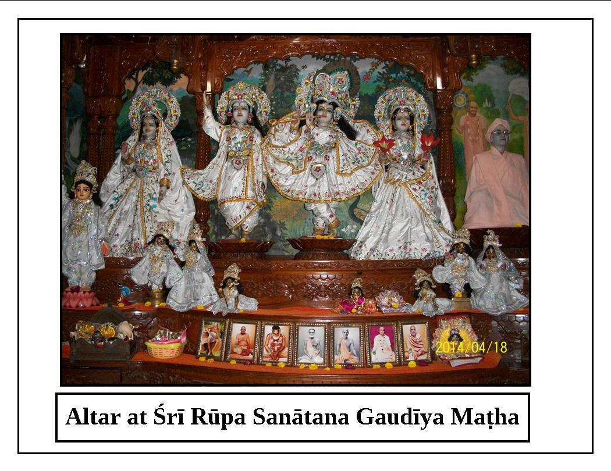

Importance of Ekādaśī
(by Tridaṇḍi-svāmī Śrī Śrīmad-Bhaktivedānta Vāmana Gosvāmī Mahārāja)

The seventh edition of the book Śrī ekādaśī-vrata-kathā has been published by Śrī Gauḍīya Vedānta Samiti. This book has been compiled from various Purāṇas and from the king of all of the Vaiṣṇava smṛtis, Śrī Hari-bhakti-vilāsa. Nitya-līlā-praviṣṭa Oṁ Viṣṇupāda Aṣṭottara-śata Śrī Śrīmad Bhakti-prajñāna Keśava Gosvāmī Mahārāja has reestablished Śrī Caitanya Pañjikā (calendar), published by Śrī Gauḍīya Vedānta Samiti. In the introductions, he has given some instructions under the title Gauḍīyera Kṛṭya (Bhāgavata-dharma) which dovetail with the ideology of Jagadguru Śrīla Bhaktisiddhānta Sarasvatī Gosvāmī Prabhupāda, who embodies the ideal of Śrī Caitanya Pañjikā. He has provided special orders regarding following the vows of the days of Lord Hari such as ekādaśī’, and regarding saṅkhyā-pūrvaka-nāma-grahaṇa(vow to chant the holy name daily a certain number of times).Following the vow of ekādaśī is mentioned among the sixty-four ways of executing devotional service. Therefore, all qualified personalities have accepted the truth and usefulness of following the vow of ekādaśī in order to attain devotional service to Hari.
It is mentioned in the Purāṇas that the beloved day of ekādaśī can fulfill all of the desires of every human being. By following this vow all sins are destroyed, one achieves all of the goals of human life, and one is able to please Śrī Kṛṣṇa. The following are four well-known considerations regarding the vow of ekādaśī: observing it pleases Bhagavān; it is based on scriptural injunctions; it imposes restrictions on taking meals; and failing to follow it results in offenses accruing. The vow of ekādaśī is very dear to Śrī Hari. Anyone who observes this vow with devotion, whether a brāhmaṇa, kṣatriya, vaiṣya, śudra, woman, or man, will attain liberation and association with Bhagavān.
It is essential for everyone to fast on ekādaśī. A person seeking the full benefit of the fasting will refrain from dinner the night before ekādaśī, from all meals the day of ekādaśī, and from dinner the night after ekādaśī. All sins such as brahma-hatyā enter grains on the day of fasting. Therefore, one who eats the five types of grains (barley, paddy, mustard, black grams, sesame, etc.) during ekādaśī accepts all types of sins and is counted among the sinners such as the killers of a mother, father, brother, or spiritual master. For brahmacārīs (celibate students under the care of a bona fide spiritual master), gṛhasthas (householder devotees), vānaprasthas (those retired from family life), and yatis (renounced persons), eating restricted foodstuffs on ekādaśī is like eating beef. There is a prescribed system for liberating drunkards, thieves, and killers of brāhmaṇas, but there is no provision for protecting persons who eat grains on ekādaśī. One who does so will go to hell along with one’s forefathers. It is also unlawful for one to insist that anyone else eat restricted foodstuffs on the day of Lord Hari.
A widow who takes grains on ekādaśī loses all of her pious merit, and persons included in all of the social and spiritual classes (sarva-varṇī and sarvāśramī) who do so, like renounced persons (yati) and chaste, married women (satī), are also destined to languish in the hell called andha-tāmisra. One who observes with faith fasting on the days of ekādaśī that fall in both fortnights of a month, along with one’s family members, will attain devotion for Bhagavān and reach the ultimate abode. One must maintain the vow of ekādaśī even in times of great adversity and during the period of impurity following the birth or death of a family member. If the occasional day of offering oblations to the forefathers (naimittika-śrāddha) falls on ekādaśī, one should fast on that day and then conduct śrāddha on dvādaśī (twelfth day of the fortnight, or day after ekādaśī). One must never perform śrāddha on the day of ekādaśī because the demigods and elevated forefathers never accept such condemned food. If one does perform śrāddha on ekādaśī, the person who makes the offering, the enjoyer of the offering, and the departed soul, all have to go to hell. It is the duty of all human beings between the ages of eight and eighty, including those who are weak, to fast on the ekādaśī of both the bright and dark fortnights. Lord Śiva told Pārvatī-devī, “If a wicked sinner who eats grains on the day of Lord Hari (hari-vāsara) tries to take shelter of devotional service to me, I will not accept him.” If a wife observes the vow of ekādaśī for the benefit of her husband, she is entitled to one-hundred-times more pious merit. Children, elderly people, and those suffering from a bodily or mental disease may follow ekādaśī by eating only once at night, or by consuming milk, fruit, and roots.
Ekādaśī has appeared for the protection of all living entities, just like a mother protects her babies, and like medicine protects a sick person. Blessed and intelligent are those who follow the vow of ekādaśī after obtaining the rare human form of life in this world that is so full of diseases. If one abandons the vow of ekādaśī for some other vow, one loses the jewel he had in his hand and replaces it with a worthless pebble. Simply by fasting on the ekādaśī of both fortnights, one attains devotion for Bhagavān and achieves the topmost destination. One should not give up the vow of ekādaśī even during times of calamity or impurity.
One can become free from this distressful material world by fasting on ekādaśī and worshiping Janārdana. Sinful people bitten by the snake of material existence will become happy and peaceful by fasting on ekādaśī. One receives the highest benefit by completely fasting from all food and water. One undergoes atonement and is delivered from material existence by remembering Govinda and fasting on ekādaśī. The vow of ekādaśī is the best among all religious observances and is very dear to the Lord of the universe, who is the shelter of all happiness, religion, and transcendental qualities. Those who faithfully observe this vow are eligible to go to Vaikuṇṭha. One becomes free from all sins and achieves the highest goal by hearing narrations about the observance of ekādaśī, by observing ekādaśī, or by giving faith to others to follow ekādaśī. Only this day of Hari, and not pious activities such as giving charity, performing austerities, or visiting holy places, can bestow liberation. Those dedicated to ekādaśī are worshipable everywhere, and for them there is no fear of disease, troubles, jealousy, depression, nor anxiety because they always remember Śrī Hari. Such persons attain spotless devotion for Śrī Kṛṣṇa because they have taste for hari-kathā and the pure intelligence to recognize their eternal religious duties. Ekādaśī is the embodiment of pious merit, the destroyer of sins, the encourager of devotion to Viṣṇu, and the bestower of the topmost spiritual destination. The Supreme Lord of the universe has personally manifested in the form of ekādaśī; ekādaśī is a potency emanating from Lord Viṣṇu that is unlimited and that pervades the entire universe.
One should accept only the vow of pure ekādaśī and should reject aruṇodaya-viddhā or daśamī-viddhā ekādaśī (ekādaśī polluted by daśamī). Ekādaśī mixed with daśamī is considered to be contaminated with all of the sins of the three worlds. Demons and atheists take shelter of ekādaśī mixed with daśamī; Bhagavān bestows the desired result only on one who fasts on ekādaśī connected with dvādaśī. Ekādaśī that is polluted by daśamī is not considered hari-vāsara. Thus, one should perform pāraṇa (breaking the fast) on trayodaśī. Jagadguru Śrīla Bhaktivinoda Ṭhākura has sung: mādhava-tithi bhakti-jananī, yatane pālana kari. Yatane pālana kari means that one should reject this polluted (viddhā) ekādaśī. Ekādaśī has many names, and there are eight great dvādaśīs with different names. This book includes many histories and details related to ekādaśī, and there is no doubt that it will be very helpful for those who choose to follow ekādaśī. The appendix includes a description of the eight great dvādaśīs, a song about the duties on the day of ekādaśī, and further glorification of ekādaśī. These additions will provide further insight and appreciation for followers of this vow. Our service and efforts in making this book will be meaningful if readers follow this vow and attain devotion to Bhagavān. What more can we say; it is our humble entreaty that if readers find any shortcomings or omissions in this book due to our inattention, out of kindness they will let us know so that the book can be corrected. Alaṁ iti vistareṇa (let this be enough).

Ekādaśī-kathā (ekādaśī story)
eka dina mātṛ-pade kariyā praṇāma
prabhu kahe–mātā, mohe deha eka dāna
One day Śrī Gaurasundara offered obeisances at the feet of Mother Śacī and requested, “Mother, please grant Me a wish.”
mātā bale–tāhi diba, tumi yā māṅgibe
prabhu kahe–ekādaśīte anna nā khāibe
Mother Śacī replied, “I will give You just what You ask for.” The Lord said, “Mother, do not eat grains on ekādaśī.”
śacī kahe–nā khāiba, bhāla kahilā
sei haite ekādaśī karite lāgilā
Mother Śacī replied, “You have spoken very nicely. I shall not eat grains on that day.” From that day onwards, Mother Śacī observed ekādaśī.
(Caitanya-caritāmṛta, Ādi 15.8,9,10)
By this incident with His mother, Śrī Caitanya Mahāprabhu is instructing every living entity to observe the vow of ekādaśī. Śrī Hari-bhakti-vilāsa (12.7) states: ekādaśī vrata nāma viṣṇu prīti kāraṇam, which means that one develops love and affection for Śrī Viṣṇu by following this vow. Therefore, another name for ekādaśī is hari-vāsara, or ‘the day of Lord Hari’. As far as fruitive vows, one may observe them and receive the desired results, and one does not incur any sin or offense by not observing such a vow. On the other hand, by following ekādaśī one achieves devotion for Śrī Kṛṣṇa, and if one does not follow it, one commits an offense and thus devotion for Śrī Kṛṣṇa will not manifest in one’s heart. Śrī Bhaktivinoda Ṭhākura has said:
mādhava tithi bhakti-jananī yatane pālana kari
kṛṣṇa vasati, vasati bali parama ādara vari
Knowing that Mādhava-tithi (ekādaśī) gives birth to devotion and Kṛṣṇa directly resides in this day, I carefully accept and observe this day with great respect.
“For Śrī Kṛṣṇa, the day of ekādaśī is superior to even Janmāṣtamī. The Supreme Lord Śrī Kṛṣṇa, the embodiment of all auspiciousness, manifests in this world in the form of Mādhava-tithi or ekādaśī. The potency of Viṣṇu, which takes innumerable forms, has appeared as the most auspicious day of ekādaśī in order to bestow all types of auspiciousness on the living entities.” (from a lecture by Oṁ Viṣṇupāda Śrīmad-Bhaktivedānta Nārāyaṇa Gosvāmī Mahārāja)
Śrīmad-Bhāgavatam describes how Śrī Kṛṣṇa’s father, Śrī Nanda Mahārāja, used to fast on ekādaśī.
ekādaśyāṁ nirāhāraḥ samabhyarcya janārdanam
snātuṁ nandas tu kālindyāṁ dvādaśyāṁ jalam āviśat
Śrī Śukadeva said, “O Parīkṣit, Nanda Mahārāja fasted on the day of ekādaśī in the bright fortnight of Kārtika month and worshiped Bhagavān Janāradana, and then he entered the water of Yamunā to take bath during the dvādaśī-tithi.”

Story of Ambarīṣa Mahārāja
The ninth canto of Śrīmad-Bhāgavatam describes the pastime in which Śrī Ambarīṣa Mahārāja, a pure devotee, strictly observed ekādaśī by not taking any food and then breaking the fast at the proper time. By honoring ekādaśī, Ambarīṣa Mahārāja was protected from the powerful curse of a brāhmaṇa.
Ambarīṣa Mahārāja was very fortunate. He was a great admirer of Bhagavān as well as a generous and virtuous soul. Although he was the sovereign ruler of the Earth, he was not attached to his wealth and opulence. Rather, he was attached to Śrī Kṛṣṇa and His loving devotees. He always engaged his mind in thinking about the lotus feet of Śrī Kṛṣṇa; his speech in glorifying the qualities of Bhagavān; his hands in cleaning the temple of Lord Hari; and his ears in hearing about the auspicious pastimes of Bhagavān Acyuta and His devotees.
One day he went to Madhuvana in Mathurā with his wife and accepted the regulative principle of observing ekādaśī which gives prominence to dvādaśī. To complete the vow in the next month of Kārtika, he fasted on three nights– the two nights before ekādaśī, and the night of ekādaśī. After taking bath in the Yamunā River, he lavishly worshiped Bhagavān Śrī Kṛṣṇa and gave his subjects cows, delicious bhagavat-prasāda (food offered to the Supreme Lord), and other types of charity. When the time neared for him to end his fast, Durvāsā Ṛṣi, who has a very angry nature, arrived there. Durvāsā Ṛṣi was very proud of his austerities, his status as a brāhmaṇa, and his great mystic powers. The king greeted him and offered obeisances at his feet, and then requested that he accept food.
Durvāsā accepted the invitation, but before eating he went to the banks of the Yamunā River to bathe. He became fully absorbed in meditation on the Supreme Lord. On this particular day of dvādaśī, the period for breaking the fast was only a muhūrta (forty-eight minutes) and the time was running out. Ambarīṣa Mahārāja, who knew all religious principles, became concerned and discussed the situation with the brāhmaṇas. He concluded, “It is improper if a host eats a meal when his brāhmaṇa guest is not present, as well as if one does not break the fast during the period of dvādaśī. Therefore, I will break the fast by drinking the foot-bath water of the Deity of Bhagavān. The śrutis say that if one drinks such water, in one sense it is eating, and in another sense it is not eating.” Considering this, Ambarīṣa Mahārāja broke his fast by drinking the foot-bath water of Bhagavān’s Deity, and then he waited for Durvāsā Ṛṣi to return.
While taking bath, Durvāsā understood through mystic meditation (dhyāna-yoga) that the king had broken his fast by drinking holy water. He became very angry, and when he returned to the palace he said to the king, “You are an imposter! Bhagavān Himself respects the brāhmaṇas, but you have disrespected me. You thought that it would be suitable to drink water to end your fast while I was gone, but you did not consider that this would be an offense to a brāhmaṇa. I must punish you for this.” Burning with anger, Durvāsā pulled out one of his dreadlocks and mystically conjured from it the demon Kṛtyā in order to kill Ambarīṣa Mahārāja. This demon, which resembled the flames at the time of the cosmic annihilation, moved quickly towards Ambarīṣa Mahārāja with a sword in its hand. Ambarīṣa Mahārāja did not move or attempt to save himself; he simply placed his palms together and remained peaceful. Śrī Bhagavān, who is affectionate to His surrendered devotees and always protects them, immediately dispatched His Sudarśana-cakra to save Ambarīṣa Mahārāja, and the demon Kṛtyā was burned to ashes.
After destroying Kṛtyā, Sudarśana-cakra advanced towards Durvāsā. As he ran for his life, he could feel the heat of the cakra, but it did not burn him. Despite all of his efforts, Durvāsā could not evade the cakra, which continued to chase him. He ran all over the universe, including to the cave of Mount Sumeru, the planetary systems such as atala and vitala that are headed by the various lokapālas (rulers of the planets), and the heavenly realm. Wherever he went, the cakra, with its blinding effulgence, continued pursuing him. Becoming desperate, he sought protection from Brahmā. Brahmā told him, “I do not have the authority to stop this cakra.” Frustrated, Durvāsā left and went for help to Śaṅkara, who said, “I also cannot save you; only the owner of this cakra can protect you.” Exhausted, Durvāsā went to the topmost abode of Vaikuṇṭha and fell at the feet of Śrī Bhagavān. Trembling, Durvāsā pleaded, “O Acyuta, O Ananta, O brahmaṇya-deva (Lord and benefactor of brāhmaṇas), O Prabhu, please save me from Your cakra!”
Śrī Bhagavān replied, “O brāhmaṇa, you addressed Me as brahmaṇya-deva, but I am unable to protect you. I am dependent on My devotees (ahaṁ bhakta-parādhīno); they love Me very much, and I love them. I do not have even slight independence from them, so I cannot help you.”
Durvāsā said, “O brahmaṇya-deva, I am a high-class brāhmaṇa, so why are You neglecting me? You are indeed the protector of brāhmaṇas.
Śrī Bhagavān replied, “You tried to burn and kill My devotee, and now you expect Me to protect you? How can I protect an enemy of My devotee? My devotees have given up attachment to their families and wealth. O brāhmaṇa, what have you given up for Me? You summoned Kṛtyā to kill Ambarīṣa, and now you are running all over the universe seeking help from Brahmā and Śiva.”
Durvāsā said, “If I have committed an offense to Your devotee, this is also an offense to Your feet. Please forgive me.”
Śrī Bhagavān said, “If a thorn gets stuck in one’s foot, one cannot remove it from one’s head. You must go to Ambarīṣa and ask him for forgiveness.”
Durvāsā replied, “You are finding fault with me, but what about Ambarīṣa? I was his guest but he took water before me, and in this way he disrespected me.”
Śrī Bhagavān said angrily, “Ambarīṣa was observing ekādaśī to please Me. He accepted caraṇāmṛta (foot-bath water from the Deity), which should not be considered as eating.”
Durvāsā asked, “What is more important–to break the ekādaśī fast on time, or to give proper respect to the brāhmaṇas?”
Agitated, Bhagavān replied, “Go and ask Ambarīṣa. You are ignorant of the truths of the religious scriptures. I do not have time to answer your foolish questions. Śrūti, which contains My words, says that drinking caraṇāmṛta can be considered as both taking a meal and not taking a meal. According to this, Ambarīṣa respected both you and dvādaśī. Not knowing this, you became angry. Go to him; I cannot forgive you, but he will.”
After hearing Bhagavān’s order, Durvāsā, who was still feeling the heat of the Sudarśana–cakra, returned to the palace and said to Ambarīṣa Mahārāja, “O king, please protect me from the intolerable heat of this cakra.”
Mahārāja Ambarīṣa felt compassion for Durvāsā, and he began to glorify the cakra. Due to the prayers and glorification by Ambarīṣa Mahārāja, the cakra became pacified and withdrew. Relieved from fear of the cakra, Durvāsā became tranquil and began to praise Ambarīṣa Mahārāja, offering many blessings to him.
One year had elapsed from the time the Sudarśana-cakra began chasing Durvāsā to the time he returned to the palace. During that entire period, Ambarīṣa Mahārāja only drank water and hoped that Durvāsā would return unharmed. Now, the king fed Durvāsā a meal according to the religious principles, and Durvāsā was satisfied. After Durvāsā finished eating and left, the king ate his food remnants. Ambarīṣa Mahārāja could understand that it was only due to the mercy of Bhagavān that Durvāsā experienced all this trouble, and was then freed from it.
Durvāsā Ṛṣi contemplated, “Although I am a great brahma-vādī brāhmaṇa, Sudarśana-cakra chased me all over the universe. I could not save myself, nor could anyone else give me shelter. This certainly shows the power of the vow of ekādaśī.” Then Durvāsā went to Tapoloka to preach this truth.

Story of King Rukmāṅgada
The Purāṇas describe King Rukmāṅgada, who was devoted to Bhagavān and who strictly followed the vow of ekādaśī. He also made his subjects follow ekādaśī through a royal decree. Due to this order of the king, all of his subjects became spiritually purified. Thus, when they died they went to the spiritual realm of Vaikuṇṭha, and the hellish abode of Yamarāja became more and more empty. Yamarāja and his assistant Citragupta, who keeps account of the pious and impious activities of the people, went with Devarṣī Nārada to see Brahmā and inform him of the situation. Brahmā understood the difficulty faced by Yamarāja, and after reflecting for sometime he created a very beautiful woman. He gave her the name Mohinī, and ordered her to enchant King Rukmāṅgada with her beauty and charm.
Mohinī approached the kingdom and began to sing in a sweet voice. At that time the king, who was riding a horse and looking after his subjects, heard her wonderful singing. Even animals and birds were attracted to that lovely sound. The curious king approached and saw the very beautiful, fair-complexioned damsel Mohinī. Enchanted by her beauty and voice, he proposed marriage to her. Mohinī said, “I am the daughter of Brahmā. I heard about your fame and good reputation, and wanted you as my husband. Thus, I was praying to Lord Śiva through my song. My condition for marrying you is that you promise to do whatever I ask.” Placing his hand on hers, the king vowed, “O Mohinī, I will fulfill all of your wishes.”
The king returned to his capital with Mohinī. He put his son Dharmāṅgada in charge of the kingdom and lived with her. Many years passed, and while he lived happily with Mohinī, he never disrespected the vow of ekādaśī. When the king developed a desire to follow the vow of Kārtika, he asked Mohinī for permission to do so. At that time the king heard the proclamation made by his son: “Tomorrow is ekādaśī tithi, and all subjects must follow it.” The king said to Mohinī, “At your request I have appointed the senior queen Sandhyāvalī to observe the vow of Kārtika; however, I will personally observe the vow of ekādaśī. You should also follow this vow with me.”
Mohinī reminded the king that he had promised to fulfill all of her desires. The king said, “I will certainly do whatever you want.” Mohinī replied, “I want you to forget about ekādaśī and have lunch with me.” The king replied, “Mohinī, you should not ask me to break my vow; I shall fulfill all of your other desires. I have personally preached about observing ekādaśī, so how can I break that vow?”
Mohinī became very angry and said with ridicule, “If you do not break the vow, your promise to me will be broken and you will go to hell. I will leave you.” Then Dharmāṅgada arrived and Mohinī explained to him what was going on. Dharmāṅgada insisted that his father obey his stepmother Mohinī. King Rukmāṅgada became very frustrated and said, “Mohinī may stay or go; she may live or die, but I will not fail to observe ekādaśī.”
Dharmāṅgada went to his mother Sandhyāvalī and requested that she try to persuade Mohinī to change her mind. However, despite Sandhyāvalī’s best efforts, Mohinī remained insistent. Mohinī said, “If the king does not eat lunch on ekādaśī, he should chop off the head of his dear son and offer it to me.” Hearing this, Sandhyāvalī began to tremble. After regaining her composure, she said, “O king, honoring your religious duties is more important than your son’s life. As his mother I have even more affection for him than you do; however, I would rather give up that affection than see you neglect your religious duties by breaking your vow. So, you should give up your affection and sense of possessiveness towards your son, and sacrifice him.” Then Prince Dharmāṅgada put a sharp sword in the king’s hand and said, “O father, please do not delay; please kill me to protect your vow.” Mohinī told the king, “Either eat food on ekādaśī or kill your son.”
The king lifted the sword and Dharmāṅgada was ready to sacrifice his life. The Earth began to tremble and great waves arose in the oceans. At that very moment, Bhagavān Śrī Hari manifested there and took the sword from the king’s hands. Lord Hari said, “O king, I am greatly satisfied by your determination to observe ekādaśī. You, your wife, and your son will go to the spiritual kingdom of Vaikuṇṭha.” Śrī Hari blessed the king with a touch and then disappeared.

Ekādaśī Tattva
Padma Purāṇa describes a conversation between Śrī Vyāsadeva and Jaiminī Ṛṣi. Śrī Vyāsadeva explained that once, Puruṣottama Śrī Bhagavān rode His carrier Garuḍa to Yamapurī, the abode of Yamarāja. While speaking with Yamarāja, Śrī Bhagavān heard crying and asked for an explanation. Yamarāja replied, “O Lord, the sinful mortal living entities are crying out and suffering in hell due to their sinful activities.”Śrī Kṛṣṇa approached those living entities, and His heart melted with compassion upon seeing them. He thought, “I created these living entities, so I must devise a way to remove their sins.” Thinking in this way, He personally assumed the form of the day of ekādaśī. He made all of those sinful personalities observe the vow of ekādaśī. As a result, they became free from their sins and they went to the transcendental abode of Vaikuṇṭha. Śrī Vyāsadeva told Jaiminī that he should certainly know ekādaśī to be a manifestation of Viṣṇu, and that ekādaśī is the best among all pious activities and vows.
Once, the merciful Bhagavān Śrī Kṛṣṇa thought, “Having forgotten Me, the living entities are suffering from distress and afflictions; they are fallen and helpless. How can I save them?” Thinking like this, He personally accepted the form of the day of ekādaśī, which became known as Mādhava-tithi. On ekādaśī, Śrī Kṛṣṇa comes to the Earth and bestows special mercy upon the living entities who follow this vow.
After some time, the pāpa-puruṣa (personification of sin) went to Śrī Kṛṣṇa and humbly prayed with folded hands: “Since You created ekādaśī, which destroys all sins, I have become weak because I cannot influence those who follow this vow. Who will give me shelter now so that I can survive? O Keśava, please protect me from fear of this day of ekādaśī!”
Śrī Bhagavān laughed and replied, “On the day of ekādaśī, which purifies the three worlds, you should reside in the five types of grains (wheat, barley, paddy or rice, uḍada and other types of lentils or pulses, mustard, sesame, etc.). This will be your shelter.”
People who eat grains on ekādaśī ingest horrible sins such as brahma-hatyā, and they must go to hell along with their forefathers. One should not give grains in charity on ekādaśī, nor should one encourage others to eat grains on that day; otherwise, one becomes a partner in that sin.
The vow of ekādaśī is eternal and should always be followed. One should not accept that vow sometimes and not at other times because observing it gives happiness to Śrī Kṛṣṇa. Śrī Rūpa Gosvāmīpāda explained that observing ekādaśī is an essential limb of devotional service.
Ekādaśī falls on the eleventh day of the dark and bright fortnights of every month. In addition, two ekādaśīs occur during the period of adhika or puruṣottama, which comes every two-and-a-half years. On special occasions Mahā-dvādaśī occurs. In this case, one should observe Mahā-dvādaśī in place of ekādaśī.

List of the days of ekādaśī
Christian Month | Traditional  Month | Vaiṣṇava Month | Fortnight | Ekādaśī
April–May | Vaiśākha | Madhusūdana | Kṛṣṇa | Varūthinī
April–May | Vaiśākha | Madhusūdana | Śukla | Mohinī
May–June | Jyaiṣṭha | Trivikrama | Kṛṣṇa | Aparā
May–June | Jyaiṣṭha | Trivikrama | Śukla | Nirjalā
June–July | Āṣāḍha | Vāmana | Kṛṣṇa | Yoginī
June–July | Āṣāḍha | Vāmana | Śukla | Śayanī
July–August | Śrāvaṇa | Śrīdhara | Kṛṣṇa | Kāmikā
July–August | Śrāvaṇa | Śrīdhara | Śukla | Pavitrāropaṇī
August–September | Bhādrapada | Hṛṣīkeśa | Kṛṣṇa | Annadā
August–September | Bhādrapada | Hṛṣīkeśa | Śukla | Pārśva
September–October | Āśvina | Padmanābha | Kṛṣṇa | Indirā
September–October | Āśvina | Padmanābha | Śukla | Pāpāṅkuśā
October–November | Kārttika | Dāmodara | Kṛṣṇa | Ramā
October–November | Kārttika | Dāmodara | Śukla | Utthāna or Prabodhini
November–December | Agrahāyaṇa (Mārgaśīrṣa) | Keśava | Kṛṣṇa | Utpannā
November–December | Agrahāyaṇa (Mārgaśīrṣa) | Keśava | Śukla | Mokṣadā
December–January | Pauṣa | Nārāyaṇa | Kṛṣṇa | Saphalā
December–January | Pauṣa | Nārāyaṇa | Śukla | Putradā
January–February | Māgha | Mādhava | Kṛṣṇa | Ṣaṭ-tilā
January–February | Māgha | Mādhava | Śukla | Bhaimī
February–March | Phālguna | Govinda | Kṛṣṇa | Vijayā
February–March | Phālguna | Govinda | Śukla | Āmalakī
March–April | Caitra | Viṣṇu | Kṛṣṇa | Pāpa-mocanī
March–April | Caitra | Viṣṇu | Śukla | Kāmadā
Leap year | Puruṣottama-māsa | Adhika | Kṛṣṇa | Kamalā
Leap year | Puruṣottama-māsa | Adhika | Śukla | Kāmadā

Mahā-dvādaśī
Brahma-vaivarta Purāṇa describes a conversation between Śrī Sūta and Śaunaka:
unmīlanī vyaṅjulī ca trispṛśā pakṣavardhinī
jayā ca vijayā caiva jayantī pāpa-nāśinī
dvādaśyo’ṣto mahā-puṇyāḥ sarva-pāpa-harā dvija
tithi-yogena jāyante catasraścāparastathā
nakṣatra-yogācca balāt pāpaṁ praśamayanti tāḥ
O dvija (twice born one), the eight dvādaśīs of Unmīlanī, Vyañjulī, Trispṛśā, Pakṣavardhinī, Jayā, Vijayā, Jayantī, and Pāpa-nāśinī are very pure and they destroy all sins. Among them, the first four manifest due to the special junction of ekādaśī with dvādaśī, and the other four manifest due to special combinations with constellations (nakṣatra).
On the one hand, observance of ekādaśī is very dear to Śrī Hari and gives rise to devotion to Him, and on the other hand, all types of dangerous sins enter into grains on that day. Therefore, eating grains on ekādaśī is accepting sins. One may raise the objection that Vaiṣṇavas simply accept mahā-prasāda offered to Śrī Kṛṣṇa, and mahā-prasāda is totally pure and completely free from all sins–so what defect can there ever be in accepting it? To address this, it is emphasized that the main object of the vow of ekādaśī is to develop love and affection for Śrī Kṛṣṇa. It is not the duty of a Vaiṣṇava to contemplate his auspiciousness or inauspiciousness by considering whether or not he has eaten sins. A Vaiṣṇava’s only concern is to please Śrī Kṛṣṇa under any circumstances. In this connection, Śrī Caitanya Mahāprabhu has shown us the ideal. Mahāprabhu used to accept the mahā-prasāda of Śrī Kṛṣṇa as directly the nectar remnants from His lips. He would say, “You should eat mahā-prasāda as soon as you receive it.” Once on ekādaśī, Gopīnātha and Sārvabhauma Bhaṭṭācārya brought Śrī Jagannātha mahā-prasāda, containing different types of cooked grains and vegetables, to Mahāprabhu, Svarūpa Dāmodara, Rāya Rāmānanda, Vakreśvara, and other devotees of Jagannātha Purī.
eka-dina gaurahari, śrī guṇḍicā parhihari’,
‘jagannātha-vallabhe’ vasilā
śuddha ekādaśī-dine, kṛṣṇa-nāma-sukīrtane
divasa rajanī kāṭāilā
One day, Gaurahari left the Guṇḍicā Temple and sat in the Jagannātha Vallabha garden. It was pure ekādaśī, and the Lord spent the whole day and night chanting the holy name of Kṛṣṇa.
saṅge svarūpa-dāmodara, rāmānanda, varkeśvara,
āra jata kṣetra-vāsi-gaṇa
prabhu bale, “ekamane, kṛṣṇanāma-saṅkīrtane,
nidrāhāra kariye varjana
Svarūpa Dāmodara, Rāmānanda Rāya, Vakreśvara Paṇḍita, and the other devotees residing in Śrī Kṣetra were there with Him. The Lord said, “Single-mindedly chant the holy name of Kṛṣṇa and avoid sleeping and eating.”
keha kara saṅkhyā-nāma, keha daṇḍa-paraṇāma,
keha bala rāma-kṛṣṇa-kathā”
yathā tathā paḍi' sabe ‘govinda’‘govinda’ rave
mahā-preme pramattta sarvathā
“Some of you should chant japa, some of you should offer obeisances, and some of you should speak about Balarāma and Kṛṣṇa.” Bowing wherever they were, everyone chanted, “Govinda! Govinda!” and became completely intoxicated with intense divine love.
henakāle gopīnātha, paḍichā sārvabhauma sātha,
guṇḍicā-prasāda laiyā āila
anna-vyañjana, piṭhā, pānā, paramānna, dadhi chānā,
mahāprabhu-agrete dharila
At that time, Gopīnātha Ācārya, Tulasī Paḍichā, and Sārvabhauma Bhaṭṭācārya brought prasāda from the Guṇḍicā Temple. They placed rice, vegetables, pancakes, sherbet, sweet rice, yoghurt, and curd before Mahāprabhu.
prabhura ājñāya sabe, daṇḍavata paḍi' tabe,
mahā-prasāda vandiyā vandiyā
triyāmā rajanī sabe, mahāpreme magna-bhāve,
akaitave nāme kāṭāiyā
On the Lord’s order, everyone bowed down and offered prayers to the mahā-prasāda. Then they spent the entire night earnestly chanting the Name, immersed in intense divine love.
prabhu ājñā śire dhari’, prātaḥ-snāna sabe kari’,
mahāprasāda sevāya pāraṇa
kari' hṛṣṭa citta tabe, prabhura caraṇe tabe,
kara-joḍe kare nivedana
Holding the Lord's order on their heads, everyone bathed in the morning, and then broke their fast by honoring the mahā-prasāda. With joyful hearts and joined palms, the devotees then made an appeal at the feet of the Lord.
“sarva-vrata-śiromaṇi, śrī hari-vāsare jāni,
nirāhāre kari jāgaraṇa
jagannātha prasādānna, kṣetre sarva-kāle mānya,
pāilei kariye bhakṣaṇa
“We know that the crown-jewel of all rites is to stay awake all night without food or water on the day of the Lord. We also know that in Śrī Kṣetra, Jagannātha’s prasāda should be honored at all times and should be eaten whenever it is received.”
e saṅkaṭe kṣetra-vāse, mana-haya baḍa-trāse
spaṣṭa ājñā tava, kariye prārthanā
sarva-veda ājñā tava, jāhā brahmā-śiva
tāhā diyā ghucāo yātanā”
“We live in Śrī Kṣetra and are very afraid because of this dilemma, so we pray that You give us a clear instruction. All the Vedas are Your instructions, and Brahmā and Śiva follow them. Please put an end to our confusion by giving us an instruction.”
prabhu bale, “bhakti aṅge, ekādaśī-māna-bhaṅge
sarva-nāśa upasthita haya
prasāda-pūjana kari’, para-dine pāile tari,
tithi para-dine nāhi raya
The Lord said, “Failing to observe the practice of ekādaśī leads to total ruination. If you worship the prasāda (on ekādaśī) and take it the following day, you will cross over this dilemma because the period of ekādaśī always ends the next day.”
śrī hari-vāsara-dine, kṛṣṇa-nāma-rasapāne,
tṛpta haya vaiṣṇava-sujana,
anya rasa nāhi laya, anya kathā nāhi kaya,
sarva-bhoga karaye varjana,
“On the day of the Lord, pure devotees are satisfied by drinking the rasa of Kṛṣṇa’s holy name. They do not partake of any other rasa or speak about anything else. They avoid all forms of enjoyment.”
prasāda-bhojana nitya, śuddha-vaiṣṇavera kṛtya,
aprasāda nā kare bhakṣaṇa,
śuddha-ekādaśī jabe, nirāhāra thāke tabe,
pāraṇete prasāda bhojana
“Taking prasāda is a daily activity of pure devotees; they do not eat anything that is not prasāda. On pure ekādaśī, however, they fast and then take prasāda to break their fast (the following day).”
anukalpa sthāna-mātra,niranna prasāda-pātra,
vaiṣṇavake jāniha niścita
avaiṣaṇva jana jāṁrā, prasāda-chelete tāṅrā,
bhoge haya divāniśī rata
pāpa-purūṣera saṅge, annāhāra kare raṅge,
nāhi māne hari-vāsara vrata
“Devotees should know for certain that non-grain prasāda is the only supplement acceptable on ekādaśī. Non-devotees enjoy day and night using prasāda as an excuse. Lightheartedly, they eat grains in which the personification of sin is present and disregard the rite for the day of the Lord.”
bhakti-aṅga-sadācāra, bhakti-sammāna-kara,
govindaraja chandralekha dilip srinivasa mahalaksmi
bhakti-devī-kṛpā-lābha habe
avaiṣṇava-saṅga-chāḍa, ekādaśī-vrata dhara,
nāma-vrate ekādaśī tabe
“Everyone should devoutly honor and properly perform the practices of devotion. Then they will attain the grace of Bhakti-devī. So, reject the association of non-devotees and follow the ekādaśī rite by following the rite of chanting the Name. Then your observance of ekādaśī will be successful.”
prasāda-sevana āra śrī-hari-vāsare
virodha na kara, prabhu bujhaha antare
“Understand within your heart that honoring prasāda and honoring the day of the Lord never conflict.”
je aṅgera jei deśa-kāla-vidhi-vrata
tāhate ekānta-bhāve hao bhakti-rata
“Sincerely devote yourself to each practice according to its place, time, rules, and rites.”
eka aṅga māne, āra anya aṅge dveṣa,
je kare, nirbodha sei jānaha viśeṣa
“Those who follow one practice of devotion but disregard the others are foolish. Know this for certain.”
sarva aṅgera adhipati vrajendra-nandana
jāhe teṅha tuṣṭa tāhā karaha pālana
“Kṛṣṇa is the enjoyer of all devotional practices, so adhere to what pleases Him.”
ekādaśī-dine nidrāhāra-visarjana
anya-dine prasāda-nirmālya susevana
“On the day of ekādaśī, give up sleep and food, and on the following day, fully honor prasāda and the other remnants of the Lord.”
śrī-nāma-bhajana āra ekādaśī-vrata
eka-tattva-nitya jāni hao tāhe rata
“Knowing service to the Name and the ekādaśī rite to be eternally one, practice them both.”
(Śrī Prema-vivarta)

By the order of the Lord, everyone offered prostrated obeisances to the mahā-prasāda. They spent the entire night doing kīrtana, and in the morning they took bath and broke the fast with mahā-prasāda. After this, with jubilant hearts and folded hands they inquired from Mahāprabhu, “One should fast and stay awake all night. Also, there is an injunction that one must eat mahā-prasāda of Śrī Jagannātha as soon as one receives it. Which of these orders should we follow? What do the Vedas say about this? Please clarify this and save us from this dangerous dilemma.”
The Lord said, “By neglecting ekādaśī, which is a limb of devotional service, one is totally ruined. One should worship mahā-prasāda and accept it the next day. Śrī Brajendranandana is the overseer of all limbs of devotional service. One should carry out the practices that please Him the most. Give up sleep and food on ekādaśī and enjoy the offered food on other days. One should become attached to ekādaśī and nāma-bhajana (devotional service through the chanting of the holy names), understanding them to be the same principle.”

Proper process for following ekādaśī
The name of the pure ekādaśī is hari-vāsara. One should give up viddhā-ekādaśī. When mahā-dvādaśī comes, one should observe dvādaśī instead of ekādaśī. One should observe celibacy on the day before ekādaśī, and one should fast even from water on ekādaśī, as well as continuously engage in devotional service throughout the night. Celibacy should also be observed on the after day ekādaśī, and the fast should be broken at the proper time. These activities constitute real respect for hari-vāsara. If one does not have the strength to observe full fasting on ekādaśī, other arrangements are permitted. One may take, in order of increasing superiority, fruit, milk, water, ghee, or pañca-gavya or air. According to Mahābhārata Udyoga-parva, one cannot break one’s fast with water, roots, fruits, milk, ghee, words of the spiritual master, or medicine. The only exception is if one has a diet exclusively of fruits. Controlling one’s eleven senses (five working senses, five knowledge-acquiring senses, and the mind), one should follow ekādaśī.

More Details of ekādaśī
In the instructions given to Sanātana Gosvāmī in the Madhya-līlā of Śrī Caitanya-caritāmṛta, Mahāprabhu says:
ekādaśī janmāṣṭamī vāmana-dvādaśī
śrī-rāma-navamī, āra nṛsiṁha-caturdaśī
ei sabhera viddhā-tyāga aviddhā karaṇa
akaraṇe doṣa kaile bhakti lambhana
(Caitanya-caritāmṛta, Madhya 24.341-342)
If the daśamī even slightly overlaps ekādaśī during the period of aruṇodaya (dawn, or one hour and thirty six minutes before sunrise), that ekādaśī is known as viddhā. If dvādaśī begins in the remaining portion of ekādaśī, there is no defect. It is certainly worthy of following. For more information, one should refer to the twelfth and thirteenth chapters of Śrī Hari-bhakti-vilāsa.

Foodstuffs that are suitable on ekādaśī
(1) All types of fruits, dry fruits, buckwheat, siṅghāḍā (pānī-phala), sugarcane and sugar and other substances made from sugarcane.
(2) Potatoes, sweet potatoes, sītāphala (kuṁhaḍā), cucumber, lemon, jack-fruit, olive.
(3) Milk and all substances prepared from it.
(4) Only clarified butter (ghee) made from the Indian breed of cows or the oil made from dry fruits such as groundnut oil, coconut oil, or almond oil.
(5) Among the spices, only ginger, black pepper, and mineral salt are permitted.

Rules for breaking the ekādaśī fast
If one has followed the vow of ekādaśī without taking even water, one should break the fast only by accepting caraṇāmṛta. If one has taken fruit, one should break the fast by accepting grain prasāda. The vow of ekādaśī is only complete if the fast is broken at the proper time. When mahā-dvādaśī comes, the vow is to be observed on mahā-dvādaśī instead of on ekādaśī.
A list of times for breaking the fast after all ekādaśīs and mahā-dvādaśis can be found in the list of Vaiṣṇava vows and festivals presented by the Gauḍīya Vedānta Prakāśāna.

Ekādaśī Kīrtana
śrī hari-vāsare hari-kīrtana-vidhāna
nṛtya ārambhilā prabhu jagatera prāṇa (1)
On ekādaśī day Mahāprabhu, who is the life and soul of all beings, decreed that everyone should gather for kīrtana. Hearing the sound of His own name, He began to dance in ecstasy.
punyavanta śrīvāsa-aṅgane śubhārambha
uṭhilo kīrtana-dhvani ‘gopāla’ ‘govinda’ (2)
In Śrīvāsa-aṅgana, Śrīvāsa Ṭhākura’s divine courtyard, He inaugurated the auspicious reverberations of the kīrtana in a booming voice: ‘Gopāla! Govinda!’
mṛdaṅga-mandirā bāje śaṅkha-karatāla
saṅkīrtana-saṅge saba hoilo miśāla (3)
In the courtyard the sounds of the mṛdaṅga, small cymbals, conch, karatālas, and beautiful singing all mixed together.
brahmāṇḍa bhedilo dhvani pūriyā ākāśa
caudikera amaṅgala jāya saba nāśa (4)
The thunderous sound passed through the entire brahmāṇḍa and filled the whole sky (reaching Śveta-dvīpa), destroying everything inauspicious in all the fourteen worlds.
uṣaḥ-kāla hoite nṛtya kore viśvambhara
yūtha yūtha hoilo jata gāyana sundara (5)
From morning Viśvambhara (He who nourishes and maintains the whole universe with bhakti) danced. Many groups sang charmingly, each with a different melody.
śrīvāsa-paṇḍita loiyā eka sampradāya
mukunda loiyā āra jana-kata gāya (6)
Śrīvāsa Paṇḍita was the guru of one group of kīrtanīyas, and Mukunda was the lead singer of another.
loiyā govinda ghoṣa āro kata-jana
gauracandra-nṛtya sabe koreno kīrtana (7)
Govinda Ghoṣa was the head of another group. Gauracandra danced in the middle of the whole kīrtana party.
dhariyā bulena nityānanda mahābalī
alakṣite advaita loyena pada-dhūli (8)
The mighty Nityānanda Prabhu protected Mahāprabhu when He swooned while dancing as Advaita Ācārya secretly took His foot-dust at that time.
gadādhara-ādi jata sajala-nayane
ānande vihvala hoilo prabhura kīrtane (9)
Tears came to Gadādhara, Mukunda, Śrīdhāra, and others upon hearing Mahāprabhu’s kīrtana, as the rising of aṣṭa-sattvika bhāvas overwhelmed their hearts.
jakhon uddaṇḍ nāce prabhu viśvambhara
pṛthivī kampita hoya, sabe pāya ḍara (10)
Viśvambhara danced with so much force that the earth trembled, causing all the devotees to become afraid.
kokhono vā madhura nācaye viśvambhara
jena dekhi nandera nandana naṭavara (11)
Sometimes Viśvambhara danced so gracefully and sweetly that He appeared to be naṭavara Nanda-nandana, the best of dancers.
aparūpa kṛṣṇa-veśa, aparūpa nṛtya
ānande nayana bhori’ dekhe saba bhṛtya (12)
Mahāprabhu’s beauty is unequaled and unsurpassed, defeating even Kṛṣṇa’s beauty (even Kṛṣṇa has no mahābhāva). All His followers’ eyes filled with ānanda seeing His dancing.
nijānande nāce mahāprabhu viśvambhara
caraṇera tāla śuni ati manohara (13)
Mahāprabhu Viśvambhara danced, absorbed in ānanda. Hearing the rhythm of His dancing feet, the devotees became spellbound.
bhāva-bhare mālā nāhi rahaye galāya
chiṇḍiyā paḍaye giyā bhakatera pāya (14)
Echoing this ecstatic mood His garland swung wildly, and unable to stay around His neck, it broke open and fell at the feet of the devotees.
caturddike śrī-hari maṅgala saṅkīrtana
mājhe nāce jagannātha miśrera nandana (15)
The auspicious sounds of śrī harināma saṅkīrtana spread in every direction while Jagannātha Miśra’s son danced in the midst of all the devotees.
jā’ra nāmānande śiva-basana nā jāne
jā’ra jaśe nāce śiva, se nāce āpane (16)
Śiva chants the same blissful name and becomes so absorbed in prema that his cloth falls down. Hearing Mahāprabhu’s glories, Śiva starts to dance, and Mahāprabhu, hearing His own glories, also dances.
jā’ra nāme valmīki hoilā tapodhana
jā’ra nāme ajāmila pāilo mocana (17)
By this same nāma, Valmīki achieved the wealth of austerity: he saw all Rāma-līlā. And by this same nāma all of Ajāmila’s anarthas and aparādhas were destroyed at the root.
jā’ra nāma śravaṇe saṁsāra-bandha ghuce
heno prabhu avatārī’ kali-yuge nāce (18)
Hearing śrī kṛṣṇa-nāma totally cuts all worldly attachments. Śrī Kṛṣṇa Himself came in Kali-yuga as Mahāprabhu, dancing and advising all to chant kṛṣṇa-nāma.
jā’ra nāma gāi śuka-nārada beḍāya
sahasra-vadana prabhu jā’ra guṇa gāya (19)
Śukadeva and Nārada also chant this kṛṣṇa-nāma and distribute it. With thousands of tongues Mahāprabhu sings the glories of this nāma.
sarva mahā-prāyaścitta je prabhura nāma
se-prabhu nācaye, dekhe jata bhāgyavāna (20)
Taking Mahāprabhu’s name constitutes the highest form of atonement. Seeing Mahāprabhu dancing, the devotees became supremely fortunate.
prabhura ānanda dekhi’ bhāgavata-gaṇa
anyonye galā dhori’ karaye krandana (21)
Seeing Mahāprabhu’s bliss, the devotees embraced each other and wept loudly (as the rays of Mahāprabhu’s ānanda entered their hearts).
sabāra aṅgete śobhe śrī candana-mālā
ānande gāyena kṛṣṇa-rase hai’ bholā (22)
All the devotees attended kīrtana and Mahāprabhu personally decorated their bodies with candana and garlands. Śrī Gaurasundara and the devotees sang and tasted kṛṣṇa-rasa with great joy.
jateka vaiṣṇava-sabe kīrtana-āveśe
nā jāne āpana deho, anya jana kise (23)
Absorbed in kīrtana, all the Vaiṣṇava devotees completely lost sense of their own bodies and everyone else around them.
“jaya kṛṣṇa-murāri-mukunda-vanamālī”
ahar-niśa gāya sabe hai’ kutūhalī (24)
“Jaya kṛṣṇa, murāri, mukunda, vanamālī.” Day and night all the devotees sang kīrtana in great happiness.
ahar-niśa bhakta-saṅge nāce viśvambhara
śrānti nāhi kāro, sabe sattva-kalevara (25)
Viśvambhara danced twenty-four hours a day with His devotees but never tired, because His body was fully transcendental.
ei-mata nāce mahāprabhu viśvambhara
niśi avaśeṣa mātra se eka prahara (26)
Daily, Mahāprabhu (in full prema) danced in kīrtana the whole night, and only stopped three hours before sunrise.
ei-mata ānanda hoya navadvīpa-pure
prema-rase vaikuṇṭhera nāyaka bihare (27)
Daily, Mahāprabhu, the Hero who enjoys the prema-rasa of Vaikuṇṭha (Śvetadvīpa), tasted and distributed great bliss in Navadvīpa.
e sakala puṇya kathā je kore śravaṇa
bhakta-saṅge gauracandre rahu tā’ra mana (28)
Gauracandra and all of His associates enter into the hearts of the devotees who hear this all-auspicious description with full faith. (Thus, their hearts become Śrīvāsa-aṅgana.)
śrī kṛṣṇa-caitanya-nityānanda-cāṅd jāna
vṛndāvana-dāsa tachu pada-yuge gāna (29)
Vṛndāvana dāsa says, “Śrī Kṛṣṇa Caitanya and the moon-like Nityānanda Prabhu are my life and soul, and I humbly offer this song at Their lotus feet.”
(Śrī Caitanya-bhāgavata)

śuddha-bhakata-caraṇa-reṇu, bhajana-anukūla
bhakata-sevā, parama-siddhi, prema-latikāra-mūla (1)
Dust from the lotus feet of pure devotees is very favorable for bhajana, and service to the Vaiṣṇavas is the highest perfection and the very root of the tender creeper of divine love.
mādhava-tithi, bhakti-jananī, jatane pālana kori,
kṛṣṇa-basoti, basoti boli’, parama ādare bori (2)
Very carefully I observe Mādhava’s holy days like ekādaśī and Janmāṣṭamī, for they are the mother of devotion. Kṛṣṇa stays in these tithis, so by honoring them we can easily achieve Him. By deeply respecting Kṛṣṇa’s līlā-sthāna (pastime places), I will receive their blessings.
gaura āmāra, je-sāba sthāne, koralo bhramaṇa raṅge
se-saba sthāna, heribo āmi, praṇayi-bhakata-saṅge (3)
In the company of praṇayi (intimate, beloved) devotees, I will go to all of the places where Mahāprabhu joyfully wandered.
mṛdaṅga bādya, sunite mana, abasara sadā jāce,
gaura-bihita, kīrtana suni’, ānande hṛdoya nāce (4)
My mind is always anxious to hear the mṛdaṅga play. When I hear kīrtana describing Mahāprabhu, my heart dances in joy.
jugala-mūrti, dekhiyā mora, parama-ānanda hoya
prasāda-sebā, korite hoya, sakala prapañca jaya (5)
I feel the highest bliss upon seeing the deity forms of Yugala-kiśora. Their prasāda enables one to conquer the five elements.
je-dina gṛhe, bhajana dekhi, gṛhete goloka bhāya
caraṇa-sīdhū, dekhiyā gaṅgā, sukha nā sīmā pāya (6)
My home is transformed into Goloka Vṛndāvana when I see Śrī Rādhā-Kṛṣṇa’s worship being performed there. When I honor Śrī Bhagavān’s caranāmṛta (foot-bath water) and look upon the Gaṅgā, my happiness knows no bounds.
tulasī dekhi’, juḍāya prāṇa, mādhava-toṣanī jāni’,
gaura-priya, śāka-sevane, jīvana sārthaka māni (7)
When I see Tulasī, my heart becomes cool and soft, because I know that she pleases Mādhava. Śāka (twenty-two varieties of greens) is very dear to Mahāprabhu, so when I honor it, I consider my life successful.
bhakativinoda, kṛṣṇa-bhajane, anukūla pāya jāhā,
prati-dibase, parama-sukhe, swīkāra koroye tāhā (8)
Everything that is favorable for kṛṣṇa-bhajana, Bhaktivinoda accepts every day most happily.
(Śrīla Bhaktivinoda Ṭhākura)

List of the lectures delivered by Śrīla Gurudeva in India and foreign countries on the topic of ekādaśī
Topic | Location | Date
ekādaśī Kathā | Śrī Keśavajī Gauḍīya Maṭha, Mathurā | 04/07/1994
ekādaśī is not a day, but Śrī Kṛṣṇa Himself | Los Angeles, California | 05/06/1998
ekādaśī-vrata | Hawaii Islands | 13/05/2000
ekādaśī fulfills all the desires | Houston, Texas | 2001
The glories of Ambarīṣa Mahārāja | Śrī Keśavajī Gauḍīya Maṭha, Mathurā | 22-24/08/2001
Mādhava-tithi | Brisbane, Australia | 23/02/2002
The story of King Rukmāṅgada | Houston, Texas | 27/05/2007

The scientific reason behind not taking grains on ekādaśī
During the bright and dark fortnights of every month, from ekādaśī until the full-moon day, and from ekādaśī until the new-moon day, there is an increased high tide in the oceans, and the waves rise very high. This is because the moon comes somewhat closer to the Earth and pulls the water towards itself by force of gravity. Ninety percent of the human body is fluid in nature. The moon has a strong influence on water during the above-mentioned days. If one eats grains, they absorb water and there is an increased chance of developing diseases due to the moon’s gravity attracting the water.
The body of a human being is like a machine. If we take food three times a day, this machine does not get any rest. If one does not take food on ekādaśī, one’s body can rest and one has more time to engage in nāma-bhajana (devotional service rendered through the chanting of the holy names). Thus, one’s devotion is nourished and can increase.
(Śrīla Bhaktivedānta Nārāyaṇa Gosvāmī Mahārāja, Hawaii, 13 May 2000)

The Vow of Ekādaśī
Hawaii: May 13, 2000
You are all observing ekādaśī today. We should surely observe ekādaśī–strictly avoiding grains, or anything prepared with any kind of grains, such as wheat, barley, corn, and so on. If you observe ekādaśī, chant the holy name, hear hari-kathā in high-class association, always remain with elevated devotees, and perform any of the nine limbs of bhakti, you will never fall down.
Sometimes, due to Kali-yuga and māyā, we become weak and cannot follow; that is why we fall down. In any situation, we must not forget to chant and remember Kṛṣṇa, and also to follow ekādaśī. Even if you are weak, try to strictly follow these principles.
Do you know the reason why waves come and go, and why on special days–from ekādaśī to Pūrṇimā and ekādaśī to Amāvasyā–waves are very high? Even if there is no wind, still, from ekādaśī to the full moon and dark moon, the water increases and there are so many high waves. Why is this? It is due to the moon. Water and waves increase due to the moon. The moon comes nearer on those days, and extracts the water.
Similarly, there is some water in our stomachs and bodies. Therefore, if we are not very careful in these five days in every fifteen, the moon will increase all our diseases. You can see in hospitals that most people die within these five days.
We have rasa, or water, within us, and wherever there is liquid, the mood attracts it. Thus, all kinds of diseases increase. However, if we are very careful by following the ancient Indian (or Vedic) process of ekādaśī, this can be controlled very easily. How do we do this? By not drinking water and taking grains. If you are weak, and you are taking water or juice but not grains, then you can save yourself. If you are taking any preparation made from grains, it will absorb the water and become saturated with that water. If you put a stone or wood in water, this will not absorb water, whereas if you give any blotting paper or cotton, it will absorb so much that it will remain fully saturated for the entire day. It will not dry, even in the sun. If you drink water but do not take grains, then like a stone, you will not be affected. However, if you take grains, the moon will attract the water, those grains will become saturated with the water, and so many kinds of sickness will come. You may even die; so be careful about this.
Here is another analogy to help us understand. The government allows that within each week there is a one- or two-day holiday. Why have they made one or two holidays? Why not work for all seven days of each week? If you work every day of the seven days, you will be tired and you won’t be able to continue the next day. Similarly, the stomach contains so many worms, which digest what we eat. If you do not give them rest, they are not able to continue digesting and they will become diseased. The whole world is suffering due to not giving the stomach any rest.
Moreover, the most important reason to follow ekādaśī is that ekādaśī is Kṛṣṇa Himself. Kṛṣṇa has become ekādaśī. He descends to this world on ekādaśī day, looks after all the people who are observing its vows, and gives special mercy to them. So we must observe ekādaśī.
Once, on the day of ekādaśī, Śrī Caitanya Mahāprabhu was in Purī with all of His associates like Svarūpa Dāmodara, Rāya Rāmānanda, Nityānanda Prabhu, and thousands of other devotees. They were performing kīrtana throughout the day and night–remembering Kṛṣṇa, hearing hari-kathā, and not sleeping for even a moment. In the meantime, at about 8:00 in the evening, the paṇḍās (priests) of Jagannātha Purī brought a great quantity of delicious, sweet mahā-prasāda and placed it in front of Mahāprabhu and His devotees.
It has been written in the scriptures, like the Purāṇas and others, that when one receives mahā-prasāda he should take it at once, without a moment’s delay. When Caitanya Mahāprabhu saw the mahā-prasāda, He became so happy. He prayed to that mahā-prasāda in various ways and performed its parikramā throughout the night. He quoted many ślokas from śāstra, explaining which he said that even the mahā-prasāda taken by hogs, pigs, crows, and dogs is still mahā-prasāda; it is so powerful. We should not dishonor it; rather, we should take it. Even if it is rotten or dry, or brought from faraway places, we should still honor it.
When it became morning, Mahāprabhu took bath in the sea along with all His associates, and then told them, “Let us now divide this prasāda and then honor it.”
On the day of ekādaśī, we should honor ekādaśī by not taking grains. Ekādaśī is the mother of kṛṣṇa-bhakti, love and affection. If you do not follow ekādaśī, kṛṣṇa-bhakti will never come. If you are young and strong, you can fast all day, not taking anything–no fruits, vegetables, juice, or even water. If you are not so strong, or you are sick or old, you can take a few fruits, or a little juice or milk. Don’t take a large quantity of juice–one or two kilos three or four times a day–or a rabrī (sweet), or other such preparations. You should take very little, only to maintain your life. You should not sleep at all during the day and you should chant like Śrīla Haridāsa Ṭhākura; then, the fruit of ekādaśī will come.
There are so many examples about ekādaśī in the Śrīmad-Bhāgavatam, such as the story of Ambarīṣa Mahārāja. Mahārāja Ambarīṣa was a very powerful king who was attacked by an agent of Durvāsā Ṛṣi. Durvāsā was not an angry person; he is a manifestation of Maheśvara (Lord Śiva). He was a high-class devotee. He wanted to glorify bhaktas and ekādaśī, so he played a trick, just as Śaṅkara preached māyāvāda philosophy on the order of Kṛṣṇa. Śaṅkara did this for the welfare of the whole world.
On our own, we cannot understand why the sage Durvāsā did so many apparently cruel things. Actually, he is an exalted devotee, always serving and glorifying Kṛṣṇa. He wanted to give some teachings to us conditioned souls. That is why, just before dvādaśī-pāraṇa (the exact time for breaking the ekādaśī fast), he told Mahārāja Ambarīṣa, “I am accepting your invitation to take prasāda here, but first I must take bath in the river and chant my gāyatrī-mantras.” Yamunā was very near, so he went there to take bath and recite prayers, and he intentionally returned late–after the pāraṇa time (time for breaking the fast) was over.
We should try to be humble like Ambarīṣa Mahārāja, and very strong in the conclusions of bhakti. He was so humble that for one year he waited for Durvāsā to come back, thinking, “I must satisfy him first, and then I can take prasāda.” He was so humble.
tṛṇād api sunīcena taror api sahiṣṇunā
amāninā mānadena kīrtanīyaḥ sadā hariḥ
[“Thinking oneself to be even lower and more worthless than insignificant grass which has been trampled beneath everyone’s feet, being more tolerant than a tree, being pride-less, and offering respect to all others according to their respective positions, one should continuously chant the holy name of Śrī Hari.” (Śrī Śikṣāṣṭaka, verse 3)]
We should be more humble than a blade of grass which, if trampled, never protests. We should be more tolerant than trees whose bark, wood, fruit, shade, and seeds are all for others. Even if you go to cut down a tree, it still gives you shade, fruits, and wood for chairs, beds, etc. Even if it is drying up and dying, it still will not ask for water. We should be more humble than that tree.
Try to give honor to all, in accordance with their qualifications in bhakti. Don’t desire your own praise. If you are like this, then when you chant and remember, you will be able to attain kṛṣṇa-prema very easily–otherwise not.

The Powers Of An Ekādaśī Family
Badger, California: June 20, 1998
Today is ekādaśī. I have discussed before that we have eleven (ekādaśa is the Sanskrit word for eleven) senses including the mind. By ekādaśī, we will always want to be near the Supreme Personality of Godhead. [On the previous ekādaśī, which was June 5th, Śrīla Nārāyaṇa Gosvāmī Mahārāja said, “This is called upa (near)-vāsa (residing).” Upavāsa generally means ‘fasting’, but here Śrīla Mahārāja gives a deeper meaning–the editors.]
If all of our senses are serving the Supreme Lord, we will surely be with the Supreme Godhead. The mind can remember Him; the ears can hear His hari-kathā; the eyes can see the Deities; the head can offer obeisance to the Bhāgavatam, the devotees, and the Deities; the hands can perform arcana; the tongue can speak hari-kathā and sing kīrtana; and the feet can walk here–this is now a strong and sacred tīrtha where hari-kathā goes on.
There are two gains in this: external and internal. On this very day, until the full moon or new moon day, if you go to the ocean you will see very high waves. Why? The moon has some connection with water. We have water in our bodies. If you do not control what you eat and drink on the ekādaśī day (the eleventh day of the full and new moon), then whatever disease you have may increase from ekādaśī up to the full moon or new moon. If you fully fast, the moon will have no bad effect, but if you take grains, capātīs, bread, and too much water, then it will have an effect. You can take account of the big hospitals and see that so many more patients die from ekādaśī to the full moon or new moon day, and after that it is ‘normal’ again.
If you don’t eat anything that you are not supposed to eat, then all things will be controlled and a good effect will come. Your body will be very strong, healthy, and light, and your digestion will be okay. On the other hand, if you eat bread, for example, it acts like blotting paper. If you drink water, it will pass out of the body as urine or sweat, just as if you pour water on a stone, cloth, or oil, it will go away. However, if you put a heap of cotton in water, that cotton will take days to dry. Even if you squeeze the cotton, it will still contain some water.
[June 5th: Not following ekādaśī will be harmful to us. On ekādaśī the moon comes closer to the Earth, and therefore it attracts water from everywhere–from the seas, rivers, our bodies, and so on. If one takes any grains on this day, the grains become like blotting paper. If you drink water, the water will very soon pass from the body. However, if you take grains and water together, the grains become like blotting paper or cotton and hold the water. Even if you squeeze the cotton, some water will remain.
Similarly, if you eat any grain, that grain becomes like a sponge; it will hold a lot of water. The moon will attract that water and all your diseases will increase. You can see this in the sea or ocean. At this time there are high tides and the waves also become very high.]
Our ṛṣis (sages) were realized in these topics-both materially and spiritually. It is said that we should not take any grain on ekādaśī. If you are influenced by Kali-yuga and become hungry from not taking grains, there is no harm–you can take water or juice. However, you should not take it constantly: first grape juice, then rabrī, then malāī (cream), then mango juice, then apple juice, and after that, very, very good capātīs made with potato flour–eating, eating, and eating. This will have a bad effect on that ekādaśī day.
You can take water twice a day on ekādaśī. Or, if you can’t just do that, you can also take fruits and certain vegetables once in the evening. If you are feeling weak, then you can take water and a little food two times, but don’t take too much; otherwise, you will not get the fruit of ekādaśī. Externally, for worldly reasons, this fasting is good for your health. Also, for poor persons, if they drink water and take nothing else on that ekādaśī day, they don’t have to spend money. If one takes so many things, like juice and dried fruits, it will cost so much.
For your increased spiritual advancement on ekādaśī, if you hear the holy name, chant, remember Kṛṣṇa, and hear Śrīmad-Bhāgavatam in the assembly of devotees, you will quickly develop kṛṣṇa-prema.
For us fallen, conditioned souls, Kṛṣṇa has personally become ekādaśī. Ekādaśī has no consideration of caste or creed. For example, it is not that ekādaśī will give its fruit only to someone who is initiated by Śrīla Bhaktisiddhānta Sarasvatī Ṭhākura. If anyone, irrespective of caste or creed or any designation, follows ekādaśī, he will gain internally and externally.
You may already know the history of Ambarīṣa Mahārāja, so I won’t speak much about it now. He engaged in worldly affairs. He was not a renounced sannyāsī or brahmacārī. He was a great ruler, a king, with a wife and children. He had a large treasury, an army, and so many commanders and priests, but he was superior to Durvāsā Ṛṣi, a brahma-jñānī. If Durvāsā Ṛṣi would curse anyone to die, that person would die; and if anyone had died, then he could sprinkle water on them and say, “Come on, come on, why are you sleeping?” and that person would immediately return to life. Still, Mahārāja Ambarīṣa defeated Durvāsā Ṛṣi. Ambarīṣa Mahārāja considered, “I will have to give honor to ekādaśī, not to any brahma-jñānī or yogī.” He wanted to honor both, but when there was a contradiction, he preferred that ekādaśī should be more honored than this class of brāhmaṇa.
You may also know the history of Rukmāṅgada and Dharmāṅgada. Rukmāṅgada was a king, a very big emperor, and his son’s name was Dharmāṅgada. He was accustomed to fully observing ekādaśī. He would not eat anything the night before ekādaśī, then he would fully fast on ekādaśī, and on the third day he would take some mahā-prasāda as pāraṇa (the breaking of the fast) after honoring all Vaiṣṇavas and worshiping Kṛṣṇa. After that, he would fast the rest of the day. He did not sleep for three nights, and he would continually chant and remember the Lord.
This is full ekādaśī. In Kali-yuga it is not possible to follow that; this was perhaps in Satya-yuga. Some concessions have been given in Kali-yuga, but don’t take undue advantage of this. Try to follow as much as you can.
Rukmāṅgada was not only practicing ekādaśī in that way, but he would make an announcement throughout his kingdom on the day before, that all his subjects should obey him and observe ekādaśī–and all would do so.
When the king became older at about fifty years of age, he gave his kingdom and position to his son, as he wanted to go into the dense forest to fully chant and remember Kṛṣṇa.
In the forest, he was practicing all of his spiritual duties. One day a very beautiful, half-naked teenage girl came along, playing and picking flowers. Seeing her standing practically in front of him, the king said to her, “You are so beautiful. Who are you, and why have you come here?” She replied, “I have been searching for a husband, but I have not found anyone in the world to marry. Now I have seen you, who are so beautiful; and even though your age is more than fifty years, you look young, like a youth of sixteen. I want to marry you.”
The king told that girl, “I have left all material things, but you are so beautiful, so I will not neglect you. I want to marry you too.” She said, “If we marry, we will have to return to the kingdom. You will again have to be king, and you will have to obey me.” “No problem,” he replied, “I will obey you.” Then she said, “If you do not obey me, I will at once divorce you.” The king assured her, “I will try to always obey you. I will not neglect you.”
He sent a message to his son: “I am returning with my new wife.” When his son heard this, he became joyful, thinking, “Now my father is coming.” He called to his mother, “Mother, the king is coming with his newly-married wife. You should not think that you are the queen. You should treat her like your older sister and try to serve them both. I will also try to do this.”
This is hard to follow nowadays. If a wife sees her husband smiling and speaking to another girl, especially a young, beautiful teenage girl, she will become upset, thinking, “What to do?! What to do?!” Then, if she again sees this, she may commit suicide, or she may give poison to her husband and his beloved as well. All intelligence disappears at that time. Here, however, when the king came with his new bride, the first queen and her son personally performed āratī to them both. She took the king’s foot-dust and told him, “I am your dāsī, your maidservant.” She continued to serve them as the king and queen. She fully gave up her false ego that, “I am queen.” She always gave preference to them.
All wives should try to be like this. If your husband talks or smiles with another, what harm is it to you? Is there any harm if he loves both you and another lady? Kṛṣṇa had so many queens. Rukmiṇī did not object, nor did Satyabhāmā. Satyabhāmā used to have māna with Kṛṣṇa, but not towards her sisters. Moreover, this was transcendental.
When the next ekādaśī was about to come, the king’s son Dharmāṅgada went out to declare everywhere, “Tomorrow is ekādaśī. All of you please obverse it.” The new queen heard this and told her husband, “What is this silly thing? What is ekādaśī? I will not follow it, and you should also not follow it. A king should be smart and strong, and if you fast, then you will be too weak to control the kingdom.”
The king replied, “I cannot give up ekādaśī. I must observe it, and I am asking you to try to observe it.” She said, “I am calling all the brāhmaṇas, and if they say that the king should observe ekādaśī, then you can observe it. If they say that there are no rules and regulations in śāstra for a king or ruler to observe ekādaśī, then you will have to give it up.” He agreed, “Yes, invite them.”
All the brāhmaṇas came, but she had bribed them the night before. Especially in Kali-yuga, brāhmaṇas have become very greedy. They will give up their brahminical principles even if you give them a few Indian rupees. These brāhmaṇas were also greedy, and because they were given so many golden coins, they declared, “A King should not observe ekādaśī. Everywhere in śāstra–in the Bhagavad-gītā, Śrīmad-Bhāgavatam, and the Purāṇas–it is said that ekādaśī is only for widows, for those who are old and cannot digest or sit properly, and for those who are going to die and have nothing to do. A married lady whose husband is alive should not follow it, and little boys and girls also should not follow it. Only widows should follow it. For rulers, for a king like you, there is no need to follow ekādaśī.” That girl became so happy and said, “You should follow the brāhmaṇas.”
The king argued, “None of them are true brāhmaṇas. I will not follow them. I know they are greedy, and they don’t know scripture.” She replied, “I am going to give you up and return to my father.” The king agreed, “You can go, no harm.”
When that new queen was ready to leave, the first queen came, fell at her feet, and asked, “Why are you doing this? You are my sister, so I would like to give you a good suggestion. Try to obey your husband. He has been following ekādaśī since his childhood, and cannot give it up.”
The girl replied, “I can obey, but on one condition. If you and the king will kill your son and give his head to me on a golden plate as a gift, I will then allow the king to observe ekādaśī.”
Hearing this, the king replied, “I don’t want a wife like her. She should go away.”
Happy to hear the girl’s condition, the first wife told the king, “I am your good wife, so please obey me also. After ten, twenty, or a hundred years my son will die. So if we make this sacrifice in relation to following ekādaśī, we will be the ideal example for the entire world, for all time. It is so auspicious to be able to offer the life of our son for the glories of ekādaśī; besides this, we can easily obtain another son. So please accept her proposal, and thus there will be no need to send your Mohinī away.”
The son said to his father, “I am very fortunate to have the opportunity to offer my life for the glories of ekādaśī; please, dear father, grant me this golden opportunity.”
Somehow, his first wife pacified him and he prepared himself. The son now became happy, thinking, “My life is successful because I am serving my father and mother. In fact, I am serving two mothers.”
When the father and mother went to cut off the son’s head, that girl suddenly changed into a deity, and Dharmarāja, a manifestation of Kṛṣṇa, appeared there. Holding up his hand, he said, “Don’t do this. I sent this girl to test you, and you have passed the examination.”
That girl then declared, “I want one thing- if anyone eats grains on ekādaśī, or eats more than he should, the fruit of his good activities (karma) will go to me; I will gain that. If anyone eats grains on ekādaśī, all kinds of sinful reactions will enter that person, and all of his good karma will go to me.” That girl was Mohinī-devī.
We are not realizing the fact of how gainful it is to follow ekādaśī. Ekādaśī is the mother of bhakti. If anyone observes ekādaśī in the right way, bhakti will come automatically. Whether one is a Vaiṣṇava or not, if he observes ekādaśī, surely he will advance in bhakti and become happy.
Therefore, on ekādaśī, by all the ekādaśa (eleven) senses, we can engage in:
śravaṇaṁ kīrtanaṁ viṣṇoḥ smaraṇaṁ pāda-sevanam
arcanaṁ vandanaṁ dāsya sakhyam ātma-nivedanam
(Śrīmad-Bhāgavatam, 7.5.23)
[Prahlāda Mahārāja said: “Hearing and chanting about the transcendental holy name, form, qualities, paraphernalia and pastimes of Lord Viṣṇu, remembering them, serving the lotus feet of the Lord, offering the Lord respectful worship with sixteen types of paraphernalia, offering prayers to the Lord, becoming His servant, considering the Lord one’s best friend, and surrendering everything unto Him (in other words, serving Him with the body, mind, and words)–these nine processes are accepted as pure devotional service.”]
One can practice the sixty-four kinds of bhakti on ekādaśī, thinking, “I will take leave from my office and worldly affairs. In the morning I will perform āratī. All day and night I will not engage in any worldly activities or eat any grains. I will constantly read and hear Śrīmad-Bhāgavatam.” Certainly, he will gain from this.
One day in India I saw that a cow was dying, but its soul was not leaving its body. Its stomach was swollen, its eyes were full of tears, and it was so sad. Many persons were looking on, but not doing anything. An elderly lady-disciple of mine was passing by and saw that cow. Weeping, she at once went to me and asked, “This cow is not dying and not living- what should I do?” I replied, “Have you followed many ekādaśīs?” She said, “Yes, so many.” I asked, “How many?” She replied, “Since childhood I have been fully fasting on ekādaśī, and also not sleeping at night.” In Mathurā, even little boys and girls fast fully, taking no water, grains, or anything else.
I asked, “Can you give the fruit of one of your ekādaśīs to that cow?” She replied, “Oh, surely.”
I said, “Say in that cow’s ear, ‘O mother cow, I am giving the fruit of one of my ekādaśīs to you. Please take it.' ” As soon as she did that, the cow looked towards her and then immediately left its body. All were in wonder, thinking, “Oh, how quickly it has been done.”
She also chanted to that cow: “Hare Kṛṣṇa Hare Kṛṣṇa Kṛṣṇa Kṛṣṇa Hare Hare, Hare Rāma Hare Rāma Rāma Rāma Hare Hare,” and put Tulasī leaves and Gaṅgā water in its mouth.
You should all have faith like this.

It Is Not A Day–It Is Kṛṣṇa
Today is ekādaśī, a very auspicious day. In this regard, let us remember the history of Ambarīṣa Mahārāja and Durvāsā Ṛṣi. There are so many things to learn from this history–first to learn, then to practice, and then to realize.
What is the speciality of today that gives it the name ekādaśī? It is the eleventh day from the dark moon day (Amāvasyā) and from the full moon day (Pūrṇimā). We have eleven senses–five working senses and five knowledge-acquiring senses. That makes ten, and the mind is the eleventh. With these eleven senses we should try to become nearer to Kṛṣṇa. Ekādaśī means that by our eleven senses we do upavāsa. Upa means ‘very near’, and vāsa means 'to reside.' On ekādaśī, we should try to somehow be nearer to Kṛṣṇa, with our entire mind and body, and with all our senses.
Not following ekādaśī will be harmful to us. On ekādaśī the moon comes closer to the Earth, and therefore it attracts water from everywhere–the seas, rivers, our bodies, and so on. If one takes any grains on this day, the grains become like blotting paper. If you drink water, it will very soon pass from the body. However, if you take grains and water together, the grains become like blotting paper or cotton–grains hold the water.
Even if you squeeze the cotton, some water will remain. Similarly, if you eat any grain, it becomes like a sponge. It will hold a lot of water. The moon will attract that water, and all your diseases will increase. You can see this in the sea or ocean. At this time there are high tides and the waves become very high.
Similarly, it is like this in our bodies. If a person already has some disease, his disease increases from ekādaśī to Pūrṇimā and ekādaśī to Amāvasyā. We have tested this in hospitals, and we see that of those who die in hospitals, most of them die on these days.
Control your eating on ekādaśī, and do not take grains. It is better to perform nirjalā, complete fasting, with no water. Today in India, so many people observe nirjalā-ekādaśī–even young boys, and even when the temperature outside is forty-eight degrees Celsius. Still these people observe nirjalā. No harm at all comes to such persons by this; rather, this fasting removes all diseases.
Be careful to observe ekādaśī in such a way that you will become nearer to Kṛṣṇa–to Kṛṣṇa and to those personalities and things related to the Lord. This includes Tulasī, Gaṅgā, Yamunā, Vṛndāvana, Girirāja, and any temple of Śrī-Sri Rādhā-Kṛṣṇa. Mostly it refers to His pure devotees-the rasika and tattva-jña uttama-adhikārīs (first–class, pure devotees), and even to madhyama-adhikārīs (intermediate devotees). If you associate with them by living in Vṛndāvana near the Tulasī plant, in Purī-dhāma where Śrī Caitanya Mahāprabhu resided for some time, or in Śrī Govinda Temple, Śrī Gopīnātha Temple, or other temples, and if you pray and hear hari-kathā, you will become nearer to Kṛṣṇa. This is called upa (near)-vāsa (residing). Try not to do any worldly activities on ekādaśī.
We should utilize at least one day in two weeks to be closer to Śrī Śrī Rādhā and Kṛṣṇa, and in that way we will not lose our bhakti. Your bhakti will certainly increase by Their association, and therefore Kṛṣṇa has arranged this opportunity–He Himself has become ekādaśī. In the form of ekādaśī, He invites us: “Today you should give your eleven senses to Me.” This is a very good thing–Kṛṣṇa has become ekādaśī–so we should try to observe it.
Kṛṣṇa called His cakra and ordered it to go to Śiśupāla, and in one second that cakra cut off Śiśupāla’s head. In the Vedic scriptures we see that whenever Kṛṣṇa takes His cakra and throws it, it cuts off someone’s head in a second. Why, then, did the cakra pursue Durvāsā, who was quickly running away from it, for one entire year, and still not reach him to cut off his head? Why? What is the reason? Why did the cakra not cutoff his head? It did not do so even after one minute, two minutes, three minutes, one hour, two hours, or one month. It still did not do so after nearly one entire year. Why did it continue to remain two fingers away from him? What is the reason?
[Devotee:] Because Ambarīṣa Mahārāja was praying to Lord Viṣṇu for the benediction that nothing should harm Durvāsā.
[Śrīla Nārāyaṇa Mahārāja:] No, this is not the reason. Ambarīṣa Mahārāja can never be opposed to Kṛṣṇa’s will. If Nārāyaṇa or Kṛṣṇa throws the Sudarśana-cakra, it must cut off a person’s head.
Sudarśana-cakra is not only a weapon. The word ‘Sudarśana’ means ‘auspicious vision’. By connection with that auspicious vision one will not die. He will not be destroyed by having his head cut off, or by any other means.
Durvāsā Ṛṣi is a pure Vaiṣṇava; he is a manifestation of Śaṅkara, Lord Śiva. He is the greatest of all Vaiṣṇavas (vaiṣṇavānāṁ yathā śambhuḥ). He wanted to glorify bhakti (pure devotion to Kṛṣṇa) and the power of the devotees of Kṛṣṇa–in an indirect way. He can give any benediction to anyone, and he even gave a benediction to Śrīmatī Rādhikā. Rādhikā received from him the benediction that whatever She cooked would be sweeter than nectar, and that is the special feature of Her cooking.
How is it possible for a person who wanted to glorify bhakti and Kṛṣṇa to be opposed to a person like Ambarīṣa Mahārāja? Durvāsā Ṛṣi is a high-class brāhmaṇa and a yogī, and he is immortal. He lives in Brahma-loka, not on this Earth planet.
Mahārāja Ambarīṣa was always chanting Hare Kṛṣṇa Hare Kṛṣṇa, Govinda Dāmodara Mādhaveti, and other devotional hymns (kīrtanas). He was very simple. He used to personally perform many services, such as collecting flowers and making garlands for Kṛṣṇa in the form of the Deity. Regarding the control and maintenance of his kingdom, he gave that job to his ministers. No one could realize that he was such a high-class devotee.
A devotee who always purely chants Hare Kṛṣṇa Hare Kṛṣṇa while doing his worldly job and maintaining his life is greater than any yogi or brahma-jñānī (one who has realized the impersonal feature of the Supreme Lord) like Durvāsā. He may not have attained his spiritual position, but still he is so much higher then any brahma-jñānī.
Sudarśana-cakra thought, “Durvāsā is also my devotee. He wants to glorify bhakti, the Lord’s devotee, and the Supreme Lord Himself. Since he is going to glorify them in an indirect way, I will also act in an indirect way. I will not cut off his head, but I will pursue him. I will do this in order to create fear in all those who are against the Lord’s devotees. They will understand that Sudarśana-cakra always protects all devotees, like Prahlāda Mahārāja, Gajendra, and others.”
Ambarīṣa Mahārāja was thinking, “What shall I do? On the one hand, if I drink caraṇāmṛta (water that has bathed the Deity of the Lord), I will be neglecting that brāhmaṇa-yogī, but on the other hand, I must consider ekādaśī. If I do not properly observe ekādaśī (which includes concluding it by honoring the Lord’s prasāda at the proper time the next day), that means I am neglecting ekādaśī. What is more harmful–to disobey a brāhmaṇa or to disobey bhakti?”
He concluded, “I may disobey thousands upon thousands of brāhmaṇas like this brahma-jñanī-yogī, but I cannot disobey the holy name or ekādaśī.”
The Vaiṣṇavas utter this prayer before honoring mahā-prasāda, the remnants of the Lord’s foodstuffs:
mahā-prasāde govinde, nāma-brahmaṇi vaiṣṇave,
svalpa-puṇya-vatāṁ rājan, viśvāso naiva jāyate
“Those who have very few pious activities to their credit can never develop faith in mahā-prasāda, in Śrī Govinda, in the holy name of the Lord, or in the Vaiṣṇavas.” [from Skanda Purāṇa, quoted in Caitanya-caritāmṛta, Antya-līlā, 16.96 purport]
We cannot disobey harināma or ekādaśī. Ekādaśī is the mother of devotion. If you observe ekādaśī, bhakti will surely come. It may seem like a very ordinary thing, but it is not ordinary at all. Mahārāja Ambarīṣa took some caraṇāmṛta, which was not pāraṇa (breaking the fast) and also pāraṇa at the same time, because this water is not like a grain or a food. When one observes nirjalā ekādaśī (fasting even from water), if one drinks water the next day at the specified time for breaking the fast, then that water is also considered pāraṇa. Otherwise, if one takes fruits and water on ekādaśī, he will have to break the fast with a grain. Mahārāja Ambarīṣa was observing nirjalā for three days. On the first day he drank water one time, on the last day (dvādaśī, the day after ekādaśī) one time, and in between, for the entire ekādaśī day, he did nirjalā. He did not sleep at night–not even for a moment. Rather, he was always chanting and remembering Śrī Kṛṣṇa’s name and glories. This is the process of ekādaśī.
We are not qualified like Mahārāja Ambarīṣa, so Kṛṣṇa has given us some concessions, and Śrīla Bhaktivedānta Svāmī Mahārāja has also given more concessions to us. You can take fruit, milk, and curd–there is no harm in that–but observe ekādaśī. Don’t take grains. Try to have one meal during the day. If you are not able, you can eat two times, but not three, four, five, or six times. Don’t take one kilo of juice, rabrī (an Indian sweet), one kilo of mango, fruit juice, orange juice, and after that apple juice, not giving a rest to your stomach– always eating. We should not do this. One or two meals is sufficient, and each time one should take only enough prasāda to half-fill the stomach. Half the stomach should remain empty. Take very little; then, it is ekādaśī.

Ekādaśī Can Fulfill All Desires
Houston, Texas: around 2001
You know how delicious Jagannātha prasāda is. The paṇḍās (priests) of Jagannātha’s temple brought some prasāda to Śrī Caitanya Mahāprabhu, who was performing kīrtana with His associates: Hare Kṛṣṇa Hare Kṛṣṇa Kṛṣṇa Kṛṣṇa Hare Hare, Hare Rāma Hare Rāma Rāma Rāma Hare Hare.
In general, the paṇḍās and others in Jagannātha Purī don’t observe ekādaśī. They think they have ‘tightened the legs of Ekādaśī-devī and tied her upside-down on the branch of a tree’ so that no one would have to observe ekādaśī. They say, “It is the glory of mahā-prasāda that even on ekādaśī, Janmāṣṭamī, and Rāma-navamī, you have no need of special fasting. You can take prasāda, and after that you can take betel-nut, and sometimes cigarettes; no harm. Just go on chanting, ‘Jagannātha, Jagannātha, Jaya Jagannātha.’”
The paṇḍās considered, “If the Gauḍīya bhaktas from Bengal and Vaiṣṇavas from other parts of India come here on ekādaśī, then our mahā-prasāda will not sell and our business will go down. Also, if all of them observe ekādaśī and we do not, they will laugh at us.”
For these reasons the paṇḍās offered Mahāprabhu Jagannātha’s mahā-prasāda on ekādaśī. They thought that He would be in a dilemma, and would then take it.
What did Mahāprabhu do? He said, “We should not dishonor mahā-prasāda, nor should we dishonor ekādaśī.” Then, He performed kīrtana with all of His devotees. For the entire night, He offered daṇḍavat praṇāmas and prayers from the Vedas, Upaniṣads, Purāṇas, and Śrīmad-Bhāgavatam to the mahā-prasāda.
Mahā-prasāda is Kṛṣṇa Himself:
mahā-prasāde govinde, nāma-brahmaṇi vaiṣṇave,
svalpa-puṇya-vatāṁ rājan, viśvāso naiva jāyate
“Those who have very few pious activities to their credit can never develop faith in mahā-prasāda, in Śrī Govinda, in the holy name of the Lord, or in the Vaiṣṇavas.” (Skanda Purāṇa)
Those who are not fortunate cannot honor mahā-prasāda with the understanding that it is Govinda Himself, as they cannot understand that Kṛṣṇa has invested all of His power, opulence, mercy, and everything else in His name. The holy name of Kṛṣṇa is Kṛṣṇa Himself; mahā-prasāda is Kṛṣṇa Himself; and the pure Vaiṣṇavas are non-different from Kṛṣṇa. There is a special power in them; we should not neglect them.
Mahāprabhu spent His entire night in such glorification. Then, at 4:00AM He went to Svarga-dvāra, the ocean. He took bath there, returned home, performed ācamana, put on tilaka, and did āhnika. He did this even though He is Kṛṣṇa Himself. Why did He always think about Kṛṣṇa? His heart is that of Rādhikā, so all He could think about was Kṛṣṇa.
After performing His morning duties, He offered praṇāma and took prasāda, and then went for darśana of Jagannātha, Baladeva, and Subhadrā. However, He did not see them; rather, He saw only Vrajendra-nandana. When He was just about to faint, He was caught by Candaneśvara, the son of Sārvabhauma Bhaṭṭācārya. Sārvabhauma had told his son, “Always go to the Jagannātha temple with Mahāprabhu, and when He is about to faint, protect Him from falling.”
We should try to observe ekādaśī in this way–not taking water, juice, fruit, or milk many times. If you are young and healthy, you can go the whole day and night without taking anything–even water. If you cannot do this, you can eat or drink once in the afternoon or evening. If you are sick or weak, you can eat a little twice a day to maintain your life so that you can chant, “Hare Kṛṣṇa, Hare Kṛṣṇa.”
More concessions have been given for Western devotees because some are weaker in body. Others are very strong. I have seen many Western devotees, especially ladies, fast the entire day and night without sleeping.
There are so many benefits from observing ekādaśī. In colleges, hospitals, and various places of work, we see that leave is given once a week for students and workers so that they can take rest, and the next day they can work with full energy. Otherwise, they would not be able to continue their activities over the years. They must take some rest.
This is also true regarding our stomach. There are bacteria in our stomach that are helpful for our health. These bacteria are always working for our digestion, so if they become sick or tired, you will become sick. We should try to give them rest for at least one day so that the next day they will work again with great energy.
Secondly, you see that in the ocean, especially from ekādaśī to Pūrṇimā, there are very large waves. This is because the moon attracts all the waters of this planet. Wherever there is water, the moon attracts it. In our body there is much water, and especially on ekādaśī the moon attracts it. If there is any disease, it will greatly increase. It is best that we avoid these things, especially grains, corn, wheat, and food made with them.
It has been said that sometimes you can take water; there is no harm in that. If you put water on a stone, the stone will at once become dry again; all of the water will disappear. On the other hand, if you pour water on some cotton or blotting paper, it will soak up the water and take hours to dry.
Preparations made from grains, wheat, rice, corn, and dāla are like cotton in our stomach. The moon attracts the water in them and diseases increase. Many people die in hospitals from ekādaśī to the full moon and ekādaśī to the new moon. It is essential to follow ekādaśī to control our diseases.
[From Gurudeva’s June 5, 1998 lecture on ekādaśī: On ekādaśī, the moon comes closer to the Earth, and therefore it attracts water from everywhere–the seas, rivers, our bodies, and so on. If one takes grains on this day, they become like blotting paper. If you drink water, it very soon passes from the body. However, if you take grains and water together, the grains become like blotting paper or cotton–grains hold the water.
Even if you squeeze the cotton, some water remains. Similarly, if you eat grain, it becomes like a sponge. It will hold a lot of water. The moon will attract that water, and all of your diseases will increase. You can see this in the sea or ocean; at this time there are high tides and the waves become very high.]
These are external reasons–for the body. I have said this for those who are attached to their bodies.
Even persons who do not believe in God should observe ekādaśī. In India, all kinds of devotees follow ekādaśī–Māyāvādīs (impersonalists), Śaivas (worshipers of Lord Śiva), Śāktas (worshipers of Durgā-devī), and Gaṇeśa worshipers. Ladies, men, and children follow it, but nowadays this is decreasing. Almost everyone is avoiding ekādaśī; it is as if a very big storm from the Western countries went to India and affected it everywhere.
In ancient times there was a king named Ambarīṣa Mahārāja, and he was in a dilemma regarding whether ekādaśī should be fully observed.
There was a very high-class brahma-vādī named Durvāsā Muni who could fly and go to Brahmaloka and everywhere else. He could disappear and take any form. Whatever he ordered would happen. He could curse someone by saying, “Oh, you should die at once,” and that person would die. He was a very angry person.
Durvāsā went to the palace of Ambarīṣa Mahārāja, and Ambarīṣa Mahārāja requested, “Please take prasāda here today, because it is dvādaśī today, pāraṇa day.” [On dvādaśī day, the day following the ekādaśī fast, the fast is broken and the ekādaśī observance is completed by taking pāraṇa during a prescribed time period. -editors]
Durvāsā said, “I will return very soon. I am going to the nearby Yamunā River to take bath and do some other things, and then I will return.”
He went and then intentionally delayed going back. Before he returned, only a few minutes remained before the pāraṇa time would expire. Ambarīṣa Mahārāja thought, “What shall I do? On the one hand, if I take pāraṇa I will dishonor that mahā-mahā-brahma-vādī, and on the other hand, if I honor that brahma-jñānī I will dishonor ekādaśī.”
If one observes ekādaśī without taking water, but does not take pāraṇa in time, the fruits from ekādaśī go away. Therefore, Ambarīṣa Mahārāja wondered what to do. At last he decided, “Let the brahma-vādī be angry; no harm. He will curse me, saying, ‘You should die'–no harm. In my next birth I will again be okay. On the other hand, if I dishonor ekādaśī by not taking pāraṇa at the proper time, my bhakti will go away. I will dishonor Kṛṣṇa Himself, the Supreme Personality of Godhead, and I will be ruined forever. If my bhakti leaves, what will be the use of honoring brahma-vādīs and doing other things? I should not dishonor bhakti.”
He then took caraṇāmṛta (water used to bath his Deity).He did not take Tulasī leaves because he had done nirjalā, a full fast, on the previous day. If he had not done nirjalā, then water would not have been sufficient to observe the pāraṇa. He would have had to take grain or something similar. He took only one drop of caraṇāmṛta to observe pāraṇa.
That Ṛṣi then returned. Knowing by his trance that Ambarīṣa Mahārāja had taken the caraṇāmṛta, Durvāsā cursed him. He took a hair from his dread-locks and said, “You should become fire.” At once that hair became a big, powerful fire demon named Kṛtyā, who was a rākṣasī, or man-eating demon. The fire demon asked Durvāsā, “What do you want me to do?” The Ṛṣi replied, “Oh, you should at once burn Ambarīṣa Mahārāja to ashes! He is inimical to brahma-jñānī ṛṣis! He doesn’t know how to honor me!” Kṛtyā immediately attacked, but Kṛṣṇa’s Sudarśana-cakra, His ultimate disc-weapon, went to protect His devotee.
We have no faith in Kṛṣṇa’s protection, or perhaps just a little–a shadow. We do not really believe that Kṛṣṇa or His cakra will come to save us. Sudarśana is always here and there. He never destroys anyone; rather, he gives su-darśana, a light by which you can see Kṛṣṇa. He is always saving devotees everywhere, because he can go everywhere.
Sudarśana had been observing Durvāsā Ṛṣi and Ambarīṣa Mahārāja, and suddenly he appeared. In a moment he burned that fire demon to ashes, and then he began to pursue Durvāsā Ṛṣi.
Why did he follow Durvāsā? He can fly faster than Durvāsā, so why did he not catch and destroy him? Why did he only continue chasing him? It is because Durvāsā Muni was actually Śaṅkara, and Śaṅkara is a bhakta. The apparently demonic behavior of Durvāsā Muni was only to glorify Ambarīṣa Mahārāja. Durvāsā is actually a high-class devotee. He is Śaṅkara. The cakra was following him only to make a show–to make a pastime in order to glorify Ambarīṣa Mahārāja and ekādaśī. Actually, even Śaṅkara cannot escape Sudarśana-cakra; he could have been burned by it. However, Śaṅkara is a manifestation of Kṛṣṇa; in Brahmaloka he is Sadāśiva, Viṣṇu-tattva. Knowing this, Sudarśana-cakra only chased him.
Durvāsā Ṛṣi first went to the planet of his father, Brahmā, who refused to help him. He then went to the planet of Lord Śiva, but Śiva (Śaṅkara) also refused. Finally, he approached Lord Viṣṇu, who also refused, saying, “I am not independent; I am dependent on My bhaktas.”
If one gets a thorn stuck in his foot, that thorn cannot be removed from his head; it must be removed from his foot. Viṣṇu told Durvāsā Ṛṣi, “Bhaktas are My feet and My heart. I cannot save you. Go back to Ambarīṣa Mahārāja, and if he accepts and forgives you, then you will be okay.”
Durvāsā Ṛṣi immediately returned to Earth, to the palace of Ambarīṣa Mahārāja. He fell flat at the feet of Ambarīṣa Mahārāja and prayed: “Oh, please forgive me.” Ambarīṣa replied, “You should forgive me. It was because of me that Sudarśana-cakra chased you everywhere and made you suffer. First, take prasāda, and then we will discuss whatever you like.” Mahārāja Ambarīṣa then served delicious prasāda to Durvāsā Ṛṣi, who realized the glory of Ambarīṣa Mahārāja.
aho ananta-dāsānāṁ mahattvam dṛṣṭam adya me
kṛtāgaso 'pi yad rājan maṅgalāni samīhase
“My dear king, today I have experienced the greatness of a Vaiṣṇava, for although I have committed a grievous offense by trying to kill you, you have prayed for my protection and well being.” (Śrīmad-Bhāgavatam, 9.4.68)
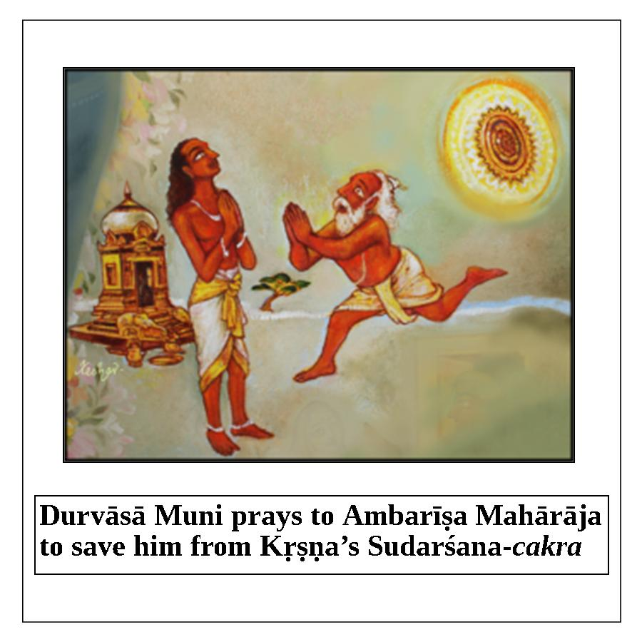

Durvāsā Ṛṣi said, “Today, I have seen how glorious the Vaiṣṇavas are; I must observe ekādaśī to become a devotee like you.”
If you want to become a devotee like Ambarīṣa Mahārāja, or like the parents of Kṛṣṇa, Nanda and Yaśodā, then you must follow ekādaśī. Nanda and Yaśodā followed ekādaśī in Vṛndāvana, and from Vṛndāvana they went to Ambikā-kānana near Mathurā and followed it there. If they did this, shouldn’t we? We must observe ekādaśī, and with care. Then, bhakti will come to us automatically.
We must follow ekādaśī under the guidance of pure Vaiṣṇavas, and also perform kīrtana under such guidance. It is okay if one does bhakti, but if he is under the guidance of a devotee who has a relation with Vraja–who has vraja-bhakti and is rasika, knowing all tattvas–that pure devotee can remove all doubts and put Rādhā, Kṛṣṇa, and Mahāprabhu in his heart. Always be in Vṛndāvana under the guidance of this caliber of Vaiṣṇava, and always chant and remember. At the same time, chant the holy name of Kṛṣṇa and remember the pastimes related to that name.
For example, if you sing “Govinda Dāmodara Mādhaveti”, you can remember the pastimes of Govinda. When the demigod Indra sent torrential rains, Kṛṣṇa held up Girirāja Mountain for seven days to protect the residents of Vṛndāvana. After those seven days, Indra realized that he had committed a great offense at Kṛṣṇa’s lotus feet. He went to Kṛṣṇa with his elephant and Surabhi cow. He performed Kṛṣṇa's abhiṣeka (sacred bathing ceremony) and then said, “You are the protector of go (cows), gopas (cowherd men and boys),gopīs (cowherd women and girls), govatsa (calves), the land, and all of the other residents of Gokula. So, it is appropriate that Your name is Govinda.” You can remember this pastime, for example.
You can also remember the pastimes of Dāmodara. You can remember the pastime of Yaśodā binding Kṛṣṇa and Kṛṣṇa weeping: “Mother, Mother, don’t beat Me!”
Once, Śrīmatī Rādhikā and the gopīs were sitting with Kṛṣṇa. Lalitā took a corner of Śrīmatī Rādhikā's veil and a corner of Kṛṣṇa’s pītāmbara, and tied the two together. Then, all of the gopīs began to sing the kīrtanas of marriage, and Viśākhā acted as the priest. When Rādhikā realized what was happening, She started to run away, but Kṛṣṇa was bound to Her. The gopīs bound Kṛṣṇa so that He could not leave Śrīmatī Rādhikā; He would always be with Her. In this way, He is Rādhā-Dāmodara.
We remember Rādhā-Dāmodara. Śrīla Rūpa Gosvāmī established the Deity of Rādhā-Dāmodara, not Yaśodā-Dāmodara. Yaśodā-Dāmodara is only a part of Rādhā-Dāmodara. We should remember and chant like this, and always think, “We are in Vṛndāvana with the Vrajavāsīs.”
Also, when you chant you can remember the following verses:
jayatāṁ suratau paṅgor mama manda-mater gati
mat-sarvasva-padāmbhojau rādhā-madana-mohanau
“All glories to the all-merciful Śrī Rādhā-Madana-Mohana! Although I am lame, foolish and devoid of intelligence, Your lotus feet are my refuge and my everything!” (Caitanya-caritāmṛta, Ādi-līlā, 1.15)
dīvyad-vṛndāraṇya-kalpa-drumādhaḥ
śrīmad ratnāgāra-siṁhāsana-sthau
śrī-śrī-rādha-śrīla-govinda-devau
preṣṭhālībhiḥ sevyamānau smarāmi
“I meditate upon Śrī Śrī Rādhā-Govinda-deva, who are seated beneath a kalpa-vṛkṣa tree on an effulgent bejeweled siṁhāsana in the supremely beautiful land of Vṛndāvana, where They are always being served by Their beloved sakhīs, headed by Lalitā and Viśākhā.”(Caitanya-caritāmṛta, Ādi-līlā, 1.16)
You can remember the pastimes of Kṛṣṇa surrounded by all of the gopīs.
When you chant the following verse, you can remember Kṛṣṇa as Gopīnātha under the shade of Vaṁśī-vaṭa.
śrīmān rāsa-rasārambhī vaṁśīvaṭa-taṭa-sthitaḥ
karṣan veṇu-svanair gopīr gopīnāthaḥ śriye'stu naḥ
"Śrī Gopīnātha, who originated the transcendental mellow of the rāsa dance, always stands beneath the Vaṁśī-vaṭa tree, attracting all the kiśorī-gopīs with the sound of His flute, thereby showering me with auspiciousness." (Caitanya-caritāmṛta, Ādi-līlā, 1.17)
Our ekādaśī will be observed well when we are chanting and remembering, and thinking that we are in Sevā-kuñja or under the shade of Vaṁśī-vaṭa, especially under the guidance of Śrīla Rūpa Gosvāmī.
Śyāmarāṇī dāsī: Gurudeva, we always hear that we should not take grains on ekādaśī because sins are stored in them on that day, but why can we not take certain vegetables, like tomato and laukī?
Śrīla Nārāyaṇa Gosvāmī Mahārāja: It is not like with grains. They do not have the qualities of grain, corn, wheat, and dahl [in that they don’t act like blotting paper or a ball of cotton]. We know from a special story that on the day of ekādaśī, all sins, including brahma-hatyā (the killing of a brāhmaṇa), mātṛ-hatyā (the killing of one’s mother), and go-hatyā (the killing of a cow) take shelter in grains and in things prepared with grains. In addition, śāstra prohibits eating certain vegetables and other foodstuffs.
A concession has been made for the Western devotees, and in India for weak persons. If you are not observing the rules and prohibitions, then all kinds of sin will come to you, and if you have some bhakti, it will be destroyed.
Weak persons can take something, as they like, but it must be within the foodstuffs allowed for ekādaśī. Children can also take as they like, but their mother and father should take care that they only eat fruits and other foods allotted for ekādaśī.
In evening class, we will discuss how we can develop our Kṛṣṇa consciousness; how we can follow Caitanya Mahāprabhu and the teachings of Rūpa and Raghunātha. We are only here for one day, so how much can I say? If we would be here for seven or ten days, as we are in other cities, then we could speak on several subjects or themes. No harm, though; I think that all are inspired by hearing this topic today.
My request is: don’t be weak. Have great faith in your Guru, your śikṣā-guru, devotees, and the pure Name. If you have no taste, then again and again continue to chant, because the Name is Kṛṣṇa Himself. It will give you darśana of Kṛṣṇa. Kṛṣṇa is coming to you in the form of ekādaśī, in the form of His Name, but you think, “Oh, it is enough to chant in any way” –lahstom pahstum– one or two rounds, and without attention. Don’t be like this. Kṛṣṇa, His Name, and ekādaśī can fulfill all of our desires, and can even give vraja-prema.
Wealth cannot save us or solve our problems, but bhakti can fulfill all kinds of desires and solve all kinds of problems. Have a very strong belief in the Name, and observe ekādaśī, Janamāṣṭamī, Rāma-navamī, Nṛsiṁha-caturdaśī, and Mahāprabhu’s birthday. Especially, try to honor devotees. Don’t neglect devotees by mind or heart, and don’t have any enemies.
Gaura Premānande!

Anu-kalpa

Restricted foods on ekādaśī:
Tomatoes, eggplants, cauliflower, broccoli, bell pepper, beets, bitter melon (karelā), laukī, parmal, toroi, kunli, drumsticks, bhiṇḍi (lady fingers or okra), banana flower.
Peas, chickpeas and all types of beans, including products made from beans [pāpaḍa (wafers), tofu, tempeh (Indonesian foodstuff made from fermented soya beans; a dish made by frying this), etc.]
All leafy vegetables: spinach, salads, cabbages, etc., and leafy herbs like parsley, coriander leaves, celery, curry leaves, etc.
Grains: millet, barley, farina, pasta, rice, corn, etc. all types of flour made from grains and beans (like rice flour, chickpea flour, urad dahl flour, etc.)
Starches from corn or grains, and products made from and mixed with these starches like: baking soda, baking powder, certain soft drinks with corn syrup, custard, certain yogurts, puddings, certain cream & cottage cheeses, certain sweets, candies, tapioca balls, etc.
Oils made from grains: corn oil, mustard oil, sesame oil, etc., and products fried in these oils: nuts, potato chips and other snack foods.
Honey and sweets made with starches.
Spices used on ekādaśī: black pepper, fresh ginger, pure salt and fresh turmeric, all taken from a new and clean package.
Spices not used on ekādaśī: hing (asafetida), sesame seeds, cumin, fenugreek, mustard, tamarind, fennel, cardamom, nutmeg, etc.

Foods that can be taken on ekādaśī
All fruits (fresh and dried), all nuts and oils made from nuts.
Potatoes, pumpkin, cucumber, radish, squash, lemon, avocado, olives, coconut, buckwheat, all sugars.
All pure milk products.

Important Letter about ekādaśī
Devotees often ask about the proper way to observe ekādaśī in the strictest sense. The following letter is written by Śrīla Bhaktivedānta Nārāyaṇa Gosvāmī Mahārāja, at the Śrī Keśavajī Gauḍīya Maṭha in Mathurā, India, on July 11, 1993. We hope this will be helpful.
Please accept my heartly blessings. All glories to Śrī Śrī Guru and Gaurāṅga and Śrī Śrī Rādhā Vinoda-viharī.
I received your letter sent to Navīna Kṛṣṇa Brahmacārī. You have inquired about nirjalā-ekādaśī and cāturmāsya-vratas. I think you have Hari-bhakti-vilāsa and you have all read these topics in that book. You have also read in Śrīmad-Bhāgavatam about Ambarīṣa Mahārāja who always used to do nirjalā-ekādaśī. From Hari-bhakti-vilāsa and from the example of Ambarīṣa Mahārāja’s vrata, we know that on the day before ekādaśī we should take prasāda only one time, and we should not take any water–even at night. On the second day we should take no water and no mahā-prasāda, throughout the entire day and night. We should not sleep. We should observe brahmacarya, always chant and hear hari-kathā, and we should read bhakti books. Also, we should always remember the pastimes of Kṛṣṇa, using our eleven indriyas (senses) in His service. On the next day, after worshiping the Deities, we can take pāraṇa, the remnant food grains of mahā-prasāda.
By chance, if Nityānanda Prabhu’s or Advaita Ācārya Prabhu’s birthday comes on that day (dvādaśī), and we want to maintain our vrata, we will break the ekādaśī-vrata by taking Kṛṣṇa caraṇāmṛta. No food grains are to be taken, but on that day we can take water. And on the next day, after worshiping Nityānanda Prabhu or Advaita Ācārya, we will break the vrata by remnants of mahā-prasāda food grains.
All this has been told for persons who are able to do so. Those who are not able should follow Śrīla Prabhupāda Bhaktivedānta Svāmī Mahārāja’s guidelines. In Kali-yuga, only rare persons can follow, but if anyone wants to follow, that is very good. I have seen generally that our Gurudeva, Śrīla A. C. Bhaktivedānta Svāmī Mahārāja, Pūjyapāda Śrīdhara Mahārāja, Pūjyapāda Mādhava Mahārāja, Pūjyapāda Bhakti-vilāsa Tīrtha Mahārāja, Pūjyapāda Bhāratī Mahārāja, and other respected ācāryas did not do nirjalā when they became elderly. They used to take milk, curd, fruit juice, boiled potato, plantains, and other vegetables with ekādaśī salt. But I have also seen Vaiṣṇavas doing nirjalā ekādaśī. You can follow which is suitable to you.
Somehow we should try to remember Kṛṣṇa, along with His associates and His pastimes, throughout the day and night. Don’t sleep, and don’t be lazy. If anyone does nirjalā ekādaśī, but at the same time gets a headache, becomes nervous, becomes lazy, and he does not remember Kṛṣṇa, then there is no use of doing nirjalā. Somehow our hearts should always remember Kṛṣṇa’s pastimes. The main objective of all our activities should be to somehow or other keep our heart always at the lotus feet of Kṛṣṇa, by hook or crook.
Regarding cāturmāsya, we should try to follow Hari-bhakti-vilāsa and Śrīla Bhaktivinoda Ṭhākura. Śrīla Bhaktivinoda Ṭhākura has written an article in which he has explained what to eat and what not to eat in each of the four months, but he did not include certain prohibitions. So you should read Hari-bhakti-vilāsa and try to follow it. If you take fruits, they should be taken once in a day, not again and again, so many times in a day. I only try to follow my Gurudeva. We should follow our Gurudeva.
Regarding serving the Deities during Cāturmāsya, certainly we cannot keep our fingernails so long. We try to be neat and clean to serve the Deities.
During the four-month cāturmāsya-vrata, we should bathe the Deities with pañcāmṛta (yogurt, milk, ghee, honey, and sugar), and this pañcāmṛta should be taken by us. At that time it becomes pañcāmṛta-caraṇāmṛta, and therefore it should be taken. This is also true in the case of dahī (yogurt) and madhu. Madhu, honey, is prohibited, but when it is included in that pañcāmṛta, it can also be taken. Only during nirjalā-ekādaśī is pañcāmrta-caraṇāmrta prohibited, although it can be taken after breaking fast.
We should try to follow the culture and activities of Vaiṣṇava behavior. Whether outsiders criticize or not, we should try to follow all principles strictly. This is pracāra. We should not leave the bhakti cult in any way. Once an Indian devotee prayed to Śrīla Bhaktivedānta Svāmī Mahārāja, “I have not shaved, I will take only tulasī-mālā on my neck, and I will not do Kārtika-vrata or ekādaśī-vrata. But I will follow you and I want to live with you.” Śrīla Svāmī Mahārāja rejected the proposal. Actually, in our cult we don’t shave daily.Brahmacārīs and sannyāsīs should only shave one time in a month as we have seen Śrīla Prabhupāda Bhaktisiddhānta Sarasvatī and his followers do, and we have also heard about Caitanya Mahāprabhu and His followers doing.
We don’t follow any other Purāṇas or Mahābhārata. We follow Caitanya Mahāprabhu and His followers. When there is any discrepancy between the Vedas and the Purāṇas, that is, Bhāgavata, we will follow Śrīmad-Bhāgavatam. We should try to follow Śrīla Rūpa Gosvāmī and Śrīla Sanātana Gosvāmī and our guru-paramparā. I have not read Mahābhārata so deeply, but I know the Vaiṣṇava paramparā. We don’t touch Tulasī on the dvādaśī day. We should follow this. And if you have seen Mahābhārata with your own eyes, then there is no harm that on Amāvasyā we do not touch Tulasī.
We hope this letter will find you in good health and Kṛṣṇa Consciousness,
Your ever well-wisher,
Svāmī B. V. Nārāyaṇa.

Stories and Anecdotes about Ekādaśī

Deliverance of a brahma-rākṣasa
Pūjyapāda Śrīmad Bhakti-bhūdeva Śrautī Mahārāja, a disciple of Śrīla Bhaktisiddhānta Sarasvatī Prabhupāda, was preaching in east India. He was a close friend and god-brother of Parama-gurudeva Śrīla Bhakti-prajñāna Keśava Gosvāmī Mahārāja. He preached pure devotion to the elderly people and children of the villages. Once, after a preaching program, he inquired from the children of the village about where to spend the night. The children directed him to a nearby abandoned house. He entered the isolated home, put his mat on the floor, and took rest for the night.
At about midnight he awoke to a terrifying voice: “I am a brahma-rākṣasa. I devour anyone who stays in this house, and I am going to devour you.” Despite the terrifying voice, Śrīmad Bhakti-bhūdeva Śrautī Mahārāja remained completely unperturbed. He knew that the only way to rescue this wretched soul who was suffering in a ghostly body was to give him the spiritual benefit of following one ekādaśī. Generally, having a ghostly body is even more distressful than being in hell. Śrīmad Bhakti-bhūdeva Śrautī Mahārāja took some water in his hand and sprinkled it in the direction of the brahma-rākṣasa, blessing him with the benefit of following one ekādaśī. Immediately, he heard a voice say, “Thank you very much for delivering me. The benefit of observing one ekādaśī has rescued me from the ghostly body of a brahma-rākṣasa. I am feeling tremendous relief. I cannot repay you for your magnanimous gift; I am eternally indebted to you.”
After offering obeisances to Śrīmad Bhakti-bhūdeva Śrautī Mahārāja, that soul left for a better body in which he would be able to practice the various forms of devotional service.

Spiritual Lottery
One may be a very poor person earning very little money. If one must borrow twice as much as one earns to meet one’s expenses, one will certainly incur more and more debt just to maintain one’s family. However, if one buys a cheap lottery ticket and hits a jackpot of millions of dollars, all of one’s debt is instantly removed and one becomes rich.
The vow of ekādaśī is like winning a spiritual lottery or jackpot. One may be spiritually weak and poor; however, if one diligently observes ekādaśī, one will become spiritually rich and powerful.

An old lady and her husband
There was an old lady possessed by a ghost. Her husband was a strict follower of ekādaśī. Although he advised her to also follow that vow, the ghost in her body would not let her do so. While that ghost would also not allow her to go to a Hare Kṛṣṇa temple, it did permit her to visit a Christian church. The prayers in that church were not powerful enough to force the ghost to leave the old lady’s body; however, the ghost would have to leave her body if she heard the chanting of the Hare Kṛṣṇa mantra or fasted on ekādaśī. Whenever that lady would attempt to observe ekādaśī or visit a Hare Kṛṣṇa temple, the ghost would get enraged and cause her to tremble severely. She would shake like a thin plantain tree in a cyclone. The ghost was comfortable living as a parasite within her body and exploiting her senses to enjoy mundane sense objects, and it did not want to be evicted.
One day, the old lady’s husband addressed the ghost in her body, “My dear friend, why are you preventing my good wife from observing ekādaśī and visiting a Hare Kṛṣṇa temple? Do not be afraid that you will become homeless by letting her do so. Rather, the great prospect of your deliverance awaits you.”
The sincere words of the old devotee awakened the good sense of the ghost, and it let the old woman observe ekādaśī. Right after the pāraṇa (completion of the ekādaśī vow), the old lady felt great relief as she became permanently free from the influence of the pesky ghost. The ghost left its subtle existence behind and received a gross body by the mercy of Ekādaśī-devī, the personal potency of Lord Kṛṣṇa.
The kind words of the old lady’s husband persuaded the ghost to move on. If a person is possessed by a ghost, someone should speak such soothing words to the ghost and give that spirit soul the benefit of following one ekādaśī. Doing so will free the ghost.

Safe Delivery
A daughter-in-law of one devotee mātājī was going to have a baby. After concluding that a normal delivery would be impossible, the doctor prescribed a cesarean delivery. Mātājī requested five minutes to come to a decision and called Śrīpāda Bhaktivedānta Daṇḍī Mahārāja. Śrīpāda Bhaktivedānta Daṇḍī Mahārāja bestowed the benefit of one ekādaśī fast on the mother. After five minutes, the doctor changed his mind and proceeded with a normal delivery.

Remote Relief
Śrī Śivarāja Kṛsṇa Dāsa, a devotee and disciple of Śrīpāda Bhaktivedānta Daṇḍī Mahārāja, is an Engineer in Bangalore. He went by train with a group of about seventy devotees from Bangalore to Śrī Navadvīpa-dhāma for the annual parikramā. Meanwhile, his elder brother in Bangalore suffered a heart attack and was admitted to the intensive care unit of a Bangalore hospital. For about fifteen days, he remained on the border of life and death. His relatives phoned Kṛṣṇa Dāsa and reported to him the news of his brother’s ill-health. Śrī Śivarāja Kṛṣṇa Dāsa was very worried, but he explained that he could not help, as he was very far from Bangalore. He took some water in his hands and threw it on the ground, bestowing the benefit of one ekādaśī on his ailing brother. His brother immediately came out of his coma and inquired about Śrī Śivarāja Kṛṣṇa Dāsa. Everyone told him that Śrī Śivarāja Kṛṣṇa Dāsa had gone on Navadvīpa Parikramā and would return after ten days.
Upon returning, Śrī Śivarāja Kṛṣṇa Dāsa saw his elder brother running to greet him. His brother hugged him tightly and thanked him profusely for saving his life. Even with the best available medical care, only the benefit of one ekādaśī fast was able to rescue Kṛṣṇa Dāsa’s brother from the terrifying jaws of Yamarāja, the god of death. His brother was fully aware of this, and therefore he was reluctant to let go of Kṛṣṇa Dāsa, clutching him tightly with brotherly affection.
Afterward, the elder brother also took a vow to strictly observe ekādaśī. Having personally experienced the life-saving grace of ekādaśī, he developed a steadfast attachment for observing it.

Two Muslim brothers
Two Muslim brothers in a city of India were living a day-to-day existence. To maintain their lives, they would pull rickshaws on the streets. Once, a rich businessman hired them to transport goods from one location to another. It was the day of Śuddhā Ekādśī. The brothers, completely unaware that it was the day of ekādaśī, pulled the carts all day long in the hot sun. They did not take any food or water that day. They died from the sweltering heat, exertion, thirst, and hunger, and were taken to hell by the associates of Lord Yama, the god of death.
Upon arriving in hell, they saw that the residents were suffering from unbearable torture at the hands of the attendants of Yamarāja. They screamed, lamented, and wailed in piteous voices. No one was rescuing them from their hellish torment. Anticipating the horrible future awaiting them, the brothers began to tremble.
Yamarāja inquired from Citragupta, who keeps the records of everyone’s sins and pious merits. Citragupta reported that these brothers had not performed any pious activity and had engaged in many sinful activities. However, they had fasted even from water up to afternoon on ekādaśī; therefore, they had earned the merit of partially observing ekādaśī. Hearing this, Yamarāja ordered their immediate release and had them escorted back to Earth with full respect.
On coming back to life, the brothers reflected on what had happened, and they were overjoyed to personally experience the glories of the ekādaśī vow.
On one particular ekādaśī, they attended a Śrīmad-Bhāgavatam discourse given by a professional reciter. After the discourse, the organizers of the event offered everyone grain prasāda. However, the Muslim brothers pointed out that it was ekādaśī, and they refused to accept any grain prasāda. They recounted the entire episode of going to hell and being personally pardoned by Yamarāja due to having partially observed ekādaśī.
Hearing their story, the Hindu members of the audience also vowed to observe a complete fast from grains and beans on ekādaśī. Fasting on ekādaśī is indeed a panacea for those already suffering hellish torment as well as those destined for hell.

Ekādaśī Māhātmya

Introduction
This book (Ekādaśī Māhātmya) has been published by the unlimited mercy of Lord Śrī Kṛṣṇa. Nobody has ever published such a book in the Bengali language. The faith of persons observing the vows of ekādaśī will be strengthened by studying the glorious subject matter of this book. Moreover, those who are inquisitive about this book will also obtain the light of knowledge.
This book does not cover the complete truth and philosophy regarding Śrī Ekādaśī; the glories of observing ekādaśī are revealed through stories. Some people may speculate that the glories described in this book are simply exaggeration, or they may think that observing ekādaśī is merely meant for achieving material happiness and prosperity. Śrī ekādaśī, which falls on the eleventh day of each waxing and waning moon, is very dear to Lord Hari; that is why this day is also known as Hari-vāsara. A proper and elaborate explanation of ekādaśī is given in Śrī Hari-bhakti-vilāsa. One should observe ekādaśī only to please the Supreme Lord. The scriptures state:
ekādaśī vrataṁ nāma sarva kāma phala pradam
kartavyam sarvadā vipraiḥ viṣṇu prīṇana-kāraṇam
“The brāhmaṇas should always observe ekādaśī to please Lord Viṣṇu, for this fulfills all of one’s desires.”
One should honor the vow of ekādaśī for the sake of satisfying the Lord; happiness and prosperity will automatically follow. Bṛhan-Nāradīya Purāṇa states that if everyone including brāhmaṇas, kṣatriyas, vaiśyas, śūdras, and women observes ekādaśī, they will certainly attain liberation, although various temporary benefits are also described in the scriptures because following ekādaśī is one of the limbs of regulative devotional service. One should understand that the principle fruit of devotional service is to develop intense love for the Supreme Lord. Even if the goals of religiosity, economic development, sense gratification, and liberation automatically come to practitioners of devotion, unalloyed, pure devotees are not satisfied with this. Rather, they abandon these objectives in favor of love of God, the fifth and highest goal of life.
jyāsī nāvaḍe ekādaśī, to jitācī narakavāsī
jyāsī nāvaḍe he vrata, tyāsī naraka tohi bhīta
jyāsī ghaḍe ekādaśī, jāṇe lāge viṣṇupāśī
tukā mhaṇe puṇyarāśī, toci karī ekādaśī
“One who does not like ekādaśī is already in hell even when alive. Hell itself is afraid of a person who does not like the vow of ekādaśī because such a person is considered to be very sinful. One who follows ekādaśī will certainly attain Vaikuṇṭha. Therefore, Tukārāma Mahārāja says that only those who have accumulated heaps of pious merit in their lives observe ekādaśī.”

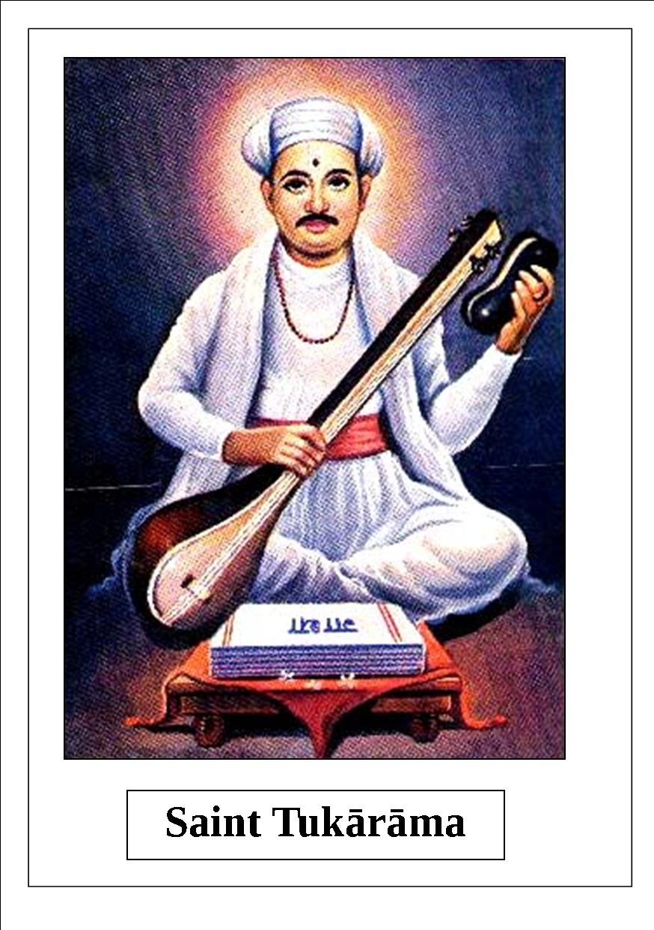
Tukārāma Mahārāja explains what happens if one eats grains on ekādaśī:
ekādaśīsa annapāna, je nara karitī bhajana
śvāna viṣṭhesamāna, adhama jana te eka
tayā dehī yamadūta, jāle tayāce aṁkita
tukā mhaṇe vrata, ekādaśī cukaliyā
“Those who eat grains on ekādaśī are indeed very fallen living entities. They are considered to be degraded because the food they take is like the stool of a dog. The Yama-dūtas (messengers of the god of death) are ready to take persons who do not observe this vow to hell.”
Since the living entities of Kali-yuga are short-lived and lusty, they are unable to perform severe austerity. They subsist on grain; they cannot survive without it. The people living in Satya, Tretā, and Dvāpara-yugas were capable of undergoing severe austerity and tolerating physical distress. That is why a minimum austerity of fasting twice a month on ekādaśī is prescribed for the people of Kali-yuga. If able, they should eat only once on the day before ekādaśī, fast totally on the day of ekādaśī, and eat only once on the day after ekādaśī. If one is unable to eat only once on the days before and after ekādaśī, he must observe a complete fast on the day of ekādaśī. If one cannot follow this, he should observe the vow of ekādaśī by fasting from the five types of grains and partaking of only fruits and roots. Mahābhārata (Udyoga Parva), quoted in Hari-bhakti-vilāsa 12-40, states:
aṣṭaitāny avrata-ghnāny āpo mūlaṁ phalaṁ payaḥ
havir brāhmaṇa-kāmyā ca guror vacanam auṣadham
“Water, fruits, roots, milk, ghee, satisfying a brāhmaṇa, following the instruction of the spiritual master, and medicine do not break one’s vow of ekādaśī.”
Since grave sinful reactions equal to that of killing a brāhmaṇa or a cow take shelter within the five types of grain on ekādaśī, persons who desire their ultimate benefit refrain from eating grains on this day. The five types of grain are rice and products made from rice (flat rice, puffed rice, etc.), wheat flour and white flour, barley, pulses (mung, chickpea, green peas, lentil, etc.), and mustard oil and sesame oil. If one eats any of these grains, his ekādaśī vow will be broken.
Another name for ekādaśī is Hari-vāsara. The main purpose of observing ekādaśī is to fully please Lord Hari with all of one’s senses. In other words, one should try to please Lord Hari and the devotees of Hari. The word upavāsa (fasting) means ‘to live nearby’. On ekādaśī one should remain aloof from all kinds of sinful activities, give up all kinds of household activities and sense gratification, and be near the Lord. Hari-bhakti-vilāsa 13-14 states, as quoted in Gṛhya-pariśiṣṭa, Kātyāyana-smṛti, Viṣṇu-dharma, and Brahma-vaivarta Purāṇa:
upavrittasya pāpebhyo yastu baso guṇaiḥ saha
upavasah sa vijṣeyaḥ sarva bhoga vivarjitāḥ
“The word upavāsa or ‘fasting’ refers to staying aloof from all kinds of sinful activities and sense gratification.”
Lord Hari is the transcendental Personality of Godhead, and He is beyond the three modes of material nature. It is not possible to be with Him by the efforts of the material body, mind, and intelligence. Every conditioned soul is covered by two bodies; namely, the gross body and the subtle body. Therefore, how can such a soul be with the Lord? Observing ekādaśī is prominent among the sixty-four limbs of devotional service described by Śrīla Rūpa Gosvāmīpāda, an associate of Śrīmān Mahāprabhu. Among those limbs, the first and foremost is to take shelter of a bona fide spiritual master. One cannot worship Śrī Hari without taking shelter at the lotus feet of a bona fide spiritual master who is well-conversant with the scriptures, attached to the Absolute Truth, and very dear to Śrī Hari. When one surrenders at the lotus feet of the spiritual master, by his mercy and empowerment one’s material pride is destroyed, and his pure, spiritual constitutional position is revived. As a result, he becomes qualified to serve the Supreme Lord through his service-oriented senses. In other words, he becomes qualified to live with the Lord. The mind is the cause of a living entity’s bondage or liberation. If one cannot convert the function of the mind so as to be favorable for devotional service, one cannot live with the Lord. It is necessary to associate with pure devotees in order to convert a mind which is averse to service into one that is inclined to serve. Without being subordinate to the devotees of the Lord, one cannot be with the Lord, even if he engages in various external, ritualistic activities. For this reason, there is a great difference between a karmī (fruitive worker) observing ekādaśī and a devotee doing so. Caitanya-caritāmṛta, Madhya 22-51 states:
mahat-kṛpā vinā kona karme ‘bhakti’ naya
kṛṣṇa-bhakti dūre rahu, saṁsāra nahe kṣaya
“Unless one is favored by a pure devotee, he cannot attain the platform of devotional service. To say nothing of kṛṣṇa-bhakti, one cannot even be relieved from the bondage of material existence.”
Those who observe ekādaśī are divided into three categories.
1. The majority of the people of this world consider their gross and subtle bodies as the self. They think that the rules and regulations of the scriptures, and the instructions of the sages, are meant for protecting the interest of their gross bodies. They are doubtful about the existence of the soul, and thus they give more importance to the interest of the body. Their conception is that if the soul exists at all, it is simply for the sake of the gross body.
2. Other people believe that the constitutional position of a living entity is that he is a spirit soul, not the body; that the Supreme Lord is the cause of the living entities; and that it is the duty of a living entity to worship the Supreme Lord. Still, they consider the deliverance of the soul and happiness of the body to both be goals of life. That is why they think that the scriptural injunctions such as observing ekādaśī are meant for both deliverance of the soul and benefit of the body.
3. A minority of people say that a living entity is constitutionally part and parcel of the Supreme Lord, and is eternal, full of knowledge, and blissful. The two coverings of gross and subtle bodies are imposed on the living entities by the external energy of the Lord, and they are undesirable. Since the gross and subtle bodies originate from the external energy of the Lord, the Supreme Lord is naturally the enjoyer and proprietor of those bodies. In other words, the soul, mind, and body of a living entity all belong to Kṛṣṇa. Therefore, it is the only duty of the soul, mind, and body to fully engage in the service of the Lord. Both oneself and others are benefited when one worships Lord Hari. Execution of pure devotional service is the only means of attaining eternal peace. Devotees cultivate the limbs of pure devotional service, such as observing ekādaśī, solely to please the Supreme Lord. They know that the principle purpose of all practices is to achieve love of God. They also know that the limbs of devotional service are not prescribed for material sense gratification or to benefit the gross and subtle bodies. This is the perspective of pure devotees who are following in the footsteps of Śrī Caitanya.
Some people, particularly many devotees from Jagannātha Purī in Orissa, say that there is no fault in accepting grain mahā-prasāda of Jagannātha on ekādaśī. However, one should consider that Vaiṣṇavas do not accept anything other than mahā-prasāda. To maintain the prestige of ekādaśī, they offer obeisances to grain mahā-prasāda on ekādaśī, but they do not take it until the next day.
In His childhood, Śrī Caitanya Mahāprabhu advocated fasting on ekādaśī. In his Bhakti-sandarbha, Śrīla Jīva Gosvāmī gives a quotation from the Skanda Purāṇa stating that a person who eats grains on ekādaśī is like a murderer of his own mother, father, brother, or spiritual master, and even if he is somehow elevated to a Vaikuṇṭha planet, he will fall down. Anything may be cooked for Viṣṇu on ekādaśī, including grains and dahl, but a Vaiṣṇava should not take grain viṣṇu-prasāda on ekādaśī. It is said that a Vaiṣṇava does not accept any foodstuff that is not offered to Lord Viṣṇu; on ekādaśī, a Vaiṣṇava should not take grain mahā-prasāda even though it has been offered to Viṣṇu. Rather, such grain prasāda may be eaten the next day. It is strictly forbidden for one to accept any kind of grain on ekādaśī, even if it is offered to Lord Viṣṇu.
In his book Prema-vivarta, Śrī Jagadānanda Paṇḍita, an associate of Śrī Gaura, gives the following description regarding the following of ekādaśī.
“Śrī Mahāprabhu said that if one disregards the vow of ekādaśī, he brings ruination on his life. One should simply respect grain prasāda on ekādaśī and save it for the next day; in this way, the negative effect will be avoided. The pious Vaiṣṇavas are satisfied by drinking the nectar of Kṛṣṇa’s holy names on ekādaśī. They do not indulge in any kind of sense gratification, they do not speak about useless topics, and they abandon all kinds of material enjoyment. Honoring prasāda is an eternal activity of the pure Vaiṣṇavas; they never eat anything that is not first offered to the Lord. Devotees should fully fast on ekādaśī and eat the Lord’s food remnants the next day. In certain situations, a Vaiṣṇava may take non-grain remnants of the Lord on ekādaśī. Non-Vaiṣṇavas engage in sense gratification day and night on the pretext of honoring prasāda. Such people associate with sinful persons and disrespect the vow of ekādaśī by eating grains. If one cultivates the limbs of devotional service with respect, one will attain the mercy of Bhakti-devī. One should give up the association of non–devotees, strictly observe the vow of ekādaśī, and chant the holy names of the Supreme Lord. It is stated in the scriptures that one should never transgress the rule of fasting on ekādaśī. O king, one should observe the vow of ekādaśī as long as he is alive.”
The Purāṇas repeatedly declare that one should fast on ekādaśī. Viṣṇu-smṛti states that all sinful reactions, such as that for killing a brāhmaṇa, take shelter in grains on ekādaśī. Therefore, if one eats grains on ekādaśī, he certainly eats sin. There is no atonement powerful enough to deliver a person who eats grains on ekādaśī. The twenty dharma-śāstras give various arrangements for atonement according to the severity of the sinful activity, but eating grains on ekādaśī is such a grave sin that there is no atonement prescribed for it.
Persons who want to cultivate pure devotional service should carefully consider the next point regarding ekādaśī. Vaiṣṇavas do not observe two different vows or festivals on the same day. In the case where two vows or festivals would fall on the same day, Vaiṣṇavas observe one vow or festival on the day after the other. According to Vedic calculation, a day starts with the sunrise. If the day of daśamī extends to the one-and-a-half hours before the sunrise of the next day, ekādaśī should not be observed on the next day. Rather, it should be observed on the day after that. In this regard, we quote some authentic scriptural statements found in Śrī Hari-bhakti-vilāsa, the king of the Vaiṣṇava smṛti.
“O brāhmaṇa, if the day of ekādaśī starts ninety-six minutes before sunrise, it is a pure ekādaśī. A householder should fast on such an ekādaśī.” [Garuḍa Purāṇa]
“If the tithi or day of ekādaśī begins one hour and thirty-six minutes before sunrise, it is called a complete ekādaśī, and if the ekādaśī starts with less time prior to sunrise, it should be considered incomplete and contaminated because it overlaps with the previous tithi. One should not follow ekādaśī if it is mixed with the previous tithi at the time of sunrise. Vaiṣṇavas in particular should never observe such a contaminated ekādaśī. The great sage Kaṇva said, ‘If the day of ekādaśī is pierced with the previous tithi, one should fast on the day after that ekādaśī, and break the fast on the following day.’” [Bhaviṣya Purāṇa]
“Most days begin with the rising of the sun and end at the next rising of the sun, but this is not always the case with ekādaśī. An ekādaśī is uncontaminated and complete only if it starts at least one hour and thirty-six minutes before sunrise.” [Skanda Purāṇa]
We request all kind-hearted readers to carefully study the following glories of ekādaśī.

The Purāṇic glories of Ekādaśī
Once, in a great assembly of sages, the renowned scholar and sage Śrī Sūta Gosvāmī discussed the twenty-six ekādaśīs. There are two ekādaśīs in each month, so there are twenty-four ekādaśīs in a year. Besides those, there are two additional ekādaśīs which occur in an extra month that comes every two-and-a-half years. The names of the first twenty-four ekādaśīs are Utpannā, Mokṣadā, Saphalā, Putradā, Ṣaṭ-tilā, Jayā, Vijayā, Āmalakī, Pāpamocanī, Kāmadā, Varuthinī, Mohinī, Aparā, Nirjala, Yoginī, Śayana, Kāmikā, Pavitrā, Annadā, Pārśva, Indirā, Paśāṅkuśā, Rāma, and Utthāna. The names of the two additional ekādaśīs are Padminī and Parama. In that assembly, the glories of all of the ekādaśīs were properly sung. Those who are unable to observe ekādaśī can attain the benefits of doing so by hearing and singing those glories.

Utpannā Ekādaśī
The glories of Utpannā ekādaśī are described in Bhaviṣya-uttara Purāṇa in a conversation between Śrī Kṛṣṇa and Arjuna. Śrī Sūta Gosvāmī said to the assembled brāhmaṇas and sages, “If a person with faith and devotion duly follows ekādaśī, hears about its glories, or hears about the rules and regulations for observing it as described by Lord Kṛṣṇa, he will attain happiness in this life and will return to the abode of Lord Viṣṇu in his next life.”

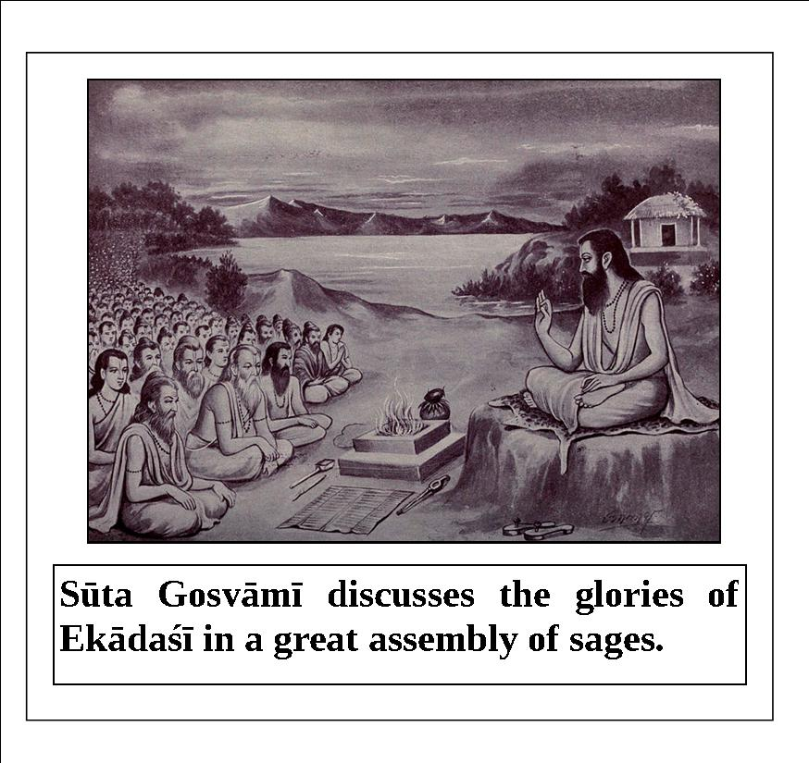

Once, Arjuna asked Śrī Kṛṣṇa, “O Janārdana, please explain to me what the benefits of fully fasting, eating only at night, and eating only once at midday on ekādaśī are.”
Lord Śrī Kṛṣṇa replied, “O Arjuna, at the beginning of autumn, on the ekādaśī that occurs during the waning moon in the period of November-December, a person should observe the vow of ekādaśī. In the early morning on that day, he should make a vow to fast. At mid-day, he should purify himself by taking a bath and pray as follows:
aśva-krānte ratha-krānte viṣṇu-krānte vasundhare
mṛttikā hara me pāpaṁ yanmayā pūvūrvarsaṁcitam
‘O Aśva-krāntā! O Ratha-krāntā! O Viṣṇu-krāntā! O Vasundharā! O Mṛttikā! O Mother Earth! Please destroy all of my sinful reactions accumulated from previous lifetimes so that I can attain the supreme destination.’
He should worship Lord Govinda after completing his bath.”
Lord Śrī Kṛṣṇa continued, “Once, Indra, the king of heaven, surrounded by the demigods, approached the Supreme Lord and prayed, ‘O Lord of the universe, O Supreme Personality of Godhead, we offer our respectful obeisances to You. You are the supreme shelter, mother, and father of everyone. You create, maintain, and destroy everyone. You are the benefactor of the Earth, sky, and entire material creation. You Yourself are Lord Brahmā, Lord Viṣṇu, and Lord Śiva. You are the Lord and enjoyer of all kinds of sacrifices, austerities, and hymns, and of their performers. There is no object within the three animate and inanimate worlds which is not owned and controlled by You. O Lord, O Supreme Personality of Godhead, O master of the demigods, O protector of the surrendered souls, O supreme mystic, the demigods have been deprived of their heavenly kingdom and driven out by the demons. Out of fear they have surrendered at Your lotus feet, so please protect them. O Lord of the universe, we have fallen from the heavenly planets to this earthly planet, and fallen in an ocean of miseries. Kindly be pleased with us.’
“Hearing this pathetic prayer of Indra, Lord Viṣṇu asked, ‘Who is the invincible demon who has defeated even the demigods? What is his name? What is the source of his prowess? O Indra, please explain everything to Mein detail, without any fear.’
“Indra replied, ‘O Lord of the demigods, O deliverer of the devotees, O Supreme Lord, a fierce demon named Nandījaṅgha appeared in the family of a brāhmaṇa and caused distress for the demigods. He had an equally powerful, infamous demon son called Mura. The great city of Candrāvatī is the capital of this great demon Mura. He has driven out all of the demigods from the heavenly planets and is living there. He has taken over the posts of Indra, Agni, Yama, Vāyu, Īśa, Candra, Nairṛti, and Varuṇa. The combined demigods could not conquer him. O Lord Viṣṇu, please kill this demon and protect the demigods.’
“Hearing these words of Indra, the Lord became very angry and said, ‘O king of the demigods, I will personally kill this powerful demon who is your enemy. Now, all of you should return to the city of Candrāvatī.’
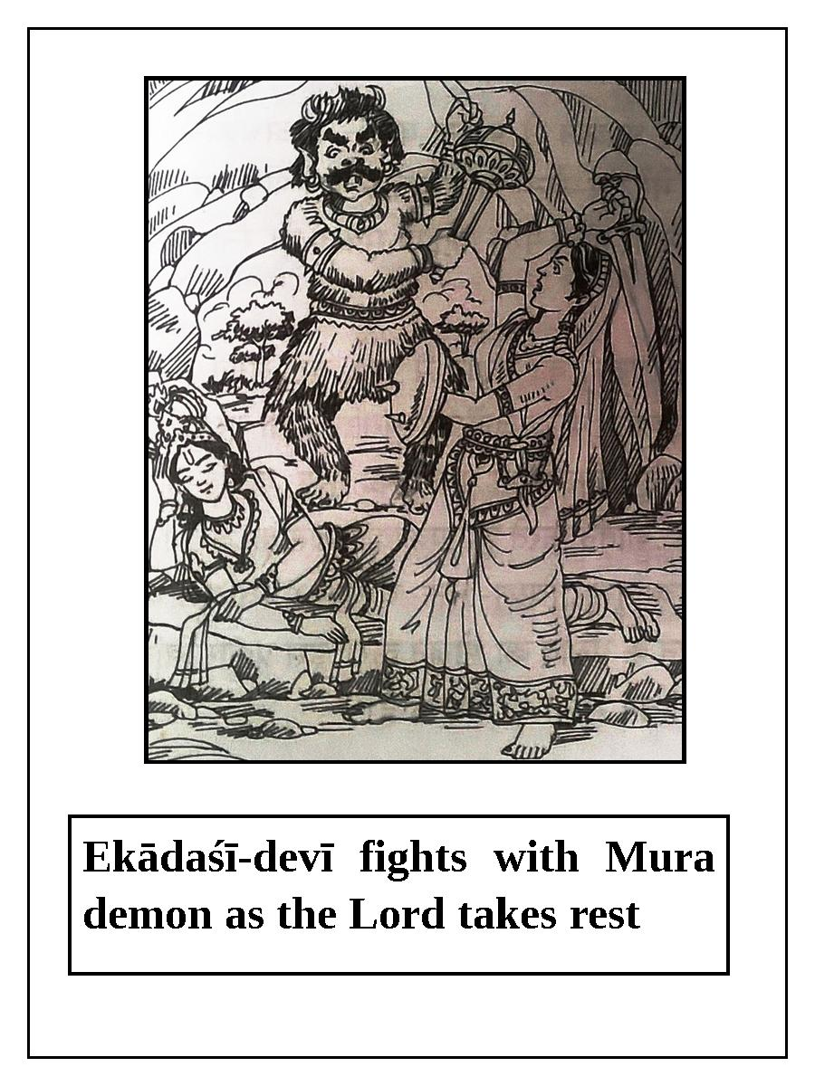
“Led by Lord Viṣṇu, the demigods proceeded to Candrāvatī. The demigods prepared for battle with their various weapons, while Mura roared, surrounded by his army of innumerable demons.
“The demons were already weakened by severe attacks from the demigods. They became extremely angry seeing the rejuvenated, fearless demigods, led by the Supreme Lord, approaching them. Although the Lord easily defeated the demon army, he did not immediately defeat Mura. After being unable to kill Mura using various weapons, the Lord engaged him in wrestling for ten thousand years. Finally, the Lord defeated him and left for Badarikāśrama, where He took rest in a beautiful cave called Hemavatī.”
The Supreme Lord continued, “O Arjuna, that demon followed Me and entered the cave. He saw Me resting there and decided to kill Me. At that time, an effulgent daughter appeared from My body holding various divine weapons, and she began to fight with Mura. After fighting with him for a long time, she finally severed his head. All of the other demons fearfully ran away to Pātālaloka. When the Lord got up from His rest, He saw the dead body of Mura lying there and an effulgent goddess humbly standing before Him with folded hands. Surprised, the Lord inquired, ‘Who are you?'
“The goddess replied, ‘O my Lord, I was born from Your body and I killed this demon. He attempted to kill You while You were lying down, so I killed him.’
“The Supreme Lord said, ‘O goddess, I am very pleased with you for this act. You can ask Me for any benediction that you desire.’
“When the goddess prayed for a benediction, the Lord said, ‘You are My spiritual energy, and since you appeared on the day of ekādaśī, your name will be Ekādaśī. Anyone who follows the vow of ekādaśī will be relieved from all sinful reactions and will attain inexhaustible heavenly happiness.’
Lord Śrī Kṛṣṇa concluded, “From that day onward, ekādaśī has been followed and worshiped in this world. O Arjuna, if a person observes the vow of ekādaśī, I award him the supreme destination. O son of Kuntī, an ekādaśī associated with dvādaśī is the highest. One should give up eating grains and honey, eating on a bell-metal plate, sex life, and applying oil on ekādaśī. If a person fully observes ekādaśī and hears its glories, he will attain the maximum results.”

Mokṣadā Ekādaśī
Mokṣadā ekādaśī occurs in the waxing moon in the period of November/December. The glories of this ekādaśī are described in Brahmāṇḍa Purāṇa in a conversation between Lord Kṛṣṇa and Mahārāja Yudhiṣṭhira.
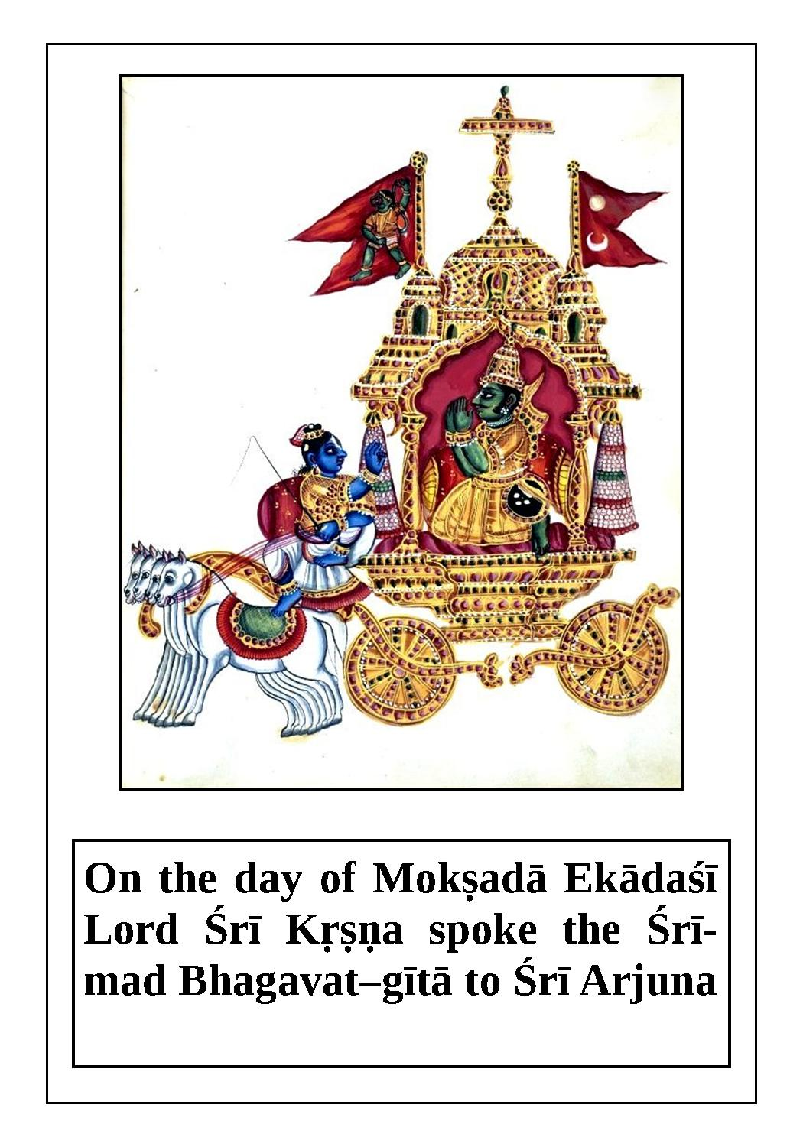
Once, Yudhiṣṭhira asked, “My dear Kṛṣṇa, what is the name of the ekādaśī that occurs during the waxing moon in the period of November/December? Please explain to me in detail the procedure for observing this ekādaśī.”
Lord Kṛṣṇa replied, “O best of kings, this ekādaśī destroys all of one’s sinful reactions. If one worships the Supreme Lord with tulasī-mañjarī on this day, the Lord becomes extremely pleased. One achieves the result of performing a Vājapeya sacrifice by observing this ekādaśī.
“A king named Vaikhānasa lived and ruled in the city of Campaka. He was very affectionate to the citizens. Many qualified brāhmaṇas who were well-versed in Vedic knowledge lived in his kingdom. One day, the king had a dream that his father had fallen to hell and was suffering unlimited miseries. Seeing this, the king was struck with wonder. The next day, he discussed his dream in an assembly of learned brāhmaṇas. He also informed them that his father had requested to be delivered from his hellish situation. After having this dream, the king became restless; he felt no happiness and had no interest in ruling his kingdom. He even dealt with his family with indifference. He thought that the life, kingdom, opulence, power, and influence of a son are completely useless if his father is suffering in hell. Thus, the king pathetically appealed to the learned brāhmaṇas, ‘Please tell me the means by which I can deliver my father from the clutches of hell.’
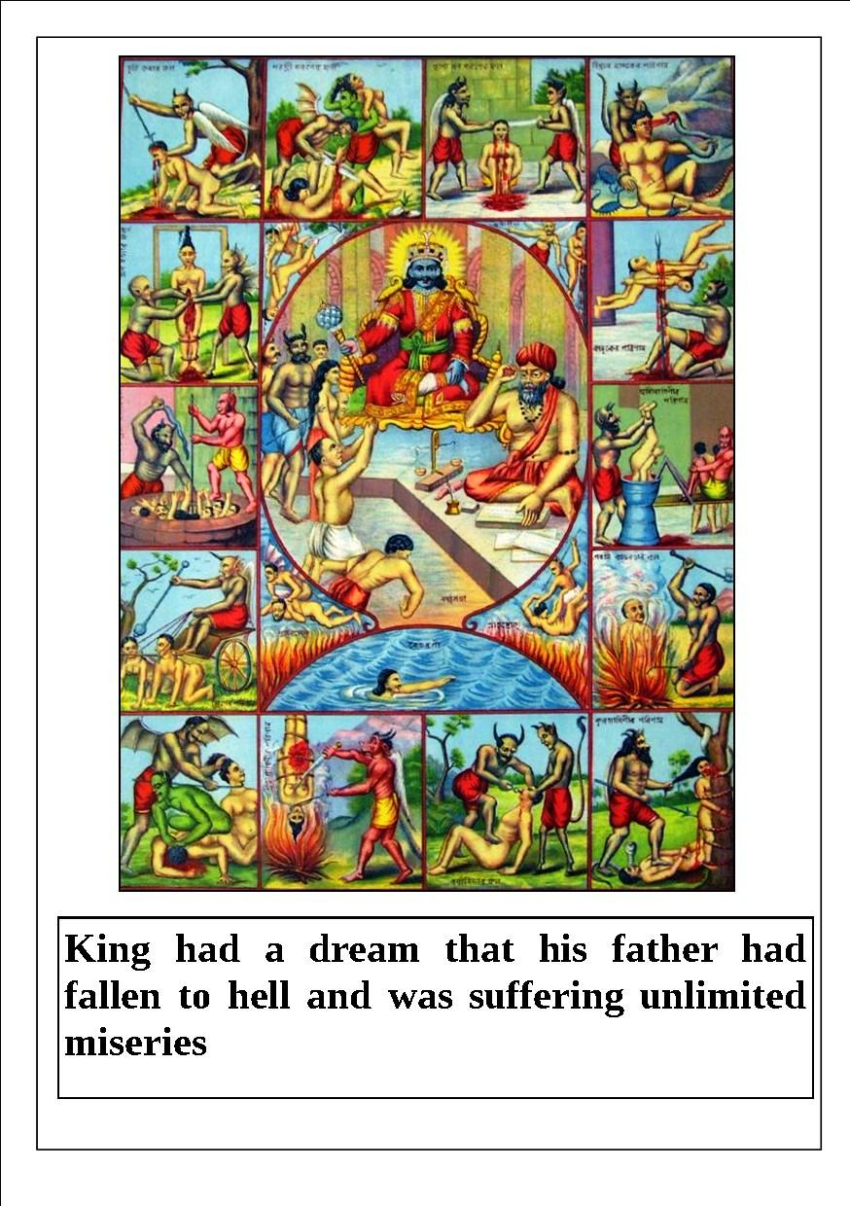
“The brāhmaṇas replied, ‘O king, Parvata Muni knows past, present, and future, and his āśrama is very near. You should go and tell him about your dream.’

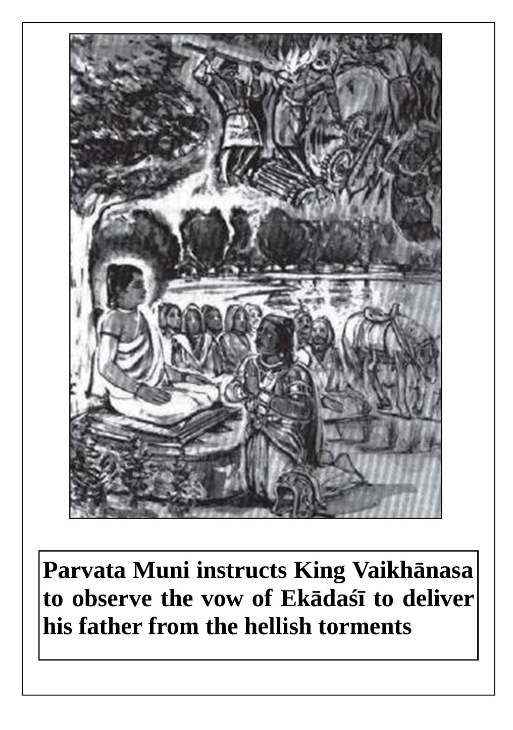
“King Vaikhānasa took their advice and went to the āśrama of Parvata Muni accompanied by the brāhmaṇas. When Parvata Muni inquired about the well-being of his kingdom, King Vaikhānasa said, ‘O my Lord, by Your mercy we are all very well, but in spite of having the kingdom and all of its facility, I am in great difficulty. A doubt has arisen in my mind, and I have come to Your lotus feet to remove it.’
“After hearing about the dream from the king, Parvata Muni sat in deep meditation. After a while, he got up and said, ‘My dear king, your father was very lusty in his previous life; hence, he degraded himself into this condition. Now, all of you should observe the vow of the ekādaśī which occurs during the waxing moon in the period of November-December. In this way you can donate your accumulated piety to your father and deliver him. He will be released from the clutches of hellish life by the influence of that piety.’ After hearing these words from Parvata Muni, the king returned to his palace, surrounded by his entourage.
“In due course of time the king, along with his wife, children, and servants, duly observed that ekādaśī, and he dedicated all of the piety to his suffering father. In this way his father attained the heavenly planets, and he blessed his son profusely.
Lord Kṛṣṇa concluded, “O king, one who properly follows this Mokṣadā ekādaśī is certainly relieved from all sinful reactions.”

Saphalā Ekādaśī
Śrī Kṛṣṇa says, “On ekādaśī, worship Śrī Nārāyaṇa during the day with upavāsa. The most prominent (śreṣṭha) among snakes is Ādi-śeṣa; among birds it is Garuḍa; among gods it is Viṣṇu; and among vratas it is the ekādaśī vrata. Perform jāgaraṇa (night vigil) with hari-bhaktas. On dvādaśī, offer coconut, pomegranate, gooseberry (āmalakī), berry fruit (ber or badarī), raw mango, betel leaves, and betel nuts. Perform pūjā with lamps (dīpa) and incense (dhūpa). Offer naivedya to Śrī Hari. Offer prasāda to learned people and then break the fast.”
Saphalā ekādaśī occurs during the waning moon in the period of December-January. The glories of this ekādaśī are described in Brahmāṇḍa Purāṇa in a conversation between Lord Kṛṣṇa and Mahārāja Yudhiṣṭhira.
Mahārāja Yudhiṣṭhira said, “O Kṛṣṇa, what is the name of the ekādaśī that occurs during the waning moon in the period of December-January, and how should one observe it? Please explain this to me in detail.”
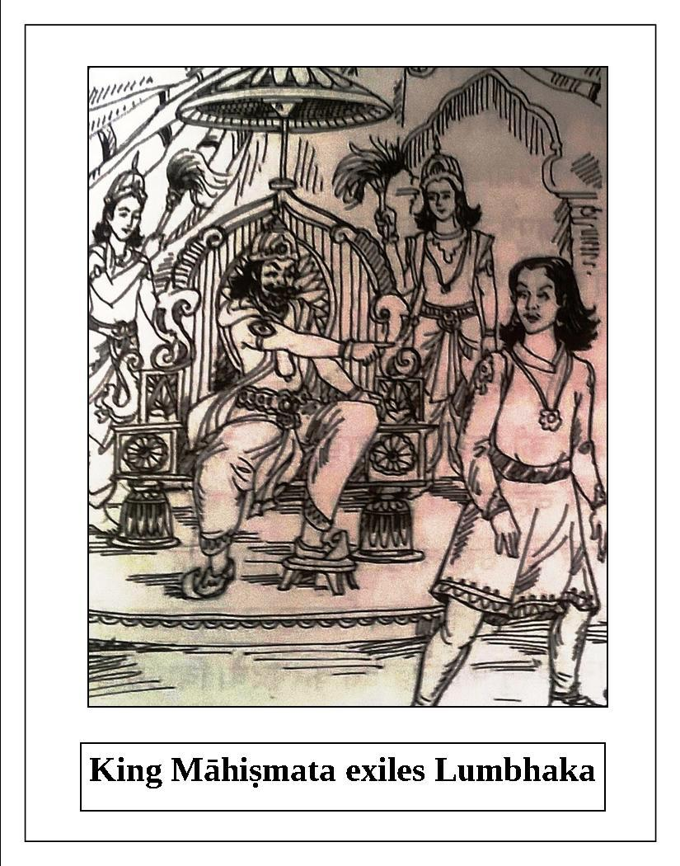

The Supreme Lord Śrī Kṛṣṇa replied, “O best of the Bhārata dynasty, just as Śeṣa is best among snakes; Garuḍa is best among birds; horse sacrifice is best among sacrifices; the Ganges is best among rivers; Lord Viṣṇu is best among demigods; and brāhmaṇas are best among humans; the vow of ekādaśī is best among vows. O best of kings, anyone who observes ekādaśī is very dear to Me. Simply by observing ekādaśī, one achieves the piety accumulated by undergoing austerity for five thousand years.”
“A famous king named Māhiṣmata lived in the city of Campāvatī. He had four sons, and the eldest Lumbhaka was very sinful. He would blaspheme the brāhmaṇas, Vaiṣṇavas, and demigods, and he was extremely attached to gambling and prostitution. For this reason, his father King Māhiṣmata exiled him. The exiled Lumbhaka lived in the jungle, and at night he would plunder the wealth of the people of his father’s kingdom. In spite of his stealing, the citizens would set him free, knowing him to be the son of the king. Lumbhaka regularly ate raw meat and fruit. There was a banyan tree in the forest which was as worshipable as the demigods, and Lumbhaka lived under it for some time.
“Coincidentally, when Lumbhaka was living like this, the ekādaśī of the waning moon of the period of November-December occurred. He fainted on the day before ekādaśī due to fatigue and weakness, and regained consciousness at mid-day on ekādaśī. Lumbhaka could not hunt and kill any animal that day because of his severe weakness, so he collected some fruits and offered them to Lord Viṣṇu for His pleasure. The sun had set by then. That night Lumbhaka remained awake.
“Due to his fasting and staying awake, he unknowingly observed Saphalā ekādaśī. Lord Madhusūdana accepts the worship and vow of this ekādaśī from any practitioner. As a result of this, Lumbhaka got an opulent kingdom. The next morning, a divine horse came and stood before him, and he heard a voice from the sky say, ‘O prince, by the mercy of Lord Madhusūdana and the influence of Saphalā ekādaśī, you will receive a kingdom and rule it without any difficulty. Return to your father and enjoy his kingdom.’ Lumbhaka followed this instruction and later accepted the responsibility of ruling the kingdom. He got a beautiful wife and had good sons. In this way, Lumbhaka happily ruled his kingdom.
Lord Kṛṣṇa concluded, “Persons attain fame in this life and liberation in the next by observing the vow of Saphalā ekādaśī. Those who follow this ekādaśī are glorious, and they achieve the result of performing an Aśvamedha sacrifice.”

Putradā Ekādaśī
The glories of Putradā ekādaśī, which occurs during the waxing moon in the period of December-January, are described in Bhaviṣya-uttarā Purāṇa in a conversation between Lord Kṛṣṇa and Mahārāja Yudhiṣṭhira.

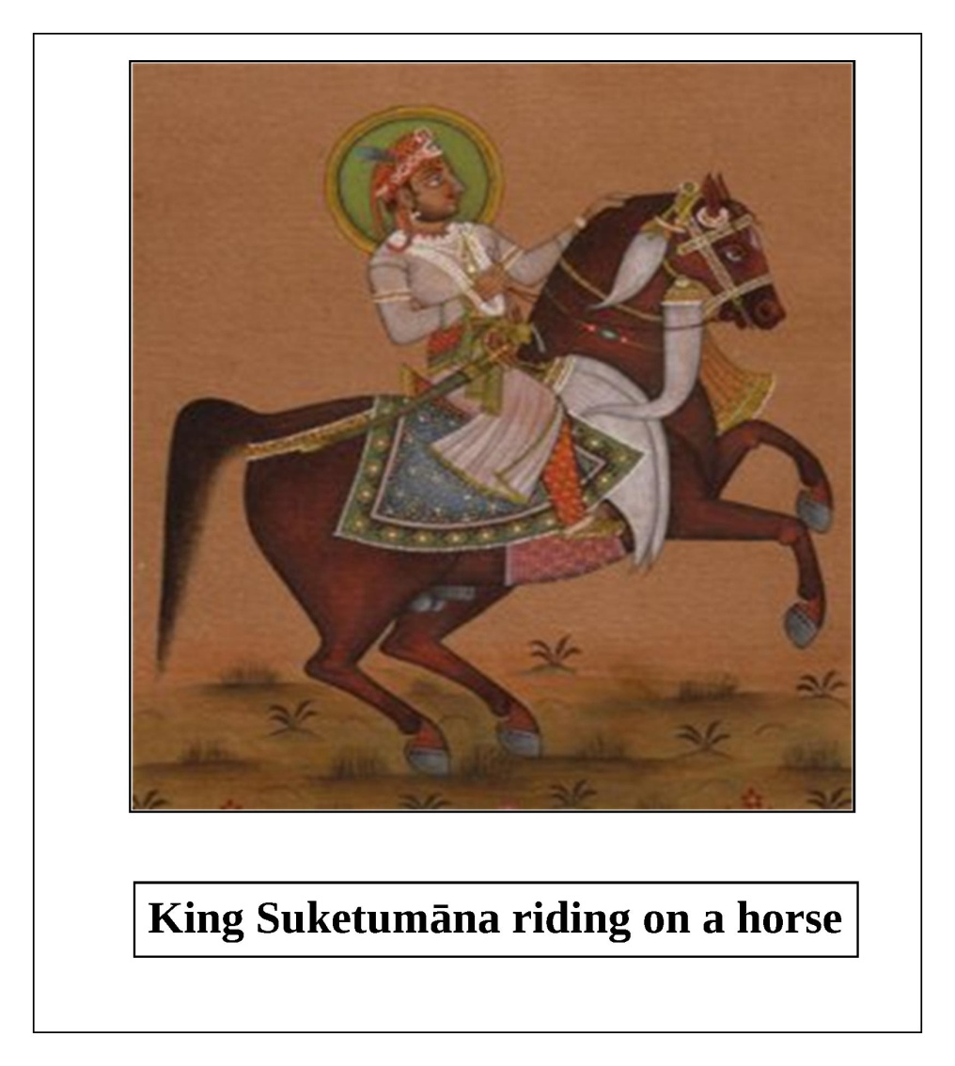
Lord Kṛṣṇa said to Yudhiṣṭhira, “My dear king, the ekādaśī which occurs during the waxing moon in the period of December-January is called Putradā. By observing this ekādaśī, all of one’s sinful reactions are counteracted. People become learned and famous by following it. Now, please hear the glories of this auspicious ekādaśī.”
“A king named Suketumāna ruled the city of Bhadrāvatī. The name of his queen was Śaibyā. They were sad because they were not able to have a son. They spent most of their time in religious activities. Due to their lamentation, the water that they offered as an oblation to their forefathers seemed hot to the forefathers. The forefathers worried that after the passing of King Suketumāna, no one would offer them oblations. Sensing the distress of the forefathers, the king became even more morose. He did not feel any satisfaction in the company of his friends, well-wishers, and ministers. Thinking that without a son life is useless, he was overwhelmed with lamentation and hopelessness. He thought, ‘It is impossible to become free from debt to the demigods, forefathers, and other people without having a son. One cannot have sons, wealth, and knowledge without heaps of pious activities and devotion to Viṣṇu. ’Considering this, the morose king secretly left for the forest riding on a horse, to seek help.

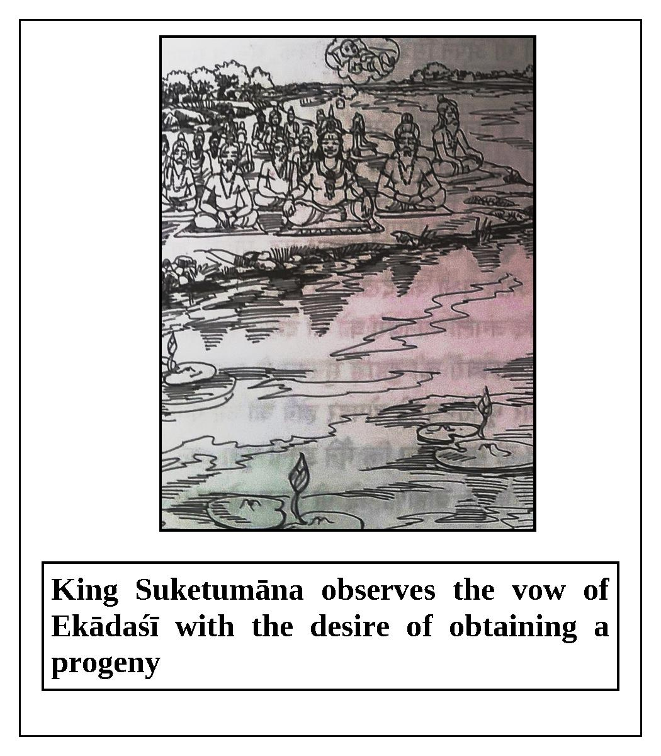

“King Suketumāna entered the forest, which was inhabited by birds and beasts, and searched for a place to take rest. He saw various trees in the dense forest such as banyan, pippala, date, tamarind, palm, sāla, maulasiri, sapta-parṇa, tilaka, tamāla, sarala, hingota, arjuna, lavhera, behaḍā (bibhītāki), sallakī, pāṭala, catechu, and palāśa, as well as various animals such as tigers, lions, elephants, deer, pigs, monkeys, snakes, leopards, and hares. Instead of resting, the king began to wonder through the forest. He was surprised and scared upon hearing the howling of jackals and the calls of owls. The king became very tired after wandering here and there for some time. It was midday and he was very thirsty. He thought, ‘I have tried to please the demigods through worship and sacrifices; to maintain my subjects like my own children; and to satisfy the brāhmaṇas by offering them foodstuffs and dakṣiṇā. Yet, I am suffering like this today.’ Absorbed in these thoughts, King Suketumāna continued to wander. Suddenly, he saw a lake as beautiful as Mānasa-sarovara, filled with lotuses. Many swans, cakravāka, and cakora birds were in that lake. Seeing some sages chanting Vedic mantras on the bank of this lake, the king got down from his horse and offered obeisances to each one individually. The sages were pleased and said, ‘O king, we are pleased with you; please ask us for some benediction.’
“The king asked, ‘Who are you and why have you come to this lake?’ The sages replied, ‘We are Viśvadevas and we have come here to take bath. Today is the auspicious Putradā ekādaśī. If a person desirous of a son observes this vow, he is certainly benedicted with a son.’ The king said, ‘I have tried so many things to get a son, but as of today I have not been successful. Since all of you are pleased with me, kindly bless me with a beautiful son.’ The sages said, ‘O king, observe this Putradā ekādaśī with great care, and by the mercy of the Lord and our blessing, you will certainly receive a son.’
“Following the instruction of the sages, the king observed the auspicious Putradā ekādaśī. He broke his fast the next day, and after repeatedly offering obeisances to the sages, he returned to his palace.
“In due course of time, Queen Śaibyā became pregnant. By the blessing of the sages and the piety gained by observing Putradā ekādaśī, the king begot a pious, brilliant son. Thereafter, the king happily ruled his kingdom and his forefathers were satisfied.
Lord Kṛṣṇa concluded, “O King Yudhiṣṭhira, by following Putradā ekādaśī one can get a son and attain the heavenly planets. Anyone who hears or sings the glories of this ekādaśī certainly achieves the results of an Aśvamedha sacrifice.”

Ṣaṭ-tilā Ekādaśī
This ekādaśī occurs during the waning moon in the period of January-February. The glories of Ṣaṭ-tilā ekādaśī are described in Bhaviṣya-uttara Purāṇa. Once, sage Dālbhya asked sage Pulastya, “O respected brāhmaṇa, people in this mortal world are involved in various sinful activities, such as killing brāhmaṇas and engaging in sense gratification. Please explain to me how they can be delivered from the hellish conditions resulting from their sinful activities.” Sage Pulastya replied, “O most fortunate one, one should worship the Supreme Lord in a pure state of mind on the ekādaśī which occurs during the waning moon in the period of January-February. At the time of worship, one should pray as follows: ‘O Lord Janārdana, O most merciful Śrī Kṛṣṇa, You are the deliverer of the sinful people. Please be merciful to those who have drowned in the ocean of material existence. O Supreme Brahman, O Supreme personality of Godhead, O Lord of the universe, along with Your consort Śrīmatī Lakṣmī-devī, please accept my worship.’ Thereafter, one should worship the brāhmaṇas by giving them umbrellas, cloth, shoes, and pitchers filled with water. According to one’s capacity, one should also give black cows and sesame seeds to the best of the brāhmaṇas. By giving sesame seeds in charity, one can live in the heavenly planets for many years. One should bathe in water mixed with sesame seeds, smear sesame seed paste on his body, perform a fire sacrifice with sesame seeds, offer oblations to the forefathers with water mixed with sesame seeds, eat sesame seeds, and give sesame seeds in charity on this ekādaśī. By doing so, all of one’s sinful reactions will be destroyed. That is why the name of this ekādaśī is Ṣaṭ-tilā ekādaśī.”
Lord Kṛṣṇa narrated the following story to Nārada Muni when he approached Kṛṣṇa to hear the glories and results of observing Ṣaṭ-tilā ekādaśī.
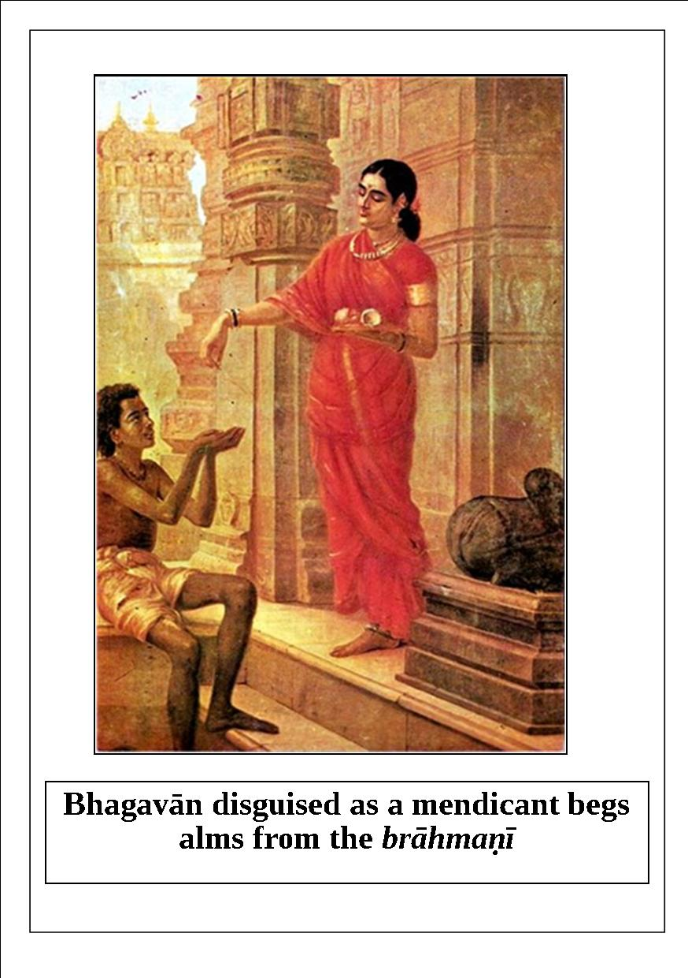
“In ancient times there was a lady brāhmaṇī who strictly followed the vow of celibacy and worshiped the Lord. Due to her various vows, she gradually became thin and weak. Although she gave some types of charity to the poor brāhmaṇas and unmarried girls, she never pleased the brāhmaṇas and demigods by giving food grains in charity. I thought, ‘Although the body of this brāhmaṇī is weak from performing many severe vows, she is not yet a fully purified soul. She has not given any food grains in charity to the hungry people.’ O best of the brāhmaṇas, in order to test her, I took the form of a mendicant and personally appeared in this mortal world. I took a begging pot in my hands and approached the house of that brāhmaṇī to beg alms.

“The brāhmaṇī said to Me, ‘O brāhmaṇa, please tell me the truth about where You have come from.’ I pretended to not hear her, and again begged for alms. She became angry and put a handful of clay in My begging pot. Thereafter, I returned to My abode. As a result of observing severe vows, that brāhmaṇī ascetic eventually was transferred to My abode. Although she got a beautiful house, it did not contain any food grains or wealth because she had put clay in my begging pot. O brāhmaṇa, she entered that house and found it empty, and due to lack of wealth, gradually she became restless. After some time she angrily approached Me and said, ‘O Janārdana, I underwent severe austerities, followed vows, and worshiped Lord Viṣṇu adequately. Why am I bereft of food grains and wealth?’
“I replied, ‘O brāhmaṇī, you have left the material world and come to My abode, so please go back to your house. Soon, the wives of the demigods, out of curiosity, will go to your house for darśana, and at that time you should inquire from them about the glories of Ṣaṭ-tilā ekādaśī. Do not open the door until they finish their narration.’ After hearing My statement, the brāhmaṇī returned home.
“One day when the brāhmaṇī was sitting in her room and the door of the house was closed, some wives of the demigods arrived at the door and said, ‘O beautiful one, we have come here for darśana, so please open the door.’ The brāhmaṇī replied, ‘If you want to see me, please explain the importance, piety, and glories of Ṣaṭ-tilā ekādaśī, and then I will open the door. ’One of the wives of the demigods then narrated the glories of that ekādaśī. After hearing the narration, the brāhmaṇī was satisfied and she opened the door. The wives of the demigods were pleased to see her.
Lord Kṛṣṇa concluded, “Under the instruction of these demigoddesses, the brāhmaṇī observed the vow of Ṣaṭ-tilā ekādaśī. Thereafter, she became beautiful and effulgent, and she received ample food grains, wealth, and gold. Still, no one should observe this ekādaśī with greed. By following this ekādaśī, one’s misfortunes and poverty are eliminated. If one donates sesame seeds on this day, all of his sinful reactions are vanquished.”

Jayā Ekādaśī

Significance
The ekādaśī in the month of Māgha is known as Jayā ekādaśī. On the dvādaśī day of śukla pakṣa, we can see the star called Punarvasu Nakṣatra; hence, this day is considered to be very auspicious. Śrī Kṛṣṇa explains the significance of Jayā ekādaśī to Dharmarāja as follows.
“O Yudhiṣṭhira, I am happy to tell you about the ekādaśī that occurs during the bright-moon half of this month of Māgha. This ekādaśī obliterates all kinds of sinful reactions and demoniac influences that may be affecting the spirit soul. It is known as Jayā Ekādaśī, and the fortunate soul who observes a fast on this sacred day is relieved of the great burden of ghostly existence. There is no better ekādaśī than this, for it truly bestows freedom from birth and death. It is to be honored very carefully and diligently.”

Significance of bathing in a river in the month of Māgha
hareḥ pūjā ca vaiśākhe tapaḥ pūjā ca kārtike
tapo homas thatā dānaṁ trayaṁ mĀghe viśiṣyate
“In Vaiśākha, Śrī Hari pūjā is prominent; in Kārttika, all tapas connected with Śrī Hari are prominent; and in Māgha, tapas, homa, and dāna connected with Śrī Hari are prominent. All charity in the name of Śrī Hari and all homa offered to Him bring great benefits.”
“In ancient times, for twelve years Aditi-devī bathed before sunrise and did not eat in Māgha. She became the mother of twelve devas called the dvādaśa ādityas. Rohiṇī-devī practiced māgha snāna-vrata and attained saubhāgya (good fortune). Arundhatī became the best among women by practicing māgha-snāna and dāna. Śacīdevī attained immense beauty by performing austerities including māgha-snāna.
The sunrays have a special effect on our bodies and souls during pre-dawn bathing in the month of Māgha. In Māgha, sesame seed dāna and pre-dawn bathing in a river are essential for bhakti to Śrī Hari.”
- Conversation between Dilīpa and Sage Vasiṣṭha
regarding significance of Māgha snāna.

The glories of Jayā ekādaśī, which occurs during the waxing moon in the period of January-February, are described in Bhaviṣya-uttara Purāṇa in a conversation between Lord Kṛṣṇa and Mahārāja Yudhiṣṭhira.
Once, Mahārāja Yudhiṣṭhira said, “O Lord Kṛṣṇa, O original Personality of Godhead, O Lord of the universe, You are the original cause of the four types of living entities– namely, those born from perspiration, those born from a seed, those born from an egg, and those born from an embryo. You alone are the creator, maintainer, and destroyer of everything. Please describe the glories of the ekādaśī which occurs during the waxing moon in the period of January-February, and explain the procedure for observing it. Also, please tell me which Deity is to be worshiped on this auspicious day.” Lord Kṛṣṇa replied, “O best of kings, the ekādaśī which occurs during the waxing moon in the period of January-February is celebrated as Jayā ekādaśī. Following it takes away all of one’s sinful reactions. The performer of this vow is never forced to accept the body of a ghost. O king, as far as awarding liberation and eliminating one’s sinful reactions, this ekādaśī has no equal. O lion-like king, now please hear a description of this ekādaśī which I previously narrated in Padma Purāṇa.
“The demigods were living happily in the heavenly kingdom of Indra. The Apsarās freely enjoyed in the nandana-kānana forest, which was filled with the fragrance of fully blossomed Pārijāta flowers. Indra enjoyed various exchanges with the Apsarās. Once, Indra arranged a dance festival with fifty-million Apsarās. There was a Gandharva singer named Puśpadanta in that assembly. Another Gandharva named Citrasena attended along with his wife Mālinī and daughter. Citrasena had a son named Puśpavāna, whose son was Mālyavān. A Gāndharvī named Puśpavantī was attracted by the beauty of Mālyavān. Pierced by the potent arrows of Cupid, the very beautiful Puśpavantī tried to captivate Mālyavān through various provocative gestures and glances. O king, how can I adequately describe the splendid beauty of Puśpavantī? She had beautiful arms which resemble the ropes of Cupid, and the beauty of her face was like that of the moon. She had attractive eyes, her ears were decorated with earrings, and her neck defeated the beauty of a conch-shell. Her waist was thin, her breasts were firm, her hips were broad, and her thighs resembled banana trees. Her shining feet defeated the beauty of a red lotus flower. Gorgeous ornaments and garments made her attractive bodily features appear even more enchanting. Mālyavān became totally captivated by the beauty of Puśpavantī.
“To please Indra, Mālyavān and Puśpavantī began to dance and sing with other Apsarās in that dance festival. Being attracted to each other, they were distracted and could not perform well, resulting in a disturbance in the dance assembly. They continuously looked at each other through the corners of their eyes, and they were pierced by the arrows of Cupid. When Indra noticed the continuous disturbance in the singing and dancing, he understood the situation. He became angry and cursed them as follows: ‘You are sinful fools. I am cursing you because you disobeyed me. You must accept the bodies of a male and female ghost and take birth on Earth to experience the results of your karma.’
“After being cursed in this way, Mālyavān and Puśpavantī became ghosts, and they began to spend their miserable lives in a cave in the Himalaya Mountains. As ghosts they felt great distress and lamentation. Due to the curse, they could not sleep or use their sense of smell or touch. Once, while wandering in the cold, dense forest of the Himalayas, they sat and began to contemplate. The male ghost said to the female ghost, ‘Alas, what heinous, sinful activities we committed that led to our receiving such miserable ghost bodies!’ They felt extremely sad and repentant. As ghosts, Mālyavān and Puśpavantī spent that day without eating and continuously repenting for their misdeeds. Coincidentally, this was the auspicious day of Jayā ekādaśī. Although they were extremely hungry and thirsty, they did not kill any living entity because of that. They even abstained from taking roots, fruits, and water. O king, in this way the ghost-couple satin misery beneath a banyan tree. They passed the entire night without sleeping, freezing in the cold air and lost in deep thoughts. There was no propensity for sense gratification in their disturbed minds.
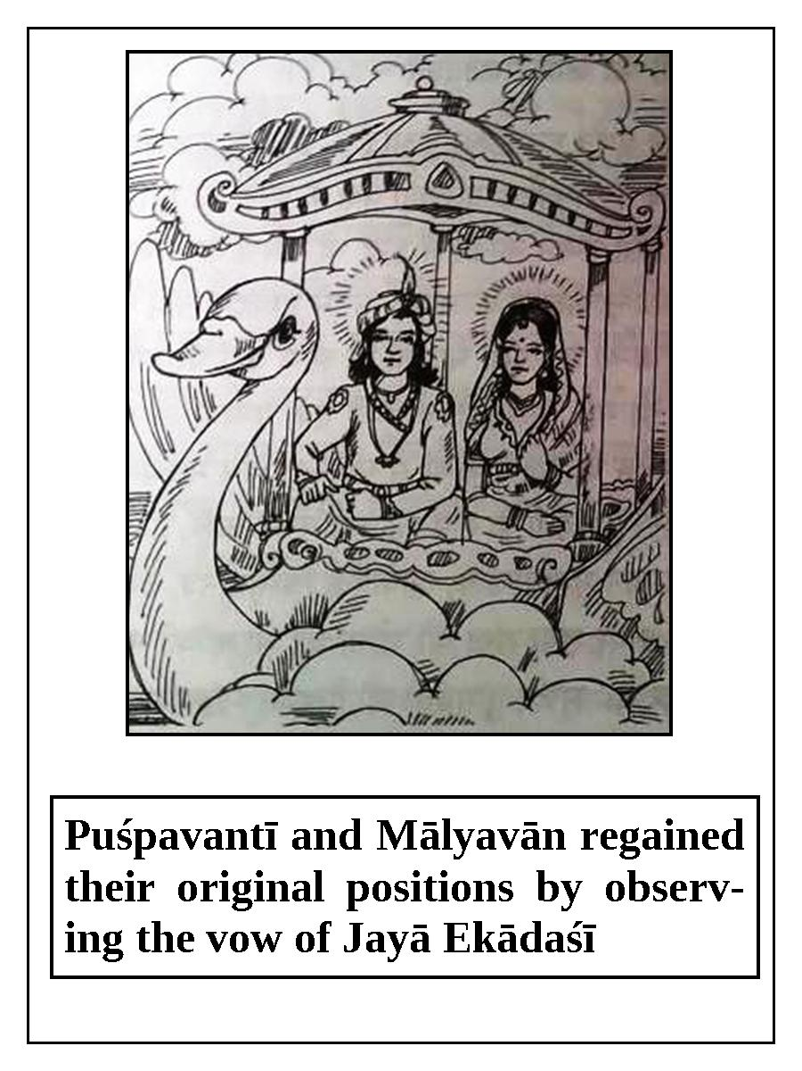

“O lion-hearted king, in this way they unknowingly observed the vow of Jayā ekādaśī, and the next day they were liberated from their ghost bodies due to the piety that they had earned. Thereafter, Puśpavantī and Mālyavān regained their original positions and they returned to heaven through the skyways. Arriving in heaven, they happily approached Indra, the king of the demigods, and offered him their obeisances. When Indra saw them, he was struck with wonder and said, ‘How astonishing! By what piety have you been freed from your ghostly condition? Which demigod released you from my curse?’Mālyavān replied, ‘By the causeless mercy of the Supreme Lord, and as a result of observing the vow of Jayā ekādaśī, which is very dear to Him, we were freed from the curse. O master, I am certain that we were freed from our ghostly lives as a result of devotional service. ’Indra said, ‘You were purified by executing devotional service to Lord Viṣṇu and observing the vow of ekādaśī. Therefore, you are now worshipable for me. I certainly worship and respect human beings who are engaged in devotional service to Viṣṇu.’ Thereafter, Puśpavantī and Mālyavān lived happily in the heavenly planets.
Lord Kṛṣṇa concluded, “O King Yudhiṣṭhira, this is why one must observe the vow of ekādaśī. Observing Jayā ekādaśī takes away even the sin of killing a brāhmaṇa. The secondary fruit of observing this vow is that one automatically receives the piety of giving charity, performing sacrifices, and visiting holy places. If one properly follows this vow with faith and devotion, he will live in Vaikuṇṭha forever. Just by reading or hearing the glories of this ekādaśī, one attains the result of an Agniṣṭoma sacrifice.”

Vijayā Ekādaśī
The glories of this ekādaśī are described in Skanda Purāṇa. Once, Mahārāja Yudhiṣṭhira said, “O Lord Kṛṣṇa, please be kind to me and describe the ekādaśī that occurs during the waning moon in the period of February-March.”
Lord Kṛṣṇa replied, “O King Yudhiṣṭhira, I would be happy to tell you about the ekādaśī known as Vijayā ekādaśī. By observing this ekādaśī, one’s sinful reactions are eradicated.
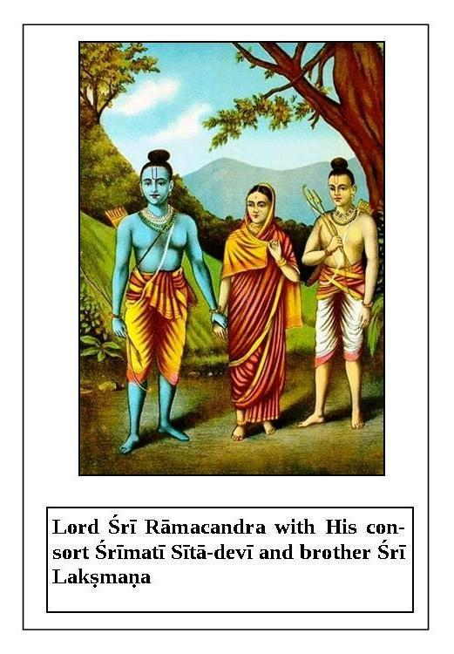

“Once, the great sage Nārada said to Lord Brahmā, ‘O best of the demigods, kindly describe to me the result one achieves by following Vijayā ekādaśī, which occurs during the waning moon in the period of February-March. ’Lord Brahmā replied, ‘My dear son, this oldest of vows is pure, and it eliminates all sinful activities. As suggested by its name, it gives the best result; this Vijayā ekādaśī undoubtedly awards one the power of victory. When Śrī Rāmacandra went to the forest for fourteen years with His wife Sītādevī and brother Lakṣmaṇa to fulfill the order of His father, for some time they lived in a beautiful forest known as Pañcavaṭī on the bank of the river Godāvarī. One day while they were residing in this forest, Rāvaṇa, the king of the demons, kidnapped austere Sītā-devī. Rāmacandra was overwhelmed with distress due to separation from her. While wandering through the forest in search of Sītā, Rāmacandra met with Jaṭāyu, the king of the birds, who was about to die. Jaṭāyu told Rāmacandra everything about Sītā’s situation, and then he left this world and returned to Vaikuṇṭha. Thereafter, Rāmacandra became friends with Sugrīva. Many monkey soldiers were summoned to help Rāmacandra. Meanwhile, Hanumān, the king of the monkeys, completed a great mission. He went to the Aśoka forest in Laṅkā and met with the kidnapped Sītā-devī. To convince her of his good intentions, he gave her Rāmacandra’s ring. Thereafter, Hanumān returned to Rāmacandra and explained to Him what had happened. Then Rāmacandra met with His friend Sugrīva and He decided to invade Laṅkā. Rāmacandra gathered a great number of monkey soldiers and took them to the shore of the ocean. He asked Lakṣmaṇa, ‘O Saumitra,how will we cross this deep ocean which is full of dangerous animals such as whales and crocodiles?’ Lakṣmaṇa replied, ‘O original Supreme Personality of Godhead, You are the primeval Lord. A great sage named Bakadālbhya lives on a nearby island; his āśrama is four miles away. O son of the Raghu dynasty, this sage has had darśana of Lord Brahmā. We should ask him about how to cross this ocean.’
“Lord Rāmacandra followed Lakṣmaṇa’s advice and went to the āśrama of Bakadālbhya, and He offered respectful obeisances to the sage. The omniscient sage immediately understood that this person was the Supreme Lord Rāmacandra, and that He had appeared in the material world to accomplish some purpose of His pastimes, such as killing the demon Rāvaṇa. The great sage asked, ‘O Rāmacandra, for what purpose have You kindly come here?’ Rāmacandra replied, ‘O brāhmaṇa, by your mercy I have come here with My soldiers to fight the demons and conquer Laṅkā. O best of sages, please tell me a way to easily cross this vast ocean. I have come to your lotus feet for this reason.’
“The great sage said, ‘O Rāmacandra, I will tell You about a great vow by which You will certainly conquer Your enemies and attain extraordinary fame and opulence. You should follow this vow with undeviated attention. O Rāma, there is an ekādaśī known as Vijayā which occurs during the waning moon in the period of February-March. You will certainly be able to cross the ocean with Your monkey soldiers by observing this ekādaśī. O Lord Rāmacandra, please hear the procedure for following it. On the day before ekādaśī, You should fill a pitcher made of gold, silver, copper, or clay with water and decorate it with mango twigs. Thereafter, You should place this pitcher on a sanctified, raised alter which is decorated with seven kinds of grains. Then, You should place a golden Deity of Lord Nārāyaṇa on this pitcher. On ekādaśī, You should take bath early in the morning and worship this Deity with devotion by offering various items such as Tulasī leaves, sandalwood paste, flowers, garlands, incense, ghee lamp, and foodstuffs. You should also stay awake that night. At sunrise on the day after ekādaśī, you should place the pitcher on the bank of a river, pond, or lake and duly worship it. Thereafter, you should donate this pitcher along with the Deity of Nārāyaṇa to a brāhmaṇa who strictly follows the vow of celibacy. You will certainly conquer your enemies by following this process.’
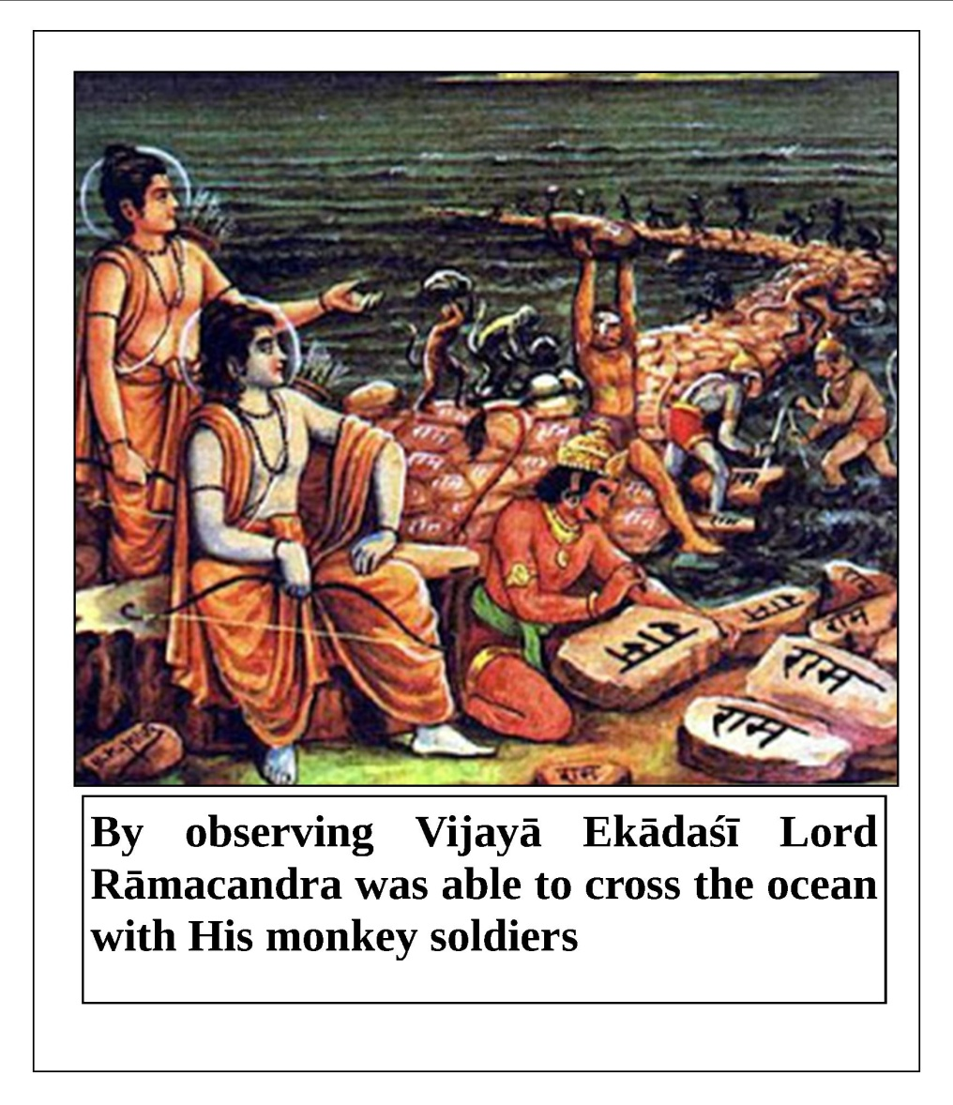
Lord Kṛṣṇa concluded, “Lord Rāmacandra followed the great sage’s instruction by perfectly observing ekādaśī, and later He was victorious in battle. A person who properly follows the vow of ekādaśī is certainly victorious in this life and in the next. Lord Brahmā said to Nārada, ‘O my dear son, this incident reveals why every human being should follow Vijayā ekādaśī. The glories of this ekādaśī destroy all of one’s sinful reactions. One who reads or hears about the glories of this ekādaśī obtains the result of a Vājapeya sacrifice.’”

Āmalakī Ekādaśī
The glories of Āmalakī ekādaśī, which occurs during the waxing moon in the period of February-March, are described in Brahmāṇḍa Purāṇa in a conversation between King Māndhātā and sage Vasiṣṭha.
Once, King Māndhātā said to Vasiṣṭha, “O most fortunate one, if you are pleased with me, be merciful and kindly describe a vow by which I can attain all auspiciousness.”Vasiṣṭha replied, “O king, I will tell you about the glories and history of a great vow which awards all auspiciousness. O king, the name of this vow is Āmalakī ekādaśī, and the piety earned by following it certainly destroys all of one’s sinful reactions, and awards liberation. By observing that vow, one attains the result of donating one thousand cows.”
“In ancient times, there was a city named Vaidiśa which was inhabited by many healthy, prosperous brāhmaṇas, kṣatriyas, vaiśyas, and śūdras. O lion-hearted king, there were no atheistic or sinful persons in this beautiful city. The entire city was filled with the sound of Vedic mantras. An honest, pious king named Caitraratha, who was born in the family of King Pāśabiṅduka, a member of the moon dynasty, lived there. King Caitraratha was powerful, heroic, opulent, and well-versed in the scriptures. During his reign, his kingdom was full of auspiciousness and prosperity. All of his subjects performed devotional service to Lord Viṣṇu, and all of them observed the vow of ekādaśī. Everyone lived happily by engaging in devotional service to Lord Hari. Not a single poor or miserly person could be found in that kingdom.
“After many years of such prosperity, Āmalakī ekādaśī coincided with dvādaśī during the waxing moon in the period of February- March. Realizing that this ekādaśī bestows great benefits, the king and his subjects resolved to properly observe all of the rules and regulations. Early in the morning on ekādaśī, they took bath in the river and went to the temple of Lord Viṣṇu situated on its bank. There was an Āmalakī tree in the temple, and the king placed a pitcher of water under it. He also brought an umbrella, clothes, shoes, and five kinds of jewels there for worship. The king worshiped Lord Paraśurāma and Āmalakī by offering water, shoes, a canopy, gold, diamonds, rubies, pearls, sapphires, and fragrant incense. Led by the sages and followed by his subjects, the king offered the following prayer to Lord Paraśurāma: ‘O Lord Paraśurāma, O Son of Reṇukā, O You who are situated in the shade of the Āmalakī tree, O bestower of material enjoyment and liberation, I offer my respectful obeisances to You.’ Then, they offered the following prayer to the Āmalakī tree: ‘O Āmalakī, O sustainer of the universe, O offspring of Lord Brahmā, O destroyer of all sins, we offer our respectful obeisances to you. Kindly accept our offerings.’ After properly worshiping the Lord and Āmalakī in this way, the king and his subjects stayed awake all night in the temple of Lord Viṣṇu. They sang devotional songs and offered beautiful prayers praising the Lord and the Āmalakī tree.

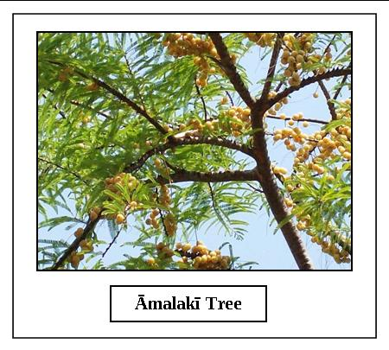
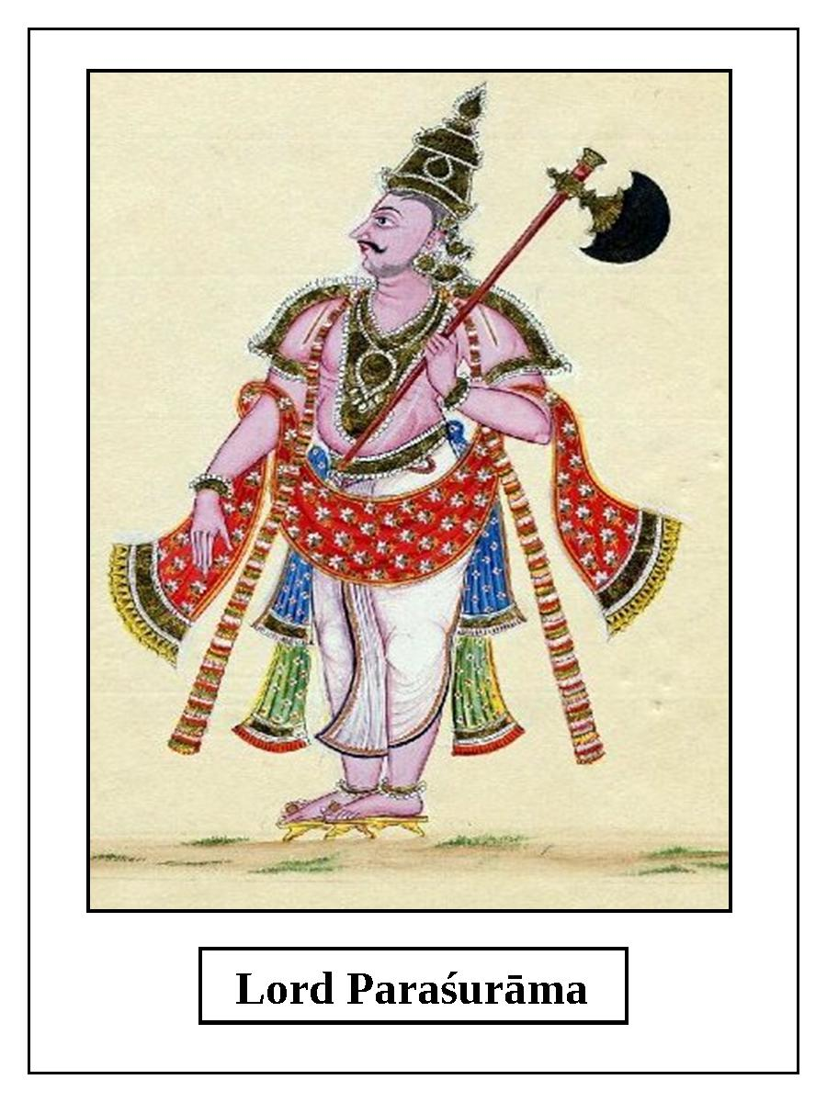

“By Providence, during the night a hunter arrived at the temple. This hunter earned his livelihood by killing various living entities. He saw that the temple was decorated with ghee lamps, incense, and other auspicious items, and he saw many people staying awake and glorifying the Lord. He sat with them and tried to figure out what was going on. That fortunate hunter took darśana of Lord Dāmodara on the pitcher and heard transcendental topics about Viṣṇu. Although he was very hungry, he was astonished by what he was seeing, and he stayed awake all night hearing the glories of ekādaśī.
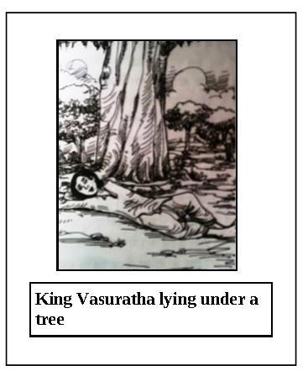
“In the morning, the king returned to his palace, and the hunter went home and happily ate a meal. After many years, the hunter left his body. As a result of staying awake on that Āmalakī ekādaśī, in his next life the hunter became a king who had an army and innumerable elephants, horses, and chariots. That king was Vasuratha, the powerful son of King Viduratha, who ruled the famous city of Jayantī. There were one million villages in King Vasuratha’s kingdom. He was as brilliant as the sun, as effulgent as the moon, as powerful as Lord Viṣṇu, and as tolerant as the Earth. He was honest and dedicated to his duties, and he became a great devotee of Lord Viṣṇu.

“One day, the very kind and charitable King Vasuratha lost his way while hunting in the forest. He became extremely tired and hungry. Having no other choice, the king lay on the ground of the dense forest, using his arm as a pillow. At that time, some barbarians who lived in the forest attacked the sleeping king and tortured him in various ways. They considered him to be their enemy, and they attempted to kill him. They blamed him for the previous deaths of their family members and relatives, and for compelling them to wander in the forest. Accusing him in this way, the barbarians tried to beat the king with different weapons. However, to their utter surprise, none of their weapons was able to touch the king’s body, and he was not injured at all. When all of their weapons failed, the barbarians became morose and full of fear. They did not know what to do and simply stood there. At that time, a beautiful, extraordinary woman decorated with various ornaments and fragrant sandalwood paste appeared from the body of the king. She wore an attractive flower garland and her eyes were reddish with anger. She raised her eyebrows and angrily rushed toward the barbarians with a disc in her hand to kill them. In a moment, that powerful woman killed all of the sinful barbarians.
“After this incident, the king woke up without knowing what had happened. He was frightened and stunned to see the ghastly killings. He thought, ‘Who is this friend and well-wisher of mine who protected me by killing these powerful enemies? I must convey my heartfelt gratitude to him for this great act.’ Then, he heard a voice from the sky say, ‘Who but Lord Keśava is capable of protecting His surrendered souls? He alone is the maintainer of His surrendered devotees. ’The king was amazed and his heart melted with devotional emotions.
The sage Vasiṣṭha concluded, “My dear king, thereafter the king returned to his palace and ruled his kingdom like Indra, without any obstacles. Any person who observes the sacred vow of Āmalakī ekādaśī undoubtedly returns to the abode of Lord Viṣṇu.”

Pāpamocanī Ekādaśī
The glories of Pāpamocanī ekādaśī are described in Bhaviṣya-uttara Purāṇa in a conversation between Lord Kṛṣṇa and Mahārāja Yudhiṣṭhira.
Once, Mahārāja Yudhiṣṭhira said, “My dear Lord Kṛṣṇa, You have already explained the glories of Āmalakī ekādaśī. Now, please describe the ekādaśī which occurs during the waning moon in the period of March-April. What is the name of that ekādaśī? Tell me about the procedure for observing it, and the results of doing so.” Lord Kṛṣṇa replied, “O best of kings, the name of that ekādaśī is Pāpamocanī. Now, please hear its glories.
“Long ago, the glories of this ekādaśī were spoken of by the sage Lomaśa to King Māndhātā. Pāpamocanī ekādaśī occurs during the waning moon in the period of March-April. This ekādaśī takes away all of one’s sinful reactions, frees one from a ghostly existence, and awards one eight kinds of mystic perfections.
“Sage Lomaśa said, ‘In ancient times, Kubera, the treasurer of the demigods, had a beautiful forest of flowers called Caitraratha, where the weather was always pleasant and spring-like. The heavenly dancing girls, such as Gandharvas and Kinnaras, enjoyed various activities there. Demigods headed by Indra used to go there to enjoy various exchanges. In that forest, a great sage named Medhāvī, who was a staunch devotee of Lord Śiva, was performing austerities. The Apsarās, or heavenly dancing girls, tried to disturb the sage in various ways. A famous Apsarā named Mañju Ghoṣā devised a means to captivate the mind of the sage. Fearing the sage’s powers, Mañju Ghoṣā built a cottage at a short distance from his āśrama, and then she began to sing in a sweet voice, accompanied by the musical instrument called a vīṇā. Mañju Ghoṣā had applied sandalwood pulp on her body, and she wore a fragrant flower garland. By her enchanting singing and appearance, Cupid, who is an enemy of Lord Śiva, tried to conquer the sage, who was a devotee of Lord Śiva. Lord Śiva had previously burned Cupid to ashes, and now, remembering this, Cupid entered the body of the sage to take revenge. At that time sage Medhāvī, who wore a white sacred thread and lived in the āśrama of Cyavana Ṛṣi, became like a second Cupid. The lusty Mañju Ghoṣā slowly approached the sage. Medhāvī became overwhelmed by lust and forgot his worshipable Lord. He gave up the practice of devotional service and became so intoxicated in relishing her association that he could not even tell day from night. In this way, sage Medhāvī spent many years enjoying lusty activities.
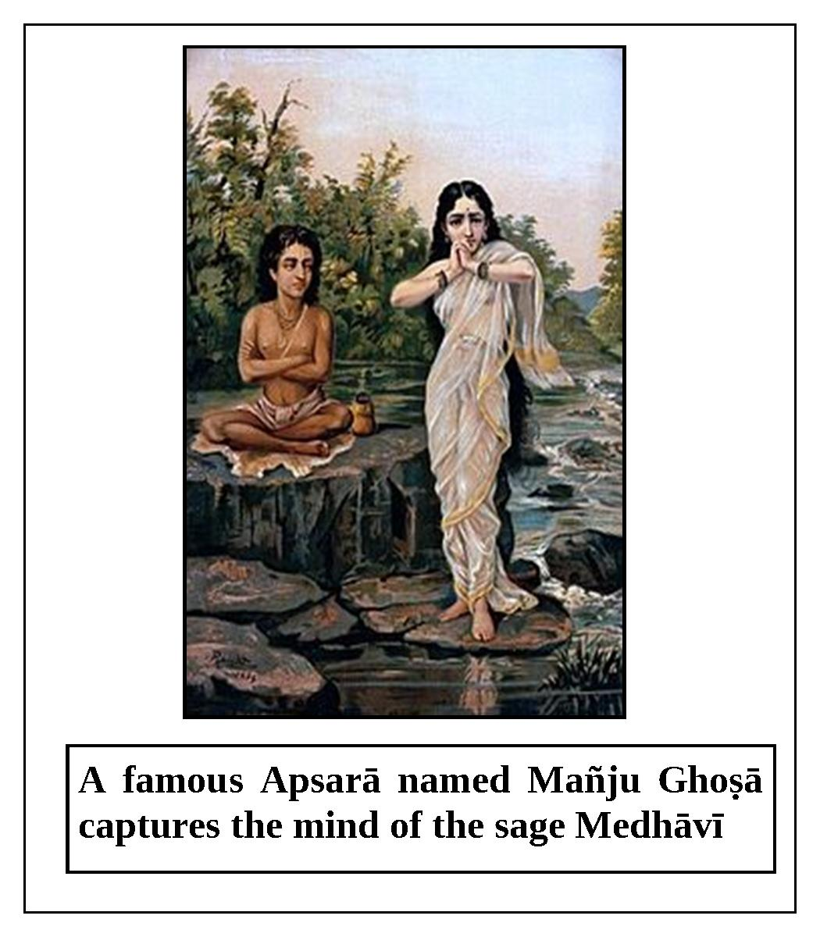
“When Mañju Ghoṣā saw that the sage had fallen down from his position, she decided to return to the heavenly planets. While they were engaged in amorous activities, she said to Medhāvī, ‘O great sage, please give me permission to return home. ’Medhāvī replied, ‘O beautiful woman, I have been with you for only a little while; please stay with me for the rest of the night and you can go home in the morning. ’Mañju Ghoṣā became frightened and remained with him for a few more years. Although she ended up living with the sage for fifty-seven years, nine months, and three days, it seemed to him to be like only a few moments. When Mañju Ghoṣā again asked permission to return home, the sage said, ‘O beautiful one, please listen to me. It is still early in the morning; please wait until I finish my morning rituals.’ The Apsarā smiled and said with amazement, ‘O great sage, how long will it take to complete your morning rituals? You are not finished yet? You have enjoyed my association for many years; therefore, please consider the actual value of your time. ’Hearing these words, the sage came to his senses, and after carefully considering how he had spent his time, he said, ‘Alas, O beautiful one, I have simply wasted fifty-seven long years of my valuable time. You have ruined everything and spoiled all of my austerities.’ The sage’s eyes filled with tears, and his entire body began to tremble. Medhāvī cursed Mañju Ghoṣā: ‘You have behaved with me like a witch; therefore, you will immediately become a witch. O sinful, unchaste lady, shame on you!’
“Mañju Ghoṣā humbly replied, ‘O best of brāhmaṇas, please withdraw your severe curse. I have been with you for many years my lord, so you should forgive me. Please be merciful.’ The sage replied, ‘O gentle lady, what will I do now? Although you have destroyed my entire wealth of austerity, I will tell you how to become free from the curse. The ekādaśī which occurs during the waning moon in the period of March-April, called Pāpamocanī, destroys all of one’s sinful reactions. If you strictly and faithfully follow this ekādaśī, your existence as a witch will be vanquished.’
“Then sage Medhāvī returned to the āśrama of his father, sage Cyavana. As soon as Cyavana saw his fallen son, he became extremely unhappy and said, ‘Alas, alas, O my son, what have you done? You have ruined yourself. You should not have spoiled your entire stock of austerities by being captivated by an ordinary lady.’ Medhāvī replied, ‘O respected father, by misfortune I committed great sins in the association of an Apsarā. Therefore, please instruct me regarding atonement.’ Hearing these pathetic words from his repentant son, sage Cyavana said, ‘O my son, by observing Pāpamocanī ekādaśī, all of one’s sinful reactions are completely destroyed. Therefore, you should observe it.’ Medhāvī later observed this ekādaśī with great enthusiasm, and as a result, all of his sinful reactions were destroyed and he became very pious. Meanwhile, Mañju Ghoṣā also observed this auspicious Pāpamocanī ekādaśī, and she was liberated from being a witch. She regained her beauty and returned to heaven.”
After narrating this story to King Māndhātā, sage Lomaśa concluded, “My dear king, just by observing this Pāpamocanī ekādaśī, all of one’s sinful reactions are automatically destroyed. By hearing or reading the glories of this ekādaśī, one achieves the result of donating one thousand cows. This ekādaśī uproots the desire to commit sinful acts such as killing a brāhmaṇa or embryo, drinking wine, or associating with one’s guru’s wife. Everyone should strictly observe this sacred ekādaśī because it is all-auspicious and destroys all sins.”

Kāmadā Ekādaśī
The glories of Kāmadā ekādaśī are described in Varāha Purāṇa in a conversation between Lord Kṛṣṇa and Mahārāja Yudhiṣṭhira.
Once, Mahārāja Yudhiṣṭhira said to Lord Kṛṣṇa, the crown-jewel of the Yadu Dynasty, “O Lord Vāsudeva, please accept my humble obeisances. O my Lord, please tell me about the ekādaśī that occurs during the waxing moon in the period of March/April. Also, explain to me the procedure for observing it and what the benefit is.”
Lord Kṛṣṇa replied, “My dear Mahārāja Yudhiṣṭhira, please listen attentively to the description of this ekādaśī which is recorded in the Purāṇa. Once, Mahārāja Dilīpa, the great-grandfather of Lord Rāmacandra, asked his spiritual master, sage Vasiṣṭha, about the name and observance of the ekādaśī which occurs during the waxing moon in the period of March/April.
“Sage Vasiṣṭha replied, ‘O king, I will certainly fulfill your desire. The name of this sacred ekādaśī is Kāmadā. It burns all of one’s sinful reactions to ashes, and awards one the privilege of having a son. Now, please hear about its glories.
“Long ago, there was a city named Ratnapura (Bhogīpura). This opulent city was ruled by a king named Puṇḍarīka. His subjects included Gandharvas, Kinnaras, and Apsarās. A beautiful Apsarā named Lalitā and a handsome Gandharva named Lalita lived in that city as husband and wife. They were overwhelmed with love for each other, and they were constantly engaged in various playful activities at their opulent house. Their love was so intense that they could not bear a moment of separation from each other.

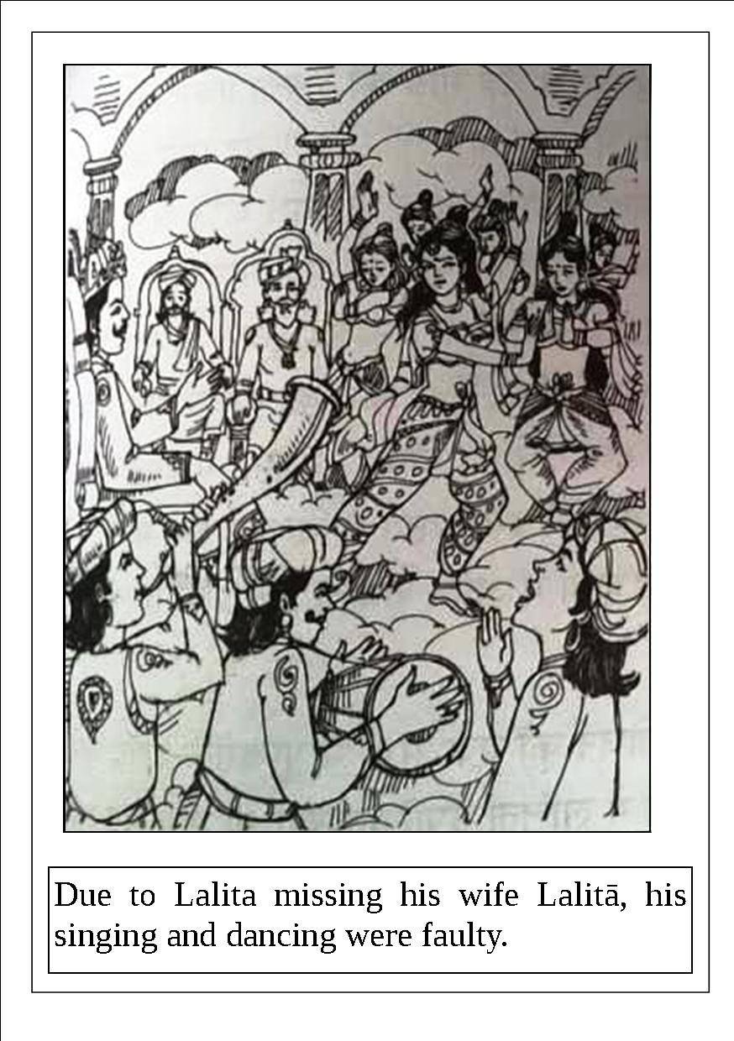
“Once in the court of King Puṇḍarīka, many Gandharvas were singing and dancing, and Lalita, without his wife, sang with them. Due to Lalita missing his wife Lalitā, his singing and dancing were faulty. A snake named Karkoṭaka was watching, and he went to King Puṇḍarīka to complain about Lalita’s performance. The king became extremely angry and cursed Lalita as follows: ‘O sinful one, O fool, you have disturbed the singing and dancing due to lust for your wife. So, I curse you to become a cannibal.’
“O best of kings, by King Puṇḍarīka’s curse, Lalita immediately transformed into a great demon. Lalitā was devastated when she saw her husband in such a terrifying form. She lived with him in the forest in great distress, always thinking, ‘What can I do? Where can I go?’
Once, while wandering in the dense forest with her husband, Lalitā saw the sacred āśrama of the sage Śṛṅgī on the top of Vindhya Mountain. Lalitā went there and offered her respectful obeisances to the sage. The sage inquired, ‘O beautiful one, who are you? Whose daughter are you? Why have you come here?’ Lalitā replied, ‘O great soul, I am the daughter of the Gandharva named Vṛndāvana. My name is Lalitā. I have come here with my cursed husband. O great sage, my husband has become a demon by the curse of the Gandharva king Puṇḍarīka. O brāhmaṇa, I am greatly distressed by his terrifying appearance. O my lord, kindly tell me how my husband can atone and be liberated from the curse. O best of brāhmaṇas, please explain how to end his life as a demon.’ The great sage Śṛṅgī said, ‘O daughter of a Gandharva, in a few days there will be an ekādaśī named Kāmadā, which occurs during the waxing moon in the period of March-April. All of one’s desires are fulfilled by strictly following this ekādaśī. O gentle lady, you should follow this vow and give the entire benefit to your husband. He will immediately be freed from the curse by that pious merit.’
“O king, after being instructed in this way by the sage, Lalitā gladly observed that ekādaśī. On the day of dvādaśī, she sat before the brāhmaṇas and the Supreme Lord Vāsudeva, and declared, ‘I observed the vow of Kāmadā ekādaśī to relieve my husband from the curse. Now, by the influence of my earned piety, let my husband be freed from his life as a demon. ’As soon as Lalitā finished her prayer, her husband, who was present, became free from all sins and regained his heavenly Gandharva form. Thereafter, Lalita and Lalitā lived happily.”
Lord Kṛṣṇa concluded, “O Mahārāja Yudhiṣṭhira, O best of kings, anyone who hears this wonderful narration about Kāmadā ekādaśī should certainly observe it to the best of his ability. There is no better ekādaśī than this, for it can eradicate even the sin of killing a brāhmaṇa, and counteract demoniac curses.”

Varuthinī Ekādaśī
The glories of Varuthinī ekādaśī, which occurs during the waning moon in the period of April-May, are described in Bhaviṣya-uttara Purāṇa in a conversation between Lord Kṛṣṇa and Mahārāja Yudhiṣṭhira.
Once, Mahārāja Yudhiṣṭhira said to Śrī Kṛṣṇa, “O Vāsudeva, I offer my humble obeisances to You. Please tell me about the ekādaśī which occurs during the waning moon in the period of April-May, including its name and glories.”
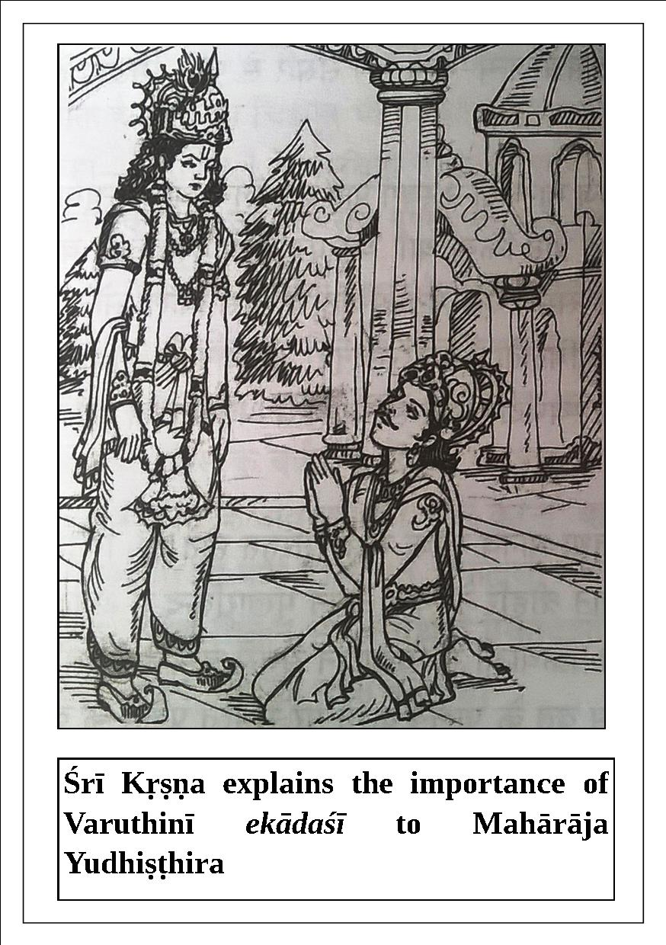

Lord Kṛṣṇa replied, “My dear king, the name of this ekādaśī is Varūthinī, and it awards one good fortune both in this life and in the next. By following this ekādaśī, a living entity attains perpetual happiness, diminishes his sinful reactions, and becomes greatly fortunate. By observing this vow, an unfortunate wife become fortunate; a human being attains happiness and prosperity both in this life and in the next; one is freed from the cycle of birth and death; all of one’s sinful reactions are nullified; and one attains devotional service to the Lord. King Māndhātā was liberated by properly observing this ekādaśī, and other kings such as Dhundhumāra were also liberated by doing so. One can achieve the result of undergoing austerities for ten thousand years simply by observing Varūthinī ekādaśī. The amount of piety one accumulates by donating forty kilograms of gold during a solar eclipse at Kurukṣetra is achieved simply by following this ekādaśī.
“O best of kings, donating an elephant is superior to donating a horse. Donating land is superior to donating an elephant, and donating sesame seeds is better than donating land. Donating gold is better than donating sesame seeds, and donating food grains is better than donating gold. In fact, there is no greater charity than giving food grains. O best of kings, one satisfies the forefathers, demigods, and all other living entities by giving food grains in charity. Learned scholars have ascertained that the charity of giving food grains is equal to the charity of giving one’s daughter. The Supreme Lord Himself has said that donating food grains is equal to donating cows.
“Among all the different kinds of charity, giving knowledge is the best. By following Varūthinī ekādaśī, one attains the results of giving all kinds of charities. A person who sells or trades his daughter certainly commits a great sin, and he will go to hell until the time of final annihilation of the universe. No one should ever accept wealth in exchange for his daughter. O king of kings, a householder who sells his daughter out of greed becomes a cat in his next life. If one decorates his daughter with ornaments according to his capacity and gives her in charity to a qualified groom, then even Citragupta, the chief secretary of Yamarāja, finds one’s piety too much to count. One should follow this ekādaśī by eating out of a bell-metal pot, and not eating masūra gram, chickpea, spinach, honey, and foodstuffs cooked by others. One should not eat more than once on that day, and should not indulge in sex starting from the day before ekādaśī. One should not gamble, sleep, eat betel nuts, brush his teeth, blaspheme anyone, gossip, speak with a sinful person, become angry, or tell lies on ekādaśī. On the day after ekādaśī, one should not eat on a plate made of bell-metal, and should not eat masūra gram, or honey. Also, one should not speak lies, exercise, labor hard, eat more then once, have sex, shave his head or face, apply oil on the body, or eat foodstuffs cooked by others. One should carefully avoid all of these activities, which destroy the vow of ekādaśī. In addition, some other prohibitions should be followed not only on ekādaśī and the days before and after it, but all of the time. If one observes the vow of Varūthinī ekādaśī according to these prescribed rules and regulations, all of his sinful reactions are eradicated and he attains the supreme destination. One who stays awake on ekādaśī and worships Lord Janārdana becomes free of all sins and attains the supreme goal of life. Anyone who hears or reads about the glories of this ekādaśī surely achieves the result of donating one thousand cows, and, being freed from all of his sinful reactions, attains the abode of Viṣṇu.”

Mohinī Ekādaśī
The glories of Mohinī ekādaśī, which occurs during the waxing moon in the period of April-May, are described in Sūrya Purāṇa.
Once, Mahārāja Yudhiṣṭhira said to Lord Kṛṣṇa, “O Janārdana, what is the name of the ekādaśī that occurs during the waxing moon in the period of April-May, and what is the process for observing it? Also, what merit is obtained by following it? Please explain all of this to me in detail.”
Lord Kṛṣṇa replied, “O son of dharma, please listen attentively as I tell you a story that sage Vasiṣṭha once told to Lord Rāmacandra.
“Long ago, Lord Rāmacandra requested the great sage Vasiṣṭha, ‘O respected sage, I am feeling great distress due to separation from Sītā, the daughter of King Janaka. Kindly tell me about a great vow I can follow to eliminate all of my sinful reactions and distress.’
“The great sage Vasiṣṭha, the spiritual master of Rāmacandra, replied, ‘My dear Rāma, your intelligence is sharp and mixed with faith. Your question is beneficial for all of humanity. Just by chanting and remembering Your all-auspicious holy names, all living entities can become purified and auspicious. For the benefit of ordinary people, I will describe to you a great vow. O Lord Rāma, the ekādaśī that occurs during the waxing moon in the period of April-May is known as Mohinī ekādaśī. This ekādaśī is very auspicious, and by following it, all of one’s sinful reactions, material miseries, and illusions are destroyed. Please listen attentively as I tell you about this pious topic.
“There was a beautiful city named Bhadrāvatī near the bank of the sacred Sarasvatī River. A king named Dhṛtimān ruled that city. O Lord Rāma, that king was born in the Moon Dynasty, and he was tolerant and truthful. A pious, prosperous devotee of Lord Viṣṇu named Dhanapāla lived there. He was a vaiśya by profession, and he built many dharma-śālās (guest houses), schools, and temples of Lord Viṣṇu, hospitals, roads, and market places. He also made arrangements for distributing water and foodstuffs, dug wells for drinking water, and built gardens full of flowers and fruits. In this way, he properly utilized his wealth for the benefit of all, and thus he successfully demonstrated the true meaning of his name. This pious, peaceful, and generous devotee of Lord Viṣṇu had five sons; namely, Samāna, Dyutimān, Medhāvī, Sukṛti, and Dhṛṣṭabuddhi. Dhṛṣṭabuddhi was the most sinful son. He was extremely wicked, ill-natured, always in bad association, and addicted to having illicit connection with unchaste women. He was fond of gambling and drinking wine. He took pleasure in killing and torturing other living entities. He was an abominable son of a very pious father, and a disgrace to the family. He never showed respect to the demigods, guests, forefathers, or brāhmaṇas. He lived a contemptible life full of sinful activities. The wretched Dhṛṣṭabuddhi misused all of his father’s wealth carrying out various useless activities. He always ate abominable food and drank large quantities of wine.
“One day, Dhanapāla saw his shameless son Dhṛṣṭabuddhi walking in public with his arm on the shoulder of a prostitute, and he became especially ashamed and angry. That day he threw his spoiled son out of the house. Dhṛṣṭabuddhi was cut off from the affection of his father, mother, brothers, relatives, and friends. Soon, he lost his position in society and was hated by everyone.
“After being thrown out of his father’s house, Dhṛṣṭabuddhi sold his clothes and ornaments and used the money to continue his sinful lifestyle. When the money ran out, he became weak and thin due to lack of sufficient food. He was poor and his so-called friends rejected and condemned him.
“Dhṛṣṭabuddhi was always full of anxiety; he had no clothes and was starving. He began to contemplate, ‘What should I do now? Where should I go? How can I survive?’ Thinking in this way, he concluded that there was no other alternative than to start stealing. He began to wander throughout the city looking for opportunities to steal. Sometimes the king’s guards would arrest him, but considering his position as the king’s son, they would release him. After being caught and released like this several times, he committed a serious theft and was taken to the king, who gave him a severe punishment. The king said, ‘O foolish creature, you can no longer stay in this kingdom, for you are the greatest of sinners. Leave immediately and go wherever you wish.’
“Dhṛṣṭabuddhi left the kingdom and went far away. In a dense forest, he became so hungry and thirsty that he began to kill and eat any creatures that he could find. He wandered in the forest with bow and arrows, killing various animals. Dhṛṣṭabuddhi lived sinfully in this way for several years.
“Dhṛṣṭabuddhi was always miserable and anxious. One day while wandering in the forest, as a result of past pious deeds he arrived at the sacred āśrama of the great sage and ascetic Kauṇḍiṇya. It was the month of Vaiśākha (April-May), and Kauṇḍiṇya was returning after taking bath in the Ganges. By providence, the sad and distressed Dhṛṣṭabuddhi came in contact with a drop of water falling from the sage’s clothes. Thus, Dhṛṣṭabuddhi was immediately relieved from his sinful reactions. Folding his hands, he humbly said to sage Kauṇḍiṇya, ‘O great brāhmaṇa, I am the most sinful person; there is no sin that I have not committed. Please inform me of the best atonement that a wretched person like me can easily perform. Due to committing innumerable sinful activities, I lost my home, wealth, relatives, and friends. My life is full of agony.’
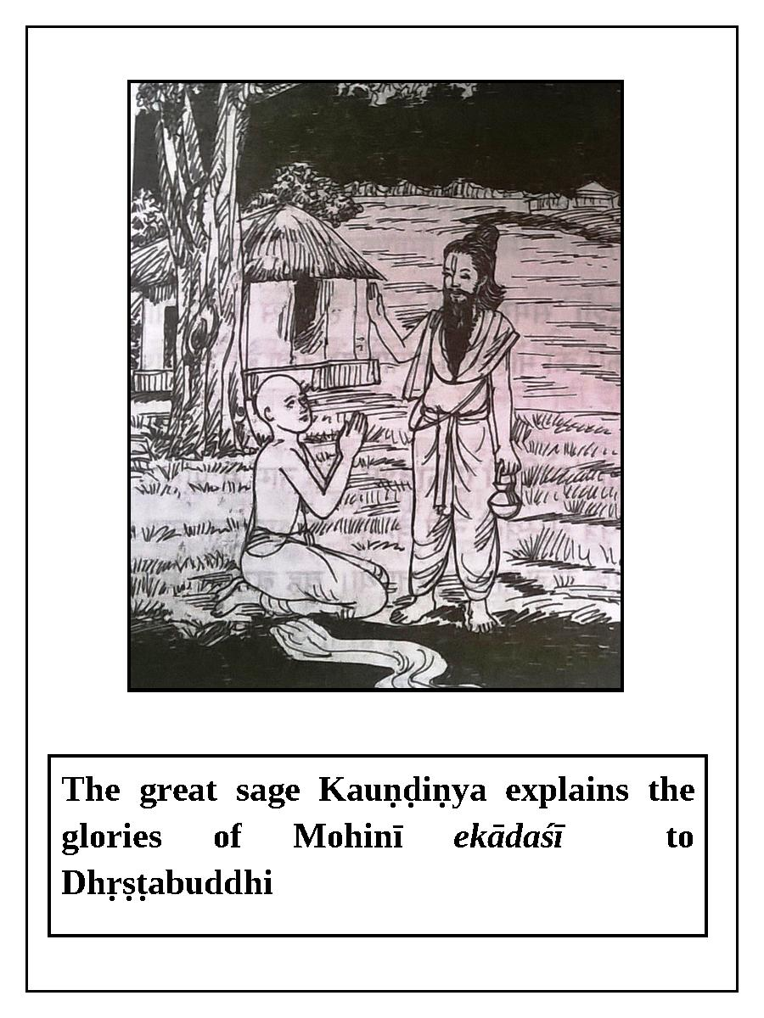
“Kauṇḍiṇya, who felt distress at seeing others distressed, replied, ‘I will tell you about a sublime way to easily and quickly nullify all of your sinful reactions, so please hear me attentively. Mohinī ekādaśī, which occurs during the waxing moon in the period of April-May, destroys even a mountain of sinful reactions that a person has accumulated over many lifetimes. You should faithfully observe this ekādaśī.’
“Dhṛṣṭabuddhi became joyful, and later he properly observed that ekādaśī according to the sage’s instructions. O best of kings, Dhṛṣṭabuddhi soon became devoid of all sinful reactions, and he assumed a divine body and rode on the back of Garuḍa to the all-auspicious abode of Lord Viṣṇu. O Rāmacandra, this vow certainly removes all kinds of illusion and the darkness of ignorance. The piety gained by taking bath in holy waters, giving charity, and performing sacrifices does not compare with the piety that one attains by observing Mohinī ekādaśī.”

Aparā Ekādaśī
Aparā ekādaśī, which occurs during the waning moon in the month of Jyeṣṭha(May-June), is described in Brahmāṇḍa Purāṇa in a conversation between Lord Kṛṣṇa and Mahārāja Yudhiṣṭhira.
Once, Mahārāja Yudhiṣṭhira asked Lord Kṛṣṇa, “O Janārdana, what is the name of the ekādaśī that occurs during the waning moon in the month of Jyeṣṭha, and what are its glories? Please explain these things to me.”
Lord Kṛṣṇa replied, “O Mahārāja Yudhiṣṭhira, you have asked an intelligent question that is beneficial for everyone. The name of this ekādaśī is Aparā. O king, it awards great piety to those who observe it, and eliminates their reactions to sins including killing a brāhmaṇa, killing a cow, killing an embryo by abortion, criticizing others, engaging in illicit sex-life, speaking lies, bearing false witness, bragging, reciting or teaching the Vedas for the sake of money, and concocting one’s own scripture. A cheater, a pseudo- astrologer, and a dishonest physician are as sinful as one who bears false witness. All of these sinful activities are totally nullified by observing Aparā ekādaśī. A kṣatriya who abandons his duty and leaves the battlefield certainly loses his position in society and goes to hell. If such a person observes this ekādaśī with faith, he is saved and he will attain the heavenly planets.
Lord Kṛṣṇa continued, “O king, a disciple who receives knowledge from his spiritual master and then blasphemes him certainly commits a great sin. Such a condemned person can be saved by following Aparā ekādaśī, and he will attain the supreme destination. O king of kings, by observing this vow one easily gets the results or piety obtained by taking bath three times at Puṣkara in the month of Kārtika; by taking bath at Prayāga in the month of January when the sun enters Capricorn; by observing the vow of Śivarātrī at Kāśī; by offering oblations at the lotus feet of Viṣṇu at Gayā; by taking bath in the Gautamī River when Jupiter enters Leo; by visiting Kedāranātha during Kumbha-melā; by visiting and worshiping Badarīnātha; by taking bath at Kurukṣetra during a solar eclipse; or by giving elephants, horses, cows, gold, or land in charity. This vow is like a sharp ax for cutting down the tree of sinful activities, and like a blazing fire for burning the forest of sins to ashes. It is like a brilliant sun for eradicating the darkness born of sinful activities, and like a lion for devouring the deer of sins. O king, by observing Aparā ekādaśī and worshiping Lord Viṣṇu in His form as Trivikrama, a person attains the all-auspicious abode of Lord Viṣṇu. Anyone who hears or reads about the glories of this ekādaśī, which I have described to you for the benefit of everyone, is relieved from all of his sinful reactions.”
The great devotee and lord of the city of demigods, Mahārāja Rukmāṅgada, had a wonderful, charming flower garden in his kingdom that everyone wanted to see. Eventually, people visiting that garden picked so many flowers that there was not even one left for the king. Thus, it became like a deserted wasteland. The king was very sad to see the pitiful condition of the garden. Although he increased the number of guards there, the theft of the flowers continued. He also took many other measures, but none were effective because the entities taking the flowers were not human beings, and they could not be caught. Those entities were the demigods, demigoddesses and Apsarās of heaven.
Finally, the king requested his family priest to solve this problem. That priest explained that if foot-bath water of Bhagavān Viṣṇu, or flowers or flower garlands offered to the Deity of Bhagavān, were placed in the garden, it would be possible to catch the thieves. The king ordered that this be done.
One night, the demigods, demigoddesses, and Apsarās descended to that garden, just as they had done previously. As soon as the foot of one of the Apsarās touched a flower that had been offered to the Lord, all of her pious merit was exhausted, and she lost her ability to return to heaven. The other demigods and demigoddesses tried to find a way to bring her back, but they failed and became dejected. They had to leave her behind when they returned to heaven. That unfortunate Apsarā, now unable to fly back to heaven, remained there alone. Separated from her friends and facing the unavoidable distressful features of this mortal world such as old age and disease, she began to weep, thinking, “Alas, I will have to live in this mortal world.”
In the morning, the guards and gardeners saw her in the garden and were astonished by her heavenly effulgence and incomparable beauty. They went to the king’s palace and told him the news. The king went to the garden and saw the Apsarā’s extraordinary beauty. Thinking that she must be Durgā, Lakṣmī, or Sarasvatī, the king offered his obeisances to her.
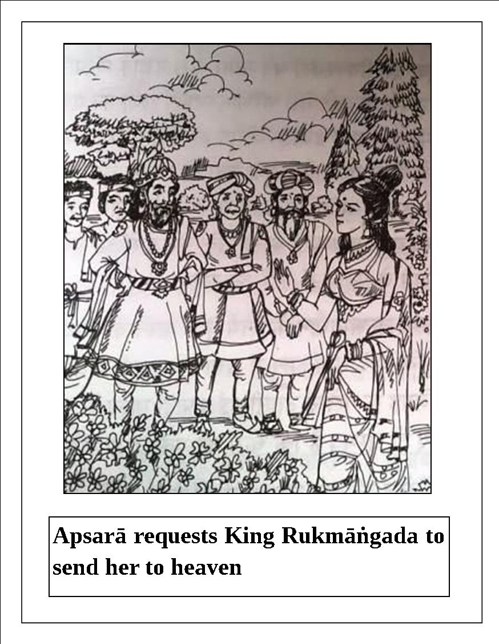
The king saw her crying and felt great compassion for her. He asked, “O goddess, why are you weeping? Why are you in distress?
The Apsarā told him her story, and that she wanted to go back to heaven. She explained that on the planet of human beings, old age comes early, many diseases attack the body, and one cannot enjoy sufficient sense gratification to satisfy one’s desires. She said, “Mahārāja, I can return to heaven if one of your subjects donates the result of one ekādaśī to me. By receiving the benefit of one ekādaśī, I will be able to enjoy the divine happiness of heaven for one kalpa.”
King Rukmāṅgada did not know anything about ekādaśī. When he inquired from his rājaguru (royal spiritual preceptor) about this, his rājaguru said, “This is the first time that I have heard about the vow of ekādaśī.”The king announced in his city that a reward would be given to any citizen who was willing to donate the result of one ekādaśī. When no citizen came forward for three or four days, he kept increasing the amount of the reward until finally he offered half of his kingdom. Still, no one came forward. Citragupta, the accountant of Yamarāja, told the Apsarā that there was a wealthy merchant in Rukmāṅgada’s kingdom whose wife had observed the vow of ekādaśī due to feelings of helplessness.
The Apsarā told the king about the rich merchant and where he lived. She said, “One day, the wife of that rich merchant went to a warehouse in an isolated place near her home to look for some goods. The rich merchant’s servants did not know that she was inside the warehouse. When the rich merchant called his servants, they locked up the warehouse and went away.
“The wife of the rich merchant was locked inside the warehouse. She banged on the door for a long time, but due to the isolated location, no one heard. Anxious and unable to do anything, she slept there overnight, thinking that someone would open the door the next day. However, due to fate, the next day was a holiday and nobody came to the warehouse. The rich merchant’s wife began to suffer from extreme hunger and thirst.
“In the meantime, the merchant and his family became very disturbed. They searched everywhere for her, but she could not be found. No one thought of looking in the warehouse because the merchant’s wife never used to go there. She had simply gone there out of curiosity the day she got locked in.
“When the merchant’s servants opened the door of the warehouse the day after the holiday, they found her unconscious. They quickly informed the merchant, and a nearby doctor was summoned. He sprinkled water on her face and massaged her hands and feet, and brought her back to consciousness. Lunch was arranged for her, and slowly she began to recuperate and gain strength.
“By coincidence, the day that the merchant’s wife went to the warehouse was daśamī, and the next day, when she was locked inside and forced to fully fast, was ekādaśī. In this way, she unknowingly observed the holy vow of ekādaśī.”
After hearing the Apsarā’s narration, the king ordered his ministers and soldiers to bring the merchant and his wife, and to treat them with proper respect. When they arrived at the palace, they offered their obeisances to the king and to the Apsarā, and they said, “Your ministers have explained everything to us. Now, please tell us what to do.”
The Apsarā said to the merchant’s wife, “If you would mercifully give me the charity of the result of your vow of ekādaśī by making a pledge, I will be able to return to heaven.” Then, the king arranged for his royal spiritual preceptor to administer the pledge to the merchant’s wife, thus bestowing the benefit of ekādaśī upon the Apsarā. That goddess expressed her gratitude to the king, the merchant, the merchant’s wife, and everyone else, and returned to heaven. The king fulfilled his promise by giving half of his kingdom to the merchant’s wife.
Through his involvement in this incident, Mahārāja Rukmāṅgada became fully convinced of the great glory and potency of ekādaśī. One day, he decided that every citizen of his kingdom must regularly observe the vow of ekādaśī, which bestows so much pious merit and benefit. Therefore, he issued the following proclamation:
aṣṭavarṇādhiko marttyodhaśīti naiva pūyaryate
yo bhuṅkte māmake rāṣṭre viṣṇorahani pāpakṛta
sa me vadhyś ca nirvvāsyo deśataḥ kālataḥś ca me
etasmāta kāraṇād viprā ekādaśyā amu poṣaṇam
kūryannaro vā nārī vā pakṣayor ubhayor ubhayor api
(Nāradīya-purāṇa)
“If anyone between the ages of eight and eighty eats grains on ekādaśī, they will be executed or banished from my kingdom. Every woman and man must follow the ekādaśī vows during both the bright and dark fortnights. This rule applies to everyone including my son, mother, father, wife, friends, and relatives. I will punish anyone who does not follow it.”
The king prominently announced this to the entire kingdom. All of his subjects followed his order and observed ekādaśī, and as a result they eventually went to Vaikuṇṭha.
The Brahma-purāṇa states that Aparā ekādaśī bestows great pious merit, nullifies even the most serious sins, and gives unlimited benefits.

Nirjalā Ekādaśī
Nirjalā ekādaśī, which occurs during the period of May-June, is described in Brahma-vaivarta Purāṇa in a conversation between Vyāsadeva and Bhīmasena.
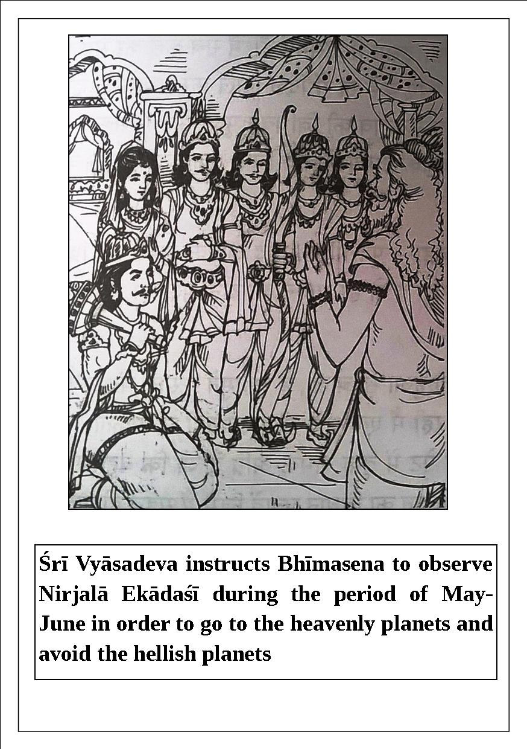

Once, Bhīmasena, the younger brother of Yudhiṣṭhira, said to the great sage Śrīla Vyāsadeva, “O my learned, worshipable grandfather, please hear my request. My elder brother Yudhiṣṭhira, my mother Kuntīdevī, my brothers Arjuna, Nakula, and Sahadeva, and Draupadī do not eat anything on ekādaśī. They, especially Yudhiṣṭhira, always tell me to fast on ekādaśī, and I tell them that although I know that fasting on ekādaśī is a scriptural injunction, due to my hunger I am unable to fast. I can give in charity as per my capacity, and I can worship Lord Keśava according to proper rules and regulations, but I cannot fast. So, please tell me how I can obtain the result of ekādaśī without fasting.”
Śrī Vyāsadeva replied, “O Bhīma, if you want to go to the heavenly planets and avoid the hellish planets, you must refrain from eating on both ekādaśīs of each month.”
Bhīma said, “O great sage, it is impossible for me to fast on twenty-four ekādaśīs every year, as instructed by the Lord. What to speak of fasting all day and night, I cannot tolerate my hunger for even a moment. The fire of hunger, vṛka, is always present in my stomach, and it is extinguished only by voracious eating. However, with great endeavor I can fast on one day a year. Therefore, please tell me about a vow by duly following of which I can attain auspiciousness both in this life and next.”
Śrī Vyāsadeva said, “O King! You have already heard from me the about the Vedic religious principles and the duties of the human beings. But in this age of Kali every one is not capable of following those rules and regulations. Therefore I will tell you a sublime method by which you can achieve great results. This method is the essence of all the Purāṇas. Any one who observes the ekādaśīs of waning and waxing moons by fasting never goes to hell.”
Hearing Vyāsadeva’s words the strongest warrior Bhīmasena became frightened and shivered like a leaf on a Banyan tree and said, “O grandfather! Then what should I do? I am totally unable to fast twice a month throughout the year. Therefore O my Lord! Kindly instruct me about observing one vow which awards the most amount of merit and following of which I can achieve all benefits.”
Then Śrī Vyāsadeva replied the ekādaśī which occurs during the waxing moon in the month of May-June during the sun’s presence in either Taurus or Gemini rāśi is called as Nirjalā ekādaśī. One should observe total fast even from drinking water in this ekādaśī. On this day one should perform Ācamana for purification by drinking that amount of water in which a single mustered seed or a drop of gold can be immersed. One should place the said amount of water in his palm which he should form to resemble a cows ear. If one drinks more or less water than this then it will amount to drinking of wine.
One must not eat anything at all on this ekādaśī otherwise his vow will be broken. One should not drink even water from the movement of sunrise from the day of ekādaśī until the sunrise on the day of dvādaśī. In this way if one strictly observes this ekādaśī without drinking water then he can attain the results of observing all the ekādaśīs of the year.
In the early morning on the day of dvādaśī one should take bath and give gold and water in charity to the brāhmaṇas. Thereafter the follower should gladly eat with the brāhmaṇas.
O Bhīmasena! Now please hear the about the piety one accumulated by observing this ekādaśī. By following this ekādaśī one can achieve the result of following all the ekādaśīs throughout the year. Once Lord Viṣṇu who holds a conch, a disc, a plough and a lotus flower in his hand told me that if a person gives up all varieties of religion and surrenders unto me and follows this Nirjalā ekādaśī which is very dear to me is certainly relieved from all sinful reactions. One cannot achieve supreme destination by giving wealth in charity or attain any benefit by following smārta rules and regulations in the Kali-yuga. In fact the Vedic religious principle have been extinct in this age of Kali which is polluted with various faults.
O Son of Vāyu! What more can I tell you? Actually eating is prohibited on all the ekādaśīs and even the drinking of water is prohibited on Nirjalā ekādaśī. By observing this ekādaśī one achieves the piety of visiting all the holy places. At the time of death such a person is not approached by the fierce looking Yamadūtas rather he is approached by the divine looking Viṣṇudūtas to be transferred to the abode of Viṣṇu. If one gives water and cows in charity after observing this ekādaśī then he is freed from all his sinful activities.
When the other Pāṇḍavas heard about the glories of this ekādaśī they resolved to observe it since Bhīmasena began observing this Nirjalā ekādaśī from that day onward this ekādaśī became famous as Pāṇḍava Nirjalā or Bhīmasenī ekādaśī. By following this ekādaśī sinful activities as huge as Sumeru or Mandara Mountain are at once burnt to ashes. O King! Lord Kṛṣṇa has declared that any pious activities such as taking bath in a holy place, giving in charity. Chanting Vedic mantras and performing sacrifices are carried out on this Nirjalā ekādaśī day become inexhaustible.
One who reads or hears the glories of this ekādaśī with devotion goes back to the abode of Vaikuṇṭha. The result one attains by observing the vow of Amāvasyā conjoined with pratipadā and offering oblations to the forefathers during the solar eclipse is attained simply by hearing the glories of this ekādaśī.

Yoginī Ekādaśī
The special ekādaśī known as Yoginī ekādaśī can cure severe diseases. Śrī Mārkaṇḍeya Ṛṣi, a great devotee of Lord Śiva, recommended following this ekādaśī to another devotee of Śiva. Thus, observing this vrata is for everyone, including devotees of Lord Śiva.
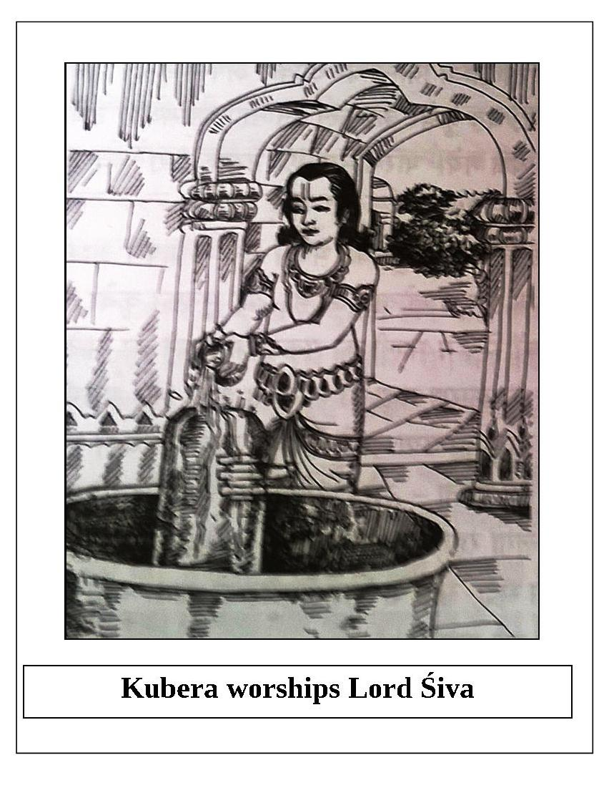
The glories of Yoginī ekādaśī, which occurs during the waning moon in the period of June-July, are described in Brahma-vaivarta Purāṇa in a conversation between Lord Kṛṣṇa and Mahārāja Yudhiṣṭhira.
Once, Mahārāja Yudhiṣṭhira said, “O Supreme Lord, O Madhusūdana, I have heard the glories of Nirjalā ekādaśī. Now, I wish to hear about the ekādaśī that occurs during the waning moon in the period of June- July.”
Lord Kṛṣṇa replied, “O king, the name of that ekādaśī is Yoginī. It destroys all of one’s sinful reactions and delivers one from the ocean of material existence.
“O best of kings, now I will narrate a story from the Purāṇas which demonstrates this. Kubera, the king of Alakā-purī, regularly worshiped Lord Śiva. He had a Yakṣa gardener named Hema, and Hema’s wife was Viśālakṣī. Viśālakṣī was very beautiful, and Hema was very attached to her. Hema often collected flowers from Mānasa-sarovara Lake and gave them to King Kubera for his worship of Lord Śiva. One day, after collecting flowers as usual, instead of bringing them to Kubera, Hema went home to be with his wife.
“O king, thus Kubera did not receive any flowers that day. He waited six hours for Hema, and without the flowers he was unable to complete his worship of Lord Śiva. The king became extremely angry and sent a messenger to find out the cause of his gardener’s failure to perform his duty.
“After some time, the Yakṣa messenger returned and said to the king, ‘O master, Hema is at home with his wife.’ Kubera became very angry and immediately ordered his servants to bring Hema before him. Realizing that he had made a terrible mistake, Hemamālī was ashamed. He fearfully went before Kubera and offered his respectful obeisances. Kubera, whose entire body trembled and whose eyes were red with anger, said, ‘O sinful one, O destroyer of religious principles, you have disregarded my most worshipable Lord Śrī Śaṅkara and engaged in sense gratification. Hence, I curse you to be afflicted with white leprosy, and you will remain separated from your dear wife forever. O low-class fool, you must immediately leave this place.'
Cursed by Kubera, Hemamālī immediately fell from Alakā-purī and took birth in this world. He was afflicted with white leprosy and suffered in extreme misery. In intense mental agony and without any food or water, he went to a dense forest. There, he suffered day and night from extreme hunger and thirst. He could not find any relief during the day and he could not sleep at night. He was miserable in both the winter and summer. However, his memory remained intact because in the past he had faithfully helped worship Lord Śiva. Although he was now engaged in various sinful activities, he was able to remember his previous pious activities, and thus his consciousness did not degrade and he remained alert.
“After wandering throughout the forest in this way, by good fortune he arrived at the Himalayan Mountains. By Providence, he met with the great sage Mārkaṇḍeya, the best of ascetics, whose life lasts for seven kalpas. Feeling very sinful, Hemamālī remained at a distance from the sage and repeatedly offered him his humble obeisances from afar. The kind-hearted sage Mārkaṇḍeya called the leprosy-ridden man before him and asked, ‘How have you come to suffer from this dreadful affliction? What sinful, condemned activities have you performed such that you have to suffer in such a miserable condition?'
“Hemamālī replied, ‘O great sage, I am the gardener of Kubera, the king of the Yakṣas. My name is Hemamālī. I used to collect flowers regularly from Mānasa-sarovara Lake and give them to my master Kubera. Kubera used the flowers in his worship of Lord Śiva. One day I neglected to give flowers to my master due to fulfilling my lusty desires with my wife. That is why Kubera, the king of the Yakṣas, became angry and cursed me. As a result, I am suffering terribly from white leprosy and I am separated from my wife. I do not know how such a wretched soul like me has had the good fortune of meeting a great personality like you. I have heard that saintly persons always feel compassion when they see the distress of others, and they always endeavor for the welfare of others. O great sage, this fallen soul surrenders to you and hopes to obtain auspiciousness. Please be kind and deliver me.'
“With compassion, the great sage Mārkaṇḍeya replied, ‘O gardener, I will instruct you about a very auspicious, beneficial vow. You should observe the ekādaśī known as Yoginī that occurs during the waning moon in the period of June-July, and by the piety you achieve you will certainly be liberated from the curse of leprosy.' Hemamālī became joyful, and with gratitude he offered his humble obeisances to Mārkaṇḍeya. In time, he duly observed that ekādaśī, as instructed by the sage. Consequently, he regained his heavenly form and returned home to reunite with his wife.
“The result one attains by feeding eighty-eight thousand brāhmaṇas is attained by observing Yoginī ekādaśī. This ekādaśī destroys all of one’s sinful reactions and awards one great piety.”

Śayana Ekādaśī
Śayana, Devaśayanī, or Padmā ekādaśī is described in Bhaviśyottara Purāṇa in a conversation between Lord Kṛṣṇa and Mahārāja Yudhiṣṭhira.
Once, Mahārāja Yudhiṣṭhira said, “O Keśava, what is the name of the ekādaśī that occurs during the waxing moon in the period of June-July? Who is the worshipable Deity of this sacred day, and what are the rules and regulations for observing it? Please explain these things to me in detail.”
Lord Kṛṣṇa replied, “O maintainer of this world, Śrī Nārada Muni once asked this question to Lord Brahmā. Now, please hear from Me the wonderful history which Lord Brahmā narrated to Nārada Muni in his reply.

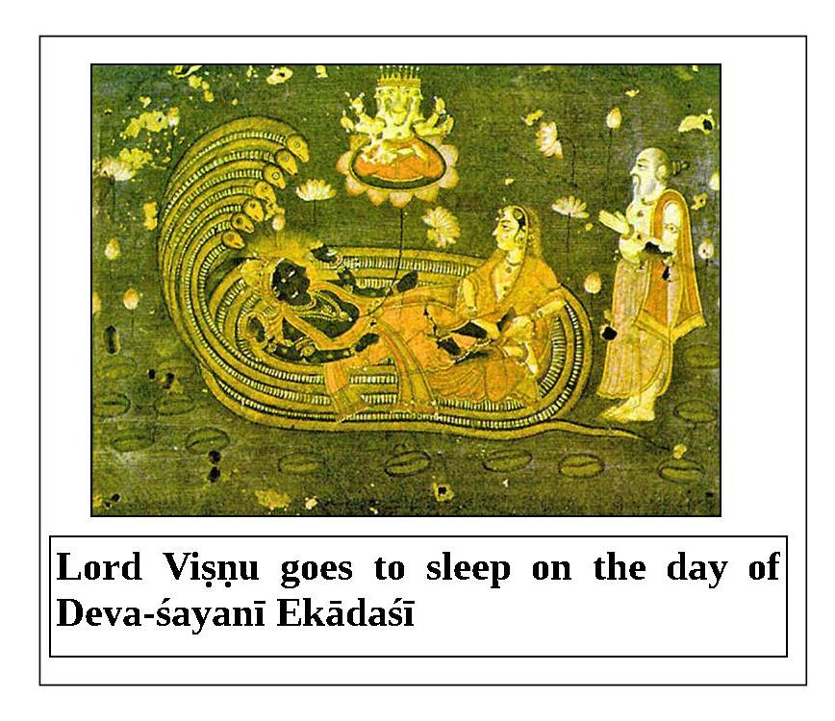
“Once Nārada, the great orator and best of sages, asked Lord Brahmā, ‘O father, what is the name of the ekādaśī that occurs during the waxing moon in the period of June-July? Kindly explain to me how to observe this ekādaśī in order to please the Supreme Lord Viṣṇu.’
“Lord Brahmā replied, ‘There is no vow in this material world that is as sacred as the vow of ekādaśī. One must follow this vow to nullify all of one’s sinful reactions. A person in this world who does not observe ekādaśī certainly goes to hell. The ekādaśī which occurs during the waxing moon in the period of June-July is called Devaśayanī or Padmā ekādaśī. One should follow this ekādaśī to please the Supreme Lord Hṛṣīkeśa.
“‘The Purāṇas state that once there was a saintly emperor named Māndhātā who ruled the entire world. He was born in the dynasty of the sun-god. He was extremely powerful and always stood up for the truth. This king maintained his subjects with piety and affection if they were his own children. There was no famine, drought, or disease in the kingdom. All of the subjects lived peacefully and prosperously, without any anxiety. All of the wealth in the king’s treasury was earned honestly. In this way, the king and his subjects happily passed their days.
“‘After many years, due to Providence and some sinful activities, there was no rainfall in the kingdom for three consecutive years. As a result, there was a lack of food and the people became hungry and full of anxiety. The performance of various sacrifices and the study of the Vedas ceased due to the scarcity of food.
“‘All of the subjects approached the king and appealed, “O king, please hear our words, which we hope will ultimately benefit us. Water is referred to in the scriptures as nāra. The Supreme Lord resides (ayana) in nāra. That is why another name of the Supreme Lord is Nārāyaṇa. The Supreme Lord Viṣṇu is all-pervading in His form as clouds. He alone causes the rain to fall. Food grains are produced from rain, so the living entities depend on rain. Presently, your subjects are suffering and decreasing in number due to lack of rain and food grains. O best of kings, please put an end to our miserable condition, and restore peace and prosperity to the kingdom.”
“‘The king replied, “Whatever you have said is true. Food grains are considered to be like Brahman; everything is sustained by food grains. All of the living entities subsist on them. The Purāṇas and other scriptures clearly state that if a king commits sinful activities, he and his subjects must suffer. Although I cannot ascertain my fault in this matter, for the benefit of my subjects I will continue to try my best to do so.”
“‘Then King Māndhātā gathered some of his principal soldiers, and after offering obeisances to Brahmā, they entered the forest. Within the forest they visited many āśramas of great sages and ascetics. One day, by Providence the king met with the great sage Aṅgirā, a son of Brahmā. Sage Aṅgirā was as effulgent as Brahmā; his effulgence illuminated all four directions. As soon as the self-controlled king saw him, he immediately got down from his carrier and offered his respectful obeisances at the feet of the sage. Then, the king folded his hands and offered prayers. The sage reciprocated and blessed the king.
“‘Then the sage inquired from the king, “How is your kingdom, and why have you come here?” The king replied, “O lord, although I have ruled my kingdom according to religious principals, for the last three years there has been no rainfall. As a result, my subjects are suffering in various ways. I have not been able to ascertain the cause of this bad fortune so that I may find a solution. Today I have come to your lotus feet with the hope that you will kindly tell me a way by which I can reestablish peace and auspiciousness in my kingdom.”
“‘Aṅgirā said, “O king, this present age of Satya-yuga is the best of all yugas. In this yuga, people worship the Supreme Brahman, and the fourfold religious principals are manifest. No one except the brāhmaṇas is supposed to perform austerities in this yuga. In spite of this standard, a śūdra in your kingdom is undergoing austerities. You are facing the consequences of this unlawful conduct in the form of drought. Therefore, killing this offender will bring peace and prosperity back to your kingdom.”
“‘The king said, “O great sage, I cannot kill an innocent person performing austerities. Therefore, please tell me of another solution.”
“‘The sage replied, “O king, in this case, you should observe the sacred ekādaśī known as Padmā or Devaśayanī, which occurs during the waxing moon in the period of June-July. Following this vow will certainly result in rain falling in your kingdom. This ekādaśī awards one all auspiciousness, and destroys all obstacles on the path to perfection. O king, you and your subjects should observe this ekādaśī.”
“‘After hearing these reassuring words of the great sage, the king offered his obeisances and returned to his palace. Thereafter, in the month of Āṣāḍha (June-July), the king, his family, and his subjects properly observed this auspicious Padma or Śayana ekādaśī. As a result, rain showered all over the kingdom. The scarcity of water was over, and soon the entire kingdom was full of food grains. By the mercy of the Supreme Lord Hṛṣīkeśa, everyone lived happily.
“‘Thus, it is everyone’s duty to observe this sacred ekādaśī, which awards happiness and liberation to all. All of one’s sinful reactions are destroyed by hearing and reading about the glories of this ekādaśī.
“‘This ekādaśī is also known as Viṣṇu-śayanī ekādaśī. Devotees observe it with pure devotion to please Lord Viṣṇu. They do not endeavor for material enjoyment or liberation; rather, they only pray for pure devotional service to the Lord. The vow of Cāturmāsya begins from this ekādaśī. Devotees observe Cāturmāsya by hearing and chanting about topics of the Lord for four months, from the day that Lord Hari goes to sleep until the day that He wakes up.’”
Mahārāja Yudhiṣṭhira said, “O Kṛṣṇa, please tell me how one should observe Śrī Viṣṇu-śayana-vrata or Cāturmāsya-vrata.”
Lord Kṛṣṇa replied, “O king, when the sun is in the constellation of Cancer, Śrī Madhusūdana, the Lord of the universe, goes to sleep, and when the sun enters the constellation of Libra, the Lord wakes up. The vow of Cāturmāsya commences on the day of Śayana ekādaśī. O King Yudhiṣṭhira, after taking bath one should dress the Deity of Lord Viṣṇu in yellow garments. He should put the Lord to rest on a bed covered with white sheets. First, under the guidance of qualified brāhmaṇas, one should bathe the Deity of the Lord with five ingredients, including yogurt, milk, ghee, honey, and sugar water. Thereafter, one should wipe the Lord’s body with a cloth and apply fragrant sandalwood paste to it. Then, he should worship the Lord by offering incense, ghee lamps, and flowers with devotion.
“One can also begin observing the vow of Cāturmāsya from the day of ekādaśī, dvādaśī, Pūrṇimā, aṣṭamī, or Saṅkrānti (when the sun enters the constellation of Cancer). The vow of Cāturmāsya ends on the day of dvādaśī which falls on the day after Utthāna ekādaśī in the month of Kārtika. A person who observes Cāturmāsya and remembers Lord Hari goes back to the abode of Lord Viṣṇu in a spiritual airplane as effulgent as the sun. Anyone who cleans the temple or its courtyard, decorates them with flowers and vines, or feeds the brāhmaṇas to the best of his ability at the end of this vow attains great happiness for seven lifetimes. One becomes fortunate and prosperous by offering ghee lamps to the Lord during this vow. One who chants the Gāyatrī mantra one hundred and eight times in the temple of the Lord in the morning, at noon, and in the evening is completely protected from committing sinful activities. Lord Vyāsadeva is pleased with such a person and sends him to the abode of Viṣṇu. Anyone who donates twenty-eight or one hundred and eight pots of sesame seeds to the intelligent brāhmaṇas at the end of Cāturmāsya is freed from all sinful reactions due to misuse of body, mind, and speech. Such a person will be free of diseases and will have intelligent children.”
“A practitioner of devotional service should not sleep on a comfortable, raised bed for the four months when Lord Janārdana takes rest. Sex is prohibited during Cāturmāsya, except for the days following menstruation. One should observe this vow by eating only supper, by eating only once a day, or by eating only that which comes without asking. One who chants and sings before the Deity of Lord Viṣṇu during Cāturmāsya goes to the planet of the Gandharvas. A person who gives up eating gur or jaggery during this time is blessed with sons and grandsons. By refraining from taking oil, one becomes beautiful and his enemies are destroyed. By fasting from food preparations which are bitter, pungent, sour, sweet, or salty, ugliness and bad bodily odor are eliminated. Those who give up the enjoyment of flowers go to the heavenly planets and become Vidyādharas. By not chewing butternuts, one immediately becomes free of diseases. If one eats food directly from the floor, he attains the heavenly abode of Indra. If one gives up milk and yogurt for the pleasure of Kṛṣṇa, he goes back to the supreme abode of Goloka. One who does not cut his fingernails and shaves his head attains the good fortune of touching the lotus feet of Lord Viṣṇu. One who circumambulates the temple of the Lord returns to the abode of the Lord in a spiritual airplane carried by swans.”

Kāmikā Ekādaśī
This special ekādaśī emphasizes the importance of tulasī in worshiping Śrī Hari.
On this day, arcana is done to Śrī Hari using tulasī leaves. One tulasī leaf is equivalent to eight tolā golden flowers and thirty-two tolā silver flowers. Worship with tulasī leaves is very dear to Śrī Hari; it is dearer to Him than worship with pearls, rubies, topaz, diamonds, or other precious stones. Worshiping Śrī Keśava with tender tulasī leaves, or bunches of tulasī leaves, wipes out all of the sins one has committed since birth. A mountain of sins is destroyed just by looking at a tulasī plant. If one touches a tulasī plant or leaf, one’s body becomes clean. If one bows down to a tulasī plant, one will be healthy. If one waters a tulasī plant, even Lord Yama is afraid to go near him. We make a connection with Kṛṣṇa when we grow a tulasī plant. If one places tulasī leaves at the feet of the Deity of Śrī Hari, one attains mokṣa. Thus, we should bow our heads to the pious tulasī plant.
People who light a ghee lamp or oil lamp in front of the Deity of Śrī Hari will in turn be worshiped with many (koṭi) lamps and taken to Sūrya-loka. For those who light lamps before the Deity of Śrī Hari in their house on ekādaśī, their forefathers will get amṛta in Svargaloka.
Kāmikā ekādaśī is described in Brahma-vaivarta Purāṇa in a conversation between Lord Kṛṣṇa and Mahārāja Yudhiṣṭhira.
Mahārāja Yudhiṣṭhira said, “O Supreme Lord Kṛṣṇa, I have heard from You about the glories of Deva-śayanī ekādaśī. Now, I would like to hear about the ekādaśī that occurs during the waning moon in the period of July-August. O Lord, please be kind and explain its glories to me.”
Lord Kṛṣṇa replied, “O king, please hear attentively as I describe this sacred vow, which removes all sins. In ancient times, Nārada Muni once asked Lord Brahmā about the same topic. He also inquired about the Deity that is to be worshiped on that day, and the process one must follow to observe this ekādaśī.
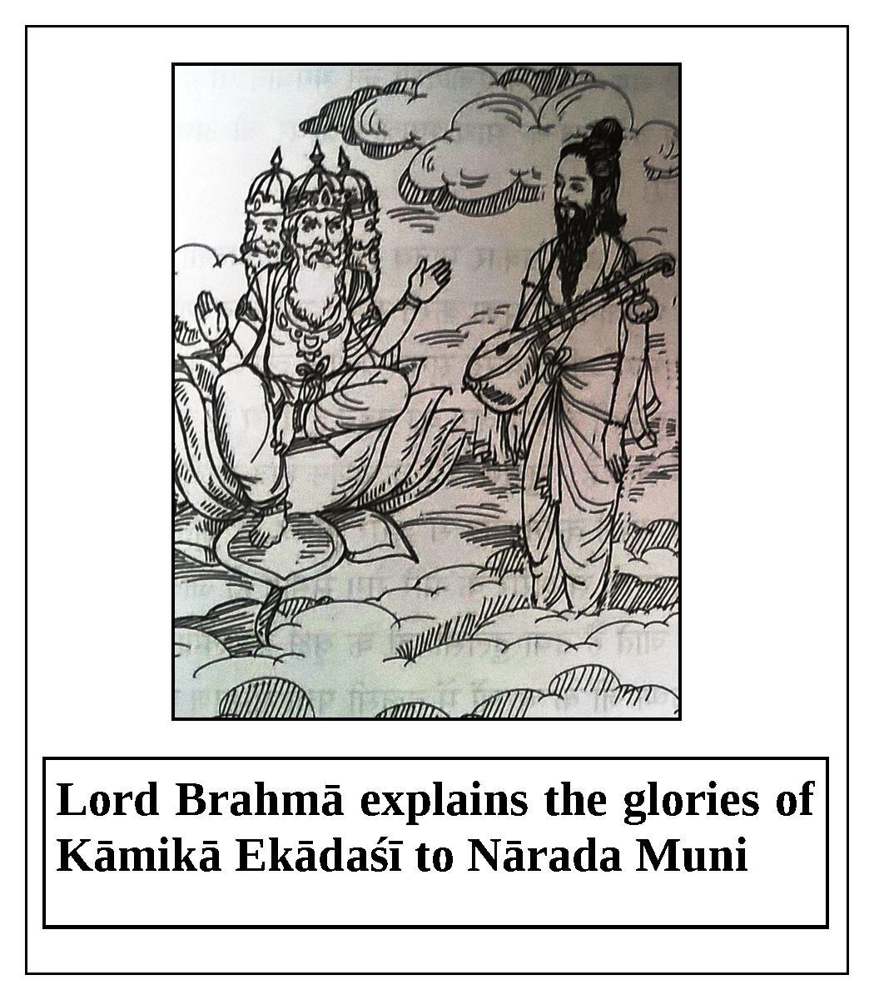
“Lord Brahmā, the spiritual master of the universe, said, ‘The ekādaśī which occurs during the waning moon in the period of July-August is called Kāmikā ekādaśī. By hearing the glories of this ekādaśī, one attains the result of performing a Vājapeya sacrifice. On this auspicious day, one should worship Lord Viṣṇu, who holds a conch, disc, club, and lotus. The results one obtains by residing and bathing in holy places like the Ganges, Kāśī, Naimiṣāraṇya, and Puṣkara are obtained simply by worshiping Lord Viṣṇu on this day. The result that cannot be obtained even by taking bath in Kedāranatha, Kurukṣetra, or during a solar eclipse is easily obtained by worshiping Lord Kṛṣṇa on this day. Therefore, it is everyone’s duty to strictly observe Kāmikā ekādaśī by worshiping Lord Viṣṇu.
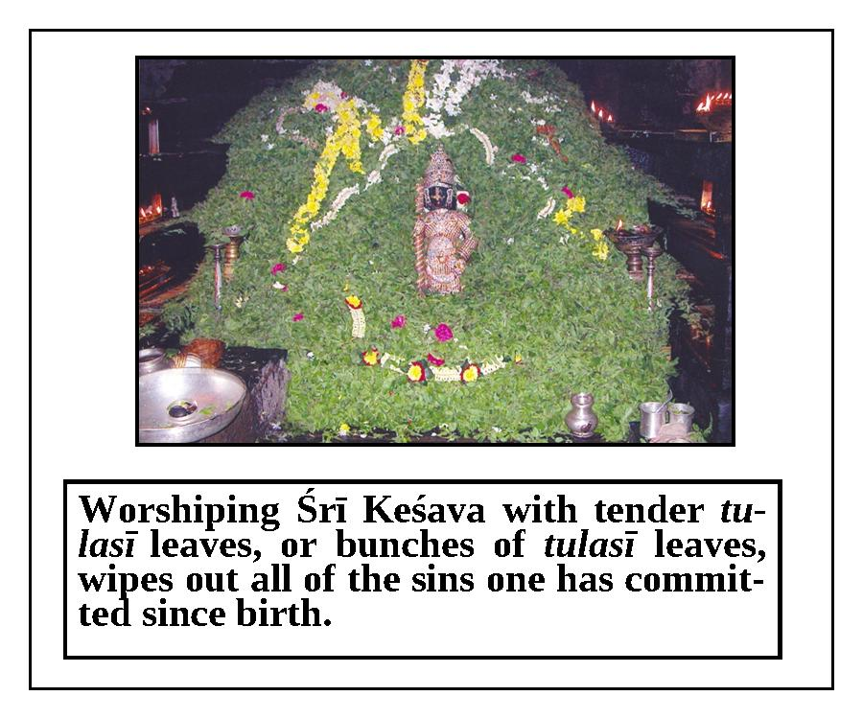

“Just as water cannot remain on a lotus leaf, reactions of sins cannot remain with a person by the influence of Kāmikā ekādaśī. Anyone who worships Lord Hari with tulasī leaves is freed from all sins. Simply by seeing tulasī, one’s sinful reactions are destroyed. By touching tulasī one’s body is purified; by offering prayers to tulasī one’s diseases are cured; by bathing tulasī one does not have to fear Yamarāja, the lord of death; by planting tulasī one becomes fortunate enough to reside with Lord Kṛṣṇa; and by offering tulasī leaves at the feet of the Deity of the Supreme Lord one attains pure devotional service. Even Citragupta is unable to estimate the piety of one who offers obeisances and ghee lamps to tulasī on ekādaśī. The sin of killing a brāhmaṇa or an embryo is nullified as a secondary effect of observing Kāmikā ekādaśī. One who hears or reads about the glories of this ekādaśī with faith certainly attains the abode of Viṣṇu.”
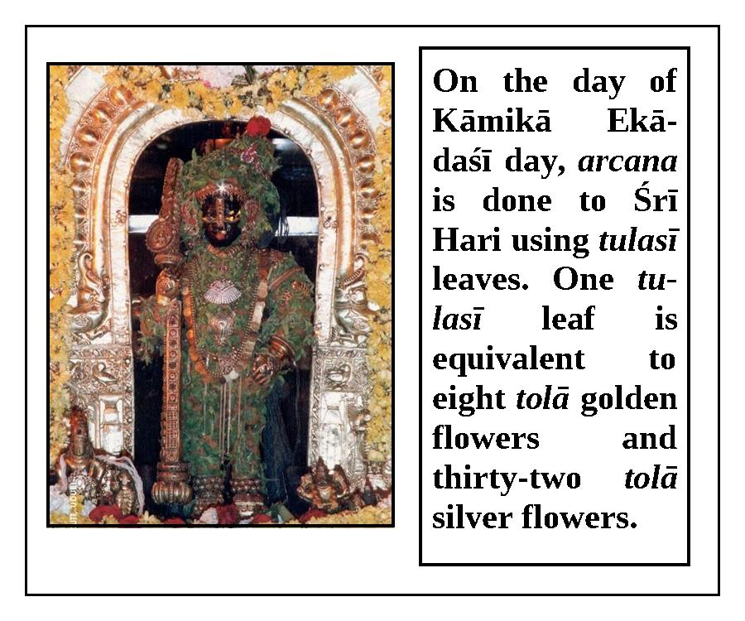

Pavitrā Ekādaśī
The glories of Pavitrā ekādaśī are described in Bhaviśyottara Purāṇa in a conversation between Lord Kṛṣṇa and Mahārāja Yudhiṣṭhira.
Once, Mahārāja Yudhiṣṭhira said to Kṛṣṇa, “O Madhusūdana, killer of the Madhu demon, what are the name and glories of the ekādaśī which occurs during the waxing moon in the period of July-August? Please explain these things to me in detail.”
Lord Kṛṣṇa replied, “O king, the name of this sacred ekādaśī is Pavitrā ekādaśī. Now, please hear attentively as I describe this ekādaśī, which destroys one’s sinful reactions. By hearing about its glories, one obtains the result of a Vājapeya sacrifice.
“In ancient times, at the beginning of Dvāpara-yuga, there was a king named Mahījita who ruled a kingdom called Māhiṣmatī- purī. The king was very unhappy because he had no sons. A married man who has no sons has no happiness either in this life or the next. The king tried for many years, but he was not fortunate enough to get a jewel-like son to bring joy to his life.“Considering his sad situation, one day the king summoned his subjects, whom he treated like his own children, to the royal assembly. He said, ‘O dear subjects, I have never committed any sinful activities in this life. None of the wealth in my treasury was obtained by unlawful means. I never stole valuables from the brāhmaṇas or demigods; I rule my kingdom by following the proper code of conduct. I have maintained all of you as if you were my very own children. I never hesitated to give due punishment to even my dear ones, like my brother or other relatives, according to their faults. I have shown due respect to even my enemies, treating them as though they were gentle and pious. O brāhmaṇas, why, in spite of my adopting a religious life like this, am I bereft of a son? Please consider this matter carefully and explain this to me.’“After hearing the king’s lamentation, his brāhmaṇa advisers discussed the subject. They decided that for the benefit of the king they would go to the forest and visit the āśramas of great sages who know past, present, and future. While wandering in the forest, they came across various āśramas, and finally met Lomaśa Muni, who was engaged in severe austerities. His body was spiritual and full of bliss. He strictly observed a vow of fasting, and he was fully self-controlled. He knew the science of eternal religious principles, and he was well-conversant with all of the scriptures. His lifespan was as long as that of Brahmā, and he was an effulgent saint. When a kalpaof Brahmā passes, one hair (loma) is lost from his body; that is why his name is Lomaśa. The sage Lomaśa knew past, present, and future.

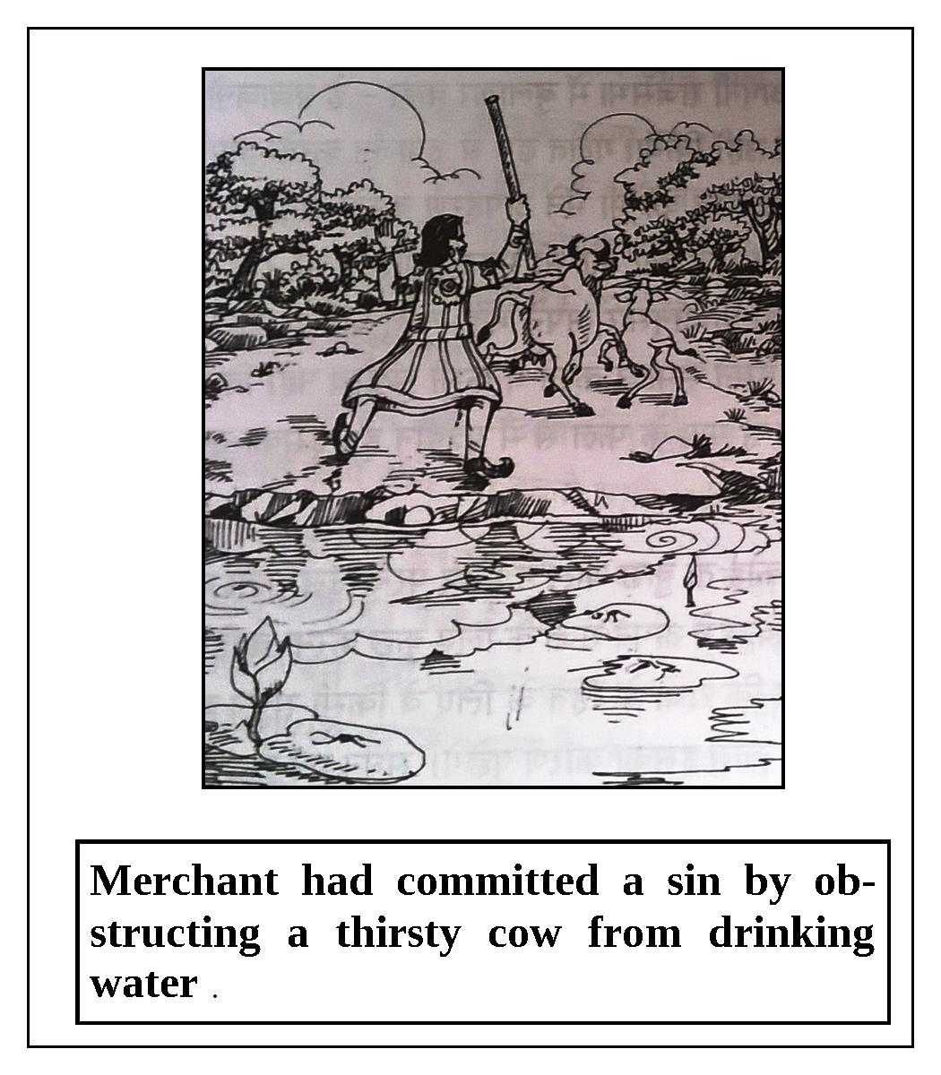
“The king’s advisers were enchanted by this great sage, and they offered their obeisances to him. They humbly said, ‘O great sage, it is our great fortune that we have met a great soul like you.’ The sage Lomaśa inquired, ‘Who are you, and why have you come here? Why are you praising me like this?’ The brāhmaṇas replied, ‘O great sage, we have come to you to remove some of our doubts. O lord, our king, Mahījita, does not have a son. We are his subjects and he treats us like his own children. It makes us sad to see the king’s distress. O best of brāhmaṇas, we want to undergo austerities here. It is the king’s good fortune that today we have met a great personality like you. A man certainly attains all perfection by having the darśana of a great personality. Please tell us of away that our king can have a son.’
“After hearing their sincere prayers, the sage Lomaśa entered into a deep meditation and immediately understood King Mahījita’s previous life. He said, ‘In his previous life, the king was a poor vaiśya (merchant) who committed a sinful act. Once, while traveling from village to village in the course of his business, he became overwhelmed with thirst. It was midday on dvādaśī in the month of July. Soon, he found a beautiful lake and decided to drink its water. At that time, a cow and its newly-born calf also went there to drink. As the cow began to drink water from the lake, the merchant drove it away so that he could drink. Thus, the merchant committed a sin by obstructing the thirsty cow from drinking and obtaining satisfaction. Due to the merchant’s pious activities he later took birth as King Mahījita, but as a result of that sinful act, the king does not have a son.’
“The king’s advisers said, ‘O great sage, the Purāṇas state that one’s piety counteracts all of one’s sinful reactions. Please tell us how the king’s sinful reactions can be nullified so that he can have a son.’
“The great sage Lomaśa replied, ‘The auspicious ekādaśī known as Pavitrā ekādaśī occurs during the waxing moon in the period of July-August. You and your king should properly observe this ekādaśī. Thereafter, you should donate the piety that you will earn by doing so. If you follow my instructions, the king will certainly be blessed with a son.’
“After hearing this, the king’s advisers became satisfied. They offered their obeisances to the sage and returned home. Then, they met with King Mahījita and explained to him in detail what they had heard from the great sage Lomaśa.
“In time, the king’s advisers remembered the sage’s advice, and they and the king properly observed the vow of Pavitrā ekādaśī. On the day of dvādaśī, all of the advisers donated their earned piety to the king, as instructed by the sage. Consequently, the queen became pregnant and in due course of time she gave birth to a beautiful son.
Lord Kṛṣṇa concluded, “O King Yudhiṣṭhira, anyone who observes this sacred ekādaśī is relieved from sinful reactions and is happy in both this life and the next. One who hears about the glories of this ekādaśī attains the happiness of having a son in this life, and goes back to Godhead in his next life.”

Annadā Ekādaśī
The glories of Annadā ekādaśī are described in the Brahma-vaivarta Purāṇa in a conversation between Lord Kṛṣṇa and Mahārāja Yudhiṣṭhira.
Mahārāja Yudhiṣṭhira asked, “O Kṛṣṇa, what is the name of the ekādaśī which occurs during the waning moon in the period of August-September? Please be kind and tell me about this.”
Lord Kṛṣṇa replied, “O king, please listen to Me with full attention. The name of that auspicious ekādaśī, which removes all of one’s sinful reactions, is Annadā ekādaśī. One who observes the vow of this ekādaśī and worships Lord Hṛṣīkeśa, the master of the senses, becomes freed from the reactions of his sinful activities.
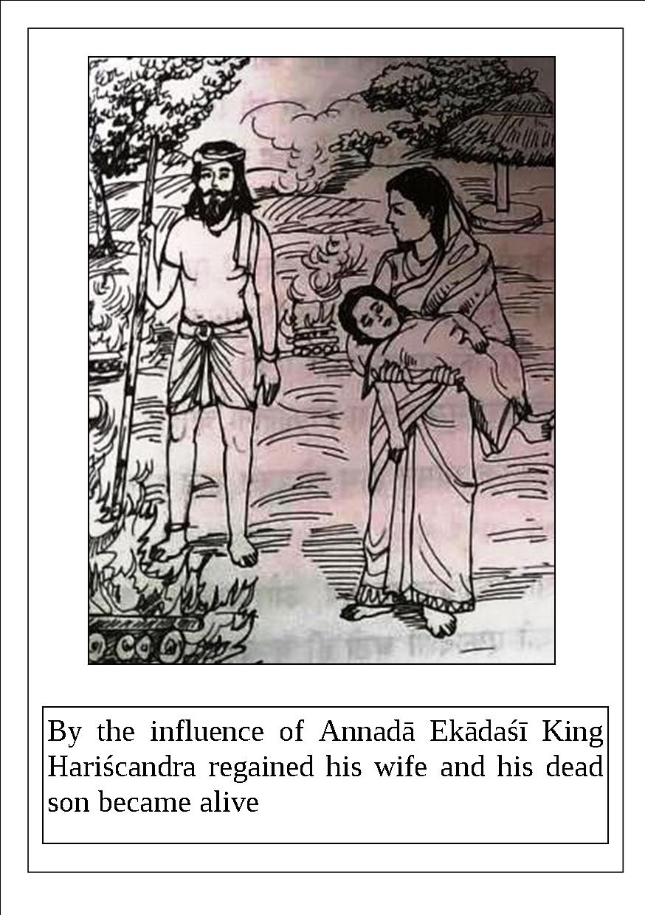
“In ancient times, there was a famous emperor named Hariścandra who was very honest. For unknown reasons and to keep a promise, he lost his great kingdom and even had to sell himself, his wife, and his son. O king, this pious former emperor became a menial servant of a dog-eater. Still, he maintained his firm faith and truthfulness. His master, the dog-eater, ordered him to accept as his salary the clothes from dead bodies at the crematorium. In spite of such low-class service, he did not lose his integrity or fall from his proper code of conduct. He passed many years in this way.
“One day, the miserable former king thought, ‘What can I do? Where can I go? How can I be delivered?' Knowing that Hariścandra was in great distress, the great sage Gautama went to him. Seeing the great sage, Hariścandra remembered that Lord Brahmā, the creator, created brāhmaṇas for the benefit of others. Hariścandra offered his respectful obeisances to that best of brāhmaṇas, and stood before him with folded hands. Thereafter, he told his entire pitiful story to sage Gautama.
“After hearing the pathetic story, Gautama was astonished and said, ‘O Hariścandra, Annadā ekādaśī, which occurs during the waning moon in the period of August-September, is extremely auspicious and removes all sinful reactions. It is your good fortune that this ekādaśī is coming soon. You should observe it by fasting and staying awake throughout the night. As a result, all of your sinful reactions will soon be eradicated. O best of kings, it is only by your piety that I have come here.’
“After instructing Hariścandra in this way, the great sage Gautama disappeared. In time, Hariścandra observed the vow of Annadā ekādaśī according to the instructions of the sage, and consequently he was liberated from all of his sinful reactions.
Lord Kṛṣṇa concluded, “O lion-like king, the wonderful effect of this ekādaśī is such that one immediately exhausts the potential suffering that he was destined to experience for many future years. By the potency of this ekādaśī, King Hariścandra was reunited with his wife and his dead son came back to life. The demigods played drums and showered flowers in the sky. By the influence of this ekādaśī, the king enjoyed his kingdom without any impediments. In the end, the king and his relatives, associates, and subjects went to the spiritual world. O king, anyone who observes this ekādaśī will be freed from all sinful reactions and will go to the spiritual world. By hearing or reading about the glories of this ekādaśī, one obtains the result of performing a horse sacrifice.”

Pārśva Ekādaśī
The glories of Pārśva ekādaśī, also known as Parivartini ekādaśī or Vāmana ekādaśī, are described in Brahma-vaivarta Purāṇa in a conversation between Lord Kṛṣṇa and Mahārāja Yudhiṣṭhira.
Once, Mahārāja Yudhiṣṭhira asked Lord Kṛṣṇa, “What is the name of the ekādaśī which occurs during the waxing moon in the period of August-September? How should one observe it, and what merit is obtained? Please explain all these things to me in detail.”

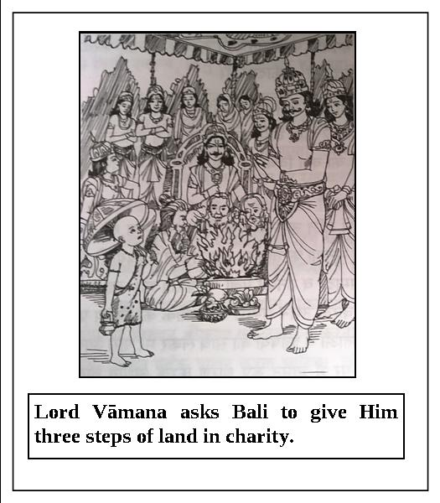
Lord Kṛṣṇa replied, “O king, the ekādaśī which occurs during the waxing moon in the period of August-September is called Pārśva ekādaśī. This auspicious ekādaśī awards one liberation and takes away all of one’s sinful reactions. Sinful reactions are vanquished just by one hearing about the glories of this ekādaśī. The piety obtained by observing this ekādaśī cannot be obtained even by performing a Vājapeya sacrifice. This ekādaśī is also known as Jayantī ekādaśī. One who worships Lord Vāmana-deva with devotion on this day is in turn worshiped by all of the inhabitants of the three worlds. A person who worships lotus-eyed Lord Viṣṇu with a lotus flower undoubtedly goes back to the abode of the Lord. On this ekādaśī, the sleeping Lord turns from His left side to His right side. That is why this ekādaśī is known as Pārśva Parivartinī (changing sides) ekādaśī.”
Mahārāja Yudhiṣṭhira said, “O Janārdana, after hearing Your narration I still have some doubts. O Lord of lords, how do You sleep, and how do You change sides? What are the procedures for observing the vow of Cāturmāsya? What should people do when You are sleeping? Why did You bind Bali Mahārāja with ropes? O my Lord, please tell me about these things in detail and remove my doubts.”
Lord Kṛṣṇa replied, “O lion-like king, in Tretā-yuga there was a great devotee of Mine named Bali. Although he was born in a demoniac family, he regularly worshiped Me and offered various prayers. He also worshiped the brāhmaṇas and performed sacrifices. Soon he became so prominent that he defeated Indra, the king of heaven, and conquered the heavenly planets. Then Indra, the other demigods, and the sages approached Me. To satisfy their prayers, I assumed the form of a dwarf (Vāmana) and went to the sacrificial arena of King Bali dressed as a brahmacārī.
“I asked Bali to give Me three steps of land in charity. When Bali requested that I reconsider and ask for something more significant, I told him that I would be satisfied with what I had asked for. Without further consideration, King Bali and his wife Vindhyāvalī gave Me three steps of land in charity. As Lord Vāmanadeva is the Supreme Personality of Godhead and non-different from Me, I expanded My transcendental body and covered the seven lower planetary systems with My first step. With My second step, I covered the rest of the planetary systems. I also expanded My body to cover the entire sky. When I as Vāmanadeva asked Bali where I should place My third step, with folded hands Bali offered his head. I as Lord Vāmanadeva placed My third and final step on the head of King Bali. I as Lord Vāmanadeva was fully satisfied by the king’s humility, so I blessed him and told him that I would always live near him.
“On Pārśva ekādaśī, a Deity form of Vāmanadeva was installed in the residence of King Bali. Another form of Mine was established in the bed of Ananta-śeṣa in the ocean of milk. There, the Supreme Lord sleeps for four months from Śayana ekādaśī to Utthāna ekādaśī. One should worship the Lord especially during these four months. One should properly observe each and every ekādaśī. By observing Pārśva ekādaśī, one obtains the result of performing one thousand horse sacrifices.”

Indirā Ekādaśī
The glories of Indirā ekādaśī are described in Brahma-vaivarta Purāṇa in a conversation between Lord Kṛṣṇa and Mahārāja Yudhiṣṭhira.
Once, Mahārāja Yudhiṣṭhira said, “O Kṛṣṇa, O Madhusūdana, O killer of the demon Madhu, what is the name of the ekādaśī which occurs during the waning moon in the period of September-October? What are the rules and regulations for observing it, and what merit is gained?”
Lord Kṛṣṇa replied, “The name of this sacred ekādaśī is Indirā ekādaśī. By observing it, one can deliver his degraded forefathers, and all of his sinful reactions are eradicated.
“O king, there was a king named Indrasena who lived in Satya-yuga. He was an expert in subduing his enemies. There was great prosperity in his kingdom, Māhiṣmatī-purī.
“He lived happily with his many children and grandchildren. He was very attached to performing devotional service to Lord Viṣṇu. As a devotee, the king was constantly absorbed in spiritual consciousness, and he spent his time chanting the holy names of Śrī Govinda, the bestower of liberation.
“One day when the king was happily sitting on his royal thrown, suddenly Śrī Nārada Muni appeared before him from the sky. Seeing the great sage Nārada, the king immediately stood up with folded hands, and then offered his respectful obeisances. Thereafter, the king duly worshiped the sage with sixteen ingredients. When the sage was happily seated, he asked Indrasena, ‘O great king, is everyone in your kingdom happy and prosperous? Is your mind fixed in religious principles? Are you engaged in devotional service to Viṣṇu?’
“The king replied, ‘O best of sages, by your mercy everything is well and auspicious. Today my life has become successful by having your darśana; now I have received the fruits of my sacrifices. O sage among the demigods, please tell me the purpose of your visit.’
“After hearing the humble words of the king, Nārada Muni replied, ‘O lion-like king, I want to tell you about a wonderful incident that happened to me. O best of kings, once I went from the abode of Lord Brahmā to the abode of Yamarāja. Yamarāja greeted me respectfully and worshiped me properly. After I was comfortably seated, I offered prayers to the pious, truthful Yamarāja. I saw your greatly pious father in the assembly of Yamarāja. Your father had to go there as a result of breaking a vow. O king, he requested that I convey a message to you. He said, “Indrasena, the king of Māhiṣmatī-purī, is my son. O lord, please tell him that due to some sinful activities I committed in my previous life, I am now living in the abode of Yamarāja. Therefore, he should observe the vow of Indirā ekādaśī and donate the resulting piety to me. Then I will be released from my present situation.” Nārada Muni continued, ‘O king, this is your father’s request to you. In order to deliver your father to the spiritual world, you should observe the vow of Indirā ekādaśī.’
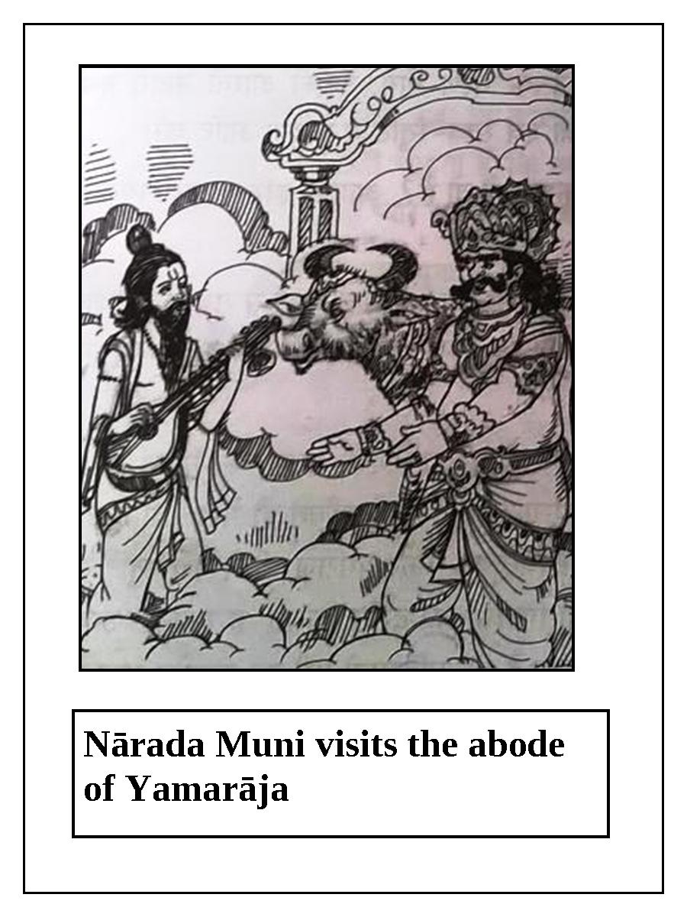
“King Indrasena said, ‘O sage among the demigods, now kindly explain to me the procedure for following Indirā ekādaśī.’
“Nārada-muni replied, ‘On the day before ekādaśī, one should take bath early in the morning and faithfully offer oblations to the forefathers for their satisfaction. On that day, one should eat only once and sleep on the floor at night. On ekādaśī, one should rise early in the morning, brush his teeth, wash his hands and mouth, and take bath. Thereafter, he should vow not to indulge in any kind of material enjoyment, and observe a total fast. He should pray to the Lord:“O lotus-eyed one, I take shelter of You.”
“‘At noon, he should offer oblations to his forefather in front of śālagrāma-śilā according to proper rules and regulation. Then he should worship the brāhmaṇas, and after feeding them sumptuously, he should give dakṣiṇā to them. Later, he should give the remnants of the oblations to cows. During the day, he should worship Lord Hṛṣīkeśa by offering Him sandalwood paste, flowers, incense, lamps, and foodstuffs with devotion. He should stay awake that night and chant, hear, and remember the names, forms, qualities, and pastimes of the Supreme Lord. On the day after ekādaśī, one should worship Lord Hari in the morning and feed the brāhmaṇas. Thereafter, one should break his fast by eating in silence with his brothers, children, grandchildren, and other relatives. O king, if you follow this ekādaśī as I have instructed, your father will certainly go to the abode of Viṣṇu.’ After speaking in this way, Nārada Muni disappeared.
Lord Kṛṣṇa concluded, “In time, King Indrasena, his children, his servants, and others strictly observed Indirā ekādaśī according to the instructions of Nārada Muni. As a result, flowers were showered in the sky. King Indrasena’s father was immediately taken on the back of Garuḍa to the abode of Lord Viṣṇu. Thereafter, saintly King Indrasena happily ruled his kingdom without any impediments. At the end of his life, the king entrusted his kingdom to his son and he returned to the spiritual world. Such are the glories of Indirā ekādaśī. Anyone who reads or hears about these glories is freed from all sinful reactions, and ultimately returns to the abode of Viṣṇu.”

Pāśāṅkuśā or Pāpāṅkuśā Ekādaśī

Significance
Śrī Kṛṣṇa said to Yudhiṣṭhira, “O king, please listen as I explain the glories of Pāpāṅkuśā ekādaśī, which nullifies all sins. On this day, one should worship the Deity of Padmanābha, the lotus-naveled Lord Viṣṇu, according to the rules and regulations of arcana-vidhi. If a Vaiṣṇava disrespects Śiva, or if a Śiva-bhakta disrespects Śrī Hari, that person will spend fourteen yugas in hell. However, even such a great sin as this is nullified when a person fasts on Pāpāṅkuśā ekādaśī. Thus, this ekādaśī should be observed by both Śiva-bhaktas and Hari-bhaktas. As a result of following this ekādaśī, people will be healthy, be wealthy, and have progeny. Moreover, the previous ten generations of both one’s mother and father will attain mokṣa.”

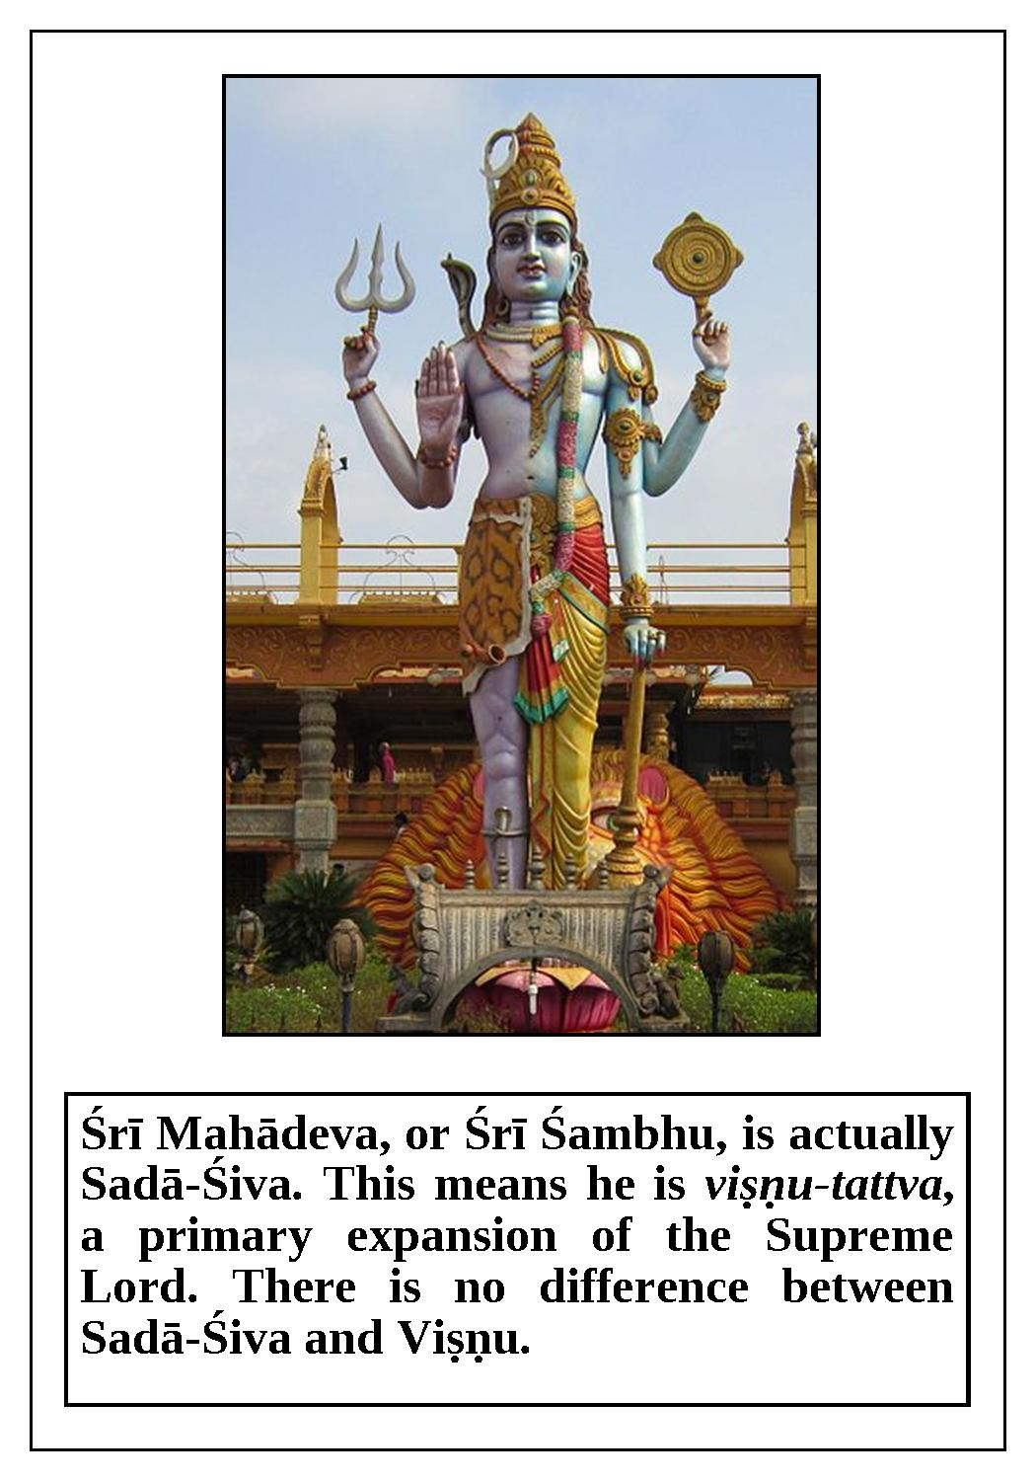

Quotes from Scriptures
Whether one is a child, a youth, or in old age, fasting on Pāpāṅkuśā ekādaśī frees him from all sins and makes him immune to suffering a hellish rebirth. Whoever observes a fast on Pāpāṅkuśā ekādaśī becomes free of all of his sins and returns to the spiritual abode of Lord Śrī Hari.

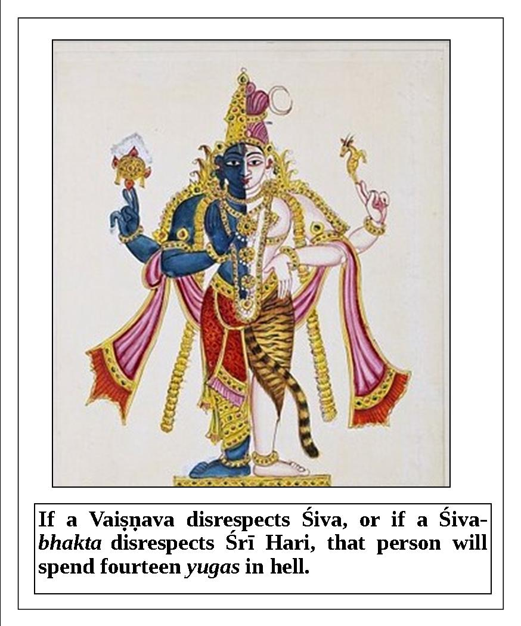
If a resident of Earth fails to perform spiritual deeds, especially the observance of a fast on days such as ekādaśī, his breathing is said to be no better than, or of as much use as, the movements of a blacksmith’s bellows. (Padma-purāṇa)

This daśāmī is also very special, with Vijayā daśāmī. It is a good day to start a new venture with a new saṅkalpa.
(Padma Purāṇa, Part-3, Uttara-khaṇḍa, 60th chapter)

The glories of Pāśāṅkuśā ekādaśī, which occurs during the waxing moon in the period of September-October, are described in Brahma-vaivarta Purāṇa in a conversation between Lord Kṛṣṇa and Mahārāja Yudhiṣṭhira.
Once, Mahārāja Yudhiṣṭhira said, “O Madhusūdana, what is the name of the ekādaśī that occurs during the waxing moon in the period of September-October? Please be kind and tell me.”
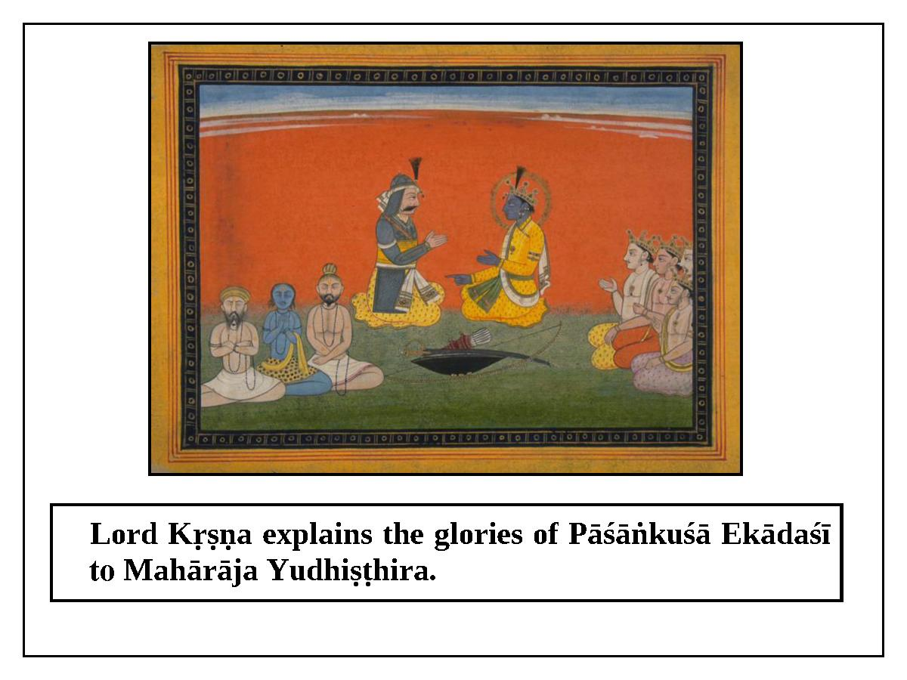

Lord Kṛṣṇa replied, “O best of kings, the name of this ekādaśī is Pāśāṅkuśā ekādaśī. Now, please hear from Me about the glories of this ekādaśī, which destroys all of one’s sinful reactions. This ekādaśī is also known as Pāpāṅkuśā ekādaśī. One should especially worship Lord Padmanābha on this ekādaśī. This ekādaśī awards a person heavenly pleasures, liberation, or other desired goals. Just by chanting the holy names of Lord Viṣṇu on this day, one attains all of the piety of visiting all of the holy places on Earth. Even if a conditioned soul indulges in various sinful activities due to illusion, he will not have to go to hell if he takes shelter of, and offers obeisances at the lotus feet of, Lord Hari, who is an expert in delivering the fallen souls.

“Both Vaiṣṇavas who criticize Lord Śiva, and Śaivites who criticize Lord Viṣṇu, undoubtedly go to hell. The result one obtains by performing one thousand horse sacrifices, or by performing one hundred Rājasūya sacrifices, is not even equal to one sixteenth of the piety that one obtains by following this ekādaśī. In fact, there is no piety in this world equal to the piety earned by observing Pāśāṅkuśā ekādaśī. Thus, there is no other day as sanctified as this ekādaśī, which is very dear to Lord Padmanābha.
“O king, when a person fails to observe ekādaśīs, sins take up residence in his body. This ekādaśī awards its follower heavenly pleasures, liberation, freedom from disease, a beautiful wife or husband, wealth, and food grains. O maintainer of Earth, if one observes this ekādaśī and stays awake that night, he easily goes to the abode of Lord Viṣṇu.

Lord Kṛṣṇa continued, “O best of kings, by observing this ekādaśī, one can deliver ten generations of his mother’s family, ten generations of his father’s family, and ten generations from his wife’s family. If a person observes this ekādaśī in childhood, youth, or old age, he does not suffer from the miseries of material existence. If one strictly observes Pāśāṅkuśā or Pāpāṅkuśā ekādaśī, all of his sinful reactions are eradicated, and at the end of his life he returns to the abode of Lord Viṣṇu. If a person gives charity in the form of gold, sesame seeds, land, cows, food grains, water, umbrellas, or shoes, he does not have to go to the abode of Yamarāja. Anyone who spends his days without engaging in pious activities is like a dead body, although breathing. His breathing is compared to the movements of a blacksmith’s bellows.
Lord Kṛṣṇa concluded, “O best of kings, a person who digs wells and lakes for the benefit of others, who donates land and houses, or who performs other pious activities such as sacrifices is not subjected to the punishment of Yamarāja. Only due to accrued piety, people live long lives, become rich, take birth in high-class families, and have good health. One should understand that the primary result of observing ekādaśī is attaining devotional service to Kṛṣṇa, while the secondary result is attaining temporary material benefits.”

Ramā Ekādaśī
The glories of Ramā ekādaśī are described in Brahma-vaivarta Purāṇa in a conversation between Lord Kṛṣṇa and Mahārāja Yudhiṣṭhira.
Once, Mahārāja Yudhiṣṭhira said, “O Janārdana, what is the name of the ekādaśī that occurs during the waning moon in the period of October-November? Please tell me.”
Lord Kṛṣṇa replied, “O lion among kings, the name of that ekādaśī is Ramā ekādaśī, and it vanquishes all of one’s sinful reactions. Now, please hear about the glories of this sacred ekādaśī.
“Long ago, there was a famous king named Mucukunda. He was a good friend of Indra, the king of heaven. He was also friends with others like Yamarāja, Varuṇa, Kubera, and Vibhīṣaṇa. This king was very truthful and always engaged in devotional service to Lord Viṣṇu. He ruled his kingdom with a proper code of conduct.
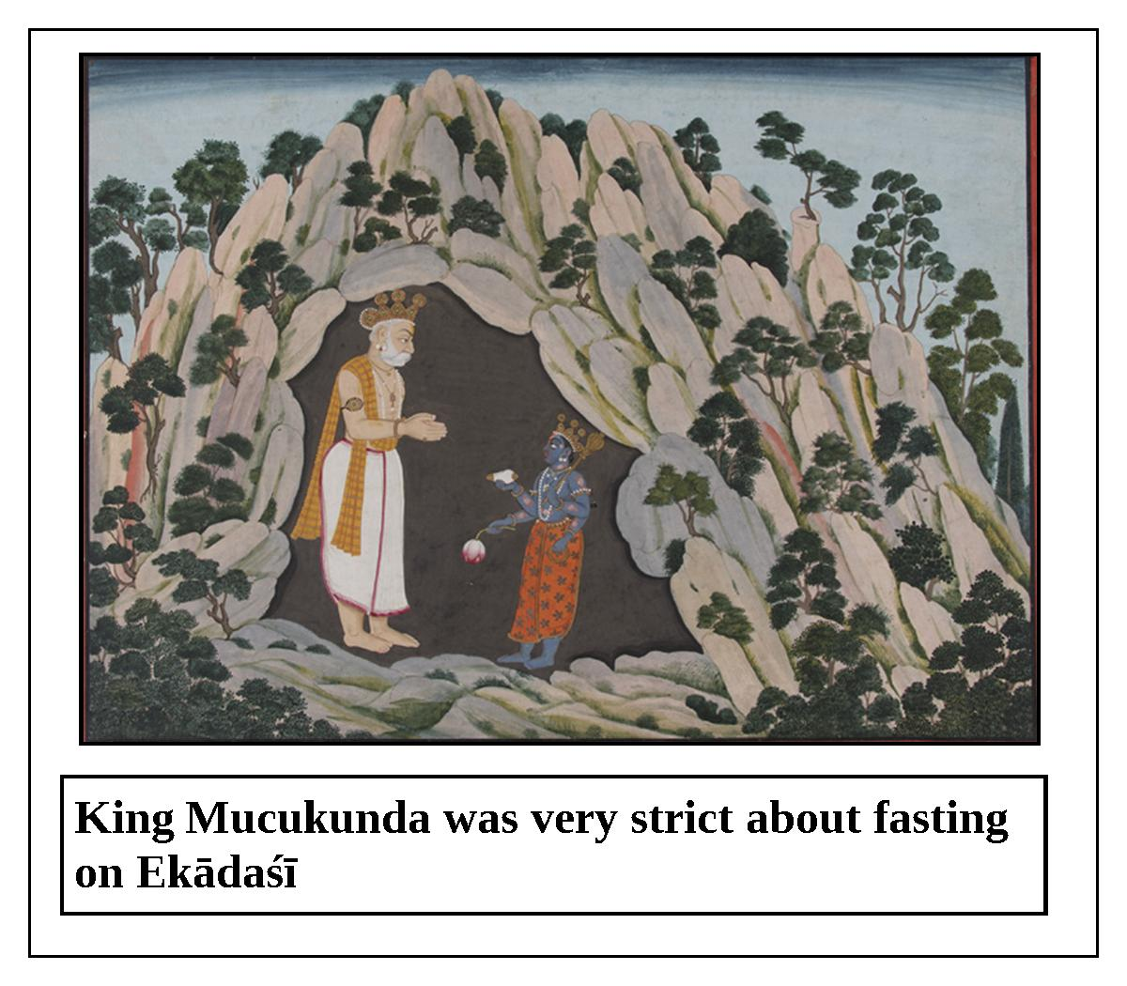

“In due course of time, King Mucukunda begot a daughter. She was given the name Candrabhāgā, after an auspicious river. She married a handsome man named Śobhana, who was the son of Candrasena. Once, Śobhana went to the house of his father-in-law, the king, on ekādaśī. Candrabhāgā became greatly worried, thinking, ‘What will happen now? My husband is not self-controlled and he cannot tolerate hunger. My father is very strict about fasting on ekādaśī. The day before ekādaśī, my father usually sends his servants to announce that no one can eat on ekādaśī.’
“When Śobhana was informed about this custom, he said to his dear wife, ‘O dear one, what should I do? How can I protect my life and not transgress the king’s order?’ Candrabhāgā replied, ‘O my lord, what to speak of the people, even the elephants, horses, and other animals in my father’s kingdom are not allowed to eat anything today. O respected husband, if you must eat today, you will have to go back to your house to do so. Please consider this carefully and make your decision.’
“Śobhana said, ‘What you have said is indeed true. I wish to observe this ekādaśī. Whatever is destined for me will certainly happen.’ Thus, Śobhana decided to observe that sacred ekādaśī. However, he soon became overwhelmed with hunger and thirst. When the sun had set, all of the Vaiṣṇavas and other pious people became very happy. O lion among kings, they happily spent the entire night chanting and worshiping the Supreme Lord. However, Śobhana was unable to bear his hunger and thirst, and he died just before the sunrise. King Mucukunda arranged for Śobhana’s funeral rites with royal honor by burning his body along with fragrant sandalwood. According to her father’s order, Candrabhāgā did not put herself in her husband’s funeral fire. After completing her husband’s śraddhā ceremony, Candrabhāgā stayed at her father’s house.
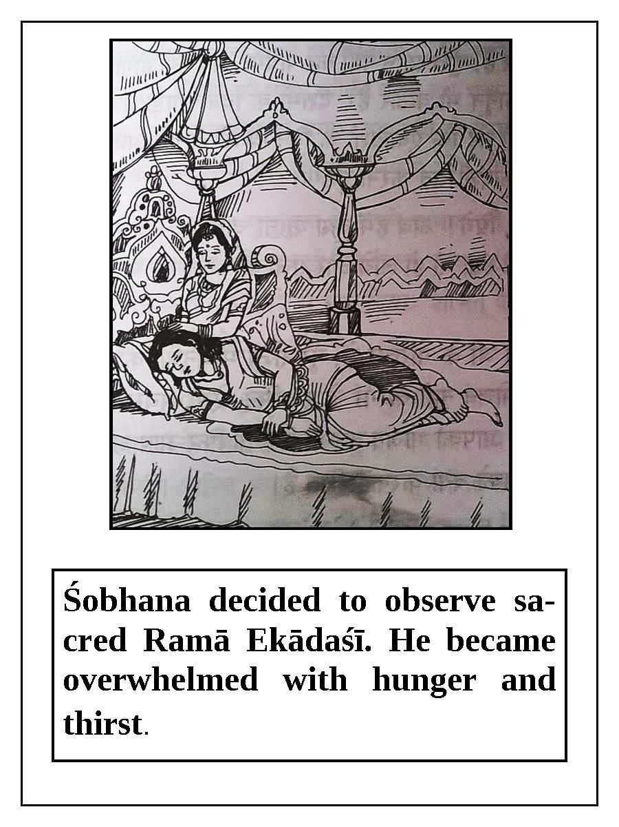

“O king, meanwhile, due to having observed Ramā ekādaśī, Śobhana went to the heavenly planets and became the king of the beautiful city of Devapura, situated at the peak of Mandara Mountain. He lived in an opulent residence in which the gold pillars were bedecked with jewels and the walls were decorated with gems and crystals. A golden crown with many jewels was on his head, and a beautiful white umbrella was held over him. He wore earrings, a necklace, and golden armlets. Śobhana sat on the royal throne dressed in this way. The Gandharvas and Apsarās always served him, and his appearance was just like that of Indra, the king of heaven.
“A brāhmaṇa named Somaśarmā was a resident of Mucukunda’s kingdom. In the course of traveling to many holy places, he went to the kingdom of Śobhana. Somaśarmā, understanding that in his previous position Śobhana was the son-in-law of King Mucukunda, approached Śobhana. As soon as the king saw him, he stood up with folded hands and then offered his respectful obeisances to the brāhmaṇa. Thereafter, Śobhana inquired about the brāhmaṇa’s well-being and that of his father-in-law Mucukunda, his wife Candrabhāgā, and all of the other residents of Mucukunda’s kingdom. Somaśarmā informed the king that everyone was living in peace and harmony. With great amazement, the brāhmaṇa said, ‘O king, I have never before seen a city as beautiful as yours! Please tell me how you obtained such a kingdom.’
“The king replied, ‘I received this temporary kingdom due to observing Ramā ekādaśī, which occurs during the waning moon in the period of October-November. O best of brāhmaṇas, please tell me how I can make my kingdom last until the end of this material universe. I think that I obtained this more temporary kingdom because I observed ekādaśī without faith. Please explain my situation to Candrabhāgā, the beautiful daughter of King Mucukunda. I think that she will know how I may extend the time that my kingdom will exist.’
“Then the brāhmaṇa returned to Mucukunda’s kingdom and told everything to Candrabhāgā. Candrabhāgā, filled with joy, said, ‘O great brāhmaṇa, it is hard for me to believe your story, which seems to me like a dream.’ The brāhmaṇa Somaśarmā reassured, ‘O daughter, I personally saw your husband at Devapurī, and I also saw his entire kingdom, which is as bright as the sun. He told me that his kingdom will not last, and that therefore, by any means, you should try to make his kingdom last longer.’ Candrabhāgā replied, ‘O respected brāhmaṇa, please take me there because I intensely desire to see my husband. I will increase the time of his kingdom on the strength of my piety. O twice-born one, please arrange for me to meet him. One gains piety by helping those who are separated to meet.’
“Somaśarmā took Candrabhāgā to the āśrama of Vāmadeva, situated near Mandara Mountain. After hearing the whole story from bright-faced Candrabhāgā, Vāmadeva initiated her with Vedic mantras. Candrabhāgā obtained a heavenly body by the power of the mantras received from sage Vāmadeva, and by the piety earned by observing ekādaśī. Subsequently, she happily went to see her husband.
“Śobhana was extremely pleased and satisfied to see his wife. Candrabhāgā said, ‘O my respected husband, please hear my beneficial words. I have been strictly observing ekādaśī from the age of eight at my father’s house. May that accumulated piety make your kingdom prosper and last until the time of annihilation of the universe.’
“Thereafter, Candrabhāgā, with her heavenly body decorated with opulent ornaments, enjoyed the association of her husband. Previously, Śobhana had received a heavenly body by the potency of Ramā ekādaśī. Therefore, O king, Ramā ekādaśī is just like a wish-fulfilling cow or touchstone.
Lord Kṛṣṇa concluded, “O king, I have thus explained to you the glories and auspiciousness of Ramā ekādaśī. A person who strictly observes this ekādaśī is undoubtedly freed from even the sinful reaction of killing a brāhmaṇa. Just as both black and white cows give white milk, both the ekādaśīs of the waning and waxing moon award liberation to those who follow them. Anyone who hears about the glories of this ekādaśī becomes liberated from all sinful reactions and happily resides in the abode of Lord Viṣṇu.”

Utthāna Ekādaśī
The glories of Utthāna ekādaśī are described in Skanda Purāṇa in a conversation between Lord Brahmā and Nārada Muni. Once, Lord Brahmā said to Nārada Muni, “O best of sages, please hear from me about the glories of Utthāna ekādaśī, which destroys all of one’s sinful reactions, increases one’s piety, and awards one liberation. O best among brāhmaṇas, the supremacy of the Ganges, and the topmost piety associated with oceans and lakes, were overshadowed by the manifestation in this world of Utthāna ekādaśī, which occurs during the waxing moon in the period of October-November, and which burns all of one’s sins to ashes. The result that one obtains by performing one thousand horse sacrifices and one hundred Rājasūya sacrifices is easily obtained by observing this ekādaśī.”
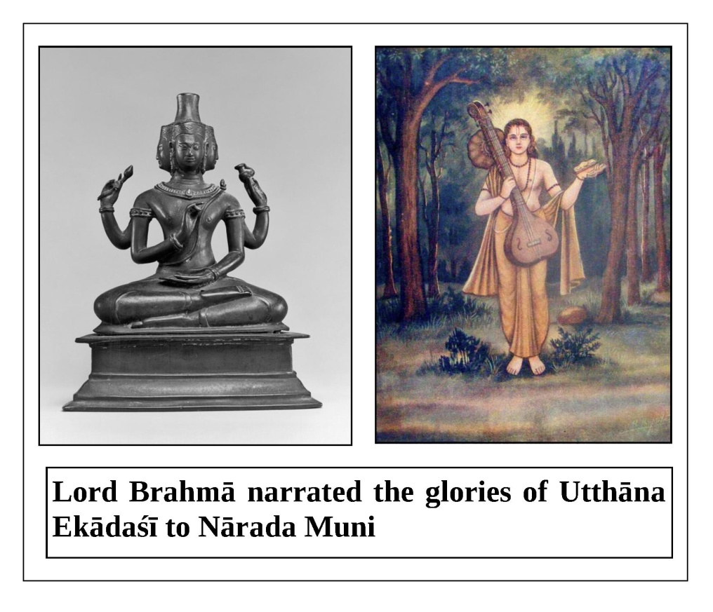
Nārada Muni said, “O dear father, please tell me about the merit one attains by eating only once in a day, by only taking supper in the evening, or by fasting completely.”
Lord Brahmā replied, “If one eats only once in a day, all of the sinful reactions from that lifetime are destroyed. If one eats only supper, the sinful reactions from two lifetimes are destroyed. By fasting completely, one destroys the sinful reactions from seven lifetimes.
“O dear son, Utthāna ekādaśī awards the rarest and most desirable things in the three worlds. This ekādaśī burns even grave sins as big as Mandara Mountain to ashes. O lion among sages, the amount of piety one achieves by observing this day is equal to Sumeru Hill. Those who do not offer prayers to the Lord, who fall from their vows, who are atheistic, who blaspheme the Vedas, who deviate from the religious scriptures, who enjoy others’ wives, and who are ignorant of religious principles will have a short lifespan. One should not indulge in sinful activities; rather, he should engage in pious activities. If one is inclined towards pious activities, his religious principles will be maintained. If one confidently follows Utthāna ekādaśī, the sinful reactions from one hundred lifetimes are vanquished. If one stays awake on the night of Utthāna ekādaśī, his past, present, and future generations will return to the abode of Viṣṇu.
“O Nārada, if a person does not observe the vow of ekādaśī in the month of Kārtika, and does not worship Lord Viṣṇu, all of his accumulated piety is ruined. O best of brāhmaṇas, one should certainly worship Lord Viṣṇu during Kārtika. In the month of Kārtika, if one cooks foodstuffs himself and eats them, he obtains the result of Cāndrāyaṇa-vrata. One who hears and chants about topics of Lord Viṣṇu during Kārtika attains the result of donating one hundred cows. By regularly studying the scriptures, one achieves the result of performing one thousand sacrifices. A person who hears about topics of the Lord and then gives dakṣiṇā to the speaker according to his ability goes to the eternal abode of the Lord.”
Nārada Muni requested, “O lord, kindly explain to me the procedure for observing ekādaśī.” Brahmā replied, “O best of the twice-born, one should rise early in the morning during brāhma-muhūrta, and after washing his mouth and taking bath, he should worship Lord Keśava. Then, while chanting a mantra he should make the following vow: ‘I will fast on ekādaśī, and not eat until dvādaśī. O Puṇḍarīkākṣa, O Acyuta, I surrender to You. Please protect me.’ One should gladly observe ekādaśī with devotion and stay awake that night hearing and chanting about the transcendental qualities of the Lord. Any pious person who follows these instructions attains the supreme destination. One should avoid all kinds of greediness on ekādaśī.”
Lord Brahmā continued, “One who worships Lord Janārdana with kadamba flowers does not go to the abode of Yamarāja. If one worships Lord Garuḍa-dhvaja or Lord Viṣṇu with roses during Kārtika, he certainly gets liberation. If one worships the Lord with bakula or aśoka flowers, he is freed from lamentation for as long as the sun and moon rise in the sky. One who worships the Lord with śamī leaves escapes the punishment of Yamarāja. If one worships Lord Viṣṇu, the controller of the demigods, with campaka flowers during the rainy season, he will not have to take birth again in the material world. If one offers yellow ketakī flowers to Lord Viṣṇu, all of his sinful reactions from millions of lifetime are destroyed. If one offers fragrant, red hundred-petaled lotus flowers to Lord Jagannātha, he returns to the abode of the Lord known as Śvetadvīpa.”
Lord Brahmā concluded, “O best of brāhmaṇas, one should stay awake on the night of ekādaśī. On the day of dvādaśī, one should worship Lord Viṣṇu and complete his vow by feeding the brāhmaṇas. If one worships his spiritual master and gives him charity according to his ability, the Supreme Lord is pleased with him.”

Padminī Ekādaśī
Mahārāja Yudhiṣṭhira said, “O Kṛṣṇa, O Janārdana, what is the name of the ekādaśī which occurs during the waning moon of the extra leap year month? What is the procedure for observing it and what merit is gained? Please explain these things to me.”
Lord Kṛṣṇa replied, “O king, the name of this sacred ekādaśī is Padminī ekādaśī. If one strictly observes this ekādaśī, he returns to the abode of Lord Padmanābha. This ekādaśī counteracts all of one’s sinful reactions. Even Lord Brahmā is unable to fully describe the results of this ekādaśī.
“Long, long ago, Lord Brahmā described the glories of Padminī ekādaśī, which awards its followers opulence and liberation, to the great sage Nārada.”
Lord Kṛṣṇa continued, “One should begin to observe the vow on the day of daśamī, the day before ekādaśī. On that day, one should not eat foodstuffs cooked by others; should not eat on a plate made of bell-metal; and should not eat Urad dāla, chickpea, spinach, or honey. One should eat boiled, sunned rice with ghee and rock salt. One should sleep on the floor and strictly observe celibacy on ekādaśī.
“On ekādaśī, one should rise early in the morning, brush his teeth, and take bath. Thereafter, he should worship the Supreme Lord with sandalwood paste, incense, lamps, aguru, camphor, and water. One should chant the holy names and glories of the Lord. One should not indulge in useless tasks. If one drinks water or milk on the ekādaśī which occurs during the extra leap year month, his vow is spoiled. One should stay awake at night on ekādaśī and glorify the holy names and qualities of the Supreme Lord. By staying awake for the first three hours of the night, one obtains the result of performing an agniṣṭoma sacrifice. By staying awake for the first six hours of the night, one obtains the result of performing a Vājapeya sacrifice. By staying awake for the first nine hours of the night, one obtains the result of performing an Aśvamedha sacrifice. By staying awake for the entire night, one obtains the result of a Rājasūya sacrifice. On dvādaśī, the day after ekādaśī, one should complete his vow by feeding the Vaiṣṇavas and brāhmaṇas. A person who observes this ekādaśī in this way certainly attains liberation.”
Lord Kṛṣṇa continued, “O sinless one, according to your inquiry I have explained the procedure for observing Padminī ekādaśī. Now, please listen to an enchanting story that Pulastya Muni once narrated to Nārada Muni.
“Once, Kārtavīryārjuna defeated Rāvaṇa and put him in prison. When Pulastya Muni saw Rāvaṇa in prison, he went to Kārtavīryārjuna and requested him to release Rāvaṇa. The king granted his request and released Rāvaṇa. Upon hearing of this amazing event, Nārada Muni humbly asked Pulastya Muni, ‘O best of sages, since Rāvaṇa defeated all of the demigods including Indra, how was Kārtavīryārjuna able to defeat Rāvaṇa? Please explain this to me.’
“Pulastya Muni replied, ‘O Nārada, in Tretā-yuga there was a king named Kārtavīrya who took birth in the dynasty of Haihaya. His capital was Māhiṣmatī-purī. King Kārtavīrya had one thousand wives, but he had no son to inherit the throne. Although the king worshiped his forefathers and saintly persons, and observed various vows under proper guidance, he was not blessed with a son. Then, the king decided to undergo austerities. He entrusted his responsibilities to his prime minister and set out to perform austerities wearing clothes made of bark. When he was about to leave his palace, his wife Padminī, the daughter of King Hariścandra, who appeared in the royal family of King Ikṣvāku, saw him. This chaste wife immediately removed all of her royal ornaments and left with her husband to perform austerities in the forest of Mandara Mountain.
“King Kārtavīrya and his wife Padminī performed severe austerities at the summit of Mandara Mountain for ten thousand years. Seeing her husband’s body gradually withering away, the chaste wife decided to seek help. Padminī went to the chaste Anusūyā, wife of sage Atri, and humbly said, ‘O chaste lady, my husband has spent ten thousand years performing austerities, yet he could not please Lord Keśava, who destroys one’s miseries. O fortunate one, please tell me about a vow by which the Supreme Lord will be pleased, and by which I will be blessed with a son who will become a powerful king. ’Pleased by the humble words of chaste Queen Padminī, Anusūyā said, ‘After every thirty-two months, an extra leap year month comes. The two ekādaśīs of this month are known as Padminī and Parama. If you observe this ekādaśī, the Supreme Lord will soon be pleased and fulfill your desire.’
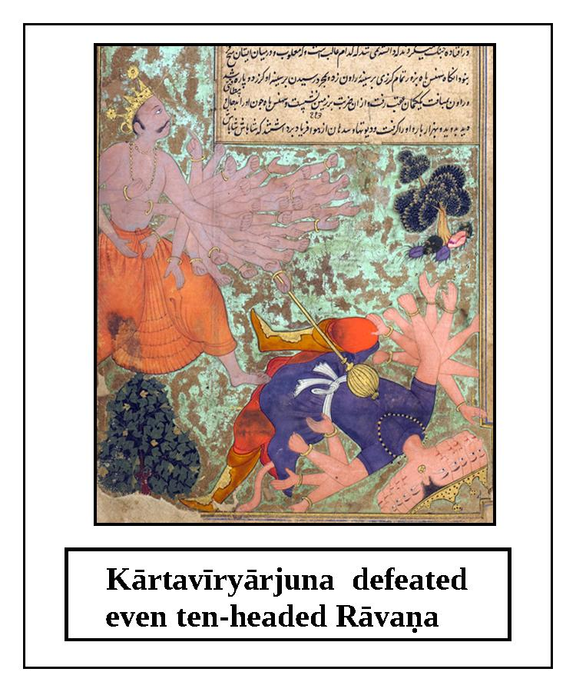
Lord Kṛṣṇa continued, “According to the instructions of Anusūyā, Queen Padminī duly observed that ekādaśī. Then Lord Keśava, riding on the back of Garuḍa, approached Padminī and ordered her to ask for a benediction. First, the queen offered her obeisances to the Lord and then offered prayers. Then, she requested the Lord to bless them with a son. The Lord said, ‘O gentle lady, I am very pleased with you. There is no month as dear to Me as Adhika-māsa, or leap year month. The ekādaśīs of this month are even dearer to Me. You have properly observed this ekādaśī; therefore, I will certainly fulfill your husband’s desire.'
“After speaking in this way to Padminī, the Lord approached the king and said, ‘O great king, please ask for a benediction. I am pleased that your wife observed the sacred vow of ekādaśī. ’Hearing this, the king became jubilant and begged the Lord to give him a son who would be very powerful and always victorious. He said, ‘O Madhusūdana, may the Lord of the universe grant me a son who will never be defeated by the demigods, humans, serpents, or demons.’ The Lord granted the king’s wish and disappeared.
“Being fully satisfied, the king and his wife regained their health and returned to their opulent kingdom. In due course of time, Queen Padminī gave birth to a powerful son who became famous as Kārtavīryārjuna. No other warrior in the three worlds was as great as him. He defeated even ten-headed Rāvaṇa. After narrating this wonderful story, the great sage Pulatsya left.”
Lord Kṛṣṇa concluded, “O sinless king, I have thus described to you the glories of the ekādaśī which occurs during the waxing moon of the extra leap year month. O best of kings, anyone who observes this ekādaśī will certainly go to the abode of Lord Hari.”
Based on these words of Śrī Kṛṣṇa, Mahārāja Yudhiṣṭhira and his entire family observed this ekādaśī. If a person faithfully follows Padminī ekādaśī, his life becomes glorious. One who hears or reads about the glories of this ekādaśī obtains a great amount of piety.

Parama Ekādaśī
The glories of Parama ekādaśī, which occurs during the waning moon in the extra leap year month, are described by Lord Kṛṣṇa to Mahārāja Yudhiṣṭhira.
Once, Mahārāja Yudhiṣṭhira said, “O my Lord, what is the name of the ekādaśī which occurs during the waning moon in the extra leap year month, and what is the procedure for observing it?”
Lord Kṛṣṇa replied, “O king, the name of that ekādaśī is Parama ekādaśī. This auspicious ekādaśī destroys all of one’s sinful reactions, and awards one material enjoyment and liberation. The procedure for observing it is the same as I have already told you. One should worship the Supreme Lord, the master of all beings, on this ekādaśī. Now, please hear an enchanting story I have heard from the sages in the city of Kāmpilya.
“A pious brāhmaṇa named Sumedhā lived in Kāmpilya, and he had a chaste wife named Pavitrā. This brāhmaṇa became poor due to some sinful activities. He barely supported himself and his wife by begging. He had hardly any food to eat or clothes to wear, and had no fixed place to sleep. Nevertheless, his young, beautiful wife faithfully served him. She often had to stay hungry for the sake of serving a guest. In spite of this hunger, her face did not become pale, but she never mentioned this to her husband.
“Seeing that his wife was becoming weaker by the day, the brāhmaṇa condemned himself and said, ‘O dear one, although I have tried to beg from the most influential people, I still did not get anything. What should I do? Should I leave and go to a foreign country to make money? If I am fortunate, I might get something by doing so. No work is successful without enthusiasm; that is why intelligent persons always praise the enthusiasm of others.’
“With folded hands and tears in her eyes, beautiful-eyed Pavitrā said, ‘No one is more intelligent than you. Whatever we do or achieve in this world is due to our previous deeds. If one has no piety from his previous life, no matter how much he tries he cannot attain happiness. If a person distributed knowledge or wealth in his previous life, he will attain them in his current life. O best of brāhmaṇas, it must be that neither you nor I gave charity in our previous lives. That is why we are in this situation. O lord, I cannot be without you for even a moment. If you leave, people will call me unfortunate and condemn me. Therefore, please be satisfied with whatever you can collect here. You will achieve happiness only if you stay here.’
“Hearing this, the brāhmaṇa gave up his plan to go to a foreign country. One day, by Providence the great sage Kauṇḍiṇya Muni arrived there. As soon as Sumedhā saw him, he and his wife became joyful, and they offered their obeisances to him. Sumedhā offered an āsana to the sage and worshiped him properly. He said, ‘O great sage, today our lives have become successful, for we have received your darśana.’ The couple fed the sage according to their ability. Then, Pavitrā asked, ‘O learned sage, what is the way to escape poverty? How can one get wealth, education, and so on without giving charity? My husband thought about going to a foreign country to make money, but I stopped him. It is our good fortune that you have come here. By your mercy, our poverty will certainly be eliminated. Now, please tell us how to improve our situation.’
“The great sage Kauṇḍiṇya replied, ‘There is an auspicious ekādaśī which occurs during the waning moon in the extra leap year month. This ekādaśī is known as Parama ekādaśī, and it is very dear to the Lord. It vanquishes one’s sinful reactions, material miseries, and poverty. By observing this ekādaśī, a person certainly becomes prosperous. This sacred ekādaśī was first observed by Kubera, and as a result Lord Śiva was pleased and awarded him the benediction of being very rich. By observing this ekādaśī, King Hariścandra regained his kingdom and the wife he previously had to sell. O beautiful-eyed one, you should observe this ekādaśī.’”
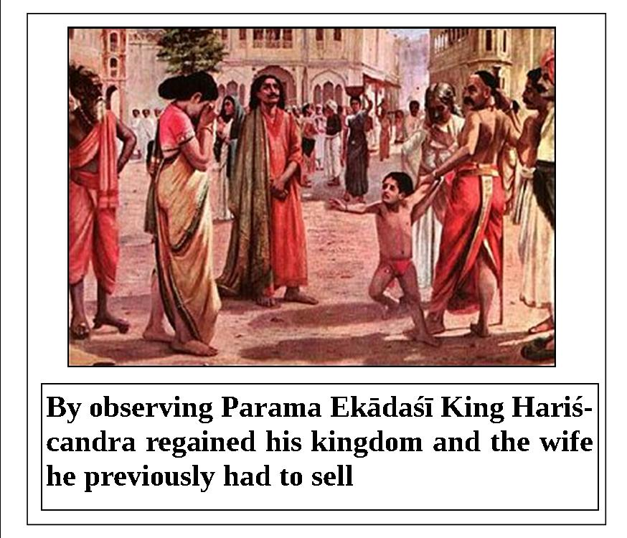
Lord Kṛṣṇa continued, “O Pāṇḍava, after happily and affectionately describing topics regarding Parama ekādaśī, Kauṇḍiṇya Muni described the auspicious vow known as Pāñcarātrika. By observing this vow, one attains liberation. One should begin the vow on the day of Parama ekādaśī, following proper rules and regulations. Anyone who, according to his ability, fasts for five days beginning from Parama ekādaśī goes back to the abode of Lord Viṣṇu along with his father, mother, and wife. One who eats only once a day during those five days is freed from all sinful reactions and goes to the spiritual world.
“Sumedhā and Pavitrā duly observed Parama ekādaśī according to the instructions of Kauṇḍiṇya Muni. When they completed the ekādaśī and Pāñcarātrika vows, a prince inspired by Lord Brahmā came from the royal palace and offered them a new house decorated with beautiful furniture. He also gave them a cow for their maintenance. After praising the brāhmaṇa couple, the prince left, and as a result of this service that prince returned to the abode of Viṣṇu at the end of his life.”
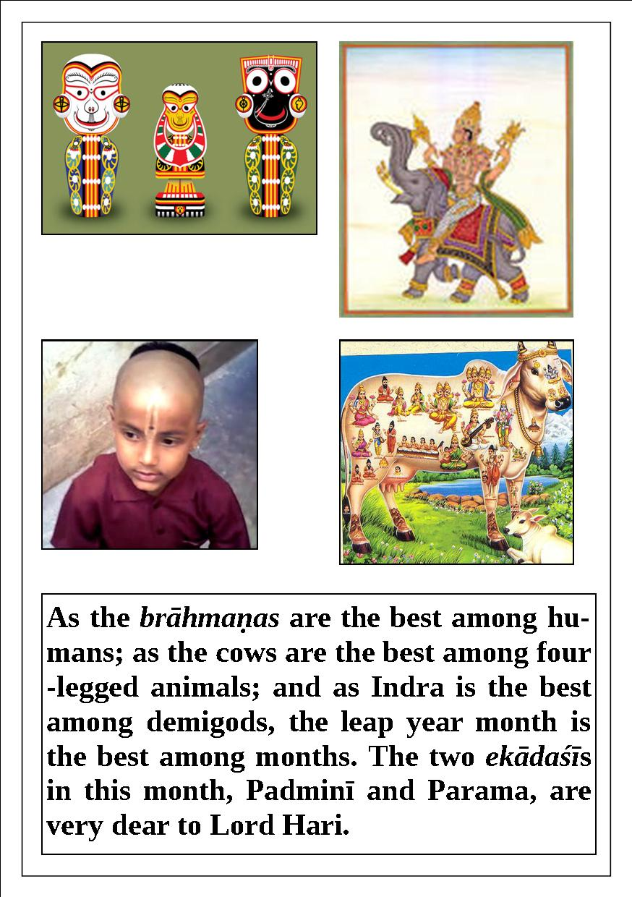

Lord Kṛṣṇa concluded, “As the brāhmaṇas are the best among humans; as the cows are the best among four-legged animals; and as Indra is the best among demigods, the leap year month is the best among months. The two ekādaśīs in this month, Padminī and Parama, are very dear to Lord Hari. A person should observe ekādaśī after having obtained the human form of life, understanding that there is no lasting happiness in the 8,400,000 species of material life. One obtains a human birth only by virtue of great piety; that is why one should certainly observe the vow of ekādaśī.”
After hearing the glories of this sacred Parama ekādaśī, Mahārāja Yudhiṣṭhira observed it along with his wife and brothers.

The glories of ekādaśī in Garga Saṁhitā
Nārada Muni said, “O Maithila, hearing about the gopīs destroys all of one’s sinful reactions, awards piety, fulfills all of one’s desires, and is the source of all auspiciousness.
“Uśinara is a country in South India. Once, it did not rain in Uśinara for ten years. The prosperous cowherd men of this place, concerned by the severe drought, left for Vraja-maṇḍala along with their relatives and cows. O king, they settled in the transcendental abode of Vṛndāvana near the Yamunā River under the guidance of Nanda Mahārāja. Many gopīs took birth in their families as a result of a benediction given by Rāmacandra. They were all transcendental, beautiful, and full of the freshness of youth. O best of kings, after seeing the beauty of Kṛṣṇa, all of the gopīs were enchanted. They approached Śrī Rādhā to learn how to please Kṛṣṇa.
“The gopīs said, ‘O Rādhā, O daughter of King Vṛṣabhānu, O lotus-eyed one, please tell us about a vow by which we can please Śrī Kṛṣṇa. Kṛṣṇa, who is the son of Nanda Mahārāja and who is rarely attained even by the demigods, is under Your control. O Rādhā, You are the enchanter of the entire universe, and You are an expert in all of the scriptures.’
“Śrī Rādhā replied, ‘Śrī Kṛṣṇa will be pleased if you observe ekādaśī. If you do so, the Lord will certainly be controlled; there is no doubt about it.’ The gopīs said, ‘O Rādhikā, please tell us the names of the ekādaśīs that occur throughout the year, and how one should observe ekādaśī.’ Rādhā replied, ‘Ekādaśī first appeared from the body of Lord Viṣṇu during the waning moon in the period of November-December in order to kill the demon Mura. Then, this exalted ekādaśī appeared every month in a different form. For your benefit, I will tell you their names: Utpannā, Mokṣadā, Saphalā, Putradā, Ṣaṭ-tilā, Jayā, Vijayā, Āmalakī, Pāpamocanī, Kāmadā, Varūthinī, Mohinī, Aparā, Nirjalā, Yoginī, Devaśayanī, Kāminī, Pavitrā, Ajā, Padmā, Indirā, Pāpāṅkuśā, Rāma, and Prabodhini. These are the twenty-four ekādaśīs which occur during one complete year. Besides them, there are two more ekādaśīs, Padminī and Parama, which occur in the extra leap year month. Anyone who chants the names of these twenty-six ekādaśīs obtains the result of observing the vow of dvādaśī for an entire year.
“‘O damsels of Vraja, now hear about the rules and regulations for observing ekādaśī. On the day before ekādaśī, one should sleep on the floor, eat only once, and control the senses. He should also drink water only once and be clean. On ekādaśī, one should rise early in the morning during brāhma-muhūrta and offer obeisances to Lord Hari. Taking bath with well water is good; taking bath in a pond is better; taking bath in a lake is even better; and taking bath in a river is best. Pious people should take bath in this way and give up their anger and greed. One should not apply oil on one’s body on ekādaśī. One should not associate with sinful or atheistic people on ekādaśī. One observing this vow should carefully avoid those who lie, who blaspheme the brāhmaṇas, who steal, who enjoy with others’ wives, who are miscreants, and who do not show respect to exalted personalities. On ekādaśī, one should worship Lord Keśava with devotion and offer Him palatable foodstuffs. One should also offer Him lamps in the temple. One should hear about the glories of this vow from the mouth of a brāhmaṇa, and then give him sufficient dakṣiṇā. One should stay awake on the night of ekādaśī and sing about the transcendental glories of Kṛṣṇa.
“‘On the day before ekādaśī, one should avoid eating in a bell-metal plate; eating pink dāla, any kind of intoxicant, spinach, honey, and preboiled rice; eating more than once; and indulging in sex. On the day of ekādaśī, one should give up gambling, sleeping, eating betel nuts and pan, brushing teeth, criticizing others, cheating, stealing, envy, having sex, anger, and telling lies. On the day of dvādaśī, one should not eat on a bell-metal plate, and should not eat Urad dāla, honey, oil, or contaminated foodstuffs. One should strictly follow these rules and regulations.’
“The gopīs said, ‘O greatly-learned one, please tell us the proper time for observing ekādaśī.’
“Śrī Rādhā replied, ‘If the tithi of daśamī consists of fifty-five daṇḍas, then one should not fast the next day; rather, he should fast on the day of dvādaśī. If an ekādaśī overlaps a daśamī by even a fraction of second, such an ekādaśī should be rejected like a pot of Ganges water that has been mixed with a drop of wine. If an ekādaśī extends into the day of dvādaśī, one should fast on dvādaśī.
“‘O damsels of Vraja, by hearing about the glories of ekādaśī, one obtains the result of a Vājapeya sacrifice. The result one obtains by following dvādaśī is equal to that of feeding 88,000 brāhmaṇas. By observing ekādaśī, one gets one thousand times greater results than by donating the entire earth with all of its oceans and forests. Observing dvādaśī is advised as a means for delivering those who are absorbed in the ocean of material existence, which is a nightmare full of sinful activities. If a person observes ekādaśī by staying awake all night, he does not go to the fearful abode of Yamarāja, even if he is very sinful.
“‘A person who worships Lord Hari with devotion on dvādaśī by offering him tulasī leaves is never tainted by sin, just as water cannot remain on a lotus leaf. The results of performing one thousand horse sacrifices and one hundred Rājasūya sacrifices is not even equal to one-sixteenth of the results obtained by observing ekādaśī. By following ekādaśī, a person delivers ten generations from his mother’s family, ten generations from his father’s family, and ten generations from his wife’s family. A cow may be white or black, but both give the same milk. Similarly, the ekādaśīs of both the waning moon and waxing moon award the same piety.
“‘O gopīs, an ekādaśī burns to ashes heaps of sinful reactions which a person has accumulated during one hundred lifetimes. Charity given on dvādaśī, regardless of the amount or whether rules and regulations are properly observed, awards merit comparable to a mountain. A person who hears about Lord Hari on ekādaśī obtains the result of giving the entire Earth, consisting of seven islands, in charity. The piety one achieves by taking bath in the holy place of Gayā and seeing the lotus feet of Lord Viṣṇu is not even equal to one-sixteenth of the piety obtained by observing ekādaśī. The merit one obtains by giving charity: at Prabhāsa-kṣetra, Kurukṣetra, Kedāranātha, Badrikāśrama, Kāśī, or Śukara-kṣetra; during solar or lunar eclipse; or during four hundred thousand Saṅkrāntis (when the sun enters into a particular rāśi) is not even equal to one-sixteenth of the merit one obtains by fasting on ekādaśī.’
“Śrī Rādhā continued, ‘O gopīs, just as Ananta is the best among snakes; Garuḍa is the best among birds; Lord Viṣṇu is the best among demigods; brāhmaṇas are the best among the varṇas, the banyan tree is the best among trees; and tulasī is the best among leaves, the vow of ekādaśī is the best among vows. The result one obtains by performing austerities for ten thousand years is obtained simply by observing one dvādaśī. O damsels of Vraja, such are the glories of the vow of ekādaśī. All of you should immediately begin to observe this vow.’
“The gopīs said, ‘O beautiful one, O daughter of King Vṛṣabhānu, You are an expert in all of the scriptures; even Bṛhaspati is baffled by Your knowledge. O Rādhā, You are an ocean of transcendental knowledge. Please tell us about those who observed ekādaśī in the past.’
“Rādhā replied, ‘O gopīs, the demigods observed this sacred ekādaśī long ago in order to regain their kingdom. King Vaiśanta observed ekādaśī in order to deliver his forefather from the abode of Yamarāja. The sinful King Lumbhaka, who was rejected by his subjects, observed ekādaśī and regained his kingdom. King Ketumāna of Bhadrāvatī, who had no son, observed ekādaśī according to the instructions of learned brāhmaṇas and was blessed with a son. Once, the wives of the demigods instructed the wife of a brāhmaṇa to observe ekādaśī. Although she was just an ordinary human, she achieved prosperity and heavenly pleasure. Puśpadanta and Mālyavān became ghosts due to being cursed by their enemies, and by observing ekādaśī they regained their original forms as Gandharvas. In ancient times, Rāmacandra observed ekādaśī in order to build a bridge across the ocean and kill Rāvaṇa. At the end of the annihilation, the demigods observed ekādaśī under an Āmalakī tree for the benefit of the entire world.
“‘Sage Medhāvī observed ekādaśī according to the instructions of his father and was freed from the bad association of Apsarās; thus, he became fully effulgent. A Gandharva named Lalita became a demon by the curse of his wife, but by observing ekādaśī, he regained his position as a Gandharva. By observing the vow of ekādaśī, many great kings like Māndhātā, Sagara, Kakuṣtha, Mucukunda, and Dhundhumāra went back to the spiritual world. By observing ekādaśī, Lord Śiva was freed from the curse of Brahmā. Dhṛṣṭabuddhi, a son of a vaiśya, returned to Vaikuṇṭha after observing ekādaśī. King Rukmāṅgada observed the vow of ekādaśī, and as a result the whole world became his kingdom, and at the end of his life, he and his subjects returned to Vaikuṇṭha. King Ambarīṣa observed ekādaśī, and as a result even the powerful curse of Lord Brahmā could not touch him. A yakṣa named Hemamālī was afflicted with leprosy due to a curse by Kubera, but after observing ekādaśī he became as spotless as the moon. By observing ekādaśī, King Mahījita was blessed with a son, and at the end of his life he returned to Vaikuṇṭha.
“‘In Satya-yuga, there was a king named Śobhana who became the son-in-law of King Mucukunda. Śobhana observed ekādaśī and attained a beautiful place among the demigods in Mandara Mountain. Even today he is ruling his kingdom with his wife Candrabhāgā. O gopīs, you should know for certain that the vow of ekādaśī is the highest of all vows. There is no tithi as auspicious as the tithi of ekādaśī.’
Nārada Muni concluded, “After hearing these descriptions from Śrī Rādhā, the gopīs properly observed ekādaśī in order to attain the favor of Kṛṣṇa. As a result, Lord Hari was pleased and He performed the rāsa dance with them on the full moon night in the month of Agrahāyaṇa (November-December).”

Eight Mahā-dvādaśīs
One should also know about the eight Mahā-dvādaśīs, which are described in Brahma-vaivarta Purāṇa in a conversation between Śrī Sūta Gosvāmī and Śaunaka Ṛṣi.
Śrī Sūta Gosvāmī said, “O learned brāhmaṇa, the eight Mahā-dvādaśīs are Unmīlanī, Vyañjulī, Trispṛśā, Pakṣavardhinī, Jayā, Vijayā, Jayantī, and Pāpanāśinī. They are very auspicious and they destroy all of one’s sinful reactions. Among these, the first four occur according to the tithi or day, and the latter four occur according to nakṣatra or stars. Each destroys heaps of sinful reactions.”
The specialties of the eight Mahā-dvādaśīs are as follows.
If an ekādaśī extends to the day of dvādaśī, but the day of dvādaśī is not extended, it is called Unmīlanī Mahā-dvādaśī. It destroys all of one’s sinful reactions.
If an ekādaśī does not extend to the day of dvādaśī, but the dvādaśī extends to the day of trayodaśī, it is called Vyañjulī Mahā-dvādaśī. It counteracts unlimited sins.
If an ekādaśī extends to the sunrise on the day of dvādaśī and the dvādaśī extends to the sunrise of trayodaśī, it is called Trispṛśā Mahā-dvādaśī. It is extremely dear to Lord Hari. If the ekādaśī overlaps with daśamī, it is not a Trispṛśā Mahā-dvādaśī.
If an Amāvasyā or Pūrṇimā is extended, the dvādaśī that comes before it is known as Pakṣavardhinī Mahā-dvādaśī. Instead of observing a fast on ekādaśī, one should observe it on dvādaśī.
These four dvādaśīs are determined according to the conjunction of the days.
In a conversation between sage Vasiṣṭha and King Māndhātā in Brahma-purāṇa, it is said that if the Nakṣatra called Punarvasu touches the day of dvādaśī of the waxing moon, it is called Jayā Mahā-dvādaśī. It is a very auspicious tithi.
Viṣṇu-dharmottara states that when Śravaṇa Nakṣatra conjoins with the dvādaśī of the waxing moon, it is called Vijayā Mahā-dvādaśī. This Mahā-dvādaśī is unlimitedly glorious since Śrī Vāmanadeva appeared during Śravaṇa Nakṣatra. Moreover, if this Mahā-dvādaśī occurs on a Wednesday in the month of August, its glories cannot even be estimated. One should particularly discuss topics regarding Śrī Vāmanadeva on that day.
If a dvādaśī of the waxing moon is conjoined with Rohiṇī Nakṣatra, it is the auspicious Jayantī Mahā-dvādaśī. It destroys all of one’s sinful reactions. This Jayantī Mahā-dvādaśī is extremely glorious since Lord Kṛṣṇa appeared during Rohiṇī Nakṣatra. One should discuss Lord Kṛṣṇa’s birth and other pastimes on this day.
Brahma-purāṇa states that if a dvādaśī of the waxing moon is conjoined with Puṣya Nakṣatra, it is called Pāpanāśinī Mahā-dvādaśī. By fasting on this day, one obtains the result of observing one thousand ekādaśīs. If Pāpanāśinī Mahā-dvādaśī occurs in the month of March, it awards unlimited piety.
Although the scriptures describe various benedictions obtained by following these vows, an intelligent, pure devotee should totally abandon the desire for results related to his own sense gratification, and aspire for pure devotional service, which aims to gratify Kṛṣṇa’s senses. Such a devotee should consider love of God to be the supreme goal of life.
Whenever one of these eight Mahā-dvādaśīs occurs, pure devotees should uphold its prestige, even if they have to give up observing the previous ekādaśī. By observing a Mahā-dvādaśī, ekādaśī is also observed, and Lord Hari will be greatly pleased.

Important Information

One should not perform śrāddha on ekādaśī
Śrīla Jīva Gosvāmī has given quotations from many śāstras stating that the śrāddha ceremony of oblations to the forefathers should not be performed on ekādaśī tithi. When the day of remembrance falls on ekādaśī, the śrāddha ceremony should be held the next day, or on dvādaśī. Brahma-vaivarta Purāṇa states:

ye kurvanti mahīpāla śrāddhaṁ caikādaśi-dine
trayas te narakaṁ yāntidātā bhoktā ca prerakaḥ

“If one performs the śrāddha ceremony of oblations to the forefathers on ekādaśī tithi, the performer, the forefathers for whom the śrāddha is observed, and the purohita, or family priest who supports the ceremony, go to hell.”

All women must fast on ekādaśī
There is a prejudice among smārta-brāhmaṇas that a widow should fast on ekādaśī, while a woman whose husband is alive should not fast. It seems that Śacīmātā did not observe ekādaśī until Lord Caitanya requested her to do so, because prior to His request her husband was alive (sa-dhava). Actually, Śrī Caitanya Mahāprabhu introduced the system that a woman, whether a widow or not, should observe ekādaśī by fasting from all grains, even those offered to the Deity of Viṣṇu.
In Brahma-vaivarta Purāṇa, it is said that one who fasts on ekādaśī is freed from all kinds of reactions to sinful activities, and he advances in pious life. The basic principle is not just to fast, but to also increase one’s faith and love for Govinda, or Kṛṣṇa. The real reasons for fasting on ekādaśī are to minimize the demands on the body and to use our time to serve the Lord by chanting or performing similar activities. The best things to do on ekādaśī are to remember the pastimes of Govinda and to hear His holy name constantly.

Nanda Mahārāja observed ekādaśī
Śrīmad-Bhāgavatam states that the rāsa dance took place on the full moon night of the śarat season. From previous chapters, it appears that the festival of Govardhana Pūjā took place just after the dark moon night of the month of Kārttika, and after that the ceremony of Bhrātṛ-dvitīyā was performed. Then, Indra showed his wrath in the form of torrents of rain and hail, and Lord Kṛṣṇa held up Govardhana Hill for seven days, until the ninth day of the moon cycle. On the tenth day, the inhabitants of Vṛndāvana discussed the wonderful activities of Kṛṣṇa, and the next day was ekādaśī, which Nanda Mahārāja observed. The following day, dvādaśī, Nanda Mahārāja took bath in the Ganges and was arrested by Varuṇa’s guards. He was released by Lord Kṛṣṇa, and then he and the other cowherd men were given a vision of the spiritual sky.
In this way, the full moon night of the śarat season came to an end. The full moon night of Āśvina is called śārad-pūrṇimā. It seems from Śrīmad-Bhāgavatam that Kṛṣṇa had to wait a year for that moon to come again before enjoying the rāsa dance with the gopīs. He lifted Govardhana Hill at the age of seven; therefore, the rāsa dance took place during His eighth year.

Important Scriptural Injunctions
tulasy-aśvattha-dhātry-ādi pūjanaṁ dhāma-niṣṭhatā
aruṇodaya-viddhas tu santyajyo hari-vāsaraḥ
janmāṣṭamy-ādikaṁ sūryo-daya-viddhaṁ parityajet
One should worship the tulasī plant, the banyan and Āmalakī trees, and everything else which has a relationship with the Lord. One should not fast on an ekādaśī which partially falls on daśamī, and one should not fast on a janmāṣṭamī which falls on saptamī.

Keeping the Ekādaśī Vow
In the same text it is said that a disciple should not eat on ekādaśī, in the waxing or waning phases of the moon. He should perform a special pūjā on ekādaśī and should hold a vigil that night. This is stated in Hari-bhakti-vilāsa (2.147): jāgaraṁ niśi kurvīta viśeṣāc cārcayed vibhum. The word viśeṣāt in this verse is explained in Sanātana’s commentary as follows: viśeṣād iti anya-tithibhyo viśeṣeṇa ekādaśyāṁ tatrāpi viśeṣato jāgaraṇe’rcayed ity arthaḥ. That is, “On ekādaśī, one should keep vigil in a way that is not done on other nights. While maintaining this vigil, one should carry out special worship of the Deity.”
The injunctions for the vigil state that one should engage in special worship activities in each of the three-hour periods or praharas of the night, such as pūjā, making food offerings, performing ārātrika, reading loudly from the scriptures, and congregationally chanting the holy names and hymns.
Injunctions from the Viṣṇu-yāmala
“On the twelfth day of the waxing moon in the month of Āṣāḍha (June-July), when Lord Hari is about to go to sleep, an initiated Vaiṣṇava should break his ekādaśī fast and then brand the symbols (tapta-mudrā) of Viṣṇu on his body.”(Hari-bhakti-vilāsa 15.24)
This marking of the body is compared to a faithful wife’s wearing symbols of marriage such as conchshell bracelets. This verse mentions that Lord Hari is about to take rest. The preceding day is Śayana ekādaśī, which marks the beginning of the Cāturmāsya period during which Lord Viṣṇu is said to be sleeping. Dvādaśī is sometimes said to be an extension of ekādaśī; thus, this kind of statement is acceptable. In some circumstances, one may do the tapta-mudrā on ekādaśī. The same injunction also applies to Pārśva ekādaśī, which marks the half-way point of Cāturmāsya when Viṣṇu is said to turn over in His sleep, and Utthāna ekādaśī, which occurs at the end of the four-month period when Viṣṇu rises.
Hari-bhakti-vilāsa (15.52) describes the symbols to be branded, called Viṣṇu’s five weapons (pañcāyudha), and where on the body they should be branded. Viṣṇu’s club, named Kaumudakī, goes on the forehead; His bow and quiver go on the head; His sword, named Nandaka, goes over the heart; His discus, Sudarśana, goes on the right arm; and His conch goes on the left arm.
Though these three days are set aside for marking the symbols of Viṣṇu using a red-hot iron, on all other occasions Vaiṣṇavas use gopīcandana clay to make such marks. Thus, it is said, “The intelligent person daily marks himself with symbols such as the discus using gopīcandana. On Śayana ekādaśī and other special days, one brands these symbols on the body.” (Hari-bhakti-vilāsa 4.116)
In the same chapter of Hari-bhakti-vilāsa, a section of the Gautamīya-tantra is quoted which gives the regulations for using gopīcandana to mark the body with Viṣṇu’s symbols: “One should place the discus on the right arm; the conchshell on both the left and right arms; the mace on the left arm; and another discus below the mace. One should stamp a lotus above the conchshell on both arms. The sword goes on the chest, and the bow and quiver go on the head. Every Vaiṣṇava should first put on the five weapons of Viṣṇu, and then he should stamp the symbol of the fish incarnation on the right hand and that of the tortoise incarnation on the left hand.” It is also said, “A brāhmaṇa should place Sudarśana-cakra, the fish, and the lotus on his right arm, and the conch, lotus, and mace on his left arm.” (Hari-bhakti-vilāsa 4.110-113)
Sanātana writes in his commentary on verse 111 that one can place any of the mudrās on any part of the body, as he wishes. This is confirmed by Hari-bhakti-vilāsa, which states: “Alternatively, following the traditions of his own sampradāya’s ācāryas, one can place the conch, discus, and other markings on any part of the body he likes, using the specific markings which, according to his devotion, signify his personal Deity.” (Hari-bhakti-vilāsa 4.114)
The scriptures say that a person whose body is decorated with markings representing the Lord’s conch and other sacred objects can never be invaded by sin. These symbols act as a shield, or kavaca, for the Vaiṣṇava.

The Spiritual Master follows Ekādaśī
Śrīla Śrīdhara Maharaja: By the special will of Kṛṣṇa, gurudeva is a delegated power. If we look closely within the spiritual master, we will see the delegation of Kṛṣṇa, and accordingly, we should accept him in that way. The spiritual master is a devotee of Kṛṣṇa, and at the same time, the inspiration of Kṛṣṇa is within him. These are the two aspects of gurudeva. He has his aspect as a Vaiṣṇava, and the inspired side of the Vaiṣṇava is the guru. On a fast day like ekādaśī, he himself does not take any grains. He conducts himself as a Vaiṣṇava, but his disciples offer grains to the picture of their guru on the altar. The disciples offer their spiritual master grains even on a fast day.

The day of ekādaśī is superior to even Janmāṣtamī
For Śrī Kṛṣṇa, the day of ekādaśī is superior to even Janmāṣtamī. The Supreme Lord Śrī Kṛṣṇa, the embodiment of all auspiciousness, manifests in this world in the form of Mādhava-tithi or ekādaśī. The potency of Viṣṇu, which takes innumerable forms, has appeared as the most auspicious day of ekādaśī in order to bestow all types of auspiciousness on the living entities. (Oṁ Viṣṇupāda Śrī Śrīmad Bhaktivedānta Nārāyaṇa Gosvāmī Mahārāja)

One must not pick Tulasī leaves on dvādaśī day
na chindyāt tulasīm vipra dvadaśyām vaiṣṇavaḥ kvacit
(Hari-bhakti-vilāsa, 7/354, Viṣṇu-dharmottara)
O brāhmaṇas, a Vaiṣṇava never picks tulasī leaves on dvādaśī (the day after ekādaśī).
bhanuvāraṁ vinā durvām tulasīṁ dvādaśīṁ vinā
jivitasya avināśāya na vicinvita dharma vit
(Hari-bhakti-vilāsa,7/355, Garuḍa-purāṇa)
A scripturally-learned person, if he does not want to decrease his duration of life, should not pick grass or tulasī leaves for worship on dvādaśī.
dvadaśyām tulasī patram dhātri patraś ca kārtike
lunati sa naro gacchet nirayaṁ ati garhitam
(Hari-bhakti-vilāsa 7/356, Padma-purāṇa,
Conversation between Kṛṣṇa and Satyabhāmā)
If a person picks Tulasī leaves on dvādaśī, or picks Āmalakī leaves during Kārtika, he falls to a grievously hellish planet to suffer.

Śrīla Bhaktivedānta Svāmī Mahārāja’s teachings about Ekādaśī

Devotee: On ekādaśī, can we offer the Deity grains?
Śrīla Prabhupāda: Oh yes, but not to guru. Ekādaśī is observed by jīva-tattva, not by Viṣṇu-tattva. We are fasting for clearing our material disease, but Rādhā-Kṛṣṇa, Caitanya Mahāprabhu... Caitanya Mahāprabhu also may not be offered grains because He is playing the part of a devotee. Only Rādhā-Kṛṣṇa and Jagannātha can be offered grains. Otherwise, to Guru-Gaurāṅga - no. The prasādam should not be taken by anyone; it should be saved for the next day. [Śrīla Prabhupāda Room Conversation, Tokyo, April 22, 1972]
Regulated fasting on ekādaśī is not an impediment to spiritual advancement. Rather, it is a perpetual aspect of devotional service and can be considered an auxiliary principle supporting the main principle of worshiping Lord Kṛṣṇa and His devotees. Because such secondary principles help one become fit for executing the primary processes of devotional service, they are also greatly beneficial. Therefore, such secondary principles are widely mentioned throughout Vedic literature. It may be concluded that such secondary principles are essential for advancement in Kṛṣṇa consciousness, and therefore one should never give up the principle of vrata, the execution of prescribed vows.
Ambarīṣa Mahārāja, along with his queen, observed the vow of ekādaśī and dvādaśī for one year. Since Ambarīṣa Mahārāja is considered to be a great jewel among Vaiṣṇavas, and since his behavior was always exemplary, it is definitely concluded that such vows as fasting on ekādaśī are imperative for Vaiṣṇavas. It is further stated in Vedic literature, “If due to negligence a Vaiṣṇava does not fast on ekādaśī, then his worship of Lord Viṣṇu is useless, and he will go to hell.” The members of the International Society for Kṛṣṇa Consciousness fast from grains and beans on ekādaśī, and this vow should always be observed by all of its members. [Śrīmad-Bhāgavatam 11.12.1-2, purport]
From the very beginning of His childhood, Śrī Caitanya Mahāprabhu introduced the system of observing a fast on ekādaśī. In the Bhakti-sandarbha, by Śrīla Jīva Gosvāmī, there is a quotation from the Skanda Purāṇa admonishing that a person who eats grains on ekādaśī becomes a murderer of his mother, father, brother, and spiritual master, and even if he is elevated to a Vaikuṇṭha planet, he falls down. On ekādaśī, everything is cooked for Viṣṇu, including regular grains and dhal, but it is enjoined that a Vaiṣṇava should not even take viṣṇu-prasādam on ekādaśī. It is said that a Vaiṣṇava does not accept anything eatable that is not offered to Lord Viṣṇu, but on ekādaśī a Vaiṣṇava should not touch even mahā-prasādam offered to Viṣṇu, although such prasādam may be saved for being eaten the next day. It is strictly forbidden for one to accept any kind of grain on ekādaśī, even if it is offered to Lord Viṣṇu. [Caitanya-caritāmṛta. Ādi. 15.9, purport]
So, parāvare brahmāṇi dharmato vrataiḥ. One should execute Kṛṣṇa consciousness, dharmataḥ, in the right path, and vrataiḥ. Bhajante māṁ dṛḍha-vratāḥ. Just like today, ekādaśī-vrata. Vrataiḥ. This ekādaśī-vrata is required. Just see. Here it is that you have performed all the vratas. The purpose of ekādaśī-vrata is that today we should not eat much usual food, grains. The actual prescription is fasting. Nirjala-ekādaśī. Nirjala means that there are many devotees who do not take even water. Water, drinking-water, according to śāstra, it is taking food. It is drinking of food, or no food. We can interpret it in both ways. Sometimes drinking of water is excused as upavāsa also. But there are many devotees who do not drink even a drop of water. The whole day and night they fast and observe ekādaśī-vrata. The night is called harivāsāra. Harivāsāra means that the whole night they would chant, “Hare Kṛṣṇa, Hare Kṛṣṇa, Kṛṣṇa Kṛṣṇa, Hare Hare, Hare Rāma, Hare Rāma, Rāma Rāma, Hare Hare.” This is called vrata. Dṛḍha-vrata.
There are other classes of men who are described in the next paragraph. He says,
na māṁ duṣkṛtino mūḍhāḥ prapadyante narādhamāḥ
māyayāpahṛta-jñānā āsuri-bhāvam āśritāḥ
[Śrīmad Bhagavad-gīta 7.15]
These are the classifications of the demons - those who are atheists, who are faithless, and who do not accept the Supreme Personality. There are others; it is not that everyone is an asura. There are devatās also. Two classes of men are always there: devatā and asura. What are the devatās? Catur-vidhā bhajante mām janāḥ sukṛtino ‘rjuna [Bhagavad-gītā 7.16]. There are four classes of men whose background includes pious activities. Catur-vidhā bhajante māṁ sukṛtinaḥ. The other word is duṣkṛtina, meaning miscreants who are always engaged in sinful activities. Others are always engaged in pious activities. Śāstra recommends that we always be engaged in pious activities: ‘do this; do that; go to the temple; take early-morning bath; take bath in the Ganges; take bath in the Yamunā’. The basic principle of Indian culture is to make all people sukṛtina, because without becoming pious, nobody can understand who God is and who Kṛṣṇa is. That is not possible. The whole civilization is based on the process of making people pious. In another place we find that Kṛṣṇa says, yeṣām anta-gataṁ pāpaṁ janānāṁ puṇya-karmaṇam. Without puṇya-karma, pious activities, nobody can enter into devotional service.
yeṣām anta-gataṁ pāpaṁ janānāṁ puṇya-karmaṇam
te dvanda-moha-nirmuktā bhajante māṁ dṛḍha-vratāḥ
So this process should be adopted - how to become sukṛtina. Sukṛti means yajña-dāna-tapa-kriyā. One must perform sacrifices as prescribed in the śāstras, and must give in charity one’s hard-earned money for Kṛṣṇa’s cause. That is called dāna. There are yajña, dāna, and tapasyā. Tomorrow is Śrī Rāma-navamī, and the tapasyā will be that all of the devotees will observe fasting from morning till evening. This is called tapasyā. On ekādaśī there is no eating sumptuously. You simply take a little fruit and a few flowers. Try to avoid that also; try not to take even water. That is really ekādaśī, but we cannot do it. In Kali-yuga things are different; therefore, we are allowed to take a little fruit and milk, which is called anukalpa. These are different methods of tapasyā. There is also yajña - saṅkīrtanaiḥ prāyair yajñaiḥ, yajanti hi su-medhasaḥ. In this age, you cannot perform a big aśvamedha yajña, gomedha yajña, rājasūya yajña, or other big yajña. It is not possible. First of all, you have no means to perform such yajñas; hundreds and hundreds of tons of ghee are required to be put into the sacrificial fire. You do not have even a drop of ghee. So, forget all of those yajñas. In this age - yajñaiḥ saṅkīrtanaiḥ prāyāiḥ - that is recommended in the śāstra.
kṛṣṇa-varṇaṁ tviṣākṛṣṇaṁ sāṅgopāṅgāstra-pārṣadam
yajñaiḥ saṅkīrtanaiḥ prāyair yajanti hi su-medhasaḥ
[Śrīmad-Bhāgavatam 11.5.32]

Prabhupāda: [laughs] No, no. It is the most auspicious. And chanting is more effective. [break] Yes.
Tamāla Kṛṣṇa: I remember you were instructing once that all of your initiated disciples should chant twenty-five rounds...
Prabhupāda: Minimum.
Tamāla Kṛṣṇa: Minimum on this day. Is that a rule that we should all follow in our temples?
Prabhupāda: We are sixteen rounds.
Tamāla Kṛṣṇa: No, I mean on ekādaśī.
Prabhupāda: Oh yes. Ekādaśī, simply you should chant. No other business. Nirjala.
Tamāla Kṛṣṇa: No preaching work? Should they go out for preaching?
Prabhupāda: No, those who are preaching, not for them. Those who are sitting idle, or they... [laughter] [break] ...has no other regulation, simply preaching. A preacher is so exalted. He hasn’t got to follow any regulation. But don’t take it. [laughter] And actually if one is busy in preaching work, that is first-class. [break] ...not my manufactured word, my Guru Mahārāja, that the... Mādhava Mahārāja, when he was a brahmacārī, his name was Hayagrīva. He was to go somewhere, but he was sick. Guru Mahārāja was informed that he was sick, and others said, “Today is ekādaśī; he cannot take his regular meals.” Guru Mahārāja said, “No, let him take his meal immediately and go.”
Revatīnandana: For preaching. [break]
Tamāla Kṛṣṇa: ...Mahārāja would sacrifice everything for preaching.

Tamāla Kṛṣṇa: We should always chant twenty-five rounds on ekādaśī if initiated.
Prabhupāda: Initiated? Everyone. Why initiated?
Tamāla Kṛṣṇa: So that should be standard for our movement on ekādaśī?
Prabhupāda: The standard is sixteen, but if one can chant more, then he is welcome.
Tamāla Kṛṣṇa: It’s not mandatory for ekādaśī.
Jayapatākā: Recommended.
Prabhupāda: No, ekādaśī means fasting and chanting.
Tamāla Kṛṣṇa: Sometimes I’m wondering, because our men have to go out on book distribution.
Prabhupāda: No, no. That is also preaching work. For that purpose you can stop this, but generally, one who has no preaching work can chant.
Tamāla Kṛṣṇa: Extra.
Prabhupāda: Extra.
Tamāla Kṛṣṇa: I see.

Rāmeśvara: On the calendar it says it is Bhīma-ekādaśī.
Prabhupāda: Bhīma-ekādaśī, yes.
Rāmeśvara: So I’ve been told that if one fasts on Bhīma-ekādaśī, that it is like fasting on all the ekādaśīs. Is that true?
Prabhupāda: Yes. Ekādaśī is meant for fasting, either Bhīma or Arjuna, but we cannot fast. Therefore, we have to take a little fruit and.... Otherwise, ekādaśī means fasting.
Tamāla Kṛṣṇa: If it is possible, should we go without eating at all?
Prabhupāda: Yes, but don’t lie down and sleep.
Mahendra: Eating mahā-prasādam is also fasting.
Prabhupāda: Who says?
Mahendra: You said that to Paramahaṁsa Swami once.
Prabhupāda: And you heard from Paramahaṁsa.
Mahendra: No, I was in the room. It was when he was trying to observe Cāturmāsya.
Prabhupāda: I never said that.
Mahendra: Oh, okay, I must have heard wrong.
Prabhupāda: If there is service and, on my fasting, service will be stopped, then I can take. The first consideration is service. If somebody feels weak, he can take mahā-prasāda and render service.

Prabhupāda: No, our life is simple; we don’t want luxury. We don’t want luxury, but as we are accustomed in so many ways, as far as possible. Life should be very simple. To increase unnecessary things unnecessarily - that is material life.
Jyotirmāyī: I was thinking in that way - simple clothes, no jewels, just like the boys, simple...
Prabhupāda: Don’t say ‘no’. Give a taste for the good; then, it will automatically be ‘no’. If you say ‘no’, then they will rebel. The four ‘nos’ are very difficult, and they are still breaking them. No illicit sex - they are breaking that. If they develop Kṛṣṇa consciousness, this will automatically be ‘no’. So, don’t bring many ‘nos’, but give them a positive life. Then it will automatically be ‘no’. If you say ‘no’, that will be a struggle; this is the psychology. Positive engagement is devotional service. If they are attracted by devotional service, other things will automatically be ‘no’. Paraṁ dṛṣṭvā nivartate. Just like ekādaśī day - we observe fasting. There are many patients in the hospital who are also fasting, but within their hearts they think, “If I get some food, I shall eat.” Those who are devotees voluntarily say ‘no’. The same fasting is going on for the devotees and the hospital patient, but there is a difference between that ‘no’ and this ‘no’. Paraṁ dṛṣṭvā nivartate [Bhagavad-gītā 2.59]. It is not meant for the mass of people, but at least if we keep a section of people ideal to the human society, they will be guided. At the present moment, there is no ideal section. Everyone is a rascal, demon, or rogue. There is no ideal character. All politicians, scientists, and leaders are drunkards and woman-hunters. So, how they can lead? There is no ideal man in society. The politicians are giving big, big speeches in the United Nations. They’ll go to the same hotel where another debauchee is dancing and drinking; that’s all. That is his character, is it not? So, what will he do? He can give a very big speech; that’s all. What is his character? There is no ideal character in present human society. Do they appreciate these restrictions of ours?
Bhagavān: Our restrictions? Yes, they are impressed. They sometimes write about the Gurukula - that we are treating the children roughly by making them so austere. But every time they see a picture of the children, the children in the picture are always happy.

Prabhupāda: Ekādaśī - one should practice fasting one or two days in a month, and then one will be able to conquer these things. These are all practical things; we should practice them ourselves and teach them to others. This is the Kṛṣṇa consciousness movement. If one thinks that he’s quite alright in this material atmosphere, then he’s doomed. Mūḍhaḥ nābhijānāti. That means aprāpya mām - without achieving Kṛṣṇa - nivartante - again he goes back - mṛtyu-saṁsāra-vartmani [Bhagavad-gītā 9.3] - in the cycle of birth and death. This means to take birth, suffer, die, take another body, again take another body, and so on. There are 8,400,000 species. Sometimes one is born as a demigod and has so-called happiness; sometimes one is born as a dog, insect, or tree. What is this business? One should think, “I am eternal. Why shall I suffer like this?” This is sense. They are simply trying to become a hog or dog, or to become God. You cannot become God. You may have some partial happiness like the demigods; they have power. They have a high standard of living, but that does not mean that they have the solution to all problems. Solving all problems means no more birth and death; that is the solution. Tyaktvā dehaṁ punar janma naiti [Bhagavad-gītā 4.9]. Remaining in the cycle of birth and death is not a solution for material problems. Who can understand this science? They have accepted birth and death, but they do not understand birth. They think that a lump of matter accidentally grows in the womb, and at a certain stage life begins. This is their idea - do they not think like that?
Satsvarūpa: Oh, yes.
(21) Initiated members shall observe the ekādaśī-vrata twice a month. On that day, they will be allowed to take only fruit, and no grains or cereals.
Śrī means opulence or auspicious. Before addressing a friend or superior, the word Śrī is used as a prefix in various ways. The real word is Śrī; other words are different forms of Śrī. Yes, Lord Jagannātha is in the spiritual sky; every form of Kṛṣṇa is in the spiritual sky. Ekādaśī is observed for increasing the strength of devotion.
Why just twenty-five rounds? You should chant as many rounds as possible. Real ekādaśī means fasting and chanting, and no other business. When one fasts, chanting becomes easier. So, on ekādaśī, other activitiess can be suspended as far as possible - unless there is some urgent business.
Hoping this will meet you all in good health.
Your ever well-wisher,
A.C. Bhaktivedanta Swami
ACBS/adb

Śrīla Gaura Govinda Svāmī’s teachings about Ekādaśī

Life is Meant for Tapasyā
nāyaṁ deho deha-bhājāṁ nṛ-loke
kaṣṭān kāmān arhate viḍ-bhujāṁ ye
tapo divyaṁ putrakā yena sattvaṁ
śuddhyed yasmād brahma-saukhyam tv anantam
[Śrīmad Bhāgavatam 5.5.1]
Lord Ṛṣabhadeva told His sons: “My dear boys, of all the living entities who have accepted material bodies in this world, one who has been awarded this human form should not work hard day and night simply for sense gratification, which is available even for dogs and hogs that eat stool. One should engage in penance and austerity to attain the divine position of devotional service. By such activity, one’s heart is purified, and when one attains this position, he attains eternal, blissful life, which is transcendental to material happiness and which continues forever.”
Tapo divyaṁ putrakā - this life is meant for tapasyā. Yes, tapasyā. Tapas caraṇa karo - to undergo severe austerities and penance. As a result, one will be in suddha-sattvam. Lord Ṛṣabhadeva says the result is śuddhyed yasmād brahma-saukhyam tv Ananta - then you will be purified. Your mind, your heart, and your consciousness will be purified. You will get brahma saukhyam, transcendental happiness and bliss. It is sac-cid-ānanda-vigraha; you will get Kṛṣṇa. This is transcendental happiness and bliss. Life is meant for tapasyā.

Giving Pleasure to Śrī Kṛṣṇa
Ambarīṣa Mahārāja is a devotee. He knows about the benefit of tapasyā, so he observes ekādaśī, dvādaśī-vrata, kṛṣṇa-prītye bhoga-tyāga, [Cc. Mad. 22.116] for the pleasure of Kṛṣṇa. To give enjoyment and happiness to Kṛṣṇa, one should give up one’s own enjoyment - kṛṣṇa-prītye bhoga-tyāga. Give up your own enjoyment; Kṛṣṇa is to be pleased. Give pleasure and happiness to Kṛṣṇa; that is the purpose of a Vaiṣṇava. Jīvera ‘svarūpa’ haya, jīva is vaiṣṇava, jīvera ‘svarūpa’ haya-kṛṣṇera ‘nitya-dāsa’. [Cc. Mad. 20.108] This is the svarūpa, identification, of the jīva. Who are you? What is your identification? Mahāprabhu says, gopī-bhartuḥ pada-kamalayor dāsa-dāsānudāsaḥ [Cc. Madhya 13.80] - “I am the servant of the servant of the servant of the husband of the gopīs.” This is my identification. Render loving service unto gopī-bhartuḥ, the husband of the gopīs, Gopīnātha. Give Him all pleasure and happiness, not for you. Śāstra, mahājana, sādhu, and Bhaktivinoda Ṭhākura mahājana-sādhu say:
nija-sukha lāgi' kichu nāhi kori āra
bhakativinoda bole, tava sukha-sāra
[Śaraṇāgati, Śrīla Bhaktivinoda Ṭhākura, Āmāra Jīvana, vs. 2]
Bhaktivinoda Ṭhākura says, nija-sukha lāgi' kichu nāhi kori āra, bhakativinoda bole, tava sukha-sāra – “I won’t do anything for my own enjoyment and happiness. O Lord, I will do everything for your enjoyment and happiness - tava sukha-sāra.” This is a bhakta or Vaiṣṇava. Kṛṣṇa-prītye bhoga-tyāga - for the pleasure and happiness of Kṛṣṇa, he gives up his own enjoyment and happiness. That is tapasyā.

Ekādaśī Vrata is an Aṅga of Bhakti
This ekādaśī-vrata is one of the aṅgas of sādhana-bhakti - ekādaśī-upavāsa, fasting on ekādaśī. In Sanātana-śikṣā, Mahāprabhu is teaching Sanātana Gosvāmī:
vividhāṅga sādhana-bhaktira bahuta vistāra
saṅkṣepe kahiye kichu sādhanāṅga-sāra
guru-pādāśraya, dīkṣā, gurura sevana
sad-dharma-siksa-prccha, sādhu-mārgānugamana
kṛṣṇa-prītye bhoga-tyāga, kṛṣṇa-tīrthe vāsa
yāvan-nirvāha-pratigraha, ekādaśy-upavāsa
[Caitanya-caritāmṛta Madhya 22.114-116]
Mahāprabhu gives instruction to Sanātana Gosvāmī while teaching sādhana-bhakti. He says - precisely I am saying – that sādhana-bhakti has manifold aṅgas - sixty-four aṅgas – and ekādaśī-vrata is one of them.
One Must Fast on Ekādaśī
kṛṣṇa-prītye bhoga-tyāga, kṛṣṇa-tīrthe vāsa
yāvan-nirvāha-pratigraha, ekādaśy-upavāsa
[Caitanya-caritāmṛta Madhya 22.116]
The next steps are as follows. One should be prepared to give up everything for Kṛṣṇa’s satisfaction, and one should also accept everything for Kṛṣṇa’s satisfaction. One must live in a place where Kṛṣṇa is present – a city like Vṛndāvana or Mathurā, or a Kṛṣṇa temple. One should acquire a livelihood that is just sufficient to keep body and soul together. One must fast on the day of ekādaśī.
Mahāprabhu has said to give up all of your sense enjoyment for the pleasure of Kṛṣṇa. Every ekādaśī one should fast. There are two ekādaśīs in a month, and twenty-four in a year. Complete fasting should be done; no eating. There are many fasting days: Janmāṣṭamī, Rāma-navamī, Nityānanda Prabhu’s appearance day, Baladeva Prabhu’s appearance day, Varāha-dvādaśī, Nṛsiṁha-caturdaśī, and Gaura Pūrṇimā. Many fasting days are there in the Vaiṣṇava calendar. Following these fasting days is considered to be a vrata. Kṛṣṇa-prītye means ‘for the pleasure of Kṛṣṇa’, so this is tapasyā.
Mahāprabhu said so many things to Sanātana Gosvāmī while instructing him on the sādhana-bhakti-aṅga.
Śrī Caitanya Mahāprabhu asked Śacīmātā to observe ekādaśī by fasting. In Caitanya-caritāmṛta, Ādi-līlā 15th chapter, you’ll find:
eka dina mātāra pade kariyā praṇāma
prabhu kahe,—mātā, more deha eka dāna
mātā bale,—tai diba, ya tumi māgibe
prabhu kahe,—ekādaśīte anna nā khāibe
[Caitanya-caritāmṛta Ādi 15.8-9]
One day, Śrī Caitanya Mahāprabhu fell at the feet of His mother and requested her to give Him one thing in charity. His mother replied, “My dear son, I will give You whatever You ask.” Then the Lord said, “My dear mother, please do not eat grains on the day of ekādaśī.”
Mahāprabhu asked His mother to fast on ekādaśī: “My mother, please don’t eat grains on ekādaśī.” Śacīmātā accepted this, and from that day forward she started to observe ekādaśī. Prior to this, Śacīmātā did not fast. She took grains on ekādaśī because according to the smārta brāhmaṇas, only women who are widows should fast on ekādaśī; those who are not widows don’t need to observe it. That was the prevailing culture at the time. So, Śacīmātā was not observing ekādaśī fasting, but Mahāprabhu requested her to now follow it. Mahāprabhu fell at the feet of His Mother and requested her to give one thing in charity. Śacīmātā replied, “My dear son, I will give You whatever You ask.” Then Mahāprabhu said, “My dear mother, please don’t eat grains on ekādaśī.” From that day on, Śacīmātā observed ekādaśī.
The Sin of Eating Grains
In the Bhakti-sandarbha, Jīva Gosvāmī has explained what will happen if someone eats anna, grains, on ekādaśī. He has quoted the Skanda Purāṇa:
mātṛhā pitṛhā caiva bhrātṛhā guruhā tathā
ekādaśyāṁ tu yo bhuṅkte viṣṇu-loka-cyuto bhavet
[Bhakti-sandarbha, Anuccheda 199]
If somebody eats grains on ekādaśī, he becomes the killer of his mother, father, brother, and guru. On the day of ekādaśī, all sorts of sinful reactions are there in grains. If somebody consciously or unconsciously eats grains on ekādaśī, he commits all sinful activities because all sins are there in grains that day. This is what the Vedic literature says - śāstra vākyam. Therefore, it is forbidden to eat grains on ekādaśī - no anna-bhojana. You’ll commit all sorts of sins by eating grains on ekādaśī. Today, all are committing this transgression.
Who should be observing it? It is said that a child up to five years of age need not observe ekādaśī. However, by the sixth year he must observe it. One can take some fruit and milk. Also, old people above eighty years of age need not observe it, but up to the age of eighty they must observe it. It is said: ekādaśyāṁ tu yo bhuṅkte visnu-loka-cyuto bhavet - if somebody eats grains on ekādaśī, he’ll fall down from Vaikuṇṭha; yes, he’ll fall down from there.
atra vaiṣṇavānāṁ nirāhāratvam nāma
mahā-prasādānna-parityāga eva
teṣāṁ anya-bhojanasya nityaṁ eva niṣiddhatvāt
ekādaśyāṁ na bhoktavyam tad vratam vaiṣṇavaṁ mahat
tatra tāvad asya avaiṣṇave’pi nityatvam
[Bhakti-sandarbha, Anuccheda 299-300]
This is a quotation from Bhakti-sandarbha. This means that those who are Vaiṣṇavas will fast from grains on ekādaśī. Every day, a Vaiṣṇava takes mahā-prasāda. The day that there is no mahā-prasāda is mahā-prasāda tyāga, also known as ekādaśī. No mahā-prasāda is to be taken on ekādaśī. Mahā-prasāda will be saved for the next day - the twelfth day, pāraṇa. Vaiṣṇavas observe pāraṇa, the exact time within which to break the fast. If pāraṇa is not observed, one cannot get the result of this vrata. Therefore, pāraṇa must be observed on the twelfth day. Mahā-prasāda is always saved and eaten on the next day, the twelfth day. This is known as mahā-prasāda tyāga. One should not take mahā-prasāda on ekādaśī. This is followed by Vaiṣṇavas, and is known as vaiṣṇava-vrata. Tatra tāvad asya avaiṣṇave - if one will not follow this vrata, he is considered an avaiṣṇava (non-devotee). So, this is what Mahāprabhu has said; so many things are there.
Fasting on Ekādaśī
Devotee: Guru Mahārāja, you were saying that we shouldn’t take mahā-prasādam on ekādaśī, but in temples they cook and offer things without any grains like fruit, milk, and vegetables that become mahā-prasādam. Should we also not take this?
Śrīla Gaura Govinda Svāmī: Mahā-prasāda should not be taken on ekādaśī.
Devotee: Even if it is anu-kalpa? Fruit and milk still should not be taken?
Śrīla Gaura Govinda Svāmī: Fruit and milk we take, but it should not be mahā-prasāda.
Devotee: Sometimes they make a special offering for Gaura-Nitāi on ekādaśī.
Śrīla Gaura Govinda Svāmī: Kṛṣṇa never does any vrata (austerity). Whatever the general prasādam is, the daily, regular preparation should be done and offered to Kṛṣṇa because He is the enjoyer. We must give Him all enjoyment. But, on ekādaśī it is forbidden for us to have mahā-prasāda. We won’t take it. We save the mahā-prasāda for the next day. We may take some fruit and milk, but that won’t be offered to Kṛṣṇa. No, it should not be mahā-prasāda. Also, we won’t take tulasī leaves on ekādaśī. There should be no tulasī taken on the day of ekādaśī. Therefore, we never take caraṇāmṛta and tulasī on ekādaśī.
Devotee: No one follows that in the West.
Śrīla Gaura Govinda Svāmī: We are now reading this section in the Śrīmad Bhāgavatam classes - ambarīṣa-carita. Ambarīṣa fasted on dvādaśī day and will take pāraṇa. Durvāsā will come as his invited guest, but time is passing and Durvāsā didn’t come. It is customary to not eat before the guest. So what to do? Ambarīṣa cannot take mahā-prasāda because his guest is there. Then what did he do? He took one tulasī leaf and some water. In this way he broke the fast. So, do you understand?
Devotees: Jaya Śrīla Gurudeva

Ekādaśī Vrata is for the Vaiṣṇava, Not the Lord
On ekādaśī, everything is cooked for Viṣṇu including regular grains and dhal. But, it is enjoined in the Vedas that a Vaiṣṇava should not take Viṣṇu prasāda, mahā-prasāda, on ekādaśī. This is a vrata followed by the devotee, not Bhagavān. Bhagavān doesn’t follow such a vrata. For Bhagavān Viṣṇu Kṛṣṇa, we will prepare all sorts of nice food and it will be offered on ekādaśī. But, a Vaiṣṇava should not eat that mahā-prasāda; it will be saved for the next day, dvādaśī. We will follow pāraṇa (breaking the fast at an exact time). It is said: “On ekādaśī, a Vaiṣṇava should not even touch mahā-prasādam offered to Viṣṇu, although such mahā-prasādam will be saved and eaten the next day. It is strictly forbidden to accept any kind of grains on ekādaśī, even if it is offered to Lord Viṣṇu.”
For the Pleasure of Kṛṣṇa
A Vaiṣṇava only accepts mahā-prasādam and never eats food which is not offered to Viṣṇu. Are you eating outside? Are you eating in hotels or at Bazaar? Are you strictly following? That is good. One should not eat in any hotel, restaurant, or bazaar outside - nothing. Only mahā-prasāda offered to Viṣṇu Kṛṣṇa will be accepted and eaten. If you eat food from outside which is not offered to Kṛṣṇa, that is not mahā-prasāda, and you commit aparādha and your consciousness will be polluted.
If you eat in hotels, restaurants, and bazaars outside, your consciousness will be polluted. “I am hungry; I am preaching; I will eat outside.” Some say, “I am preaching and I am far away from the temple. I cannot go back to take prasāda. How can I get mahā-prasādam? Where is it available? If I am hungry, how can I preach? I must eat.” Yes, nobody says, “Don’t eat.” Eat, but don’t eat food which is not mahā-prasāda - food which is not offered to Kṛṣṇa or Viṣṇu.
Don’t eat food from outside hotels or restaurants. This food is not offered and they have not cooked for Viṣṇu or Kṛṣṇa. You may say, “Yes, I may not eat fish, meat, onion, or garlic; I request the restaurant owner to please cook in this way. ‘Don’t put on any onion or garlic. I am a Vaiṣṇava; I will eat vegetarian food.’” The owner is doing business; he earns money by selling food. He may say, “Oh yes, I have cooked for you and I have not put any onion, garlic, fish, or meat in the food.” You may think, “I will take this food and offer it to Kṛṣṇa; then, it becomes mahā-prasādam and I will eat it.” But, Kṛṣṇa will not touch it, because it was not cooked for Him. The cook in the outside restaurant has not cooked for Kṛṣṇa. Kṛṣṇa knows the intention and who has cooked. Kṛṣṇa knows if the food was cooked for selling, to get money. The outside cook has not cooked for Kṛṣṇa, so Kṛṣṇa will never accept it.
If you offer outside-cooked food to Kṛṣṇa, you will find that your consciousness has still become polluted. Yes, many do like that. Therefore, they cannot make any advancement on the path of Kṛṣṇa consciousness because they are eating outside. So for us, we should follow very strictly if we are serious about developing Kṛṣṇa consciousness. Follow strictly so as not to pollute your consciousness. For devotees preaching outside, it is best to take some uncooked food. Never take cooked food from outside. Fruits are always available everywhere. Different uncooked foods are also available. For example, we have chipped rice, sugar, molasses, and so on. You may purchase and prepare them. Prepare them yourself for Viṣṇu Kṛṣṇa, and then offer them. Then, you may take them.

Quotes from Kṛṣṇa-amṛta-mahā-arṇava

Kṛṣṇa-amṛta-mahā-arṇava means ‘the great ocean of Śrī Kṛṣṇa’s nectarean devotional service’. It is a wonderful book by Śrīla Madhvācārya.

Śloka 156: Sūta said: “Brāhmaṇas must learn about the day when ekādaśī occurs from astrologers who discuss and determine the same. Having determined the same, fasting must be done on that day, else one will attain hell!”
Śloka 157: If tithis are in deficit (kṣaya) or excess, or if all three tithis occur on ekādaśī, fasting on dvādaśī is beneficial. An ekādaśī which contacts daśamī must be avoided.
Śloka 158: If one fasts on an ekādaśī which contacts daśamī (daśamī begins at sunrise), one loses all accumulated merit, destroys his lineage, and loses his wealth.
Śloka 159: O excellent brāhmaṇas, just as Gaṅgā water contaminated by even a drop of alcohol must be avoided, fasting on ekādaśī must be avoided if there is even slight contact with daśamī. (Note: fasting should be done on dvādaśī.)
Śloka 160: O excellent brāhmaṇas, just as pañcha-gavya, even though very pure, is avoided if it comes in contact with a dog’s skin, ekādaśī must be avoided if there is contact of daśamī, irrespective of whether it occurs in the śukla-pakṣa or kṛṣṇa-pakṣa.
Śloka 161: Therefore, O brāhmaṇas, one should never fast on an ekādaśī that overlaps with daśamī. Just as a fallen brāhmaṇa spoils the śrāddha ceremony, fasting on Viddhā ekādaśī destroys all of one’s accumulated merit.
Śloka 162: Just as darkness vanishes upon sunrise, all of one’s merit earned by japa, dāna, homa, snāna, and worship of Lord Hari vanishes if one observes Viddhā ekādaśī.
Śloka 163: O brāhmaṇas, if dina-kṣaya occurs on ekādaśī, dvādaśī is the appropriate day for fasting. Consequently, pāraṇa (breaking the fast) must be done on trayodaśī. (Note: if a day starts with navamī, enters daśamī, and later enters ekādaśī; if daśamī continues after sunrise; or if ekādaśī occurs only for a few ghaṭikās at sunrise and then daśamī starts, it is called dīna-kṣaya. In such situations, fasting must be done on dvādaśī, and pāraṇa on the subsequent day.)
Śloka 164: For Padya (pratipadā) and other days, it is considered auspicious for counting to go from the previous sunrise to the next day’s sunrise. However, such a calculation does not apply to Hari-vāsara (ekādaśī).
Śloka 165: One should know that if one fasts on an ekādaśī which overlaps with daśamī, even if only during Aruṇodaya (dawn), such a fast will lead to accumulation of sins.
Śloka 166: If daśamī-tithi begins during Aruṇodaya and one still fasts on such an ekādaśī, this leads to destruction of puruśārthas such as dharma, artha, and kāma. Therefore, there should be no observance of ekādaśī on such a day.
Śloka 167: The four ghaṭikās before sunrise (4×24 minutes) is known as Aruṇodaya Kāla. For yatis, this is the most appropriate time for bathing. The śāstras proclaim this time to be as pure as the Gaṅgā
Śloka 168: O brāhmaṇas, if ekādaśī begins two muhūrthas (four ghaṭikās) before sunrise, such an ekādaśī is called Sampūrna (complete) and fasting should be observed on that day.
Śloka 169: If ekādaśī begins only three ghaṭikās before sunrise, such an ekādaśī is called Sandigdhā (doubtful). Fasting should be avoided on this day, as it can cause destruction of dharma and artha.
Śloka 170: Regarding Viddhā ekādaśī, fasting must be done on dvādaśī for the betterment of one’s children and grandchildren. Similarly, pāraṇa must be done on trayodaśī. By following this, one gets the merit of performing hundreds of sacrifices.
Śloka 171: If ekādaśī starts even two ghaṭikās before sunrise, it is considered as Saṅkīrna ekādaśī. Those desirous of dharma and artha should not fast on such ekādaśīs.
Śloka 172: Gandhārī lost all of her one hundred sons due to fasting on an ekādaśī which overlapped with daśamī at the beginning. Thus, fasting on Viddhā ekādaśī must be avoided.
Śloka 173: The learned say that fasting on an ekādaśī which overlaps with even a small portion of daśamī must be avoided, just as amṛta (nectar) contaminated with alcohol must be avoided.
Śloka 174: Different śāstras sometimes give contrasting rules about fasting on ekādaśī. If brāhmaṇas are not in agreement about when to fast, it is safer to fast on dvādaśī and perform pāraṇa on trayodaśī.
Śloka 175: In the case of ekādaśī with vedha (intrusion) of daśamī, even if the nakṣatra during dvādaśī is śrāvana, it is correct to fast on dvādaśī, during both śukla and kṛṣṇa pakṣas.
Śloka 176: The piety associated with thousands of eclipses, ten thousand Vyatipātas, or lakhs of Amāvasyas is not equal to even one sixteenth of the piety associated with fasting on dvādaśī.
Śloka 177: Even if there is a little bit of overlap of dvādaśī and trayodaśī, it is just as suitable for fasting as a pure or full-day dvādaśī. Daśamī is like poison and ekādaśī is like amṛta. Therefore, fasting on an ekādaśī which overlaps with poisonous daśamī must be avoided, while fasting on nectar-like ekādaśī must always be accepted.
Śloka 178: Those who fast on a Viddhā ekādaśī and perform pāraṇa the next day (dvādaśī) are fools who go to hell!
Śloka 179: Sāstras which recommend fasting on Viddhā ekādaśī are oriented towards material gains such as wealth. Ekādaśī with the vedha of daśamī is never pleasing to Lord Hari.
Śloka 180: In response to a prayer by Mohinī, wife of King Rukmāṅgada, Lord Janārdana, in the form of Vedavyāsa, wrote statements in the Purāṇas recommending fasting on Viddhā ekādaśī just to confuse those who are evil.
Śloka 181: As a consequence of such misleading statements in the Purāṇas, the worship of lesser gods who could only grant material wealth would increase; the wealth of evil people would eventually disappear; the ignorance and misconceptions of asuras (demons) would increase; and the number of pāśandas would increase. In this way, such evil people would not get the true knowledge of the Supreme Being, and they would not be able to attain mokṣa (liberation).
Śloka 182: Thus, if one does not fast on Viddhā ekādaśī and instead fasts on dvādaśī, by that single observance, sinful reactions accumulated over crores of births will be destroyed.
Ślokas 183-184: If one observes ekādaśī in spite of resistance or obstruction from others, such a person will get a crore-times more merit than one who fasts with no resistance or obstruction. If one gets another person to start observing ekādaśī, not only will one’s past sins from many lifetimes be destroyed, but the sins that one might commit in future births will be destroyed as well. There is no person dearer to Lord Hari and Rūdra.
Śloka 185: If there is no vedha in ekādaśī, pāraṇa on dvādaśī must never be compromised. The śāstras say that for pāraṇa and Maraṇa, the particular Tithi at that time must be considered. (Note: this śloka means that if there is no vedha, fasting must be done on ekādaśī, and pāraṇa on dvādaśī. Also, Maraṇa refers to the time to be considered for performing śrāddha for departed ancestors.)
Śloka 186-187: Bachelors, householders, people retired from active life, sannyāsīs, brāhmaṇas, kṣatriyas, vaiśyas, śūdras, sumangalīs (married women), widows, those outside of the four varṇas such as sūtas (chariot drivers or professional historians), Vaidehikas (men of the Vaideha caste), and all others should observe ekādaśī without fail during both the śukla and kṛṣṇa pakṣas.
Śloka 188: If one consumes grains on either a śukla-ekādaśī or kṛṣṇa-ekādaśī due to ignorance or misconception, such a person will definitely go to hell.
Śloka 189: Those who out of ignorance think that śukla pakṣa ekādaśī is suitable for fasting and that kṛṣṇa pakṣa ekādaśī is unsuitable are sinners who will certainly go to hell.
Śloka 190: Śaṅkara said: “O dear one, a cow must never be killed whether it is black or white. Similarly, one must never eat grains on ekādaśī whether it is śukla-pakṣa or kṛṣṇa-pakṣa.”
Śloka 191: Statements such as ‘ekādaśī should not be observed in kṛṣṇa-pakṣa’ and ‘fasting should not be done on ekādaśī connected with Bharaṇī Nakṣatra’ are meant only to cheat those who observe ekādaśī in order to achieve materialistic rewards.
Śloka 192: Those who fast with materialistic motivation should fast on every ekādaśī in order to attain mokṣa or fulfill wordly desires. However, the real purpose of fasting is to please the Supreme Lord.
Śloka 193: Therefore, whether it is śukla-pakṣa or kṛṣṇa-pakṣa, or even if there is Bharaṇī Nakṣatra or any other consideration, one must fast on ekādaśī in order to obtain love of Lord Hari and attain His abode.
Śloka 194: On the day of trayodaśī, if dvādaśī extends for a ghaṭikā or even a kalā (twenty-four seconds), doing pāraṇa (breaking the fast) on dvādaśī destroys the accumulated merit of twelve dvādaśī pāraṇas. (Note: if there is any contact of dvādaśī with trayodaśī the next day, fasting must be done on two days and pāraṇa must be done on trayodaśī.)
Śloka 195: If one does not fast on an atirikta dvādaśī (extension of dvādaśī on trayodaśī), or if dvādaśī ends at the time of pāraṇa on trayodaśī, one loses the merit accumulated over twelve dvādaśī pāraṇas.
Śloka 196: If dvādaśī extends on the day of trayodaśī and one still eats on the previous dvādaśī day, or if one does not perform pāraṇa on the morning of such a trayodaśī when dvādaśī is still occurring, the merit accumulated over twelve dvādaśī pāraṇas is destroyed.
Śloka 197: If one does not fast on a dvādaśī which occurs with śrāvaṇa-nakṣatra, such an ignorant person will lose all merit accumulated over five years. (Note: srāvaṇa-nakṣatra and dvādaśī tithi should coincide only until noon. If srāvaṇa-nakṣatra extends to trayodaśī, fasting must not be done on such a dvādaśī.)
Śloka 198: If one fasts on both ekādaśī and dvādaśī (śrāvaṇa-dvādaśī), missing dvādaśī pāraṇa does not count as a mistake. After all, isn’t Lord Hari the Lord of both of these days?
Śloka 199: It is not a mistake if one does pāraṇa initially with only water, and then has a proper meal.
Śloka 200: If there is very little time left on dvādaśī, one should perform all morning and afternoon rituals before dawn. A meal that is consumed later will have a negative impact on merit.
Śloka 201: If one is unable to practice dvādaśī pāraṇa as previously described, some say that one should perform pāraṇa with water first, and then consume food.
Śloka 202: The knowledgeable say that if one drinks water, it should be considered as both eating and not eating. Hence, one should perform saṅkalpa in this way: “I will perform the vrata of dvādaśī-pāraṇa by only drinking water.”
Śloka 203: None of Kāśī, Gayā, Gaṅgā, Narmadā, Godāvarī, or Kurukṣetra is equal to the day of Lord Hari (ekādaśī).
Śloka 204: The merit obtained by performing thousands of Aśvamedha sacrifices or hundreds of Vājapeya sacrifices is not equivalent to even one-sixteenth of the merit gained by fasting on ekādaśī.
Śloka 205: O excellent king, the merit obtained by fasting on ekādaśī is like a fire that instantly burns to ashes the wood of our sins that have accumulated over hundreds of lifetimes.
Śloka 206: There is no day on this Earth as purifying and capable of destroying our sins as the day of Lord Padmanābha (ekādaśī).
Śloka 207: O king, sins can accumulate and stay in the human body only until one fasts on the day of Lord Padmanābha.
Śloka 208: O lord, all of the sins committed by the eleven sense organs are destroyed by fasting on the eleventh day (ekādaśī). (Note: the eleven sense organs are the eyes, ears, nose, tongue, skin, voice, hands, legs, anus, genitals, and mind (mānasa)).
Śloka 209: O king, there is nothing as effective as ekādaśī in destroying one’s sins. Even if one observes ekādaśī just to show off, such a person shall not see Yama.
Śloka 210: Lord Vedavyāsa said, “On My day (ekādaśī), if one offers Me even a little food, one will go to hell, what to speak of a person who consumes food himself.”
Śloka 211: Lord Vedavyāsa said, “One who consumes grains on ekādaśī, be it in śukla-pakṣa or kṛṣṇa-pakṣa, will incur sin equivalent to brahma-hatyā, go-hatyā, thieving, or guru-patnī-gamana.”
Śloka 212: Even the sins of sleeping with one’s mother, consuming beef, killing a brāhmaṇa, or drinking alcohol are insignificant compared to the sin of consuming grains on ekādaśī.
Śloka 213: People who consume grains on the auspicious day of ekādaśī are the lowest among humans. If one sees the inauspicious face of such people, one should purify oneself by looking at the sun.
Śloka 214: All of the great sins on this Earth, such as brahma-hatyā (killing a brāhmaṇa), take shelter and reside in grains on the day of Lord Hari (ekādaśī).
Śloka 215: Rukmāṅgada said, “A person over the age of eight or under the age of eighty who consumes grains on the day of Lord Viṣṇu is a great sinner.”
Śloka 216: One who consumes grains on the day of Lord Padmanābha (ekādaśī) is a criminal who deserves punishment, be it one’s father, son, wife, or friend.
Śloka 217: Dharma-Vibhuṣaṇa said, “O devotees, tomorrow morning is ekādaśī. Hence, do not consume any kṣāra substances (cotyledons) today. Do not even eat salt. Eat only haviṣ substances (milk, curds, fruits, āmalā, and so on).”
Śloka 218: “Do not have sex today. Sleep on the floor and continually think of the ever-present Lord of Brahma and everyone else, who is the best among Puruṣas.”
Śloka 219: “On daśamī, have food only once. On ekādaśī, observe complete fasting and do not perform rituals such as śrāddha, Tilodaka, Piṇḍa Pradhāna, or Jala Tarpaṇa.”
Ślokas 220 and 221: Brahma and Vyāsa said, “Those who perform Upavāsa on the holy day of dvādaśī, which destroys all sins, shall never see Yama or suffer in Naraka (hell).”
Śloka 222: Śaṅkara said, “All of the Purāṇas proclaim again and again that one should not consume grains on ekādaśī.”
Śloka 223: One should observe dvādaśī as long as one is alive. One should worship Lord Hṛṣikeśa with a pure heart.
Śloka 224: O learned ones, Lord Hṛṣikeśa can only be attained by devotion, not by wealth. He grants all of the desires of those who worship Him with devotion.
Śloka 225: Just as one suffering from thirst is greatly satisfied by drinking water, Lord Jagannātha, the destroyer of all sorrows, is greatly satisfied if one worships Him with even a little water.
Śloka 226: O Narasiṁha, who has lotus-like eyes, always reside in my heart, whether I am sitting, sleeping, standing, or walking.
Śloka 227: O Lord Narasiṁha, who is omnipresent and indestructible, who has lotus-like eyes, and who is the Lord of all, reside in my heart in all of my various states of mind.
Śloka 228: O Lord Kṛṣṇa, who has eyes like lotuses, please give me Your hands, which are my only refuge, as I am sinking in the ocean of mud that is this worldly life (the cycle of birth and death).

Hari-bhakti-vilāsa–Ekādaśī-tattva
ekādaśyāṁ nirāhāro yo bhuṅkte dvādaśī-dine
śuklā vā yadi vā kṛṣṇā tad vrataṁ vaiṣṇavaṁ mahat
(Hari-bhakti-vilāsa 12/5 Matsya Purāṇa and Bhaviṣya Purāṇa)
Lord Śrī Kṛṣṇa is very pleased with one who fasts on the ekādaśīs of both the light and dark fortnights of the month and eats the next day (dvādaśī).
ekādaśyāṁ na bhuñjīta vratam etad dhi vaiṣṇavam
(Hari-bhakti-vilāsa 12/6 Agni Purāṇa)
Fasting on ekādaśī is certainly very pleasing to Lord Kṛṣṇa, while full eating is condemned.
brāhmaṇa-kṣatriya-viśāṁ śūdrāṇāṁ caiva yoṣitām
mokṣa-daṁ kurvatāṁ bhaktyā viṣṇoḥ priyataraṁ dvija
(Hari-bhakti-vilāsa 12/7 Bṛhan-Nāradīya Purāṇa)
O brāhmaṇas, kṣatriyas, vaiṣyas, and śudras, whoever one may be, one will certainly achieve liberation by fasting on ekādaśī with full devotion.
ekādaśyāṁ na bhuñjīta kadācid api mānavaḥ
(Hari-bhakti-vilāsa 12/15 Viṣṇu Smṛti)
A human being should never eat grains on ekādaśī.
ekādaśyāṁ na bhuñjīta dṛṣṭe rajasy api
(Hari-bhakti-vilāsa 12/16 Śṛṅgi Ṛṣi)
A woman should not eat grains on ekādaśī even if she is going through menstruation.
vaiṣṇavo yadi bhuñjīta ekādaśyāṁ pramādataḥ
viṣṇv-arcanaṁ vṛthā tasya narakaṁ ghoram āpnuyāt
(Hari-bhakti-vilāsa 12/32 Gautamīya-tantra)
If a Vaiṣṇava eats grains on ekādaśī due to bewilderment, whatever merit he has attained by worshiping Lord Śrī Viṣṇu disappears and he falls to hell.
samādāya vidhānena dvādaśī-vratam uttamam
tasya bhaṅgaṁ naraḥ kṛtvā rauravaṁ narakaṁ vrajet
(Hari-bhakti-vilāsa 12/33 Viṣṇu Rahasya)
If one takes a vow to observe dvādaśī (ekādaśī) and then breaks it, he falls to the terrible hell known as Raurava.
vidhavā yā bhaven nārī bhuñjītaikādaśī-dine
tasyās tu sukṛtaṁ naśyed bhrūṇa-hatyā dine dine
(Hari-bhakti-vilāsa 12/34 Kātyāyana-smṛti)
If a widow eats grains on ekādaśī, she becomes bereft of all of her pious merits, and she incurs sin equivalent to that of performing an abortion daily.
yathā śuklā tathā kṛṣṇā yathā kṛṣṇā tathottarā
tulye te manute yas tu sa vai vaiṣṇava ucyate
(Hari-bhakti-vilāsa 12/54 tattva-sāgara)
The ekādaśī of the light fortnight and that of the dark fortnight are equally powerful. One who knows this is addressed as a Vaiṣṇava.
śanair vāre raver vāre saṅkrāntyāṁ grahaṇe’pi ca
tyājyā naikādaśī rājan sarvadaiveti niścayaḥ
(Hari-bhakti-vilāsa 12/63 Devala Ṛṣi)
O king, one should never give up fasting on ekādaśī, even if it falls on a Saturday, a Sunday, an eclipse day, or saṅkrānti day.
varṇānām āśramāṇāṁ ca strīṇāṁ vara-varṇinī
ekādaśy-upavāsas tu kartavyo nātra saṁśayaḥ
(Hari-bhakti-vilāsa 12/74 Padma Purāṇa Uttara-khaṇḍa,
Conversation between Lord Śiva and Pārvatī)
O dear wife, among all kinds of social and spiritual orders applicable to women, everyone should fast on ekādaśī - there is no doubt about it.

Śrīla Sanātana Gosvāmī remarks in his Digdarśiṇī-ṭīkā commentary that everyone should fast on the auspicious day of ekādaśī. Everyone in all of the social and spiritual orders is authorized to fast on this day, even gṛhasthas. It is specifically said that fasting is appropriate for brāhmaṇas, kṣatriyas, vaiṣyas, śūdras, men, and women. Śudras and women have not been excluded from fasting on ekādaśī; married women, unmarried women, and widows are authorized to fast. Manu Mahārāja says, “A woman is not authorized to independently perform a fire sacrifice or observe fasting.” Lord Viṣṇu says, “If a woman’s husband is alive and she fasts without asking him, she reduces the duration of her husband’s life and goes to hell.” This means that a woman must request her husband’s permission to perform auspicious functions. The Sankha-likhita scripture advises: “A woman should begin taking vows for spiritual functions and fasting by the order of her husband.” Therefore, a Vaiṣṇava understands that a gṛhastha should fast with his wife and children. A Vaiṣṇava should naturally understand these injunctions regarding women. Rukmāṅgada said, “A man should fast on ekādaśī with his children, wife, and relatives.”
aṣṭavarṣādhiko martyo apūrṇāśītivatsaraḥ
ekādaśyām upavaset pakṣayor ubhayor api
(Hari-bhakti-vilāsa 12/75 Kātyāyana-smṛti)
A person between the ages of eight and eighty should fast on all of the ekādaśīs in both the light and dark moon phases of the month.
vaiṣṇavo vātha śaivo vā kuryād ekādaśī-vratam
(Hari-bhakti-vilāsa 12/78 Viṣṇu Dharmottara)
Everyone, including Vaiṣṇavas and Śaivas, should fast on ekādaśī.
eka-bhaktena naktena bāla-vṛddhāturaḥ kṣipet
payomūla-phalair vāpi na nirdvādaśiko bhavet
(Hari-bhakti-vilāsa 12/91 Mārkaṇḍeya Purāṇa)
Children, old persons, and others who are unable to fast completely can have milk, fruit, or water in the evening or once in the day, but they should properly follow the ekādaśī restrictions. No one should give up fasting from grains on ekādaśī.
vyādhibhiḥ paribhūtānāṁ pittādhika-śarīriṇām
triṁśad-varṣādhikānāṁ ca naktādi-parikalpanam
(Hari-bhakti-vilāsa 12/93 Baudhāyana-smṛti)
Sick people like those troubled by bile and people who have been out of household life for more than thirty years are advised to eat allowed food in the evening on ekādaśī.

Śrīla Sanātana Gosvāmī explains that household life is understood to end at around sixty years of age, so adding thirty years to that makes ninety years of age. It is said that one should go to the forest at the age of fifty. According to this, life as a gṛhastha lasts until about fifty years of age; a gṛhastha has decided to live with his family until the age of fifty. In this case, if thirty years is added, it makes eighty years of age. Thus, full fasting is recommended until at least the age of eighty.
aṣṭaitāny avrata-ghnāni āpo mūlaṁ phalaṁ payaḥ
havir brāhmaṇa-kāmyā ca guror vacanemauṣadham
(Hari-bhakti-vilāsa 12/100 Mahābhārata, Udyama Parva)
Taking water, fruits, roots, milk, or ghee; complying with the request of a brāhmaṇa; obeying the order of the spiritual master; and taking medicine do not spoil one’s fast.
mad-utthāne mac-chayane mat-pārśva-parivartane
atra yo dīkṣitaḥ kaścid vaiṣṇavo bhakti-tat-paraḥ
annaṁ vā yadi bhuñjīta phala-mūlam athāpi vā
aparādham ahaṁ tasya na kṣamāmi kadācana
kṣipāmi tarake ghore yāvad āhūta-samplavam
(Hari-bhakti-vilāsa 12/101,102 Kaśyapa-Pañcarātra,
Spoken by the Supreme Personality of Godhead)
If a devotee who is properly initiated and who is doing devotional service eats on the ekādaśī days when I go to sleep, turn from one side to the other, or awaken, whether he eats grains, fruits, or roots, I never forgive him for this offense, and I send him to a terrible hell until the annihilation of this material world.
mac-chayane mad-utthāne mat-pārśva-parivartane
phala-mūla-jalāhārī hṛdi śalyaṁ mamārpayet
(Hari-bhakti-vilāsa 12/103)
If one takes fruits, roots, or even water on the ekādaśī days on which I go to sleep or turn from one side to the other, he pierces My heart with a sharp spear.
samāyāsya mahā-rogād duḥkhināṁ sarva-dehinām
ekādaśy-upavāso’yaṁ nirmitaṁ paramauṣadham
(Hari-bhakti-vilāsa 12/110 Tatva Sāgara)
This ekādaśī day was created as the supreme medicine to remove the disease of having a miserable material body and mind.
tāvat pāpāni dehe’smiṁs tiṣṭhanti manujādhipa
yāvan nopavasej jantuḥ padmanābha-dinaṁ śubham
(Hari-bhakti-vilāsa 12/114 Nārada Purāṇa, spoken by Vasiṣṭha Muni)
O king, as long as one does not fast on ekādaśī, the day of Lord Hari, who has a lotus-navel, all of his sins remain in his body.
na gangā na gayā bhūpa na kāśī na ca puṣkaram
na cāpi kauravaṁ kṣetraṁ na revā na ca devikā
yamunā candra-bhāgā ca puṇyā bhūpa harer dināt
vyājenāpi kṛtā rājan na darśayati pātakam
anāyāsena rājendra prāpyate vaiṣṇavaṁ padam
(Hari-bhakti-vilāsa 12/119, 120 Nārada Purāṇa, spoken by Vasiṣṭha Muni)
None of Gaṅgā, Gayā, Kāśī, Puṣkara, Kurukṣetra, Revā, Vedikā, Yamuna, or Candrabhāgā is equal to the day of Lord Hari, ekādaśī. O king, even if unknown to others one fasts on ekādaśī, all of his sins are at once burned to ashes, and he easily attains the spiritual world.
evaṁ samasta-sukha-dharma-guṇāśrayaṁ ca
ekādaśī-vratam idaṁ kaliketur uktaḥ
śāstreṣu śaunaka jagat-patiṣu priyaṁ ca
śraddhā-paraḥ prakurute labhate na muktim
(Hari-bhakti-vilāsa 12/137 Brahma Vaivarta Purāṇa)
O Śaunaka, ekādaśī is the source of happiness, religiosity, and good qualities. It is the most auspicious day, and the dearest day to the Supreme Lord, the Lord of the universe. Anyone who takes a vow to fast on this day becomes eligible for complete liberation from this material world.

Śrīla Sanātana Gosvāmī comments that the words kali ketu mean ‘the most auspicious day’. Ketu means ‘that which is the source of all kinds of happiness’. All scriptures state that by observing ekādaśī, all of one’s desires will be fulfilled.
nāśvamedha-sahasraiś ca tīrtha-koṭy-avagāhanaiḥ
yat phalaṁ prāpyate vatsa dvādaśī-vāsare kṛte
(Hari-bhakti-vilāsa 12/164 Skanda Purāṇa,
Conversation between Lord Brahmā and Nārada Muni)
O son (Nārada), the merit one achieves by fasting on dvādaśī day cannot be achieved by performing a horse sacrifice or by going to millions of places of pilgrimage to take bath.
na bhaven mānasī pīḍā rogāś cātyanta-duḥkhadāḥ
māhātmyaṁ paṭhataḥ puṁso dvādaśī-sambhavaṁ kalau
(Hari-bhakti-vilāsa 12/170 Skanda Purāṇa,
Conversation between Lord Brahma and Nārada Muni)
In Kali-yuga, if somebody studies the glories of dvādaśī (ekādaśī) on ekādaśī, he will not suffer from mental or bodily diseases.
ekādaśī-vratād anyad yad vrataṁ kriyate naraiḥ
tat phalaṁ tad vijānīyād duḥkhodbhūtam ivāṅkuram
(Hari-bhakti-vilāsa 12/178 spoken by Sanat-kumāra)
If one does not fast on ekādaśī but fasts on other days, he suffers from hunger and thirst without attaining any benefit. His austerities go in vain.
ekataś cāgni-hotrādi dvadaśīm ekataḥ prabhuḥ |
tulayātaulayat tatra dvādaśī ca viśiṣyate
(Hari-bhakti-vilāsa 12/179 Saura-dharma
The Supreme Personality of Godhead once took a measuring scale and put sacrifices, austerities, and the like on one side, and put dvādaśī day on the other side. He found that dvādaśī is more meritorious.
ekādaśī-vrataṁ yas tu bhaktimān kurute naraḥ
sarva-pāpa-vinirmuktaḥ sa viṣṇor yāti mandiram
(Hari-bhakti-vilāsa 12/192 Vāyu Purāṇa)
Anyone who observes an ekādaśī fast with devotion becomes free from all difficulties and sins, and after being purified, he attains the abode of Lord Viṣṇu.
yaḥ karoti naro bhaktyā ekādaśyām upoṣaṇam
sa yāti viṣṇu-sālokyaṁ prāpya viṣṇoḥ svarūpatām
(Hari-bhakti-vilāsa 12/197 Śiva Purāṇa)
Anyone who fasts on ekādaśī with devotion attains the same form as Viṣṇu and goes to His abode to live with Him.
ekādaśī ca sampūrṇā viddheti dvividhā smṛtā
viddhā ca dvividhā tatra tyājyā viddhā tu pūrvajā
(Hari-bhakti-vilāsa 12/199 Śiva Purāṇa)
There are two kinds of ekādaśīs - complete ekādaśī and overlapping ekādaśī. The overlapping ekādaśīs are also of two kinds – those that have overlap at the beginning, and those that have overlap at the end. One should never fast on an ekādaśī which has overlap at the beginning.
ekādaśīm upavased dvādaśīm athavā punaḥ
vimiśrāṁ vāpi kurvīta na daśamyā yutāṁ kvacit
(Hari-bhakti-vilāsa 12/202 Saura-Dharmottara)
Ekādaśī and dvādaśī are both suitable for fasting. One should fast when ekādaśī overlaps with dvādaśī, but one should never fast when ekādaśī overlaps with daśamī.
nopoṣyā daśami-biddhā sadaivaikādaśī tithiḥ
samupoṣya naro jahyāt puṇyaṁ varṣa-cātodbhavam
(Hari-bhakti-vilāsa 12/205 Nārada Purāṇa)
One should never fast on days when ekādaśī overlaps with daśamī. If one does so, he loses whatever merit he had accumulated over one hundred years.
pūrvam tvayā sabhāryeṇa daśamī śeṣa saṁyuta
kṛta ca ekādaśī rājan tasya idam kāraṇam matam
(Hari-bhakti-vilāsa 12/211 Brahma Purāṇa, Maitreya speaks to Dhṛtarāṣṭra in answer to his question as to why all of his 100 sons had been killed)
O king, previously you and your wife fasted on an ekādaśī which overlapped with daśamī; therefore, you are now suffering from being separated from all of your sons.
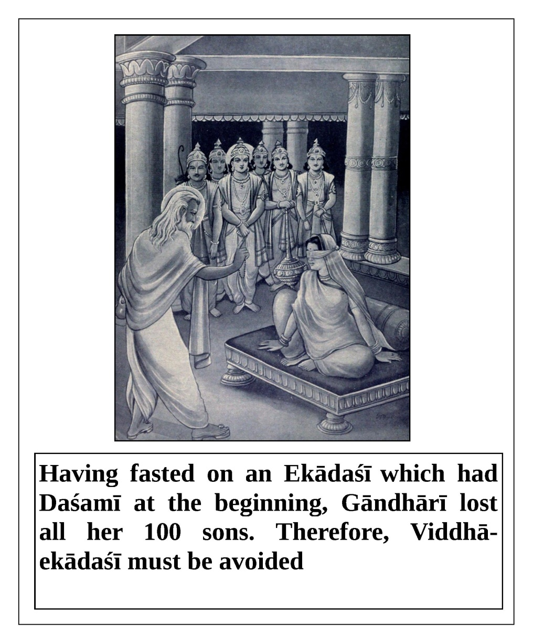

daśamyaikādaśīṁ pūrvaṁ samupoṣya janārdanaḥ
abhyarcitas tvayā devi tasyedaṁ karmaṇaḥ phalam
(Hari-bhakti-vilāsa 12/214 Brahma Purāṇa,
Vālmīki Muni answered Mother Sītā's questions.
She had asked him why she had been sent to the forest by Lord Rāma)
Previously, you fasted on an ekādaśī which overlapped with daśamī and worshiped Lord Śrī Hari. You are now experencing the result of this.
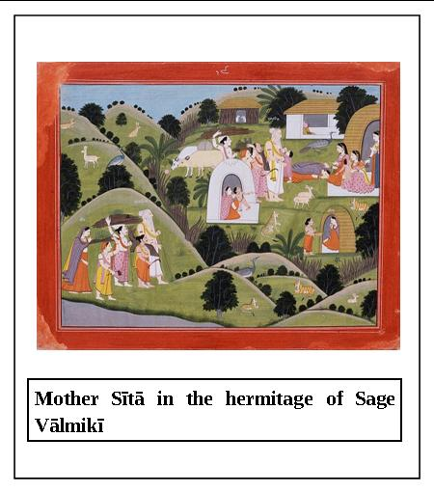

daśamī-śeṣa-saṁyuktāṁ yaḥ karoti vimūḍha-dhīḥ
ekādaśī-phalaṁ tasya na syād dvādaśa-vārṣikam
(Hari-bhakti-vilāsa 12/218 Kūrma Purāṇa,
Nārada Purāṇa and Viṣṇu Rahasya)
A foolish person who fasts on an ekādaśī which overlaps with daśamī loses the merit he had accumulated by observing ekādaśī over the past twelve years.
gaṅgodakasya sampūrṇaṁ yathā tyājyaṁ ghaṭaṁ bhavet
surā-bindu-samāyuktaṁ tat sarvaṁ madyatāṁ vrajet
(Hari-bhakti-vilāsa 12/223 Brahma Vaivarta Purāṇa)
Just as a cup of Ganges water mixed with a drop of wine must be rejected, fasting on an ekādaśī which overlaps even slightly with daśamī must be avoided.
viddhām ekādaśīṁ viprās tajyanty eāṁ manīṣiṇaḥ
tasyām upoṣito yāti dāridryaṁ duḥkham eva ca
(Hari-bhakti-vilāsa 12/226 Garuḍa Purāṇa)
O brāhmaṇas, learned souls do not observe ekādaśīs which overlap with daśamī. They know that doing so would bring them only poverty and misery.
dvāparānte tu gāndhārī kuru-vaṁśa-vivardhinī
kariṣyati ca senāni mūḍha-bhāvāc chikhi-dhvaja
tena putra-śataṁ tasyā nāśam eṣyaty asaṁśayam
(Hari-bhakti-vilāsa 12/228 Skanda Purāṇa)
O chief of the demigods (Skanda), at the end of Dvāpara-yuga, Gāndhārī will increase the Kuru dynasty by producing one hundred sons. However, due to bewilderment and madness, she will observe an ekādaśī which is mixed with daśamī, and as a result, all of her sons will die. There is no doubt about this.
daśayaikādaśī yatra tatra sannihito’suraḥ
dvādaśyaikādaśī yatra tatra sannihito hariḥ
(Hari-bhakti-vilāsa 12/230 Skanda Purāṇa)
Demons reside in any ekādaśī which overlaps with daśamī, and anyone who fasts on such a day achieves negative results. Lord Hari resides in ekādaśīs which overlap with dvādaśī. If one properly observes fasting on such a day, he receives completely positive results.
ye śaṁsanti dinaṁ viṣṇor daśamī-vedha-dūṣitam
jñeyās te pāpa-puruṣāḥ śukra-māyā-vimohitāḥ
(Hari-bhakti-vilāsa 12/234 Skanda Purāṇa,
conversation between Lord Śiva and Umā devī)
It should be understood that anyone who fasts on an ekādaśī which is contaminated by daśamī, or influences someone else to do so, has been controlled and bewildered by Śukrācārya, the spiritual master of the demons.
dvādaśīṁ daśamī-viddhā dhana-santāna-nāśinī
dhvaṁsinī sarva-puṇyānāṁ kṛṣṇa-bhakti-praṇāśinī
(Hari-bhakti-vilāsa 12/239 Skanda Purāṇa)
If one fasts on a dvādaśī or ekādaśī which overlaps with daśamī, one’s offspring will be ruined, one’s accumulated pious merit will be lost, one’s devotional service to the Lord will be taken away, and one will take birth among the devils and ghosts.
daśamī-śeṣa-saṁyuktaṁ niṣiddhaṁ viṣṇunā purā
tasmād bhāgavatair bhūpa śodhayitvā harer dinam
upoṣitavyaṁ yatnena pūrva-saṅgati-varjitam
(Hari-bhakti-vilāsa 12/244 Skanda Purāṇa,
Mārkaṇḍeya Ṛṣi speaks to King Bhagīratha)
O king, previously the Supreme Lord Viṣṇu prohibited one from fasting when an ekādaśī overlaps with daśamī. Therefore, the devotees of the Supreme Personality of Godhead should avoid fasting on such an ekādaśī, and should only fast on pure ekādaśīs.
kurute vaiṣṇavo bhūtvā sa-śalyaikādaśī-vratam
jñānato’jñānato vāpi na sa viṣṇu-priyo bhavet
(Hari-bhakti-vilāsa 12/246 Skanda Purāṇa)
If a Vaiṣṇava knowingly or unknowingly fasts on an ekādaśī which overlaps with daśamī, Lord Śrī Viṣṇu will certainly not be happy with him.
tasmād ekādaśī yuktā daśamyā nara-sattama
na kartavyā prayatnena niṣkalā dvādaśī matā
(Hari-bhakti-vilāsa 12/248 Skanda Purāṇa)
Therefore, O best among human beings, it is not recommended to observe fasting on an ekādaśī which overlaps with daśamī. Great sages have recommended fasting only on pure ekādaśīs.
puṇyaṁ susañcitaṁ yāti kalpa-koṭi-śatārjitam
saśalyaṁ ye prakurvanti muktidaṁ mama vāsaram
(Hari-bhakti-vilāsa 12/253 Dvārakā Māhātmya, spoken by the Supreme Personality of Godhead)
If one fasts on the liberating day of Mine which is mixed with daśamī, his accumulated pious merit from the past one hundred cycles of creation (one cycle equals 1000 yugas) is destroyed.
sa-viddhaṁ vāsaraṁ yasmāt kṛtaṁ mama pitāmahaiḥ
pretatvaṁ tena samprāptaṁ mahā-duḥkha-pradāyakam
(Hari-bhakti-vilāsa 12/256 Dvārakā Māhātmya, Śrī Candra Śarmā prays to the Supreme Personality of Godhead.)
O Supreme Personality of Godhead, my forefathers sometimes fasted on the day of Lord Hari which was mixed with daśamī. This is why they were forced to accept the miserable life of a ghost.

Śrīla Sanātana Gosvāmī remarks in his Digdarśiṇī-ṭīkā that Candra Śarmā brāhmaṇa was a devotee of Lord Śiva, and he was against the Supreme Personality of Godhead Śrī Kṛṣṇa. In a dream, he saw that his forefathers had become ghosts due to fasting on ekādaśī which overlapped with daśamī. A devotee of the Lord advised him to approach the Supreme Personality of Godhead in Dvārakā, worship Him, and pray to Him to free his forefathers from their unfortunate condition as ghosts. Due to his prayers, the Lord freed them.
śukreṇa mohitā viprā daityānāṁ kāraṇena tu
puṣṭy-arthaṁ daśamī-viddhaṁ kurvanti mama vāsaram
vāsaraṁ daśamī-viddhaṁ daityānāṁ puṣṭi-vardhanam
madīyaṁ nāsti sandehaḥ satyaṁ satyaṁ pitāmaha
(Hari-bhakti-vilāsa 12/257, 258 Padma Purāṇa, The Supreme Personality of Godhead speaks to Lord Brahmā.)
The Supreme Personality of Godhead said, "O Brahmā, only brāhmaṇas bewildered by Śukrācārya fast on ekādaśī mixed with daśamī. Such improper fasting increases one’s demonic nature. There is no doubt about this.”
yāvad daśamyā saṁyuktaṁ kariṣyanti dinaṁ mama
tat puṇyaṁ daitya-jātīnāṁ surair dattaṁ pitāmaha
tena puṇyena sampuṣṭo hiraṇyākṣaḥ pitāmaha
nirjitya vāsavaṁ saṅkhye hṛtaṁ rājyaṁ divaukasām
(Hari-bhakti-vilāsa 12/259, 260), Padma Purāṇa, conversation between the Supreme Personality of Godhead and Lord Brahmā)
O grandfather of the world, when people fast on ekādaśī mixed with daśamī, the power of the demigods is tranferred to the demons. In this way, the demon Hiranyākṣa became extremely strong, defeated Indra in battle, and usurped the kingdom of the demigods.
pūrṇāviddhām upāste ko nandāṁ veda-balād api
ko veda vacanāt tāta gosave gāṁ nihanti vai
(Hari-bhakti-vilāsa 12/268 Bhaviṣya Purāṇa and
Mārkaṇḍeya Purāṇa)
O son, after hearing the warnings against fasting on daśamī, what person would fast on an ekādaśī which overlaps with daśamī? After hearing the Vedic instructions, what person would kill a cow in the name of worship?
supuṇyaikādaśī sūta yadi śalya-vivarjitā
kartur niraya-pātāya saśalyā samupoṣitā
śalyaṁ vedha iti proktaṁ purāṇārtha-vicakṣaṇaiḥ
(Hari-bhakti-vilāsa 12/270 Kūrma Purāṇa and Brahma Vaivarta Purāṇa, Śrīla Vyāsadeva speaks to Sūta Gosvāmī)
O Sūta Gosvāmī, if one strictly observes a pure ekādaśī which is not mixed with daśamī, it is all-auspicious. If one fasts on an ekādaśī mixed with daśamī, one falls to the hellish planets. Learned persons who know the Vedic literature have determined that fasting on an impure ekādaśī is improper.
dvayor vivadatoḥ śrutvā dvādaśīṁ samupoṣayet
pāraṇaṁ tu trayodaśyām eṣa śāstra-vinirṇayaḥ
dvādaśī daśamī-yuktā yataḥ śāstre pratiṣṭhitā
na tat śāstram ahaṁ manye yadi brahmā svayaṁ vadet
(Hari-bhakti-vilāsa 12/277, 278 Kūrma Purāṇa,
Śrīla Vyāsadeva speaks to Sūta Gosvāmī)
If the exact date and time of an ekādaśī cannot be determined, scriptures say that one should fast on dvādaśī and break the fast on trayodaśī. I (Vyāsadeva) do not accept any scripture, even if written by Lord Brahma, which recommends fasting on an ekādaśī mixed with daśamī.
kṣaye vāpy athavā vṛddhau samprāpte vā dina-traye
upoṣyā dvādaśī śuddhā trayodaśyāntu pāraṇam
(Hari-bhakti-vilāsa 12/286 Nārada Purāṇa)
If there is a reduction in the day of the fortnight; if there is an extension of a day; or if three days are combined, then one should fast on a pure dvādaśī and break the fast on trayodaśī.
ūrdhvaṁ hari-dinaṁ na syād dvādaśīṁ grāhayet tataḥ
dvādaśyām upavāso’tra trayodaśyāṁ tu pāraṇam
evaṁ kurvan naro bhaktyā viṣṇu-sāyujyam āpnuyāt
anyathā kurute yas tu sa yāti narakaṁ dhruvam
ekādaśī ṛṣīṇāṁ tu dvādaśī cakrapāṇinaḥ
(Hari-bhakti-vilāsa 12/293-295 Skanda Purāṇa)
If ekādaśī is connected with daśamī, it is not called the day of Lord Hari; therefore, one should fast on dvādaśī and break the fast on trayodaśī. If one follows this process with devotion, one goes to live in the Lord’s abode after liberation. If one does otherwise, he falls to the hellish planets. Ekādaśī is the day of the sages, and pure ekādaśī with dvādaśī is the day of Lord Hari.
udayāt prāk yadā vipra muhūrta-dvaya-saṁyutā
sampūrṇaikādaśī nāma tatraivopavased gṛhī
(Hari-bhakti-vilāsa 12/316 Garuḍa Purāṇa,
Bhaviṣya Purāṇa, and Śiva Rahasya)
O brāhmaṇa, if an ekādaśī begins ninety-six minutes before sunrise, it is called a complete and pure ekādaśī. Everyone, including all householders, should fast on such an ekādaśī.
ataeva parityājya samaye cāruṇodaye
daśamyaikādaśī viddhā vaiṣṇavena viśeṣataḥ
(Hari-bhakti-vilāsa 12/318 Bhaviṣya Purāṇa)
Therefore, one should not fast on an ekādaśī which overlaps with daśamī, even if that ekādaśī begins before sunrise. Vaiṣṇavas should always avoid fasting on ekādaśīs which overlap daśamīs.

Śrīla Sanātana Gosvāmī remarks in his Digdarśiṇī-ṭīkā that even if an ekādaśī begins ninety-six minutes before sunrise, it is unsuitable for fasting if it overlaps with the previous day. Regardless of the exact time before sunrise that an ekādaśī overlaps with daśamī, fasting on such an ekādaśī should always be avoided, especially by Vaiṣṇavas. A Vaiṣṇava’s duty is to reject fasting on an ekādaśī which overlaps with the previous day. Instructions like this from the Bhaviṣya Purāṇa are meant specifically for Vaiṣṇavas. Other scriptures indicate that Śaivas and others can observe fasting on an ekādaśī which overlaps with the previous day.
aruṇodaya-velāyāṁ daśamī-saṁyutā yadi
atropoṣyā dvādaśī syāt trayodaśyāṁ tu pāraṇam
(Hari-bhakti-vilāsa 12/319 Kanva Ṛṣi)
If an ekādaśī overlaps with daśamī before sunrise, one should fast on dvādaśī and break the fast on trayodaśī.
udayāt prāṅ-muhūrtena vyāpiny ekādaśī yadā
saṁyuktaikādaśī nāma varjayed dharma-vṛddhaye
(Hari-bhakti-vilāsa 12/322 Garuḍa Purāṇa)
If an ekādaśī begins forty-eight minutes before sunrise, it is still said to overlap with the previous day. People interested in increasing their pious merit should not fast on such an ekādaśī.
daśamī sesa samyukto yadi syad arunodayah
vaisnavena na kartavyam tad dinaikadasi vrtam
(Hari-bhakti-vilāsa 12/336 Bhaviṣya Purāṇa)
If ekādaśī begins at sunrise, a Vaiṣṇava should not fast on that ekādaśī.
ardha-rātram atikramya daśamī yadi dṛśyate
tadā hy ekādaśīṁ tyaktvā dvādaśīṁ samupoṣayet
(Hari-bhakti-vilāsa 12/354, Kūrma Purāṇa)
If daśamī extends past midnight, one should not fast on that ekādaśī, but should fast on dvādaśī instead.
sampūrṇaikādaśī yatra prabhāte punar eva sā
vaiṣṇavī ca trayodaśyāṁ ghaṭikaikāpi dṛśyate
gṛhastho’pi parāṁ kuryāt pūrvā nopavaset tadā
(Hari-bhakti-vilāsa 12/360, Garuḍa Purāṇa)
If an ekādaśī that begins at dawn extends until sunrise the next day, it is better to fast the next day. It is the duty of both gṛhasthas and sannyāsīs not to fast on such an ekādaśī.
dvādaśī-miśritā grāhyā sarvatraikādaśī tithiḥ
dvādaśī ca trayodaśyāṁ vidyate yadi vā na vā
(Hari-bhakti-vilāsa 12/362 Padma Purāṇa)
It does not matter if ekādaśī overlaps with trayodaśī, and an ekādaśī which overlaps with dvādaśī should be followed like any other ekādaśī fast.
ekādaśī-kalā yatra parato dvādaśī na cet
tatra kratu-śataṁ puṇyaṁ trayodaśyāṁ tu pāraṇam
(Hari-bhakti-vilāsa 12/365 Skanda Purāṇa)
If an ekādaśī overlaps with dvādaśī by even a moment, and dvādaśī does not overlap with trayodaśī, one should fast on dvādaśī and break the fast on trayodaśī. Such fasting gives the same benefit as performing one hundred sacrifices.
ekādaśī-kalā-yuktā upoṣyā dvādaśī naraiḥ
trayodaśyāṁ tu yo bhuṅkte tasya viṣṇuḥ prasādati
(Hari-bhakti-vilāsa 12/371 Baudhāyana Smṛti)
It is desirable for human beings to fast on a dvādaśī that overlaps with ekādaśī, and to break the fast on trayodaśī. If they do so, Lord Śrī Viṣṇu will be pleased with them.
ekādaśī bhavet pūrṇā parato dvādaśī yadā
tadāhy-ekādaśīṁ tyaktvā dvādaśyāṁ samupoṣayet
(Hari-bhakti-vilāsa 12/372 Skanda Purāṇa)
An ekādaśī which begins at dawn is complete, and a dvādaśī which overlaps for even a moment with trayodaśī is also complete. In such a case, one should not fast on ekādaśī; rather, one should fast on dvādaśī.
ekādaśī tu sampūrṇā parato dvādaśī bhavet
upoṣyā dvādaśī tatra tithi-vṛddhiḥ praśasyate
(Hari-bhakti-vilāsa 12/373 Kālikā Purāṇa)
If ekādaśī is a complete day and dvādaśī is extended, one should fast on dvādaśī. This is called extended fasting.
sampūrṇaikadaśī tyājyā parato dvādaśī yadi
upoṣyā dvādaśī śuddhā dvādaśyām eva pāraṇam
na garbhe viśate jantur ity āha bhagavān hariḥ
(Hari-bhakti-vilāsa 12/376 Bhāgavatādi-tantra)
The Supreme Personality of Godhead said, "If dvādaśī overlaps for even a moment with trayodaśī, one should not fast on ekādaśī, but should fast on dvādaśī. One who fasts in this way will not take another birth in the material world.”
ekādaśī dvādaśī ca rātri-śeṣe trayodaśī
tribhir miśrā tithiḥ proktā sarva-pāpa-harā smṛtā
(Hari-bhakti-vilāsa 12/378 Kūrma Purāṇa)
If ekādaśī and dvādaśī fall within the same day, and at night trayodaśī overlaps with them - in other words, if the three days overlap in a day and night - it is called Trispṛśā. This tithi or day is said to remove one’s sins.
trispṛśaikādaśī yatra tatra sannihito hariḥ
tām evopavaset kāmī akāmo viṣṇu-tatparaḥ
(Hari-bhakti-vilāsa 12/380 Kūrma Purāṇa)
Lord Hari Himself resides in Trispṛśā ekādaśī. Both devotees who are full of desires and those who are desireless should fast on Trispṛśā Mahā-dvādaśī.

Śrīla Sanātana Gosvāmī says in his Digdarśinī commentary that when ekādaśī, dvādaśī, and the end of the night (trayodaśī) overlap, one should fast with his sons, grandsons, and other family members. Whether one desires wealth, sons, liberation, or other things, or one is a desireless Vaiṣṇava interested only in pleasing the Supreme Lord Viṣṇu, one should fast on Trispṛśā ekādaśī. By doing so, one becomes free from even the sin of killing a brāhmaṇa. He is freed from all kinds of miseries accumulated over many births, and he attains the benefit of performing sacrifices. This fasting is a source of auspiciousness which increases one’s pious merit. Therefore, one should certainly observe it.
purā caikādaśī svalpā ante caiva trayodaśī
sampūrṇā dvādaśī madhye trispṛśā sā hari-priyā
(Hari-bhakti-vilāsa 12/387 Dvārakā-māhātmya)
If at the beginning there is a trace of ekādaśī, in the middle there is a complete dvādaśī day, and at the end there is a small portion of trayodaśī, it is called Trispṛśā ekādaśī, which is very dear to Lord Hari.
śuddhaiva dvādaśī rājan upoṣyā mokṣa-kāṅkṣibhiḥ |
pāraṇas tu trayodaśyāṁ pūjayitvā janārdanam
(Hari-bhakti-vilāsa 12/407 Viṣṇu Rahasya,
Spoken by Śrīla Vyāsadeva)
O king, those who desire liberation from this material world observe a pure dvādaśī fast and break it on trayodaśī after properly worshiping Lord Janārdana.

Śrīla Sanātana Gosvāmī states in his Digdarśinī-tīkā commentary that attaining liberation means becoming free from birth and death, which bind one to the material world. One who liberates others from misery is called a liberator, like Lord Śrī Viṣṇu. A real devotee of the Lord is interested only in attaining love of Godhead; that is his liberation and ultimate desire. It is said here that if the day of Vaiṣṇavas (dvādaśī) is not available, one can worship Lord Śrī Janārdana on trayodaśī and break one’s fast. This is undoubtedly an authorized instruction.
itthaṁ śāstra-vicāreṇa śiṣṭācārānusārataḥ
ekādaśī-vyavastheyaṁ kṛtā vaiṣṇava-sammatā
vidvāṁso’py atra mūḍhāḥ syur vinā kṛṣṇa-prasādataḥ
ataḥ sadāsau nirdhāryā pṛṣṭvā bhāgavatottamān
(Hari-bhakti-vilāsa 12/410, 411 Viṣṇu-rahasya)
The timing for ekādaśī, which is pleasing to the Vaiṣṇavas, is established by studying the rules in the scriptures and following the guidance of realized souls. Even if one is very learned, without the direct mercy of the Lord it is very difficult to determine the correct timing for ekādaśī days. Therefore, to assure that one is performing the ekādaśī fast properly, one should always consult the most advanced Vaiṣṇava devotees of the Lord to find out the exact date and timing.

Śrīla Sanātana Gosvāmī explains in his Digdarśinī-tīkā the ways that Vaiṣṇavas and non-Vaiṣṇavas determine the exact dates of ekādaśī. One should consider the statements of the scriptures, and also discuss this subject with learned personalities. One should not just rely on the scriptures; it is important to consult learned souls as well. According to Vaiṣṇavas, one should follow pure Vaiṣṇava ekādaśī, not a contaminated ekādaśī that overlaps with the previous day (daśamī). If dvādaśī is available, one should not fast on an ekādaśī which overlaps with daśamī. Trispṛśā ekādaśī, which is not connected with daśamī and occus during cāturmasya in one of the dark fortnights, is suitable for fasting. In essence, an advanced Vaiṣṇava should always be consulted for proper guidance. Due to the influence of Śukrācārya, even learned scholars who are experts in the Vedic literature sometimes become illusioned or bewildered, and thus they are unable to properly determine the day for fasting on ekādaśī. Therefore, one should be a devotee who depends on the mercy of the Supreme Personality of Godhead; that is the best way to determine the day to fast on ekādaśī.
dvādaśyā nirṇaye bhūpa mūḍham atra jagat-trayam |
atra mūḍhā mahīpāla prāyaśo ye narāḥ purā
(Hari-bhakti-vilāsa 12/412, Viṣṇu Rahasya,
Conversation between Mārkaṇḍeya and King Indradyumna)
O king, regarding establishing the correct day for fasting on dvādaśī, the three worlds are bewildered. What to speak of now, even in ancient times great persons found it very difficult to perfectly determine the correct days for fasting.

Hari-bhakti-vilāsa–Fifteenth Vilāsa
Text 543
atha pārśva-parivartanotsavaḥ
bhādrasya śuklaikādaśyāṁ sāyanotsavavat prabhoḥ
kaṭi-dānotsavaṁ kuryād vaiṣṇavaiḥ saha vaiṣṇavaḥ
The Pārśva-parivartana Festival - on the śukla-ekādaśī of Bhādra, a Vaiṣṇava, accompanied by other Vaiṣṇavas, should celebrate the Kaṭidāna festival, which is like the Śayana festival.
Text 544
bhaviṣyottare
prāpte bhādra-pade māsi ekādaśyāṁ site ‘hani
kaṭi-dānaṁ bhaved viṣṇor mahā-pātaka-nāśanam
In the Bhaviṣya Purāṇa, Uttara-khaṇḍa, it is said that on the śukla-ekādaśī of the month of Bhādra, one should observe the kaṭi-dāna (turning-over) festival of Lord Viṣṇu, a festival that destroys great sins.
Text 545
jalāśayāntikaṁ nītvā samyag abhyarcya prabhum
karṇikā-parivṛttiṁ ca dakṣiṇāṅge prakalpayet
One should approach the Supreme Lord as He naps on the ocean, and arrange for Him to turn over in His sleep so that He now rests on His right side.
Text 546
atha abhyarthana-mantraḥ
deva deva jagannātha yogi-gamya nirañjana
kaṭi-dānaṁ kuruṣvādya māsi bhādra-pade śubhe
The Mantra-Prayer - O Lord, O master of the universes, O Lord of the yogīs, O Lord who is untouched by matter, now that it is the auspicious month of Bhādra, please turn over to Your other side.
Text 547
mahā-pūjāṁ tataḥ kṛtvā vaiṣṇavān paritoṣya ca
devaṁ sva-mandire nītvā yathā-pūrvaṁ niveśayet
Then, one should perform great worship, please the Vaiṣṇavas, and return the Deity of the Lord to His place in the temple.
Text 548
atha śravaṇa-dvādaśī-vrataṁ
bhādrasya śukla-dvādaśyāṁ yuktāyaṁ śravaṇena hi
upoṣya saṅgame snātvā devaṁ vāmanam arcayet
The Vow of Śravaṇa-dvādaśī - when the star Śravaṇā is conjoined with the moon on the śukla-dvādaśī of the month of Bhādra, one should fast, bathe, and worship Lord Vāmana.
Text 549
atha tan-māhātmyaṁ māsi bhādra-pade śuklā
dvādaśī śravaṇānvitā mahatī dvādaśī jñeyā
upavāse mahā-phalā arcayitvācyutaṁ bhaktyā
labhet puṇyaṁ daśābdikam
The Glory of That Vow - when the star Śravaṇa is conjoined with the moon on the śukla-dvādaśī of the month of Bhādra, that day is known as a mahā-dvādaśī. By fasting and devotedly worshiping the infallible Supreme Personality of Godhead on that day, one attains the result of having performed ten years of pious deeds.
Text 550
phalaṁ datta-hutānāṁ ca
tasyāṁ lakṣa-guṇaṁ bhavet
On that day, the results of giving charity and performing yajñas are multiplied by a hundred-thousand-times.
Text 551
skaṇde
māsi bhādra-pade śuklā dvādaśī śravaṇānvitā
mahatī dvādaśī jñeyā upavāse mahā-phalā
In the Skanda Purāṇa, it is said that when the star Śravaṇa is conjoined with the moon on the śukla-dvādaśī of the month of Bhādra, that day is known as mahā-dvādaśī (great dvādaśī). Fasting on that day brings a great result.
Text 552
saṅgame saritaḥ puṇye dvādaśīṁ tam upoṣitaḥ
āplavād eva cāpnoti dvādaśa-dvādaśī-phalam
A person who fasts and bathes in a sacred river on this dvādaśī attains the benefits of observing twelve dvādaśīs.
Text 553
budha-śravaṇa-samyuktā saiva ced dvādaśī bhavet
atyanta-mahatī tasyāṁ dattaṁ bhavati cākṣayam
If on that day both Mercury and Śravaṇa are conjoined with the moon, that day is known as atyanta-mahā-dvādaśī (very great dvādaśī). Whatever charity is given on that day becomes eternal and inexhaustible.
Text 554
arcayitvācyutaṁ bhaktyā labhet puṇyaṁ daśābdikam
phalaṁ datta-hutānāṁ ca tasyāṁ lakṣa-guṇaṁ bhavet
By worshiping the infallible Supreme Personality of Godhead on that day, one attains the results of ten years of pious deeds. On that day, the results of charity and yajñas are multiplied by a hundred-thousand-times.
Texts 555 and 556
brahma-vaivarte pitā-putra-samvāde
māsi bhādra-pade śuklapakṣe yadi harer dine
budha-śravaṇa-samyogaḥ prāpyate tatra pūjitaḥ
prayacchati śubhān kāmān vāmano manasi sthitān
vijayā nama sā proktā tithiḥ prīti-karī hareḥ
In the Brahma-vaivarta Purāṇa, a father tells his son, “If Mercury and Śravaṇa are both conjoined with the moon on the śukla-ekādaśī of the month of Bhādra, that day is called Vijayā ekādaśī. That day is very pleasing to Lord Hari. Lord Vāmana fulfills the auspicious desires in the heart of one who worships Him on that day.”
Text 557
saṅgame sarva-tīrthānāṁ saṅgamas tatra jāyate
śuklā bhādra-pade svargaṁ kṛṣṇā kaluṣa-saṅkṣayam
When Mercury and Śravaṇa are both conjoined with the moon on the dvādaśī of the month of Bhādra, it is as if all of the holy places are present. When Mercury and Śravaṇa are both conjoined with the moon on the śukla-dvādaśī of the month of Bhādra, fasting leads to residence in Svargaloka. When they are both conjoined with the moon on the kṛṣṇa-dvādaśī of the month of Bhādra, fasting leads to the destruction of sins.
Text 558
phālgune kurute mokṣam api brahma-vadhān nṛṇām
mahā-puṇya-pradā hy eṣā saṅgame vijayā tithiḥ
sarva-pāpa-kṣayo nūnaṁ jāyate tad-upoṣiṇām
When Śravaṇa is conjoined with the moon on the śukla-dvādaśī of the month of Phālguna (February-March), that day is called Vijayā dvādaśī. It grants great piety, and purifies even the sin of murdering a brāhmaṇa. Whoever fasts on that day becomes free from all sins.
Text 559
kiṁ ca
sarva-tīrthāni bhū-pṛṣṭhe saṅgame yānti saṅgamam
vijayā-vāsare sarve devānāṁ saṅgamo bhuvi
It is also said that on Vijayā dvādaśī, all of the holy places and all of the demigods gather together on Earth.
Text 560
idaṁ sarva-purāṇeṣu rahasyaṁ parigīyate
saṅgame vāmanaṁ pūjya preta-yonau na jāyate
A secret told in all of the Purāṇas is that simply by worshiping Lord Vāmana on this day, one is protected from having to take birth as a ghost (preta).
Text 561
viṣṇu-dharmottare śrī-paraśurāma uvāca
upavāsāsamarthānāṁ kiṁ syād ekam upoṣitam
mahā-phalaṁ mahā-deva tan mamācakṣva suvrata
In the Viṣṇu-dharma Purāṇa, Uttara-khaṇḍa, Śrī Paraśurāma asks, “What result is attained by persons who generally cannot fast, but who are able to do so once on this day? O saintly Śiva, please explain this to me.”
Text 562
śrī-śaṅkara uvāca
yā rāma śravaṇopetā dvādaśī mahatī tu sā
tasyām upoṣitaḥ snātaḥ pūjayitvā janārdanaṁ
prāpnoty ayatnād dharma-jña dvādaśa-dvādaśī-phalam
“O Paraśurāma, who is wise in spiritual truth, a person who fasts, bathes, and then worships Lord Kṛṣṇa on mahā-dvādaśī, when the star Śravaṇa is conjoined with the moon, attains the results of observing twelve dvādaśīs.”
Text 563
kiṁ ca
śravaṇa-dvādaśī-yoge budha-vāro bhaved yadi
atyanta-mahatī rāma
Lord Śiva also said, “O Paraśurāma, if Śravaṇa-dvādaśī (when the star Śravaṇa is conjoined with the moon) falls on a Wednesday, then it is said to be atyanta-mahatī (very great).”
Text 564
snānaṁ japyaṁ tathā homo dānaṁ śrāddhaṁ surārcanam
sarvam akṣayam āpnoti tasyāṁ bhṛgu-kulodvaha
“O scion of the Bhṛgu dynasty, bathing, japa, yajña, charity, śrāddha, and demigod-worship all yield unlimited and inexaustable pious merit when done on that day.”
Text 565
tasmin dine tathā snāto yo ‘pi kvacana saṅgame
sa gaṅga-snāna-jaṁ rāma phalaṁ prāpnoty asaṁśayam
“O Paraśurāma, a person who bathes anywhere on that day attains the result of bathing in the Ganges - there is no doubt about this.”
Text 566
śravaṇe saṅgamaḥ sarve paripuṣṭi-pradaḥ sadā
viśeṣād dvādaśī-yukte budha-yukte viśeṣataḥ
“When this dvādaśī falls on a Wednesday, it grants especially great piety.”
Text 567
bhaviṣyottare śrī-yudhiṣṭhira uvāca
upavāsāsamarthānāṁ sadaiva puruṣottama
ekā yā dvādaśī puṇyā taṁ vadasva mamānagha
In the Bhaviṣya Purāṇa, Uttara-khaṇḍa, Śrī Yudhiṣṭhira requests, “O sinless Supreme Person, please describe to me the piety attained by persons who are generally unable to fast, but who are able to do so once on this day.”
Text 568
śrī-kṛṣṇa uvāca
māsi bhādra-pade śuklā dvādaśī śravaṇānvitā
sarva-kāma-pradā puṇyā upavāse mahā-phalā
Śrī Kṛṣṇa said, “When the star Śravaṇa is conjoined with the moon during the śukla-dvādaśī of the month of Bhādra, that day is very sacred. It fulfills all desires; fasting on that day gives a great result.”
Text 569
saṅgame saritāṁ snatvā gaṅgā-snānādi-jaṁ phalam
sopavāsaḥ samāpnoti nātra karyā vicāraṇā
“A person who fasts and bathes in any river on this day attains the result of bathing in the Ganges - there is no doubt about this.”
Text 570
kiṁ ca
budha-śravaṇa-samyuktā saiva ced dvādaśī bhavet
atīva mahatī tasyāṁ sarvaṁ dattam ihākṣayam
“It is also said that if on this dvādaśī Śravaṇa and Mercury are both conjoined with the moon, it is an especially great dvādaśī. Any charity given on that day leads to unlimited and inexhaustable pious merit.”
Texts 571 and 572
kiṁ ca tatraiva vaṇig-upākhyāne
śravaṇa-dvādaśī-yoge pūjayitvā janārdanam
dānaṁ ca dattvā viprebhyaḥ sopavāso jitendriyaḥ
mahā-nadī-saṅgame ca snātvā diṣṭāntam āgataḥ
avāpa paramaṁ sthānaṁ durlabhaṁ sarva-mānavaiḥ
“A person who fasts, controls his senses, bathes in a great river, gives charity to the brāhmaṇas, and worships Lord Kṛṣṇa on a śravaṇa-dvādaśī attains, at the moment of death, a celestial world that is difficult for human beings to enter.”
Text 573
yatra kāma-phalā vṛkṣā nadyaḥ pāyasa-kardamāḥ
śītalāmala-pānīyāḥ puṣkariṇyo manoharāḥ
“In that world the trees fulfill all desires, and there are beautiful lotus-filled lakes with pure, refreshing water. The bottom of those lakes is like pāyasa (condensed milk).”
Text 574
taṁ desām āsādya vaṇiṅ mahātmā
su-mṛṣṭa-jāmbūnada-bhūṣitāṅgaḥ
kalpaṁ samagraṁ sura-sundarībhiḥ
sākaṁ sa reme muditaḥ sadaiva
“Once, a noble-hearted merchant attained that world. He was decorated with ornaments of the finest gold. He enjoyed there with many beautiful demigoddesses.”
Text 575
kiṁ cānte
budha-śravaṇa-samyuktadvādaśyāṁ
saṅgamodakam
dānaṁ bahv-odanaṁ śastaṁ
upavāsaḥ paro vidhiḥ
“It is also said that when both Śravaṇa and Mercury are conjoined with the moon on this dvādaśī, one should fast and give abundant grains in charity.”
Text 576
sagareṇa kukutsthena dhundhumāreṇa gandhinā
etaś cānyaiś ca rajendra kāmadā dvādaśī kṛtā
“O king of kings, Sagara, Kakutstha, Dundhumāra, Gandhī, and many others attained their desires by observing this dvādaśī.”
Text 577
yā dvādaśī budha-yutā śravaṇena sārdhaṁ
syāt sā jayeti kathitā munibhir nabhasye
tam ādareṇa samupoṣya naro hi samyak
prāpnoti siddhim aṇimādi-guṇopapannaḥ. iti.
“The sages call the dvādaśī in the month of Bhādra, when Śravaṇa and Mercury are both conjoined with the moon, Jayā. A person who respectfully fasts on that day attains aṇimā-siddhi (ability to become atomic in size) and other mystic perfections.”
Text 578
atha śravaṇa-dvādaśī-vrata-nirṇayaḥ
dvādaśy ekādaśī vā syād upoṣyā śravaṇanvitā
viṣṇu-śṛṅkhala-yogaś ca taṁ trayaṁ miśritaṁ yadi
One should fast on either a dvādaśī or an ekādaśī when Śravaṇa is conjoined with the moon. When all three of these conditions occur on the same day, that day is called Viṣṇu-śṛṅkhala-yoga.
Text 579
atha śravaṇa-dvādaśy-upavāsaḥ śrī-mārkaṇḍeyaḥ
śravaṇarkṣa-samāyuktā dvādaśī yadi labhyate
upoṣyā dvādaśī tatra trayodaśyāṁ tu pāraṇam

Text 580
yamaś ca
yadā tu śukla-dvādaśyāṁ nakṣatraṁ śravaṇaṁ bhavet
tadāsau tu mahā-puṇyā dvādaśī vijayā smṛtā
Yamarāja explains that when the star Śravaṇa is conjoined with the moon on a śukla-dvādaśī, that very sacred day is called Vijayā dvādaśī.
Text 581
tatra dānopavāsādyaṁ akṣayaṁ parikīrtitam
ekādaśyā viśuddhatve dvādaśyāṁ tu pare ‘hani
śravaṇe sati śaktasya vrata-yugmaṁ vidhīyate
On that day, fasting, giving charity, and other pious deeds yield unlimited and inexhaustable benefits. If the ekādaśī is pure and the star Śravaṇa is conjoined with the moon on the dvādaśī, if one is able one should fast on both ekādaśī and dvādaśī.
Text 582
asamāpte vrate sarve naiva kuryād vratāntaram
ity ādi vacanasyātra bādhakaṁ vaṁ na vidyate

Text 583
tathā hi bhaviṣyottare
ekādaśīm upoṣyaiva dvādaśīṁ samupoṣyate
na cātra vidhi-lopaḥ syād ubhayor devatā hariḥ. iti.
In the Bhaviṣya Purāṇa, Uttara-khaṇḍa, it is said that if in this situation one fasts on both ekādaśī and dvādaśī, there is no fault, for Lord Kṛṣṇa is the Deity of both days.
Text 584
aśaktas tu vrata-dvandve bhuṅkte vaikādaśī-dine
upavāsaṁ budhaḥ kuryāc chravaṇa-dvādaśī-dine
If a wise person is unable to fast on both days, he should eat on ekādaśī and fast on śravaṇa-dvādaśī.
Text 585
tathā ca nāradīye
upoṣya dvādaśīṁ puṇyaṁ viṣṇu-ṛkṣena samyutam
ekādaśy-udbhavaṁ puṇyaṁ naraḥ prāpnoty asaṁśayam
It is said in the Nārada Purāṇa that by fasting on this dvādaśī, when the star sacred to Lord Viṣṇu is conjoined with the moon, one attains the pious benefits attained by fasting on ekādaśī. There is no doubt about this.
Texts 586 and 587
vājapeye yathā yajñe karma-hīno ‘pi dīkṣitaḥ
sarvaṁ phalam avāpnoti asnāto ‘py ahuto ‘pi san
evam ekādaśīṁ tyaktvā dvādaśyāṁ samupoṣaṇāt
pūrva-vāsara-jaṁ puṇyaṁ sarvaṁ prāpnoty asaṁśayam. iti.
Just as a person initiated into the performance of a Vājapeya-yajña attains all of the benefits of the yajña, even though he does not personally do any of the work of the yajña, like offering oblations or performing the ritual bath, a person who does not fast on this specific ekādaśī, but fasts instead on dvādaśī, attains the same pious benefits as fasting on ekādaśī. There is no doubt about this.
Text 588
aty-alpo ‘py anayor yogo bhavet tithi-bhayor yadi
upādeyaḥ sa eva syād ity atropavased budhaḥ
Even if the junction of the tithi and star is very slight, a wise person will fast on that day.
Text 589
tathā ca śravaṇa-dvādaśīṁ prakṛtya tatraivoktaṁ
tithi-nakṣatrayor yoge yogaś caiva narādhipa
dvi-kalo yadi labhyeta sa jñeyo hy aṣṭa-yāmikaḥ

In that scripture, it is also said regarding śravaṇa-dvādaśī: “O king, if the yoga of tithi and star occurs for two kalās, that day is called Aṣṭa-yāmika.”
Text 590
tathaiva mātsye
dvādaśī śravaṇa-yuktā kṛṣṭnā puṇyatamā tithiḥ
na tu sā tena yuktā catāvaty eva praśasyate
It is said in the Matsya Purāṇa that when Śravaṇa is conjoined with the moon, this dvādaśī is a very sacred day. That conjunction makes it glorious.
Text 591
atha śravaṇa-nakṣatra-yuktaikādaśy-upavāsaḥ
nāradiye
yadi na prāpyate ṛkṣaṁ dvādaśyāṁ vaiṣṇavaṁ kvacit
ekādaśī tadopoṣyā pāpa-ghnī śravaṇānvitā
It is said in the Nārada Purāṇa that if Śravaṇa is not conjoined with the moon on dvādaśī, but it is conjoined with the moon on ekādaśī, one should fast on the ekādaśī. Such a fast destroys sins.
Text 592
ubhayor devatā viṣṇuḥ purāṇaḥ puruṣottamaḥ
vibhedo ‘tra na kartavyo vibhedāt patate naraḥ
Lord Viṣṇu, the primeval Supreme Personality of Godhead, is the presiding Deity of both of these days; therefore, one should not make a distinction between them, saying that one day is better than the other. One who makes such a distinction falls down.
Text 593
ata eva bhaviṣyottare
ekādaśī yadā ca syāt śravaṇena samanvitā
vijayā sā tithiḥ proktā bhaktānāṁ vijaya-pradā

It is said in the Bhaviṣya Purāṇa, Uttara-khaṇḍa, that when the star Śravaṇa is conjoined with the moon on this ekādaśī, the day is called Vijayāekādaśī, for it brings victory (vijaya) to the devotees.
Text 594
viṣṇu-purāṇe
yāḥ kāścit tithayaḥ proktāḥ puṇyā nakṣatra-yogataḥ
tāsv eva tad-vrataṁ kuryāc chravaṇa-dvādaśīṁ vinā. iti.
It is said in the Viṣṇu Purāṇa that Śravaṇa-dvādaśī is not usually counted among the various holy days with auspicious stars (it is usually included in the corresponding ekādaśī).
Text 595
ekādaśy-upavāse ca
dvādaśyāṁ kṛṣṇam arcayet
prādurbhūte hi bhagavān
dvādaśyām eva vāmanaḥ
One should fast on that ekādaśī, and worship Lord Kṛṣṇa on dvādaśī, because Lord Vāmana appeared in this world on that dvādaśī.
Text 596
tathā ca matsya-puraṇe
upoṣyaikādaśīṁ tatra
dvādaśyāṁ pūjayed dharim. iti.
It is said in the Matsya Purāṇa that one should fast on that ekādaśī and worship Lord Hari on dvādaśī.
Text 597
ato yadi na labhyeta
madhyāhnedvādaśī tadā
dvādaśī-madhya evārcyo
vāmanas tarhi sūribhiḥ. iti.
If dvādaśī does not begin by midday, devotees should wait until such a dvādaśī occurs and then worship Lord Vāmana.
Text 598
atha śrī-viṣṇu-śṛṅkhala-yogaḥ
mātsye
dvādaśī śravaṇa-spṛṣṭā spṛśed ekādaśīṁ yadā
sa eṣa vaiṣṇavo yogo viṣṇu-śṛṅkhala-samjñitaḥ
It is said in the Matsya Purāṇa that when a dvādaśī associated with Śravaṇa is connected with this ekādaśī, that day, called Śrī Viṣṇu-śṛṅkhala-yoga, is very sacred to Lord Viṣṇu.
Text 599
tasminn upoṣya vidhi-van
naraḥ saṅkṣīṇa-kalmasaḥ
prāpnotv anuttamāṁ siddhiṁ
punar-āvṛtti-durlabhām. iti.
A person who fasts on that day becomes free from sin. He attains perfection, which is rare in this world of repeated birth and death.
Text 600
ekādaśī-padenātra tad aho-rātra ucyate
anyathā dvādaśī-sparśas tasyāṁ nityaṁ na vidyate
Here, the word ekādaśī refers to both the day and night. If this were not so, dvādaśī would almost never overlap with ekādaśī.
Text 601
tithi-nakṣatrayor yoga ity ādyaṁ yat tu darśitam
tenālpa-kāla-samyoge ‘py aṣṭa-yāmikateṣyate
Text 589 states that even if the yoga of tithi and star is very brief, the day is called Aṣṭa-yāmika.
Text 602
atraivadvādaśī-madhye pāraṇaṁ śravaṇe ‘dhike
vakṣyamānaṁ ca ghaṭate ‘nyathā prāgvad dvidhā vratam
If Śravaṇa is conjoined with the moon, it is best to break the fast on dvādaśī. If Śravaṇa is not conjoined with the moon, the vow may be observed in two ways, as already described. More will be said of this later.
Text 603
dvādaśī śravaṇarkṣaṁ cety asmin pāṭhe bhaved idam
dvādaśī-śravaṇa-spṛṣṭety asmiṁś ca spṛṣṭatā khalu
tat-tat-sāhityam evāha pūrvasmād eva hetutaḥ
The first line of text 589 may also be read as dvādaśī śravaṇarkṣaṁ ca (dvādaśī and the star Śravaṇa). This refers to a connection between dvādaśī and Śravaṇa, for the same reason given previously.
Text 604
atha tasmād ayaṁ tu tatraiva viśeṣaḥ dvitīya-viṣṇu-śṛṅkhala-yogaḥ
yathā viṣṇu-dharmottare
ekādaśī dvādaśī ca
vaiṣṇavyam api tad bhavet
tad viṣṇu-śṛṅkhalaṁ nāma
viṣṇu-sāyujya-kṛd bhavet
tasminn upoṣanād gacchec
chvetadvīpa-puraṁ dhruvam
In the Śrī Viṣṇu-dharma Purāṇa, Uttara-khaṇḍa, it is said that when ekādaśī, dvādaśī, and the star Śravaṇa are connected in a single day, it is called Śrī Viṣṇu-śṛṅkhala-yoga. By fasting on that day, one achieves Viṣṇu-sāyujya liberation, or one goes to the eternal realm of Śvetadvīpa.
Text 605
dvādaśyām upavāso ‘tra trayodaśyāṁ tu pāraṇam
niṣiddham api kartavyaṁ ity ājñā parameśvarī. iti.
In this case, one must fast on dvādaśī and break the fast on trayodaśī, even if someone forbids him from doing so. This is the order of the Supreme Lord.
Text 606
yogo ‘yam anyo dvādaśyāḥ kṣaya eveti lakṣyate
dvādaśyām upavāsāc ca trayodaśyāṁ tu pāraṇāt
trayodaśyāṁ pāraṇaṁ hi śravaṇe ‘pi nisetsyate
Fasting on the dvādaśī and breaking the fast on the trayodaśī breaks the special yoga of the dvādaśī in this situation. It is also forbidden to break the fast on the trayodaśī when the star Śravaṇa is present on ekādaśī.
Text 607
ataḥ viṣṇu-śṛṅkhala eva viśeṣāntaraṁ
dvādaśyekādaśī saumyaḥ śravaṇaṁ ca catuṣṭayam
deva-dundubhi-yogo ‘yaṁ yajñāyuta-phala-pradaḥ. iti.
When dvādaśī, ekādaśī, Wednesday, and the star Śravaṇa all occur on the same day, it is called deva-dundubhi-yoga.
Fasting on that day yields pious merit equal to that obtained by performing ten thousand yajñas.
Text 608
pāraṇāhe tu dvādaśyāḥ śravaṇāyāś ca vṛddhitaḥ
rātrau tu pāraṇābhāvād yuktaṁ kartuṁ vrata-dvayam
One may break the fast on a dvādaśī connected with Śravaṇa. One may not break the fast at night. One may fast on both ekādaśī and dvādaśī.
Text 609
na cātra vidhi-lopaḥ syād ubhayor devatā hariḥ
There is no fault in fasting on both days, for Lord Hari is the presiding Deity of both days.
Text 610
dvādaśyām upavāso ‘tra trayodaśyāṁ tu pāraṇam
In this situation, one may fast on dvādaśī and break the fast on trayodaśī.
Text 611
dina-dvaye ‘pi śravaṇābhāve
tad-yoga-hānitaḥ
ekādaśyām upoṣyaiva
dvādaśyāṁ vāmanaṁ yajet
If the star Śravaṇa is not conjoined with the moon on either ekādaśī or dvādaśī, there is no yoga. In that situation, one should fast on ekādaśī and worship Lord Vāmana on the dvādaśī.
Text 612
viṣṇu-śṛṅkhalake ‘pi syād
vṛttir niśi paratra cet
yad ādhikyaṁ tithi-bhayoḥ
śaktaḥ kuryād vrata-dvayam
When there is a Śrī Viṣṇu-śṛṅkhala-yoga and both the tithi and Śravaṇa occur at night, it is best to fast, if one is able, on both days.
Text 613
pāraṇāya anaucityaṁ tāvatyāṁ niśi ced bhavet
aśaktas tūttaraṁ kuryād yogasyaivasya gauravat
However, it is not proper to break the fast at night. If one is not able to fast on both days in this situation, one should fast on the dvādaśī, as in this way the yoga is more prominent.
Text 614
atha tatra pāraṇa-kāla-nirṇayaḥ
sa ca vrata-vikalpe dvitīye viṣṇu-śṛṅkhale ca spaṣṭa eva. kevala-śravaṇa-niṣkarṣe tu na tad-ādaraḥ. tithi-nakṣatrasaṁyoge
ity ādi vakṣyamānebhyaḥ.
This is clear on the second Śrī Viṣṇu-śṛṅkhala. However, when the star Śravaṇa is not conjoined with the moon, this is not so. This will be discussed in the verse beginning with the words tithi-nakṣatra-samyoge.

Text 615
prathama-viṣṇu-śṛṅkhale pāraṇa-nirṇayaḥ
anuvṛttir dvayor eva pāraṇāhe bhaved yadi
tatrādhikye tither vṛtte bhānte saty eva pāraṇam
After the first Viṣṇu-śṛṅkhala, it is best to break the fast on the next day, after both the tithi and star-conjunction have ended.
Text 616
yad uktaṁ nāradīye
tithi-nakṣatrayor yoge upavāso bhaved yadā
pāraṇaṁ tu na kartavyaṁ yāvan naikasya saṅkṣayaḥ. iti.
This is described in the Nārada Purāṇa. When the tithi and the star are both present, one should fast. One should not break the fast until at least one of these has ended.
Text 617
ṛkṣasya sati cādhikye tithi-madhye tu pāraṇam
dvādaśī-laṅghane dośo bahuśo likhito yataḥ
If the star is still conjoined by the middle of the dvādaśī, one should break the fast then, for the scriptures affirm that it is a great fault not to break the fast on dvādaśī.
Text 618
tathā coktaṁ
tithi-nakṣatra-samyoge upavāso yadā bhavet
tavad eva na bhoktavyaṁ yāvan naikasya saṅkṣayaḥ
It is said that one should fast when the tithi and star are both present. One should not break the fast until at least one of the two has passed.
Text 619
viśeṣena mahī-pāla śravaṇaṁ vardhate yadi
tithi-kṣayena bhoktavyaṁ dvādaśīṁ naiva laṅghayet. iti.
O king, this is especially so when the star Śravaṇa is prominent. One should fast when the tithi has ended. One should not ignore dvādaśī.
Text 620
evaṁ dvayor niśa-vyāptau cāhni pāraṇam īritam
na rātrau pāraṇaṁ kuryād iti hy anyatra sammatam
When both are present at night, one should break the fast on the following day. One should not break the fast at night; this is also confirmed in other scriptures.
Text 621
yato rātrāv ṛkṣa-labdhāv api dvādaśy-atikramaḥ
ataḥ kṛtaṁ paunar-uktyaṁ dvādaśīṁ naiva laṅghayet
When the star is present during the whole night and is still present during dvādaśī, one should not neglect the dvādaśī. The fast should be broken on dvādaśī; this is said again and again.
Text 622
eva-kāreṇa ca punas tad eva niradhāri yat
dvādaśy-anādaro nātaḥ kāryo bhasya tu sa smṛtaḥ
The word eva (indeed) in this verse emphasizes that one should not disrespect the dvādaśī, even if the star is still present.
Text 623
tathā ca skānde
yāḥ kāścit tithayaḥ proktāḥ puṇyā nakṣatra-yogataḥ
ṛkṣānte pāraṇaṁ kuryād vinā śravaṇa-rohiṇīm. iti.
It is said in the Skanda Purāṇa that when special star-moon conjunctions occur during holy days, one should break the fast after the stellar conjunction has ended. However, the stars Śravaṇa and Rohiṇi are exceptions to this rule.
Text 624
yato rātri-gato dvādaśyaṁśo nātra vicāryate
ato vardhata ity āha pāraṇāsamayātyayam
The time at night when dvādaśī is over is not considered here. That time, which occurs after the fast has been broken, is called ato vardhata.
Text 625
trayodaśyāṁ pāraṇaṁ tu naitad viṣayam iṣyate
trayodaśyām apīty etad anukter advidhā smṛtaḥ
One should not break the fast on the trayodaśī; this is confirmed by the words of scripture.
Text 626
praty utātra tu-śabdena tasyaikadhyaṁ pradarśitam
paryavasyed ato yuktyā dvādaśī-kṣaya eva tat
Here, the word tu (indeed) indicates that one should properly observe the end of dvādaśī.
Text 627
tathāpi sandihānaś ced gṛhṇīyāc caraṇāmṛtam
pāraṇāyāḥ paraṁ samyak pūrakaṁ tad bhaved yataḥ
If there is any doubt about whether the fast should be broken at that time, one may accept caraṇāmṛta, water that has been used to wash the feet of the Deity.
Text 628
gautamīye tu sphuṭam evoktaṁ
yad-ṛkṣaṁ vā tithir vāpi rātriṁ vyāpya vyavasthitā
divase pāraṇaṁ kuryād anyathā patanaṁ bhavet. iti.
It is said in the Gautamīya-tantra that when the star or tithi is present during the night, one should break the fast on the following day; otherwise, one will fall down.

The science behind the ekādaśī fast
Ekādaśī is the eleventh day of the moon cycle, both from the full moon and from the new moon.
According to modern science, the air pressure on our planet peaks on both the day of the new moon (Amāvasyā) and the day of the full moon (Pūrṇimā). This is due to the combination of the orbital paths of the sun, moon, and Earth.
This can be observed by the change in the nature of the ocean waves on the new moon and full moon days. The waves are very high and rough at those times, but from the next day onwards the waves become calmer, indicating that the air pressure has decreased.
Based on this, the significance of ekādaśī fasting can be explained in two ways.
1) According to science, it takes about three to four days for the energy from the food that we eat to reach our brain. If we eat lightly or fast on ekādaśī days, that energy will reach the brain on the corresponding new moon or full moon day. On both of these days, the air pressure of the Earth is at its maximum, leading to various imbalances, including in our thought process. If the energy input to the brain is at a minimum, the chance of the brain indulging in negative or unfavorable thoughts due to pressure–induced imbalance is minimized.
2) The atmospheric pressure on the ekādaśī days is lower than it is on other days of the lunar cycle. Thus, this is the best time to fast and cleanse the bowel system. If we fast on other days, the high pressure may cause a strain and damage our system. Thus, after fasting on ekādaśī, we should get up early the next day (dvādaśī) and eat as soon as possible.
As indicated by both of these considerations, fasting on ekādaśī has firm scientific basis. Observing this fast involves not eating any type of grain, and restricting oneself to a light diet of nuts, milk, fruits, and other allowable items.
Fasting gives our bodily systems a rest. Due to overeating or lack of discrimination in diet, systems like digestion may become overworked. Thus, the fortnightly ekādaśī fasting gives our bodies an opportunity to recover. We know that the digestive system draws blood circulation towards the digestive organs, and that we feel sleepy after eating because blood circulation to the brain is decreased. Thus, observing ekādaśī contributes to refreshing our brain and mind, making us more alert and focused.
Fortnightly ekādaśī fasting, which provides for light, healthy eating, improves insulin responsiveness, lowers blood cholesterol, and increases lifespan. It helps to improve mental stability in people suffering from anxiety and depression. It also detoxifies the body, cleanses the blood, and improves kidney and liver function. It is amazing how observing ekādaśī, as first practiced by the ancient Vedic Indians, keeps us healthy and protects us from negative influences!

Scientific Explanation of Ekādaśī Benefits
The human body is 80% liquid and 20% solid. Keeping this biological fact in mind helps us to understand the benefits of the ekādaśī fast.
We are aware of high tides on new moon and full moon days, and low tides on the seventh day of the lunar cycle. This is due to the moon’s gravity attracting the water on Earth. The Earth and moon always attract each other, but on certain days the attraction is higher due to their proximity. This attraction causes tides in the oceans, and it is certain that our bodies and minds are also subject to cycles and effects governed by the moon. The gravitational force of the moon exerts its influence on the water in the human body, just as it does on the oceans of the Earth.
Arnold Lieber, a Miami, Florida psychiatrist, experimented and found that ‘biological tides’ affect our moods and behavior. Many psychiatric hospitals have reported that the behavior of mental patients becomes more disturbing and erratic on full moon or new moon days. In the article, “Does the Moon Control Your Moods?” Edgar Ziegler reports that the Phoenix, Arizona fire department found that it receives twenty-five to thirty more calls on full moon nights than on other nights. On high tide days, when the moon is closest to the Earth, people whose mind or body is weak are especially vulnerable to suffering. Some people with weak bowels complain of the worst problems on such days.
Edgar Zieglar’s article tells of many amazing incidents. He writes that Fergus Wood, a scientist with the U.S. National Ocean Survey, reported several years ago that two consecutive extreme high tides would occur on January 8 and February 7 of 1974. Wood realized that on those days the Earth, sun, and moon would be positioned along a nearly-straight line called a Sygy, and that on January 8, 1974 the moon would be especially close to the Earth. This astronomical alignment causes ocean water to rise far above normal levels. Hearing of this prediction and fearing a disturbance, Arnold Lieber alerted the Miami police department, the newspapers, and the psychiatric ward at Miami’s Jackson Memorial Hospital. It turned out that Miami’s murder rate for the week including January 8, 1974 was two times higher than that for all of January 1973. Also, there were numerous incidences of crimes without an obvious motive. This is just one example of how human behavior and personality are affected by the gravity of the moon.
Studies on the influence of celestial bodies on us have shown that an imbalance of hormones and fluids can occur, and that these imbalances can play a major role in our bodily and mental diseases. Certain glands and hormones are involved in the physio-psychic expressions known as vṛttis (propensities), which include fear, greed, hatred, passion, and anger. There are fifty such vṛttis, and they may be subject to abnormalities by hormone imbalances stemming from overproduction or underproduction. Arnold Lieber considered only a few of these vṛttis, but many or all of them may be affected by the lunar cycle.
Also, our skin is a semi-permeable membrane that permits movement of electromagnetic forces in both directions, maintaining a dynamic equilibrium. Arnold Lieber says that each nerve impulse generates a small aura of energy in the associated cells, like a miniature solar system, and produces a faint electromagnetic field. It is possible that the gross electromagnetic forces originating in celestial bodies affect the balance in these microscopic cellular worlds. During extreme tides, there is a chance of heavy bombardment by massive, disturbing electromagnetic fields that may affect the nervous system and weaken nerve fibers.
Lieber found in his research on a number of manic depression patients recurrences of depression, restlessness, insomnia, and rapid heartbeat during days of extreme tides. Attacks of mental illness are more common on days of extreme tides, and this effect is seen from ekādaśī to the new moon, or from ekādaśī to the full moon. Thus, fasting on ekādaśī has various effects on the body and mind, including counteracting negative influences. The first and foremost effect is keeping hormones and other secretions from glands and cells in balance. As there will be no or less food and water in the stomach on fasting days, lunar gravity will not affect the intestines, kidneys, liver, and other organs as much. Further, the forces within the body will tend to be centripetal – oriented toward the inside of the body. So, the internal gravitational force will be better able to compensate for and balance the elevated external gravitational force of the moon. This will help control the functions of all of the organs, as well as chemical changes, cell growth, and other biological processes.
As long as bodily and mental functions are normal and balanced, diseases will be rare and longevity will be greatly extended. It is good to fast on both the ekādaśī day of the full moon and that of the new moon. Fasting on ekādaśī is a must for everyone, male and female, older than twelve years. As ekādaśī falls between the seventh and fifteenth days of the lunar cycle (the days of neap tide and high tide), fasting on ekādaśī helps to balance the effects of lunar attraction. For the best results, fasting can be done on four days of the month: ekādaśī before the new moon, the day of the new moon, ekādaśī before the full moon, and the day of the full moon. In this way, there will be less or no damage from celestial electromagnetic forces on the tiny cells of our body, and equilibrium can be better maintained.
Experiments have shown that manic depression patients may be cured by such systematic fasts, and many other mental problems prevalent in the modern world may be reduced. Excessive sexual agitation, anger, irritation, fear, greed, and passion, for example, may be controlled by these fasts. Even hypertension can be effectively managed with the help of ekādaśī fasting.
Some people fear that they will become weak due to fasting, but this fear is unwarranted. Fasting for a day gives a rest to the machinery of the stomach, thereby helping it to function better in the future. Moreover, there will be time for undigested or partially digested food to be completely digested. Additionally, fasting increases the power of digestion and facilitates the conversion of food energy into blood and other necessary bodily components, leading to better health and nutrition. Fasting helps to prevent not only stomach ailments, but other types of ailments as well. It promotes better function of the liver, pancreas, intestines, kidneys, and other organs, thereby reducing the chance of a multitude of diseases.
Fasting on ekādaśī also helps in the conversion of chemicals in the body into subtler materials like the ectoplasmic substance of the mind (citta or mind-stuff), which is important because this ectoplasmic substance allows contact with higher spheres of consciousness. If one seriously practices the science of meditation, fasting may be done more strictly by not eating anything and also not drinking anything. Spiritually, fasting (upavāsa) means to stay in divine consciousness so that one may be close to the Supreme Conscious Being. This is only possible if one rejects the activities of the external sensory and motor organs (indriyas), and concentrates on the various aspects (bhāvas) of the Supreme Consciousness or Supreme Lord. One will certainly remain physiologically and psychologically balanced, and be a candidate to attain the ultimate spiritual purpose of life, by not eating or drinking on ekādaśī, and meditating on transcendental topics.

Scientific importance of fasting on ekādaśī
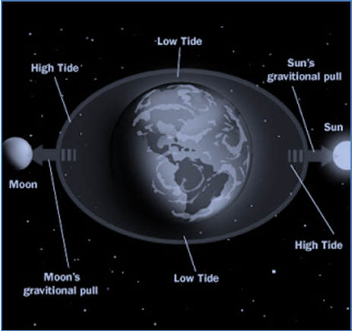
Since time immemorial, devotees have been fasting twice a month on the ekādaśī days. This fasting is, in general, for everyone. Ekādaśī (eka means ‘one’, and daśa means ‘ten’) is the eleventh day in the lunar cycle, counting from the new moon day and also from the full moon day.
According to research, the air pressure in the Earth’s atmosphere changes rapidly on both the day of the new moon (Amāvasyā) and the day of the full moon (Pūrṇimā). This is due to the orbital paths of the sun, moon, and Earth, and their varying distances from one another at particular intervals (for example, relative to the twenty-four-hour period for one complete rotation of the Earth). Accordingly, the atmospheric pressure changes drastically over time, and varies from day to day.
This is apparent from the changes in the ocean waves on the new moon and full moon days. On an Amāvasyā, the waves are very high and rough due to the increased atmospheric pressure on the ocean. However, after that the waves become calmer, indicating that the air pressure has lessened. On the eleventh day from the new moon or full moon days, the air pressure is at its minimum.
Compared to the other days of the lunar cycle, atmospheric pressure is lowest on ekādaśī, making this the best time to fast and cleanse our bodies. Due to higher air pressure, fasting on other days may have undesirable effects. On ekādaśī the body is more resistant to discomfort and pain while we cleanse ourselves, and the various organs, especially the liver, stomach, and bowels, will be refreshed. Since the atmospheric pressure doubles on the twelfth day from Amāvasyā and Pūrṇimā (dvādaśī), people fasting on ekādaśī are advised to consume food as early as possible the next day to avoid any complications in the body.
It is noted that fasting on ekādaśī is also very conducive for concentrating on meditation and prayers. According to science, it takes three or four days for the brain to absorb energy from our food after we eat. It is said that if we eat lightly or not at all on ekādaśī days, that energy will reach the brain at the optimal time on the new moon or full moon day.

Health Benefits
Nowadays, people also fast for health reasons; fasting helps in the detoxification of the body. Everyone wants to look good by keeping their bodies in shape. Accordingly, many youngsters across India are regularly fasting. In the medical context, fasting refers to the bodily condition after a meal is digested. A number of metabolic adjustments occur during fasting, and many medical diagnostic tests for blood sugar and cholesterol levels are standardized to fasting conditions. Thus, fasting in India has both medical and religious significance.
Cleansing of the bowels - those who fast on ekādaśī stay in good health; their bowel system is cleansed and they usually do not suffer from frequent ailments. Also, it is said that for those on the spiritual/religious path, observing ekādaśī fasting leads to the peace of self-realization. The austerity of fasting is believed to aid in the spiritual path by purifying the body and mind.
Providing a better way of life - Fasting improves blood circulation and elimination of toxins from the body, resulting in better overall health. The regular faster feels more energetic and alert, and is more resistant to diseases. Fasting even slows down the aging process, which in general is a result of our accumulated bad habits and negative thinking. A day of fasting teaches one self-control and discipline, and regular fasting helps us to break addictions that are spoiling our lives and to establish new, positive habits.
Now, let us look at some other scientific facts concerning the eleventh day from the full and new moons. In the Indian Vedic system, there are different methods to calculate a month. One such method involves counting from the new moon day (Amāvasyā). The period from the new moon day to the full moon day is called Śukla-pakṣa (waxing/growing moon). The period from the full moon day to the next Amāvasyā is known as Kṛṣṇa-pakṣa (waning/shrinking moon). In celestial phenomena, the Earth and moon rise and set at the same time on Amāvasyā. From the next day to Amāvasyā, the moon moves about twelve degrees from the solar path. On the ekādaśī day (eleventh day from the full moon), the moon stays at a distance of about 135 degrees from the solar path, and this results in lower gravitational force and lower atmospheric pressure. Therefore, fasting on ekādaśī will protect the bodily systems, and it is also said that hunger is at its minimum at this time.

Ekādaśī Kathā by Śrīla Bhakti Rakṣaka Śrīdhara Mahārāja
Ekādaśī is considered to be the favorite day of Kṛṣṇa, and it is when devotees refrain from material activities. Ekādaśī is aprākṛta. Aprākṛta means that which is like prākṛta, but is supramundane. We are warned that ekādaśī is not mundane, though it seems to be. Because it is influenced by the moon, ekādaśī seems to be mundane. The heat of the world and the watery portion of the body increase due to the influence of the moon, just as the high tide and low tide of the ocean are affected by the moon. As we approach the full moon and the new moon, the watery portion of our bodies is enhanced by the movement of the Earth, the moon, and the sun, and thereby the enjoying spirit is also developed.
So, fasting is necessary to meet with that external movement of nature. Fasting can save us from that peculiar reaction. Fasting has been recommended, and especially, if one can't fast at all, then one may take some process of diet that will give less cause for excitement. Therefore, one may take anukalpa (non-grains). We fast to check the senses, because the senses, by the natural flow, become more intense at that time. The result is that one will be excited and want to enjoy - to encroach on the environment. This unfair encroachment of one's own self is to be controlled; therefore, this fasting has been recommended - this is one way.
We take some types of food, and not others, because they are considered to be less injurious, and less exciting to the body. Also, it is mentioned in Hari-bhakti-vilāsa that some particular sins are fond of taking shelter in those foods that we reject. Pāpa means a type of sin that is very fond of taking shelter in grains and in places that we surely want to avoid. First-class fasting means without even taking water (nirjala). Those who cannot do without food may take fruit, roots, and milk.
Also, from the spiritual perspective, Kṛṣṇa Himself also feels more necessity for enjoyment, and when Kṛṣṇa feels more necessity, the devotees have a greater chance to offer service. The time is more valuable for them, because Kṛṣṇa wants to enjoy, and at that time, devotees should be busy to supply the things for His enjoyment - so much so that they won’t have any time for their own necessities. So, the first reason is to please Kṛṣṇa and the secondary reason is that by fasting, we can make our body dry and so our enjoying spirit will be lessened. This is the general explanation. There are so many other things also. Everything is conscious; everything is personal; and ekādaśī has her own personal character, and she devotes herself with all her company in the service of Kṛṣṇa.
She does not take any food or anything else, and also does not allow others in her group to take food or waste time, but is always engaged in the service of Kṛṣṇa. We are told that ekādaśī and dvādaśī are favored by Hari - the underlying cause is already explained. Hari will be pleased with any small service performed on these days. So, dvādaśī and ekādaśī are both considered the favorite days of Kṛṣṇa. Ekādaśī observance is compulsory; though dvādaśī is also honored as the favorite of Hari, still ekādaśī has preference. Dvādaśī has preference over ekādaśī only in eight cases, determined by the combination of nakṣatra, tithi, etc. - when we observe Mahā-dvādaśī and not ekādaśī.
On ekādaśī and dvādaśī, even a little service gives some greater remuneration. Remuneration means that our serving attitude and our earnestness will be enhanced at that particular time. In a deeper sense, this means that Hari, at that time, wants to accept more service. That is the fortune of the servitors - that Hari demands more of the servitors - so the importance for the servitors increases at that time during ekādaśī and dvādaśī. On dvādaśī, we do not pick the leaves of tulasī because it is considered that Tulasī-devī has observed fasting on ekādaśī.
It is also noted that service is the first consideration. If I fast and do not take any water, then I may have to lie down and not be able to do any service to the Lord. That is not desirable. So, to take anukalpa and do service to the Lord is better.
Service is better than sitting idly. So, if prasāda-sevā is taken as service, this is best. But at the same time, the individual position of a devotee should be considered. The Sahajiyās do not observe ekādaśī fasting at all. They say, “Oh, we are in Vṛndāvana - no fasting here!” But Śrīla Prabhupāda did not like this; the Sahajiyā, in the name of kṛṣṇa-bhakti, goes on feeding the senses. But when necessary for the service of Kṛṣṇa, to keep up the body, we take prasādam; we don’t like that by fasting the loss of energy may occur. In this way we honor ekādaśī. If fasting does not hamper our service, we may go on fasting.
Once on Janmāṣṭamī day, Hayagrīva Brahmacrārī (later Mādhava Mahārāja) had to arrange for Prabhupāda to go to Mathurā, in order to observe the Puruṣottama-māsa. Hayagrīva was sent one day earlier to hire a suitable house, and that day happened to be Janmāṣṭamī. Prabhupāda asked his own cook to feed Hayagrīva rice on Janmāṣṭamī day. “He will have to take a tedious journey and his energy will be wasted; he has an important duty to arrange that house there.” That was his order. But Hayagrīva hesitated and the cook also hesitated. Anyhow, he did not take rice on Janmāṣṭamī; instead, he took sābu (tapioca), plantain, and curd.
However, if Professor Sanyal had been in such a position, he would have certainly taken rice; he was so much adherent and extremely submissive to Prabhupāda’s order. He would have said, “Oh, Prabhupāda has asked me to take rice, so I must take rice!” That was his line of thought. But Hayagrīva hesitated, “No, no, it is not necessary. I am strong enough; I can do my duty.” Also, when Prabhupāda wanted to eat something on fasting days, he would take anukalpa.
My Guru Mahārāja felt that you will get the maximum energy if you take good food and you do good service. That was his maxim. Kṛṣṇa is not a liquidated party. Take full prasādam and do full service. Whatever is necessary, take it for the cause of Kṛṣṇa - not for your own cause. You are Kṛṣṇa’s, so if you grow weak and your service is hampered, then you will be the loser. “Better that my soldiers are well fed and working well” - that was my Guru Mahārāja’s principle.

Ekādaśī Kathā by Śrīla Bhakti-ballabha Tīrtha Gosvāmī Mahārāja
In Sanātana dharma scriptures of India, there are two main divisions: karma-kāṇḍa and bhakti. Karma-kāṇḍa is the part of the Vedic literatures that prescribes ritual and ceremonies suitable for the obtainment of material, temporary benefits. This is called karma-kāṇḍa–smārta. From smṛti comes the word smārta. Those brāhmaṇas who are well versed in smṛti are called smārta brāhmaṇas. They prescribe laws and regulations taken from the smārta scripture advising, “If you perform this sort of vow, you will get this sort of benefit.” To encourage worldly people, they speak of worldly benefits. By this the worldly-minded are inspired, but pure devotees do not want any such material, temporary benefits. This is called śuddha-bhakti. Devotees know the fact that whatever happiness and sorrow they are getting is because of their previous karma. No one can change that. Śrī Prahlāda Mahārāja said, “No one is working for sorrow. Everyone is working hard to stay happy. Still, one gets sorrow in life. Why? This is because happiness and sorrow will come as per our previous karma. It is better to perform righteous karma (devotion) so that our future is better.”
For example, there is Mohinī ekādaśī. It is said that one who observes Mohinī ekādaśī is relieved of the burden of all sins. In Karma-kāṇḍa śāstra, you may find that this sort of encouragement is given, but a śuddha-bhakta observes ekādaśī solely for the satisfaction of the Supreme Lord.
The purpose of the ekādaśī fast is to remember Bhagavān. Wherever your mind is, you are there also. It is said in scriptures that all sorts of sins are accumulated in grains on this day. Eating grains on ekādaśī means committing grave sins, and accumulating fruits of heinous sins that cannot even be imagined. One can eat many items other than grains on ekādaśī.
The effect of observing ekādaśī is illustrated in the story of the life of Ambarīṣa Mahārāja.
When Sage Durvāsā could not get any shelter throughout the fourteen worlds, he went to Śrī Viṣṇu. He fell flat before Śrī Viṣṇu and pleaded, “O Lord, Your Sudarśana Cakra is chasing me and wants to kill me. Please save me. I have traveled for one year to take shelter of You. Nobody will accept me or help me. Everybody says, ‘We cannot help you; you should go to Śrī Viṣṇu.' Now I have come to You. It is Your disc. You can help me and save me.”
Śrī Viṣṇu said, “I cannot save you.”
“What do You mean, Sir? If this is the case, to whom can I appeal? You are the supreme authority, and the weapon belongs to You. If You don’t help me, who will? You must help me; please help me.”
“No, I cannot help you, but I will advise you. You must go to whoever you committed an offense to and offer prayers to him. Then you will be saved.”
Then, the sage went to Śrī Ambarīṣa Mahārāja, who had been observing Śrī Ekādaśī vrata for one year. He had observed all of the ekādaśīs without taking even a drop of water.
On the day of daśamī he would eat only once, and on the day of dvādaśī he would eat only once. Although he was the emperor, he would spend all of his time in this way. He had established a congress committee to manage his empire. All of the ṛṣis (sages) would perform yajña with him on the bank of the Yamunā river. The king used to serve the Supreme Lord from morning until night, engaging all of his senses. He would look at the Lord with his eyes; hear the glories of the Lord with his ears; and smell flowers and tulasī offered at the feet of the Lord with his nose. He would honor the prasādam of the Supreme Lord, and prepare and cook bhoga for the Lord. Though he was the emperor, he thought of himself as a servant of the Lord. He would circumambulate the Lord’s temple and dhāma, offer obeisances, and perform many other services. All of the limbs and parts of his body were engaged in the service of the Lord. His whole life was dedicated to performing nine types of devotion: śravaṇa, kīrtana, smaraṇa, arcana, vandana, pāda-sevana, dāsya, sakhya, and ātmā-nivedana.
Śrī Ambarīṣa had performed the ekādaśī vrata for one year, completing it in Mathurā. On dvādaśī day, he distributed food, clothes, and cows in charity. When dvādaśī ends, trayodaśī begins.
As per the rules, if he would break his fast after dvādaśī ended, that would be an offense at the feet of Lord Viṣṇu. After distributing charity, Śrī Ambarīṣa noticed that only five minutes remained before the end of dvādaśī. He was about to break his fast when Sage Durvāsā came.
Śrī Ambarīṣa welcomed him and said, “Sir, it is fortunate for me that you have come. Please take bath and then take prasāda. I’m about to break my ekādaśī fast; only five minutes remain for me to do so.”
Durvāsā went to take bath, but he did not return right away.
Śrī Ambarīṣa thought, “What shall I do now? If five minutes pass and I do not break my fast, I will commit an offense at the feet of Lord Viṣṇu. However, if I eat or drink something now, before my invited guest Durvāsā has been served, he will accuse me of committing an offense to him and curse me. What shall I do?”
He consulted great scholars.
He concluded, “I will take one drop of water and put it on my tongue; that will break the fast. However, that drop of water will not relieve my hunger, and it is not food. Also, that drop will not relieve my thirst. So, niyama-rakṣā - in this way, my pāraṇa (breaking the fast) will be timely. It will not matter if Durvāsā is even half an hour late.”
As he took the drop of water, Sage Durvāsā arrived and said, “Mahārāja, you are a kṣatriya and a gṛhastha, whereas I am a yogī, a jñānī, and a great scholar. I have been to Brahma-loka. You were not able to recognize my superior position and you committed an offense. You promised me food, but before giving it to me, you took it first.”
Śrī Ambarīṣa said, “Sir, I did not take any food. You were late, and I was about to commit an offense at the feet of this Viṣṇu–vrata by not breaking my fast. So, I simply put a drop of water on my tongue. It was absorbed on my tongue and never even entered my throat. Please excuse me.”
“That is no excuse; I will punish you.”
Saying this, Durvāsā removed one of his jaṭā (dreadlocks) and threw it on the ground, and from that jaṭā a fiery being with a sword appeared. She wanted to kill Ambarīṣa, and she began moving towards him. Ambarīṣa simply stood there with folded hands. He was the emperor who had everything, including a military force, and who could do anything, but as if he had committed a great offense, he just stood there with folded hands. He waited, and when that devil approached him, Śrī Sudarśana Cakra suddenly appeared.
Śrī Viṣṇu holds Śaṅkha, Cakra, Gadā, and Padma in His four arms. The powerful Cakra can destroy the whole world.
Lord Viṣṇu had ordered that Cakra, “You must save Ambarīṣa. No one should be able to harm him. Not only that, but you must also look after his empire. You must patrol his empire, and if anybody attacks, you should protect it.”
Sudarśana destroyed that devil, and then went toward Durvāsā, who had created it. Afraid of dying, Durvāsā ran and ran to Bhūrloka, Bhuvarloka, Svarloka, Maharloka, Janaloka, Tapaloka, Satyaloka, and finally to Brahmā. Nobody could give him shelter, so finally he went to Brahmā and requested, “Please save me, sir.”
Brahmā replied, “I cannot save you. This weapon belongs to Viṣṇu. We must carry out the orders of Viṣṇu. It is only through the orders of Viṣṇu that I create the world."
After being rejected, Durvāsā went to Mahādeva and requested, “Sir, please save me.”
Mahādeva replied, “I cannot help you. I am only His servant. I follow Him and His advice, and I destroy the world whenever He wants.”
After Durvāsā was rejected again, he went to Viṣṇu. Śrī Viṣṇu said, “You must go to Ambarīṣa. You have committed an offense to him. He is the emperor and he could have had you killed, but he did not do so because he is a devotee. He always tries to give respect to all, and he never harms anyone. So, he did not harm you, although as the emperor he has weapons and a military force. He accepts suffering for himself, but he never allows others to suffer, and he never seeks revenge.”
If an ordinary person is wronged by another, he will say, “I want revenge. You have done this, so I must do that. You have harmed me, so now I must harm you.”
This is the attitude of revenge. A devotee does not have such an attitude; he always forgets and forgives. Thus, Śrī Ambarīṣa Mahārāja forgave the yogi Durvāsā.
Śrī Viṣṇu said, “You have committed an offense to Śrī Ambarīṣa. He did not harm you; you arrived late. He kept his promise; as you were not there, he did not take food. Now, he has been waiting for one year to have food. He will not accept any food until you have eaten. He still wants to keep his promise to you. One year has passed since you began running from one loka to another. Now, you should return to Śrī Ambarīṣa and offer your respects to him. If you beg him to excuse you, he will do so. Then, Sudarśana Cakra will stop pursuing you and leave. Until you do this, Sudarśana Cakra will never leave you alone. I cannot stop Sudarśana Cakra because Ambarīṣa is in My heart.”
sādhavo hṛdayaṁ mahyaṁ,
sādhūnāṁ hṛdayaṁ tv ahaṁ
“My heart is Ambarīṣa. I am the heart of Ambarīṣa; Ambarīṣa is My heart.”
Durvāsā asked, “So, what do I have to do?”
Śrī Viṣṇu replied, “Ambarīṣa must give the key to you. He has the key to the door. Your heart will be opened if he gives you the key. He is My heart, and I am his heart. Now, go to him.”
Then Durvāsā returned to Ambarīṣa and saw him waiting with folded hands.
Śrī Ambarīṣa said, “Sir, I have been waiting for you, and now you have come. Please take some food.”
Food was prepared and Durvāsā ate. Then he said, “Yes, now I can recognize and realize the glories of a Vaiṣṇava; a sādhu; a saint, and the extent of the power that you possess. I thought that I was more powerful than you. You are a kṣatriya and a gṛhastha, while I am a brāhmaṇa and a brahmacārī. My power was completely defeated by your power of devotion. So, now I can understand the glory of devotion to the Lord, and the glory of the devotees of the Lord. So, I offer my respects to you.”
Śrī Ambarīṣa said, “No, don’t offer your respects to me. I am a gṛhastha, so I must offer my respects to you.”
Śrī Ambarīṣa offered his respects to Durvāsā. Such is the character of a sādhu. One must be a sādhu. A sādhu is one who does not find fault with anybody - no fault at all. He thinks that he has many faults, although sādhus actually have no faults. They never do anything wrong. They think, “I am the one doing wrong. I am a sinner with so many faults. The sādhus are pure.”

Saṅkalpa Mantras for the Ekādaśī fast
Daśamī Saṅkalpa Mantra
daśamī divase prāpte vratasthohaṁ janārdana
tridinaṁ devadeveśa nirvighnaṁ kuru keśava
(Brahma-vaivarta Purāṇa)
Since today is daśamī, I am ready for a three-day vow. O Lord of lords, O Keśava, please see that no obstacles come to disturb my vow.

Ekādaśī Saṅkalpa Mantra (Vow to fast on ekādaśī)
ekādaśyāṁ nirāhāraḥ sthithvāhani pare hyahaṁ
bhokṣyāmi puṇḍarīkākṣa śaranaṁ me bhavācyuta
(Bṛhan-Nāradīya Purāṇa, 21st Chaper, Verse 15)
After fasting on ekādaśī, I will honor prasādam on dvādaśī. Please be my refuge, O Acyuta!
Saṅkalpa for fasting for two days
adyaśvaśeha nirāhāro bhūtvāhaṁ dvādaśī dine
vidhāsye pāraṇaṁ deva prīto bhava ma māniśam
(Varāha Purāṇa)
I will fast tonight and tomorrow, and break the fast on dvādaśī. O Lord, may You be pleased! (The evening meal on daśamī, two meals on ekādaśī, and the evening meal on dvādaśī - four meals in total - are forbidden over these three days.)
Dvādaśī Saṅkalpa Mantra
ekādaśyupavāsena dvādaśī pāraṇena ca
yadarjitaṁ mayā puṇyam tena prīṇātu keśava
May Lord Keśava be pleased with the pious merit that I have earned by fasting on ekādaśī and breaking the fast on dvādaśī.
Pāraṇena Anantara Samarpaṇa Mantra
(Dedication of the result to Bhagavān after breaking the fast)
ajñāna-timirāndhasya vṛtenānena keśava
prasannaḥ sumukhobhūtvā jñāna-dṛṣṭi-prado bhava
O Lord, O Keśava, I am blinded by the darkness of ignorance. May my fasting on ekādaśī please You so that You will bless me with the light of knowledge.

Ekādaśī-kathā by Śrīla Nārāyaṇa Gosvāmī Mahārāja
Śrīla Nārāyaṇa Gosvāmī Mahārāja: Do you know the story of Sagara Mahārāja? He had many sons, and one son was named Asamañjasa. From his boyhood, Asamañjasa was very wicked, so much so that he used to kill other boys by drowning them. Sagara Mahārāja exiled him, telling him, “You are no longer in our family line. You must leave.” Asamañjasa then went to the forest, where he began to grow a mustache and beard, and to engage in activities that were opposed to Indian culture. It is from him that the Yavana race manifested. While we follow ekādaśī, the Yavanas refuse to do so. The only similarity between us and them is that we walk on our feet and they do as well. If they could walk on their hands, they would.
%^%
Śrīla Nārāyaṇa Gosvāmī Mahārāja: The best way is to serve guru and follow his instructions. By chanting the holy name, all of your wishes will be fulfilled, and all of your miseries and problems will disappear. In this way, after some time, you will serve Rādhā and Kṛṣṇa in your transcendental form and be happy forever. This is the highest aim and object of our life. I want everyone to be happy.
Indulekhā dāsī’s niece: Yesterday was the first time that I observed ekādaśī. I did it for my mother, though, because she is dying of liver cancer.
Śrīla Nārāyaṇa Gosvāmī Mahārāja: This is good. There was once a cow lying on the street, dying. Her body was flapping about, but her life was not leaving her body. One of my lady disciples saw her and said, “O Mother Cow, I am giving you the fruit of one of my ekādaśīs. You should now be able to very easily give up your life.” Then at once, without delay, the cow left her body. Last year, one of Nanda-gopāla’s horses was dying, and at the same time, not dying. I said ‘Hare Kṛṣṇa’ in his ear, and he easily left. This chanting is miraculous and very powerful.
%^%
Śyāmarāṇī dāsī: Today is ekādaśī. In relation to ekādaśī, you once told the history of Rukmāṅgada Mahārāja. You said that his first wife was willing to sacrifice the life of her son so that his new wife, Mohinī, would not leave him. What is the value of her sacrificing her own son so that a materialistic woman would stay and be happy with her husband?
Śrīla Nārāyaṇa Gosvāmī Mahārāja: She was a chaste lady (pati-vratā), so she wanted her husband’s vow to be fulfilled. She desired that he would not be deviated from his word: “I will always follow ekādaśī.”
Śyāmarāṇī dāsī: That is clear. But Mohinī had told Rukmāṅgada, “If you follow ekādaśī, I will leave you.” Rukmāṅgada was determined to follow ekādaśī whether Mohinī would stay or not. Still, the chaste wife did not want Mohinī to leave. Because of that, she was willing…
Śrīla Nārāyaṇa Gosvāmī Mahārāja: She knew that this new lady was favorable for him in the sense that she could fulfill his desires (kāma-vāsanā). She thought, “I cannot satisfy him, but she can; so it is better that she doesn’t go. It is better that she stays with my husband.”
Bhadrā dāsī: This is Vāsudeva Datta Prabhu. He has been in ISKCON for twenty years or more, and he has been looking forward to meeting you.
Śrīla Nārāyaṇa Gosvāmī Mahārāja: Are you happy?
Vāsudeva Datta dāsa: Yes, very happy.
Śrīla Nārāyaṇa Gosvāmī Mahārāja: ISKCON leaders cannot give you prema-bhakti, but we can give it to you. That is why, when I come to any city, the ISKCON leaders create festival programs so that their disciples will not come to our program. Some ISKCON devotees preach that, “Nārāyaṇa Mahārāja gives harināma and dīkṣā initiation to the disciples of Śrīla Bhaktivedānta Svāmī Mahārāja, and that is why he changed the name of Jadurāṇī to Śyāmarāṇī.”
Brajanātha dāsa: They call this re-initiation.
Śrīla Nārāyaṇa Gosvāmī Mahārāja: I never do this. Out of affection, I gave her this name. I cannot address her as ‘Jadurāṇī’. I can address her as ‘Śyāmarāṇī’. Śrīla Bhaktivedānta Svāmī Mahārāja inspired me to give her this nickname. When she first came to him, he wanted her to understand Kṛṣṇa’s Godhood. He therefore gave her the name ‘Jadurāṇī’, which is in relation to Kṛṣṇa in Dvārakā. Now he wants her to further her understanding of Kṛṣṇa in Vṛndāvana, so he inspired me to give her the name ‘Śyāmarāṇī’.
%^%
I think it is proper that on holidays like Janmāṣṭamī and ekādaśī, and on Sundays, all of you should attend the programs at the farm, and give classes there also. Paṇḍitajī should give respect to the senior Vaiṣṇavas. Preach together, without difference of opinion, and give respect to each other. In this way so many new devotees will come. I have created this harmonious situation in so many places. In Houston, for example, all the devotees are together, giving respect to each other and helping each other. In Mathurā, India, I used to go to homes and give programs. I used to invite those in each home to our grand-scale Janmāṣṭamī procession with horses, camels, elephants, kīrtana parties, big bands, and with more than 5,000 devotees performing kīrtana. In this way I have preached in Mathurā, Navadvīpa, and so many other places.
Try to preach like this – all together. There should be no difference of opinion. You can take turns preaching, and you can do house programs. I think that many new persons will be coming to the āśrama, so they should hear all the topics that I have been speaking about.
$^$
Rāma-tulasī dāsa: Is Ekādaśī-devī Śrīmatī Rādhikā?
Śrīla Nārāyaṇa Gosvāmī Mahārāja: Ekādaśī is not Rādhikā, but she may be considered a manifestation of Rādhikā. Kṛṣṇa has personally become ekādaśī. Since ekādaśī and Kṛṣṇa are the same, and Rādhā and Kṛṣṇa are the same, it can be said that ekādaśī is a manifestation of Rādhikā. Śrīmatī Rādhikā, who is the personification of hlādinī-śakti (Kṛṣṇa’s supreme pleasure potency), is more than ekādaśī. In Goloka Vṛndāvana, there is no observance of ekādaśī. Ekādaśī is only for those practicing sādhana (devotion) in this material world. There, in Goloka Vṛndāvana, Śrīmatī Rādhikā is the supreme power of Kṛṣṇa, so there are differences between Her and ekādaśī. (Note: One might argue that Nanda Mahārāja followed ekādaśī, and he is a resident of Goloka Vṛndāvana. Actually, Nanda Mahārāja follows ekādaśī only in prakaṭa-Vṛndāvana, Vṛndāvana as it is manifested in this world, which is sādhana-bhūmī, the world of devotional practice. He did so only for the purpose of teaching others - Śrīpāda Mādhava Mahārāja.)
Rāma-tulasī dāsa: There is a story that when Kṛṣṇa was sleeping in a cave, the Mura demon came to kill Him. At that time, a śakti (power) came out from Kṛṣṇa’s body in the form of a devī (goddess) with many arms and killed that demon.
Śrīla Nārāyaṇa Gosvāmī Mahārāja: I think you are referring to Śrīmad-Bhāgavatam’s narration of the demon Kālayavana. When Kālayavana was chasing Kṛṣṇa, Kṛṣṇa entered a cave where Mahārāja Mucukunda was sleeping. Mucukunda had previously gone to heaven to fight.
Rama-tulasī dāsa: There is a book about ekādaśī that was written by Kṛṣṇa-Balarāma Svāmī. In that book there is a description of a manifestation of that devī. It states that when Kṛṣṇa woke up, He saw her with multiple hands.
Śrīla Nārāyaṇa Gosvāmī Mahārāja: That book is not authentic. Kṛṣṇa-Balarāma Svāmī does not follow his own guru, Śrīla Bhaktivedānta Svāmī Mahārāja. He thinks, “I was born as a brāhmaṇa and my gurudeva was not; so I am greater than him.” He came to me, but I refused to meet with him. I told him, “You don’t have any faith in your gurudeva or guru-paramparā. Śrīla Raghunātha dāsa Gosvāmī was not born in a brāhmaṇa family, but he is equal to Śrīla Rūpa Gosvāmī, Śrīla Sanātana Gosvāmī, Śrīla Raghunātha Bhaṭṭa Gosvāmī, Śrīla Jīva Gosvāmī, and Śrīla Gopala Bhaṭṭa Gosvāmī. Śrīla Narottama dāsa Ṭhākura was not a brāhmaṇa by birth, but he was more qualified than any brāhmaṇa.” Kṛṣṇa-Balarāma Svāmī’s thoughts are very bad. It is best not to read his book.
Śrīpāda Padmanābha Mahārāja: In that ekadāsī book he collected many stories from different Purāṇas for each ekadāsī.
Śrīla Nārāyaṇa Gosvāmī Mahārāja: We also have a collection of such histories, but not in English. Ours is in Bengali, but we can translate it into English. That translation will be authoritative.
Balarāma dāsa: Can I ask you a question, Gurudeva? Tomorrow is nirjala ekādaśī (to be observed by full fasting, even from water). If there were any defects in our following ekādaśīs during the year, how can we properly observe this nirjala ekādaśī?
Śrīla Nārāyaṇa Gosvāmī Mahārāja: We should try to follow all ekādaśīs. If there was a defect in your observance of any previous ekādaśīs, simply continue practicing. By chanting nāma, everything will be okay.
Balarāma dāsa: Should one clean one’s teeth on nirjala ekādaśī?
Śrīla Nārāyaṇa Gosvāmī Mahārāja: Why not? Should you not take bath?
Balarāma dāsa: Bath is not drunk.
Śrīla Nārāyaṇa Gosvāmī Mahārāja: But somehow the water is entering your body. Of course, you must bathe, but do not take caraṇāmṛta on that day; simply offer praṇāma to the caraṇāmṛta.
Balarāma dāsa: What about ācamana?
Śrīla Nārāyaṇa Gosvāmī Mahārāja: Just touch the water to your lips.
Vṛndāvana dāsa: When you do ācamana, the water is supposed to go to your heart. It says in the Hari-bhakti-vilāsa that the proper way to do ācamana is like this (demonstrates) – like a chicken.
Śrīla Nārāyaṇa Gosvāmī Mahārāja: I have not seen this in any scripture.
Vṛndāvana dāsa: It also says that when you take ācamana, it has to come into the body and purify the heart.
Śrīla Nārāyaṇa Gosvāmī Mahārāja: You can take ācamana in that way on other days, but not on ekādaśī.
Śrīpāda Nemi Mahārāja: Actually, if we have somehow or other not observed other ekādaśīs, will observing nirjala ekādaśī compensate?
Śrīla Nārāyaṇa Gosvāmī Mahārāja: I have just answered this. You can compensate only by harināma – not by properly following nirjala ekādaśī. You will have to follow every ekādaśī. Only for Bhīma was a concession given; only for him.
Vṛndāvana dāsa: We always understood that if someone does not observe the other ekādaśīs throughout the year, if he very strictly follows Pāṇḍava nirjala ekādaśī, then he won’t get a bad reaction for not following all of the other ekādaśīs. Is this not true?
Śrīpāda Mādhava Mahārāja: It is not true at all.
Vṛndāvana dāsa: No, but we always thought this. Everyone thought this.
Nṛhari dāsa: It is also stated in Kṛṣṇa-Balarāma Svāmī’s book – the book you told us not to read.
Śrīla Nārāyaṇa Gosvāmī Mahārāja: They are all wrong. ISKCON [the disciples of Śrīla Bhaktivedānta Svāmī Mahārāja, but not Śrīla Bhaktivedānta Svāmī Mahārāja personally] has discovered this.
Vṛndāvana dāsa: They are doing this because of Bhīma.
Śrīla Nārāyaṇa Gosvāmī Mahārāja: They are not Bhīma. From ancient times up to the time of the Six Gosvāmīs, like Śrī Rūpa and Śrī Sanātana Gosvāmī, devotees used to observe all ekādaśīs as nirjala ekādaśī, without taking even water. Ambarīṣa Mahārāja observed each ekādaśī for three days: on the first day he controlled his eating; on the second day he avoided eating and drinking (nirjala); and on the third day he ate only once.
Śrīpāda Mādhava Mahārāja: The Pāṇḍavas used to regularly observe nirjala ekādaśī, but Bhīma once told Kṛṣṇa, “It is not possible for me to do nirjala every time. Kṛṣṇa replied, “On other ekādaśīs you can take fruits and roots, but you must follow nirjala on this one day.” Bhīma was thus permitted to observe nirjala on this day alone, but he had to observe all the other ekādaśīs. This day is therefore called Pāṇḍava nirjala ekādaśī.
Śrīla Nārāyaṇa Gosvāmī Mahārāja: In India, every ekādaśī is generally observed without food or water. Pūjyapāda Śrīla Bhaktivedānta Svāmī Mahārāja saw that the Western devotees were somewhat weak, so he introduced a concession for them. He said that they could take anukalpa (eating a little, just to maintain one’s life) three times in the day. However, instead of following anukalpa, they took ‘bṛhat-kalpa,’ eating and drinking as much as they could take. Do you understand? This is not good.
Brajanātha dāsa: They say that if they do not eat sufficiently, they would not have any strength or power.
Śrīla Nārāyaṇa Gosvāmī Mahārāja: Bogus; that was the argument of Mohinī. (Mohinī was the enchanting and alluring female creation of Brahmā who tested King Rukmāṅgada, a determined follower of ekādaśī.)
^%^
Excerpts from The Hidden Path of Devotion, chapter 3
Which limbs are practiced in rāgānuga-bhakti? Which are essential and which are disregarded? To answer this, Śrīla Viśvanātha Cakravartī Ṭhākura has described five categories of devotional practices for a person with genuine greed:
(1) Abhīṣṭa-bhāva-mayī: absorption in one’s siddha-bhāva – the mood of a mañjarī.
(2) Abhīṣṭa-bhāva-sambandhī: those practices related to one’s cherished mood. Such practices surely deliver the desired goal.
(3) Abhīṣṭa-bhāva-anukūla: those practices which are favorable to one’s cherished mood.
(4) Abhīṣṭa-bhāva-aviruddha: those practices which are neutral, neither favorable nor opposed to one’s desired mood.
(5) Abhīṣṭa-bhāva-viruddha: those practices which are detrimental to the attainment of one’s desired mood.
… First is abhīṣṭa-bhāva-mayī, and then bhāva-sambandhī. The practices of bhāva-sambandhī are superior to those of nimitta-kāraṇa, which are bhāva-anukūla. The bhāva-sambandhī practices are the mūla-kāraṇa, the main cause, in the development of abhīṣṭa-bhāva-mayī. Ekādaśī, Janmāṣṭamī, etc. are secondary. The injunction that ekādaśī is secondary is for a person who gives stress to ekādaśī, Janmāṣṭamī, and Rāma-navamī, but who is not hearing hari-kathā, chanting, and remembering Kṛṣṇa. What is the harm in neglecting ekādaśī? For one who has greed and is so engaged in bhāva-mayī or bhāva-sambandhī that he is unaware of his external surroundings, there is no harm. Vaṁśī dāsa Bābājī Mahārāja is an example of this. He was observing ekādaśī for three or four days, on Aṣṭamī (the eighth lunar day) and Navamī (the ninth lunar day). Then, on ekādaśī, the eleventh lunar day, he was completely unaware of the day due to being absorbed in internal consciousness. Similarly, Śrīla Raghunātha dāsa Gosvāmī would be internally absorbed in remembering his services in the pastimes of Rādhā and Kṛṣṇa for many days, and ekādaśī would pass by at that time. Because these two mahā-bhāgavatas (topmost self-realized devotees) were performing rāgānuga-bhajana, there was no harm in their missing ekādaśī. However, if one misses ekādaśī when one is externally conscious, this would be very harmful for his bhakti.
Śrīpāda Śrīdhara Mahārāja:
vidhi-mārga-rata-jane svādhīnatā ratna-dāne
rāga-mārge karān praveśa
rāga-vaśavartī haiyā pārakīya bhāvāśraye
labhe jīva kṛṣṇa-premāveśa
Kalyāṇa-kalpataru by Śrīla Bhaktivinoda Ṭhākura
[To the person fixed in the regulative principles, the holy name gives the jewel of independence, placing him on the path of spontaneous devotion (rāgānuga-bhakti). That person, overcome by spontaneous attachment to the Lord, takes shelter of the parakīya mood and goes on to become absorbed in love for Śrī Kṛṣṇa.]
Śrīla Nārāyaṇa Gosvāmī Mahārāja: The meaning of this śloka is that in Śrī Caitanya Mahāprabhu’s sampradāya the practices of vaidhī-bhakti take one to rāgānuga.
Śrīpāda Dāmodara Mahārāja: Does that vaidhī-bhakti have a special name?
Śrīla Nārāyaṇa Gosvāmī Mahārāja: No. It is not rāgānuga at first. It begins from vaidhī-bhakti. If one in the line of Śrīla Rūpa Gosvāmī follows vaidhī-bhakti, that vaidhī-bhakti is really the beginning of rāgānuga. Will a rāgānuga-bhakta follow ekādaśī, or not?
Devotees: Yes.
Śrīla Nārāyaṇa Gosvāmī Mahārāja: Is this vaidhī-bhakti or rāgānuga-bhakti?
Devotees: Vaidhī.
Śrīla Nārāyaṇa Gosvāmī Mahārāja: Will that rāgānuga-bhakta celebrate Janmāṣṭamī (Śrī Kṛṣṇa’s appearance day), or not? And what about Nṛsiṁha-caturdaśī? Is Nṛsiṁha-caturdaśī (the appearance day of Lord Nṛsiṁhadeva) vaidhī-bhakti or rāgānuga-bhakti?
Śrīpāda Mādhava Mahārāja: It is one hundred percent vaidhī.
Śrīla Nārāyaṇa Gosvāmī Mahārāja: Still, everyone should observe these holy days, otherwise they will be corrupted.
Śrīla Nārāyaṇa Gosvāmī Mahārāja: [Speaking to a brahmacārī] My brahmacārī, do you want to go down? [Meaning, do you want to leave your brahmacārī-āśrama?]
Devotee: Yes.
Śrīla Nārāyaṇa Gosvāmī Mahārāja: I will slap you. Sannyāsīs should not fall down, and brahmacārīs should prepare to become sannyāsīs in the future. One who gives up either the sannyāsa or brahmacārī āśrama has no bhakti. Be careful. What you want depends on you. I cannot control you.
^%^
Yaśasvinī dāsī: If someone performs nirjala ekādaśī but takes your personal prasādam remnants, does that break the ekādaśī? (Nirjala: nir means ‘no,’ and jala means ‘water;’ - to observe a full fast, even from water.)
Śrīla Nārāyaṇa Gosvāmī Mahārāja: Yes.
Yaśasvinī dāsī: So which is better – to do nirjala and take Gurudeva’s remnants, or do nirjala and not take it?
Śrīpāda Mādhava Mahārāja: You can keep Gurudeva’s remnants for honoring on the day after nirjala. [In that way nirjala is protected and the devotee is also honoring Gurudeva’s prasādam.]
Devotee: I have committed some offenses.
Śrīla Nārāyaṇa Gosvāmī Mahārāja: Don’t commit offenses. If you increase your chanting, offenses will disappear.
^%^
Mahābuddhi dāsa: There is a local Indian priest who recites Bhagavad-gītā and Śrīmad-Bhāgavatam, and he knows Bengali and Hindi. He wants to take initiation from you.
Śrīla Nārāyaṇa Gosvāmī Mahārāja: See if he will follow the four regulative principles. He will have to follow ekādaśī, and he cannot take meat, wine, eggs, and so on.
Mahābuddhi dāsa: If he hears this personally from you, it will make a strong impression on him and he will be able to follow.
Śrīla Nārāyaṇa Gosvāmī Mahārāja: Please bring him; I will tell him.
^&^
It is not difficult to perform bhajana. Kṛṣṇa is very merciful. He has invested all His energies, mercy, and qualities in His holy names. Whatever Kṛṣṇa can do, His name can also do. This is why the chanting of His holy names is the easiest sādhana to perform, whether sitting, standing, moving, sleeping, at night, in the day, after bathing, without bathing, in a pure state, or in an impure state. The Lord has given such a great chance that even if you chant His holy names only one time, He will very quickly take you to Goloka Vṛndāvana where there is no birth, death, lamentation, or distress; where we find only transcendental service to Rādhā and Kṛṣṇa, for an eternal life full of bliss, devotion, happiness, and peace. Do bhajana, chant the holy name, and observe ekādaśī, Janmāṣṭamī, and other festivals. You are already earning money, so you can maintain your family and at the same time do bhajana. What I have just taught you is the essence of all śāstras, Vedas, Purāṇas, and Śrīmad-Bhāgavatam. Don’t say, “I will start doing bhajana tomorrow.” What you have decided to do tomorrow, do it today; what you have decided to do today, do it now. Tomorrow may be the end of the world. Nobody can be sure whether or not ‘tomorrow’ will come at all. So from today, from this very day, start doing bhajana.
Śrīpāda Tridaṇḍī Mahārāja: How will they have time for bhajana when they have to look after their families?
Śrīla Gurudeva: Kṛṣṇa will look after their families. If a person’s wife is dying, the only thing he can do is take her to the hospital. Kṛṣṇa has created rules and regulations that everyone has to die, and those who are dying will come again in rotation. Only those who perform bhajana will not come again; they will go to Goloka Vṛndāvana. Gṛhasthas should maintain their families, but at the same time always remember Kṛṣṇa and do bhajana. This is essential.
Rādhā-kānta dāsa: Can one attain sādhu-saṅga by engaging in pious acts?
Śrīla Gurudeva: No, this is not possible. By performance of pious acts you can get money, beautiful women, husbands, sons, and other facilities, but you cannot come to bhakti. In order to come to bhakti, one must visit the dhāma, do parikramā, follow ekādaśī and Janmāṣṭamī, offer ghee lamps, and do some sevā for the sādhus residing there. Bhāgavata-sukṛti will arise, and from this one can get sādhu-saṅga. Even millions of lifetimes of pious acts cannot get you sādhu-saṅga; you will continue roaming in this material world.
^%^
My special request is that all the devotees who are in our maṭha in Govardhana, especially young ladies and boys, will plan how to distribute books during ekādaśi and Pūrṇimā days when so many religious persons perform parikramā around Śrī Girirāja Govardhana. Discuss with each other how to set up book tables on the parikramā-mārga [path]. From there, thousands of books will be distributed.
^&^

Illuminations from the book “Śrī Hari-vāsara-kathā”
The meaning of the term ‘Hari-vāsara’ is ‘the day of Lord Śrī Hari’. Actually, every moment of every day, week, month, and year depends on Śrī Hari; however, the scriptures specify certain days as special. On such days, which are known as ‘Hari-vāsara’, Lord Hari personally expands into the entire day.
It is the duty and dharma (religious principle) of every living entity to observe a vow of fasting on all of these days. However, in current times human beings have forgotten their dharma; therefore, religious principles have been established as duties in the scriptures through vidhi-vidhāna (positive injunctions and regulative principles).
All of these duties have been established so that the living entities may achieve auspiciousness. Śrī Hari Himself does not have any personal gain or loss in this. Parents must sometimes use clever means to convince a sick child to eat properly and take the prescribed medicine; out of love they want their child to be happy and healthy. Similarly, Śrī Hari has established the system of vows and fasts for the benefit of human beings. All of the living entities are His parts and parcels - children of Śrī Hari. Therefore, only Śrī Hari knows perfectly how the living entities can be happy.
It is certain that by practicing the vow of fasting on the day of Śrī Hari (Hari-vāsara), the living entity becomes completely free from all types of sins and miseries. Only the vow of Śrī Hari-vāsara is capable of destroying all of the sins of the living entities; there is not even the slightest doubt about this. One can obtain temporary relief from sins and miseries through other vows or efforts, most of which are inconvenient and troublesome. Therefore, every pious living entity should follow the vow of Śrī Hari-vāsara and experience its glories.
Ordinary people regard only the day of ekādaśī to be ‘Śrī Hari-vāsara’. However, Śrī Kṛṣṇa-janmāṣtamī, Śrī Rāma-navamī, Śrī Nṛsiṁha-caturdaśī, and other such appearance days of Bhagavān are also special and should be considered as ‘Śrī Hari-vāsara’. Therefore, one should observe fasting on the appearance days of Bhagavān, just as one does on ekādaśī. In Śrī Caitanya-caritāmṛta, there are brief instructions from Śrī Caitanya Mahāprabhu regarding what days to fast on, the timing of fasting, how to observe fasting, the benefits of fasting, and the consequences of not fasting.
ekādaśī, janmāṣṭamī, vāmana-dvādaśī
śrī-rāma-navamī, āra nṛsiṁha-caturdaśī
ei sabe viddhā-tyāga, aviddhā-karaṇa
akaraṇe doṣa, kaile bhaktira lambhana
“Ekādaśī, Janmāṣṭamī, Vāmana-dvādaśī, Rāma-navamī, and Nṛsiṁha-caturdaśī should all be observed. You should recommend the avoidance of mixed ekādaśī, and the observance of only pure ekādaśī. You should also explain the fault in not observing these days. One should be very careful concerning this topic. If one is not careful, one will be negligent in executing devotional service.”
The glories of these days and the proper way of observing vows on them are described in the scriptures. This information has been compiled and explained in a certain manner. One should certainly read about this the day before observing a vow of fasting. By doing so, one will cultivate faith and respect, and also be able to properly understand and follow the process. As a result, the living entity will attain the topmost auspiciousness.

The vow of fasting on ekādaśī
The day of ekādaśi is not any ordinary day of this dull material world. It is directly the beloved of Bhagavān Viṣṇu; in other words, it is Bhagavatī Devī. Ekādaśī mahā-puṇyā viṣṇor īśasya vallabhā (Vaiṣṇava-tantra) - “This most virtuous day bestows the happiness of the Supreme Lord Viṣṇu.” The most merciful Lord Śrī Jagannātha-deva is personally present in this world in the form of ekādaśī. It is to be understood that the infinite potency of Viṣṇu has manifested in the form of the most auspicious day of ekādaśī in order to bring about the welfare of all of the living entities (Bhaviṣya Purāṇa).
This day of ekādaśī is known in the scriptures by different names such as ‘Hari-vāsara’, ‘Mādhava-tithi’, ‘Vaiṣṇava-tithi’, and ‘Harer-dina’. The appearance days of Bhagavān, such as Śrī Kṛṣṇa-janmāṣṭamī and Rāma-navamī, are also known by the name ‘Hari-vāsara’ (the day of Lord Hari). Therefore, discussions about the significance, goals, process, and regulations regarding the vow of ekādaśī also apply to other days of Lord Hari, such as Śrī Janmāṣṭamī.
It is essential to fast on this most auspicious day. “All of the scriptures repeatedly proclaim that one should never feed grains to anyone when the day of Lord Hari (Hari-vāsara) arrives.” (Padma Purāṇa). These words were spoken by Śrī Rukmāṅgada to Mohinī. In Pādmottara Khaṇḍa, Śrī Śiva speaks the same words to Śrī Durgā. “When ekādaśī arrives, all sins, such as the sin of killing a brāhmaṇa, take shelter of grains. Therefore, if one eats grains on the day of Lord Hari, he simply eats sins.” (Śrī Nāradīya Purāṇa, 1.23.8) “One who eats grains on the day of ekādaśi practically eats all of the sins on the Earth.” (Śrī Nāradīya Purāṇa, 2.13.16) “If one eats anna (grains) on ekādaśī, he becomes the killer of his mother, father, brother, and guru (guruhā). He falls down from the abode of Lord Viṣnu forever.” (Skanda Purāṇa) “It is possible to atone for sins such as killing a brāhmaṇa. However, if one eats grains on ekādaśī, atonement is not possible.” (Bṛhan-nāradīya Purāṇa)
Some people may think, “Although I will fast from grains on ekādaśī, there is no harm in feeding grains to family members, relatives, or guests for their satisfaction.” In this connection, Lord Śīva tells Goddess Pārvatī in Padma Purāṇa, “Advising family members, relatives, friends, and guests to eat grains on ekādaśī is the same as advising them to kill a brāhmaṇa, to kill a woman, or to drink liquor. All of these activities result in the same degradation.” “On ekādaśī, it is everyone’s duty to fast with his children, wife, and relatives.” (Viṣṇu-dharmottara)

eka dina mātṛ-pade kariyā praṇāma
prabhu kahe–mātā, mohe deha eka dāna
One day Śrī Gaurasundara offered obeisances at the feet of Mother Śacī and requested, “Mother, please grant Me a wish.”
mātā bale–tāhi diba, tumi yā māṅgibe
prabhu kahe–ekādaśīte anna nā khāibe
Mother Śacī replied, “I will give You just what You ask for.” The Lord said, “Mother, do not eat grains on ekādaśī.”
śacī kahe–nā khāiba, bhāla kahilā
sei haite ekādaśī karite lāgilā
Mother Śacī replied, “You have spoken very nicely. I shall not eat grains on that day.” From that day onwards, Mother Śacī observed ekādaśī.
(Caitanya-caritāmṛta, Ādi 15.8,9,10)
If Bhagavān Śrī Gaurasundara requested that His own mother follow the vow of Śrī Ekādaśī, that request is certainly of great importance for all of us mortal human beings. Thus, it is essential for all human beings, both male and female, to observe this vow of fasting.
The ruler of Devapura, the great devotee King Rukmāṅgada, used to proclaim the following while beating a drum on the back of his largest elephant:
aṣṭavarṣādhiko martyo hy aśītir naiva pūryate |
yo bhuṅkte māmake rāṣṭre viṣṇor ahani pāpakṛt ||76||
sa me vadhyaś ca nirvāsyo deśataḥ kālataś ca me |
etasmāt kāraṇād vipra ekādaśyām upoṣaṇam |
kuryān naro vā nārī vā pakṣayor ubhayor api ||77||
(Śrī Nāradīya Purāṇa)
“If anyone in my kingdom between the ages of eight and eighty eats grains on the day of ekādaśī, he will be killed or banished. Every man and woman must fast on both the ekādaśī that occurs in the dark fortnight and the one that occurs in the bright fortnight.”

To satisfy the curious and to inspire feelings of devotion in the hearts of the people of this world, the history of King Rukmāṅgada will now be summarized.
The king of Kauśika was dedicated to the devotional service of Bhagavān, and he was especially strict in executing the vow of ekādaśī. He would proclaim to the entire kingdom, accompanied by various drums: “Today is ekādaśī; therefore, anyone between the ages of eight and eighty who eats grains will be executed or banished from the kingdom. What to speak of others, this order applies to my own family members and relatives. My father, mother, wife, son, and friends will all have to observe this vow; otherwise, they will be severely punished. On the day of ekādaśī, one will have to take bath in the Ganges and give charity to an elevated brāhmaṇa.”
As a result of following this order of the king and observing ekādaśī, all of the residents of his kingdom went to the spiritual world of Vaikuṇṭha after death. Dharmarāja Yama did not have any work to do in the hellish world, and his account-keeper Citragupta no longer needed to take account of people’s pious and impious activities.
One day, Devarṣī Nārada arrived in the city of Yama and heard the story of how Yama was distressed due to lack of residents in the hellish world. Then, Yamarāja, Citragupta, and Nārada went to Satyaloka and apprised Brahmā of the situation. Brahmā pondered for a while about how to satisfy the pride of Yamarāja, and then he created a very beautiful woman whose name was Mohinī. He ordered her: “Quickly go to Mandāra Mountain and enchant King Rukmāṅgada.”
Mohinī offered obeisances to Brahmā and then went to the pinnacle of Mandāra Mountain. She sat there and began to sing a beautiful melody called Malhāra. Attracted by that singing, demigods, demons, and other living entities began to arrive there.
King Rukmāṅgada gave the kingdom to his son Dharmāṅgada and went to the forest to hunt. Actually, he only went on the pretext of hunting; his real purpose was to protect his subjects by killing dangerous, violent criminals and theives. After accomplishing this, the king rode by horse one hundred and eight yojanas to the āśrama of Vāmadeva Muni. The muni could understand that in his previous life the king was a śudra who had a wicked wife, and as a result of this, he would have to experience poverty in his present life. However, in this lifetime, he received the wealth of a king due to executing the vow of ekādaśī.
With the permission of Vāmadeva Muni, the king visited Mandāra Mountain. There he saw that all of the animals and birds were going toward some extraordinary musical sound. The king investigated and discovered that the sound was coming from the beautiful Mohinī, who had a complexion like molten gold. Attracted by her beauty, he asked her to become his wife. Mohinī said, “I am the daughter of Brahmā. After hearing of your glories, I am worshipping Śaṅkarajī (Lord Śiva) by singing in order to obtain you as a husband. He has immediately answered my prayers.” The king placed his hand on Mohinī’s hand and took a vow: “Mohinī, whatever desires you have, I will fulfill.” Then they returned to the capital.
After returning home, the king spent eight years enjoying sensual pleasure with Mohinī. After another year, when the auspicious month of Kārttika arrived, the king told Mohinī, “I have spent many years enjoying your company. Now, I want to give up my attachment to you and observe the vow of Kārttika. Please give me permission to do so.”
During the entire time that the king had been engaged in sense gratification with Mohinī, he had never disrespected the vow of ekādaśī. Mohinī replied, “I cannot live for even a moment without you. Therefore, instead of following Kārttika, please donate food and other things to the brāhmaṇas and let your first wife observe the vow of Kārttika.”
Just then, the king heard an announcement made by his son Dharmāṅgada, which was accompanied by the beating of drums: “Tomorrow is ekādaśī!” After the retirement of his father, Prince Dharmāṅgada had assumed his father’s throne, and now he was reminding the subjects about ekādaśī. The king said, “Mohinī, today I will be tolerant with you. By your wish, I have appointed Sandhyāvalī to observe the vow of Kārttika. However, I will personally observe the vow of ekādaśī, and you should show tolerance and follow it with me.”
Mohinī replied, “O king, although you might find it necessary to observe ekādaśī, remember that in Mahuvāvana you promised that you would do whatever I say.”
The king said, “Yes, I will fulfill whatever desire arises in your heart.”
Mohinī said, “It is my desire that you not observe ekādaśī and eat a meal with me. If you do not follow my words, you will go to hell for breaking your promise.”
The king replied, “O auspicious woman, please do not force me to break my vow. I will grant you anything you want in return for this favor. I have personally preached that no living entity should eat grains on ekādaśī; how can I behave in a contrary manner? Even if Indra loses his power; even if the oceans become dry; even if fire loses its heat - King Rukmāṅgada will not disregard the vow of ekādaśī.”
Mohinī angrily said, “O king, if you do not comply with my wish, you will fall down from the path of religiosity. I will return to the home of my father.” Mohinī prepared to depart, but Dharmāṅgada stopped her, and she explained the situation to him. Then Dharmāṅgada went to his father and requested that he fulfill Mohinī’s desire. Angered by his son’s request, the king said, “Mohinī may die, but I shall never give up the vow of ekādaśī.”
Dharmāṅgada called his mother Sandhyāvalī and asked her to try to get Mohinī to change her mind. Despite many humble entreaties, Mohinī’s heart was not moved. She said, “If the king fasts on ekādaśī, he should cut off the head of his dear son and offer it to me.” Hearing this, Sandhyāvalī began to tremble. She told the king, “Mahārāja, taking the life of one’s son is better than giving up one’s religious principles. The love and affection of a mother is greater than that of a father. Although I am a mother, I would rather sacrifice my son than see my husband break his vow and abandon his religious principles. So, you should let go of your attachment to our son and sacrifice him.”
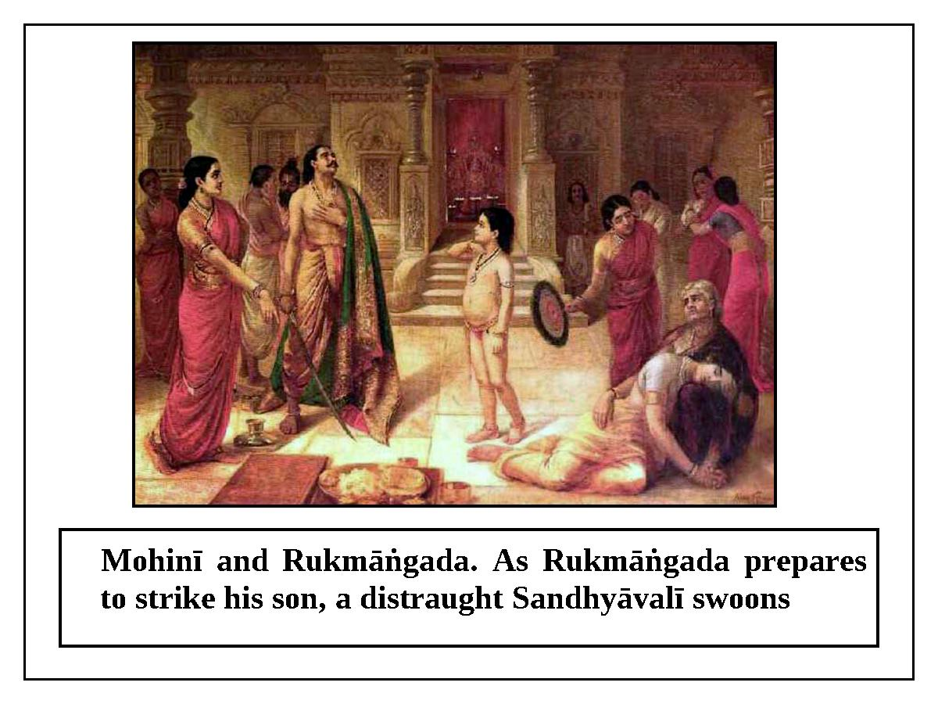

Then the prince, who strictly followed religious principles, fell flat before Mohinī and said, “O angry woman, please accept the sacrifice of my life.” The prince gave a sharp sword to the king and said, “Father, please do not delay; fulfill your promise to Mohinī. May my death be auspicious and serve your welfare.” Mohinī said to the king, “If you eat on ekādaśī, you will not have to kill your son; otherwise, you must do so.”
At that time, Bhagavān Viṣṇu suddenly appeared in the sky. The king happily offered obeisances to Bhagvān and took the sword, and the prince happily placed his head on the ground. When the king raised the sword, the Earth began to shake, giant waves formed in the oceans, and meteors fell from the sky. Seeing these bad omens, Mohinī fainted. At that very moment, Śrī Hari grabbed the sword and said, “O king, I am very pleased with you. Please go to the Vaikuṇṭha planets with your wife and son.” Śrī Hari blessed the king with a touch and then disappeared.
The glories of observing the vow of Śrī Ekādaśī are unprecedented. The lesson of this history is that regardless of circumstances, it is the duty of every man, woman, and child to fast on the ekādaśīs which fall in the bright and dark fortnights.
Why is it forbidden to take grains on ekādaśī?
In Brahma-vaivarta Purāṇa, Śrī Nārāyaṇa says to Devarṣī Nārada: satyaṁ sarvāṇi pāpāni bhrama-hatyādikāni ca. On the day of ekādaśī, all types of great sins enter and take shelter of grains. Less intelligent people who eat grains on ekādaśi will be considered great sinners, and after death they will go to the hell called Kumbhīpāka for as many ages as there are ekādaśīs. After that, they will take birth in the family of a dog-eater and suffer from the terrible disease of leprosy for seven births before finally being freed. This is the statement of Brahmājī.
When we become familiar with the truth about Śrī Ekādaśī, we will be able to understand the necessity of observing it. In Śrī Padma-purāṇa, it is said that once, Jaimini Ṛṣi asked his gurudeva Maharṣi Śrī Vyāsadevajī, “O Gurudeva, when did Ekādaśī-devī manifest? What is the process for observing this fast? When does one have to observe this vow? What is the result of fasting on ekādaśi? Who is the worshipable Deity of this vow? What sinful reactions are incurred if one does not observe this vow? Please mercifully explain all of these things to me; only you are capable of doing so.”
Śrī Vyāsadeva then blissfully gave Jaimini the answers to his questions. He explained that in the beginning of the creation of this world, which is made of the five elements earth, water, fire, air, and ether, Bhagavān created the moving and non-moving living entities. Afterwards, He created Pāpa-puruṣa (sin personified) to rule over the sinful-minded human beings. All of the limbs of that Pāpa-mūrtī (personification of sin) were produced from sin. His head is the sin of killing a brāhmaṇa; his eyes are the sin of drinking alcohol; his face is the sin of stealing gold; his ears are the sin of enjoying the wife of one's spiritual master; his nostrils are the sin of killing a woman; his arms are the sin of killing a cow; the back part of his neck is the sin of stealing wealth; the front part of his neck is the sin of abortion; his chest is the sin of having sex with another's wife; his belly is the sin of killing one's friend or relative; his navel is the sin of killing one who has surrendered; his waist is the sin of self-praise or boasting; his thighs are the sin of criticizing one's spiritual master; his penis is the sin of selling one's daughter; his anus is the sin of not keeping a secret; his feet are the sin of killing one's father; and his hair is all of the lesser sins. In this way, the fearsome Pāpa-puruṣa has a vast body composed of the various sins.
Seeing the terrible, gigantic Pāpa-puruṣa that He created, Bhagavān, who relieves the distress of the living entities, began to think. He rode on Garuḍa to the abode of Yamarāja. Yamarāja seated Him on a suitable golden throne, worshiped Him, and washed His feet according to proper rituals.
While talking to Yamarāja, Puruṣottma Bhagavān heard weeping from the southern direction and asked about it. Yamarāja answered, “O Lord, those are the cries of the sinful mortal living entities who are suffering in hell due to their past misdeeds.” Bhagavān then went to see hell, and compassion manifested in His heart upon seeing the torment of the sinful mortal living entities. He thought, “I created all of these living entities, and despite My presence, they are suffering hellish torment due to their past misdeeds.” Thinking in this way, He personally took the form of the day of ekādaśī to give the living entities an opportunity to become free from their sinful reactions. There is evidence for this in the scriptures:
etaccānycca vipraṣe vicintya karuṇāmayaḥ
babhūva sahasā tatra svayaṁ ekādaśī tithiḥ
tatastān pāpinaḥ sarvān karayāmāsa tad-vratam
te ca sarve paraṁ dhāma yayur galita-kalmaṣāḥ
tasmāt ekādaśīṁ mūrttiṁ viddhi paramātmanaḥ
samasta sukṛta-śreṣṭhāṁ vratānāṁ uttamaḥ dvija
“Thinking like this, the merciful Bhagavān Śrī Kṛṣṇa suddenly manifested in the form of the day of ekādaśī. Then, He inspired all of the sinful people to observe the vow of ekādaśī. As a result, they all became free from their sinful reactions and returned to Vaikuṇṭha. Therefore, O dear son Jaiminī, you should understand the day of ekādaśī to be a manifestation of Viṣṇu, the indwelling Supersoul. Observing this ekādaśī, which is superior to all other virtuous activities and is the best among all vows, purifies the three worlds.”
After some time had passed, the Pāpa-puruṣa created by Bhagavān went to Viṣṇu. Afraid, he folded his hands and prayed, “O Bhagavān Viṣṇu, I am a servant created by You. My duty is to give distress to the sinful living entities who take shelter of me. However, due to the influence of ekādaśī, I am becoming weak. Almost everyone is following this vow and becoming a resident of Vaikuṇṭha after death. Now, whose shelter shall I take? If all of the living entities go to Vaikuṇṭha, what will happen to this mortal world? Therefore, O Keśava, please protect me from the results of ekādaśī. O killer of the Kaiṭabha demon, fearing ekādaśī, I took shelter of human beings, animals, birds, insects, worms, mountains, trees, water, land, rivers, oceans, forests, secluded paths, heaven, the Earth, the lower planetary system, demigods, and Gandharvas. I could not find a suitable place to stay, so now I have taken shelter of You. O Lord of lords, ekādaśī has become prominent in the millions of universes that You created; therefore, I could not find shelter anywhere. Please be merciful and give me a place where I can be free from fear.” Bhagavān, who relieves all distress, smiled and said, “O Pāpa-puruṣa, do not be unhappy. When the day of ekādaśī, which purifies the three worlds, occurs, you may take shelter in rice and ravi-śasya (wheat, barley, and sesame). My manifestation as ekādaśī will not harm you when you are in grains.”
Thus, on the day of ekādaśī the Pāpa-puruṣa enters and stays in rice and other grains. Therefore, on ekādaśī it is forbidden to eat rice or other grains.

The aim of observing the vow of ekādaśī
The real aim and object of fasting on ekādaśī is to obtain loving devotion to Śrī Bhagavān.
“When one observes this vow in the company of pure devotees, one will start regarding even the four mundane goals of human life (economic development, sense gratification, mundane religiosity, and liberation) to be trivial, and one will attain pure devotion to Śrī Kṛṣṇa” (Skanda Purāṇa)
Ordinary people cannot understand the incomparable glories of devotion to Lord Hari. “All types of liberation, mystic perfection, and sense gratification follow the great goddess of devotional service to Bhagavān like maidservants.” (Nārada Pañcarātra)
“One should observe this vow of ekādaśī, which fulfills all of one’s desires, only for the pleasure of Śrī Viṣṇu” (Śrī Hari-bhakti-vilāsa 12/8)
It is said in the Mādhurya-khaṇḍa of Garga-saṁhitā that Bhagavatī Śrī Rādhikā Herself instructed the cowherd damsels, who in past lives were golden Sītās present with Lord Rāmacandra at fire sacrifices. She said, “O gopīs, if you want to please Śrī Kṛṣṇa, observe the vow of ekādaśī. There is no doubt that He will be controlled by this.” (śrī kṛṣṇasya prasādārthaṁ kurutaikādaśī-vratam | tena vaśyo hariḥ sāksād bhaviṣyati na saṁśayaḥ||) Thus, the real goal of the ekādaśī vow is the happiness of Śrī Kṛṣṇa, by which He becomes controlled by his devotees.
Still, the scriptures also mention other benefits of observing ekādaśī, including becoming free from sinful reactions, going to heaven, attaining liberation, and living without diseases and distress. “This vow is like a philosopher's stone and desire tree.” In other words, this vow is capable of fulfilling all of the desires of the living entities. Human beings with fruitive desires are ignorant of the glories of pure devotional service. Therefore, the scriptures first mention the secondary benefits. In this connection, Śrī Caitanya Bhāgavata (Madhya, 19th Chapter) states:
vedeo bhujhāya ‘svarga' bale janā janā
mūrkha-prati kevala se vedera karuṇā
viṣaya-sukhete baḍa lokera saṇtoṣa
citta bujhi’ kahe veda, vedera ki doṣa
dhana-putra pāi gaṅgā-snāna hari-nāme
śuniyā calaye loka vedera kāraṇe
jete mate gaṅgā-snāna harināma kaile
dravyera prabhāve bhakti haibeka hele
ei veda-abhiprāya, mūrkha nāhi bujhe
kṛṣṇa-bhakti chāḍiyā viṣaya-sukhe maje

“The Vedas also point to heaven because that is the goal of ordinary people. This shows the compassion of the Vedas for the foolish. Ordinary people are greatly attracted to sense gratification. The Vedas take into consideration the various kinds of desires within people's hearts, and instruct them accordingly. There is no fault in the Vedas in this. If ordinary people hear from the Vedas that by bathing in the Ganges River and chanting the holy name of Lord Hari one obtains wealth and progeny, they will perform those sacred activities. Somehow or other, by bathing in the Ganges River and chanting the holy name of Lord Hari, one will develop devotion by the influence of divine places and association. Foolish people do not understand the good intentions of the Vedas for gradual upliftment, and for this reason they neglect devotional service to Kṛṣṇa in favor of the vastly inferior happiness derived from sense objects.”

Śrī Hari-bhakti-vilāsa states that all human beings who fast and observe the regulative principles on ekādaśī during the dark and bright fortnights will ascend to Svarga (heaven). In his commentary on Śrī Hari-bhakti-vilāsa, Śrīla Sanātana Gosvāmī gives the meaning of svarga: svarga-śabdenātrordhva-loko lakṣyate, tena ca śrī-vaikuṇṭha-padam. This indicates that in the scriptures, ‘Svarga’ usually refers to the transcendental abode of Vaikuṇṭha. Regarding Svarga, Śiva Ṭhākura mentions anucaratva (being an associate) or dāsatva (being a servant) of Śrī Viṣṇu: viṣṇor anucaratvaṁ hi mokṣaṁ āhur manīṣiṇaḥ (Padma Purāṇa).
To always be close to Śrī Bhagavān, the abode of all good qualities, by becoming free from all sinful reactions, is the real upavāsa (fasting). Only giving up food is not the real meaning of the word upavāsa: upa-vṛttasya pāpebhyo yastu vāsaḥ guṇaiḥ saha| upavāsa sa vijñeyo nopavāsastu laṅghanam (Bhaviṣyottara-purāṇa).

The glories of ekādaśī
All of the scriptures abundantly describe the incomparable glories of the vow of ekādaśī. “If one abandons this vow in favor of other vows, it is like throwing away a jewel and picking up a stone.” (Tattva-sāgara) “One may have committed thousands of sins and murdered hundreds of brāhmaṇas; nevertheless, one will be purified of all of those sins if one fasts on ekādaśī with devotion. If one abandons this vow and undertakes some other, he will not be happy and the final result will be stress.” (Śrī Hari-bhakti-vilāsa 177-178) Without Hari-vāsara, charity, austerity, holy places, and pious activities do not lead to liberation.” (Skanda Purāṇa) “When Brahmā put Aśvamedha, Rājasūya, and other sacrifices, along with austerity and charity, on one side of a balance, and put one Vaiṣṇava vrata on the other side, he saw that the weight of a vow of a Vaiṣṇava who chants the holy name was greater.” (Padma Purāṇa)
“When an intense fire burns in a forest, all types of wood, whether dry or wet, are burned to ashes. Similarly, by observing the vow of Hari-vāsara, all past and future sinful reactions of the living entity are destroyed.” (Brahma-vaivartta) Śrī Yamadeva tells his messengers that if they want auspiciousness for him, they should leave people who observe ekādaśī alone, even if they have committed hundreds of sins.” (Skanda Purāṇa) “Execution of this fast is the atonement for all sins, and it liberates one from material existence.” (Brahma-vaivartta) “If one follows the vow of ekādaśī with real devotion, he becomes free from all sinful reactions and returns to the abode of Lord Viṣṇu.” (Vāyu Purāṇa) “If one hears with devotion stories about ekādaśī, fasts on ekādaśī, instructs others to observe ekādaśī, or gives faith to ignorant living entities regarding following this vow, one becomes free from all sinful reactions and attains the transcendental residence of Bhagavān Viṣṇu, who has the symbol of Garuḍa on His flag.” (Brahma-vaivartta Purāṇa)
Śrī Ekādaśī is the best among all vows. As the primary result, it gives devotion to Lord Hari, and as secondary results it gives benefits such as mundane religiosity, economic development, sense gratification, and liberation.
In ancient times, there was a king named Koṭiratha who was very religious, wise, and honest. He had conquered anger. He worshiped Nārāyaṇa and was dedicated to the vow of the day of Lord Hari (Hari-vāsara or ekādaśī). His wife Suprajñā also had all good qualities, such as showing kindness to everyone. They both fasted on ekādaśī and would spend the whole night worshiping Viṣṇu by dancing and singing.
Once, a brāhmaṇa named Śauri approached them and asked, “O king and queen, you are both glorious. Vaiṣṇavas like you are very rare in this world. How did you become fixed in religious principles?
The queen, who remembered her previous life, replied, “In our previous lives, we were great sinners. However, Yamarāja kindly spared us from the cruel punishment of hell. This story is highly confidential; however, considering you to be the best among Vaiṣṇavas, I will tell it to you. I was a prostitute named Chitrapadā who engaged in many types of sinful activities. The king was a śudra named Nityadaya who was devoid of any good conduct. He was a plunderer attracted to the wives of others. He was full of false pride and was a blasphemer of religious principles. All of his relatives, friends, and well-wishers had rejected him due to his bad behavior. We began to live together like husband and wife. Once, on the day of ekādaśī, I developed a severe fever. Due to my suffering, I called out, ‘He Hari, He Govinda, He Nārāyaṇa, please protect me!’ I lit a ghee lamp and stayed awake the entire night. Out of affection for me, the king accompanied me that night, and he did not eat any grains. The next day I died, and according to destiny he also died - our material bodies merged into the five elements of earth, water, fire, air, and sky. Then, the messengers of the god of death took us to the abode of Yamarāja by a hidden path. Citragupta, who maintains accounts of the religiosity and irreligiosity of all humans, told Yamarāja, ‘These two are great sinners, but by the influence of the vow of ekādaśī, they have become free from all sinful reactions. Whoever fasts on ekādaśī, even unwillingly or unknowingly, is freed from all sinful reactions and goes to the topmost abode of Vaikuṇṭha.’ Hearing this, Yamarāja show us affection by worshiping us with various paraphernalia and feeding us. He seated us on a divine chariot and said, ‘You both are the best among pious persons. You may go to the place where Bhagavān Viṣṇu resides.’”

One should fast only on a pure day of ekādaśī (Śuddha Ekādaśī)
Ekādaśī is of two types – saṁpurṇā (complete) and viddhā (contaminated or overlapped). Viddhā is also of two types – pūrva-viddhā and para-viddhā. Purva-viddhā ekādaśī, ekādaśī which overlaps with daśamī, is not suitable for fasting. (Śrī Hari-bhakti-vilāsa) “Saṁpurṇā ekādaśī, and especially para-viddhā ekādaśī (overlapping with dvādaśī), are pure and are suitable for fasting. However, one should never fast on an ekādaśī that overlaps with daśamī.”(Saura-dharmottara) “At the time of aruṇodaya-kāla (four daṇḍas, or one hour and thirty-six minutes), if there is even a trace of overlap with daśamī, an ekādaśī is pūrva-viddhā and unsuitable for fasting.” (Bhaviṣya Purāṇa). “An ekādaśī that overlaps with dvādaśī is also acceptable” – dvādaśī-miśritā grāhyā sarvatraikādaśī tithiḥ |. (Padma Purāṇa) It is said in Nārada Purāṇa that when there is doubt regarding the exact time and day for fasting, one should fast on dvādaśī and perform pāraṇa on trayodaśī. “Those scriptures that instruct one to fast on an ekādaśī that overlaps with daśamī should not be followed, even if spoken by Brahmājī himself.” (Śrī Hari-bhakti-vilāsa 12.278)
Padma-purāṇa describes a conversation between Bhagavān and Brahmājī in which it is said, “O grandfather, the truth is that the daśamī-viddhā ekādaśī (ekādaśī that overlaps with daśamī) strengthens the demons – there is no doubt about this.” In Brahma Purāṇa, Maitreya Muni explains to Dhṛtarāṣṭra that he had fasted with his first wife on an ekādaśī that overlapped with daśamī, and as a result, his one hundred sons perished. Skanda Purāṇa clearly explains that it should be understood that sinful people who advise others to fast on a day of Lord Hari which overlaps with daśamī are indeed bewildered by the illusory potency of Śukrācārya. In the same Purāṇa, in a conversation between Umā (Pārvatī) and Maheśvara (Śiva), it is said that those who observe daśamī-viddhā ekādaśī certainly desire residence in hell.
The vow of ekādaśī should be observed by all women and men, without discrimination
“It is the duty of all men and women between the ages of eight and eighty, without any discrimination, to fast on the day of ekādaśī.” (Kātyāyana Smṛti) Padma Purāṇa describes a conversation in which Lord Śiva tells Pārvatī-devī, “There is no doubt that the members of all of the social divisions (varṇas) such as brāhmaṇa and kṣatriya, the members of all of the spiritual divisions (āśramas) such as brahmacārī and gṛhastha, and all women should fast on ekādaśī.” Some scriptures state that if a wife observes a vow of fasting while her husband is alive, she will go to hell and her husband's lifespan will decrease. However, such statements do not apply to fasting on the day of Lord Hari. Otherwise, Lord Śiva would not have given such instructions to Pārvatī-devī. Bhagavān Śrī Caitanya Mahāprabhu personally instructed His mother Śacī-mātā to fast on ekādaśī, even when His father was alive. (Caitanya-caritāmṛta, Ādi-līlā, 15/8-10) In Viṣṇu-dharmottara, the statement saputraś ca sabhāryaś ca svajanair bhakti-saṁyutaḥ advises one to fast on ekādaśī along with one’s husband. Moreover, Śrī Nārada Purāṇa states that King Rukmāṅgada had proclaimed that any man or women between the ages of eight and eighty residing in his kingdom would be punished if he or she did not fast on ekādaśī. Women are forbidden from eating grains on ekādaśī even during menstruation – ekādaśyāṁ na bhuñjīta dṛṣṭe rajasy api. (Hari-bhakti-vilāsa 12/16)
It is incorrect to say that the ekādaśī fast is a Vaiṣṇava vow, and thus that it should be observed only by Vaiṣṇavas. In Skanda Purāṇa, Lord Śiva declares, “If one eats grains on the day of Lord Hari, he cannot be accepted as a devotee of Lord Śiva or the sun-god. He does not belong to any spiritual division (āśrama), and he is not a servant of the holy places. He is more sinful than even a dog-eater. Anyone who disrespects this vow on the pretext of worshiping me is not at all dear to me.”
One cannot accept grain mahā-prasāda on ekādaśī
All of the scriptures declare that the glories of mahā-prasāda are unlimited. However, one disrespects both the mahā-prasāda and ekādaśī by accepting mahā-prasāda on ekādaśī. Some proud people who claim to be Rāga-mārgīya Vaiṣṇavas (devotees of Lord Kṛṣṇa on the path of spontaneous devotion) eat mahā-prasāda on the days of Lord Hari, including ekādaśī. For them, the Gautamīya Tantra states, “If any Vaiṣṇava, out of negligence, eats grains on ekādaśī, not only does his worship of Viṣṇu go in vain, but he also goes to hell.”

Śrī Puruṣottma Dhāma and Hari-vāsara Vrata
(The holy abode of Lord Jagannātha and the day of ekādaśī)
In Śrī Puruṣottma-dhāma, all of the vows of Hari-vāsara are important. Considering this, some people devoid of knowledge of philosophical truths eat mahā-prasāda on ekādaśī. This practice is totally opposed to the scriptures. Gaurahari Himself fasted on the days of Hari-vāsara, and He gave evidence that eating mahā-prasāda on ekādaśī is not a legitimate practice. Once on ekādaśī, someone brought the wonderful mahā-prasāda of Śrī Jagannātha-deva. At that time, Gaurahari told all of the devotees gathered there:
prasāda-sevana āra śrī-hari-vāsare
virodha na kara, prabhu bujhaha antare
Understand within your heart that honoring prasāda and honoring the day of the Lord never conflict. Therefore, there is no offense in not accepting mahā-prasāda on the day of ekādaśī or some other special vow.
eka aṅga māne, āra anya aṅge dveṣa,
je kare, nirbodha sei jānaha viśeṣa
It is to be understood that only a totally foolish person accepts one limb of devotional service but disregards the other limbs.
ekādaśī-dine nidrāhāra-visarjana
anya-dine prasāda-nirmālya sevana
On the day of ekādaśī, give up sleep and grains. On other days, prasāda and the other remnants of the Lord can be honored. (Śrī Prema-vivarta)
There is never a contradiction if devotees accept mahā-prasāda (on days other than ekādaśī) for the pleasure of Bhagavān, and also observe the vow of ekādaśī.

Those who cannot fully fast may accept anukalpa
One should not give up the vow of ekādaśī due to ill-health or old age. “Young children, the elderly, and sick persons should not give up fasting on ekādaśī under any circumstances. They can observe this day by eating once at night or accepting milk, fruit, and roots.” (Mārkaṇḍeya Purāṇa) “Those afflicted with diseases and those who have excessive bile, as well as those who are more than thirty years old, can accept anukalpa at night.” (Hari-bhakti-vilāsa 12.93) In the Udyoga-parva of Mahābhārata, it is said that water, fruits, roots, milk, ghee, the words of the spiritual master, and medicine do not spoil one's vow of ekādaśī. (Hari-bhakti-vilāsa 12.100) People who are incapable of fully fasting may accept anukalpa once during ekādaśī; they are forbidden from eating many times.

Only grains are forbidden on ekādaśī
Proud Vaiṣṇavas and pseudo-Vaiṣṇavas do not consider the flour śyāmā kā cāvala (or śyāmāka taṇḍula, the grain of Panicum Frumentaceum, a kind of cultivated millet), sūjī (farina), and canā (chickpeas), for example, to be grains (anna), and they eat them on ekādaśī. However, annam means attuṁ yogyaṁ annam; it includes all foods with grain ingredients. Actually, no foods with grains as ingredients are acceptable on the day of Lord Hari (hari-vāsara). Fruits, roots, water, and milk do not spoil the fast; therefore, there is an arrangement for accepting these items (anukalpa) if one is absolutely incapable of fully fasting. In this connection, Padma-purāṇa describes a conversation in which Śiva tells Pārvatī, “O Girijā (daughter of the Himālaya Mountains), food produced from grains is known as anna. In this world, there are many types of grains; listen very carefully as I list them: śyāma (śyāmā rice), masūra (lentils), dhānya (grains), kodrava (koda-dhāna, a kind of grain eaten by the poor), sarṣapa (mustard seeds), jau (barley), wheat, muṅga dāla, sesame seeds, paṅgu (kāuna, a kind of Panic seed; several varieties are cultivated as food for the poor), kulatha, gavedhuka (tṛna-dhānya, barley-meal prepared with Coix barbata), ātaka, maṭara (green peas), maṇḍuka, bājarā (millet), ralka, kīcaka (bāsa-dhānya, bamboo grains), baravaṭī, tilaka (homa-dhāna), and canā. The word ādi (etcetera) indicates jvāra and makkaī.” Therefore, śyāmā-cāvala, wheat floor, canā (chick peas), and so on are counted as grains, so they are unsuitable for eating on ekādaśī.

Ekādaśī should not be neglected even during Saṅkrānti (passage of the sun or a planet from one sign or position in the heavens into another), janana-śauca (period of purification observed after the birth of a child), or maraṇa-śauca (period of purification observed after the death of a family member)
“Whether a cow is white or black, it produces the same milk. Similarly, the ekādaśīs that fall in the bright and dark fortnights are equally beneficial.” (Garga-saṁhitā) “The basis of sin in this world is the illusion by which one makes a distinction between the benefits of ekādaśīs depending on whether they fall in the dark or bright fortnight.” (Kālikā Purāṇa) According to a popular smārta injunction, householders with children should not fast on Sundays, during Saṅkrānti, or at the time of a lunar or solar eclipse. In this connection, Jaiminī explains that fasting on Sundays is inappropriate only if it is done for the sake of achieving fruitive results. However, fasting on Hari-vāsara is eternal; therefore, there is never any type of prohibition. (Hari-bhakti-vilāsa 12.59-60) “One must not abandon the vow of fasting on ekādaśī even in times of tragedy or great joy, during janana-śauca, or during maraṇa-śauca.” (Viṣṇu-rahasya)

It is forbidden to perform śrāddha during Hari-vāsara
The Uttara-khaṇḍa (6.234.13-14) of Padma Purāṇa states that if ekādaśī falls on the same day as the anniversary of the death of one’s mother or father, one should perform śrāddha (oblations to Lord Viṣṇu for the benefit of deceased relatives) on the day of dvādaśī. One should never perform śrāddha on the day of fasting; the demigods or deceased forefathers will never accept foodstuffs offered on ekādaśī. (Hari-bhakti-vilāsa 12.70) If one performs śrāddha on ekādaśī, the person who donates the food, the person who makes the offering, and the deceased relative will all go to hell. (Brahma-vaivarta Purāṇa)

The process of observing ekādaśī

On the day before ekādaśī (daśamī), after getting out of bed in the morning one should take bath, but should not brush the teeth. One should then apply oil to the body and worship Viṣṇu. While meditating on Śrī Hari, one should take food only once in the afternoon. One should not eat salt, or vegetables.
The following activities are forbidden: eating masūra (a type of lentil), chickpeas, greens, beans, honey, or kodo; conversing with a person of the opposite sex; eating more than once a day; eating food offered by others; eating in bronze pots; eating brinjal (eggplant), laukī (bottle gourd), neem, or jambira (citron - large lemon); eating or drinking excessively; and eating betel-leaf or betel-nut. One should follow the same regulations prescribed for daśamī on dvādaśī. If one wants to get the desired result, one should not eat at night on daśamī. On daśamī, one may brush the teeth in the afternoon. At a temple of Śrī Hari, one should meditate on Śrī Hari, whose lotus feet are the ultimate shelter, and chant the following mantra.
etat gṛhītaṁ govinda mayā tvat purato vratam
siddhiṁ gacchantu nirvighnaṁ tava pādānukampayā
ati caṅcala-citto'haṁ lobha-mohamayo naraḥ
śaknomyetad vrataṁ karttuṁ kiṁ tavānugrahamṛte
“O Govinda, I accept this vow of ekādaśī in Your presence. By Your mercy, may I complete this vow without any obstacles. I am a restless, greedy, bewildered living entity; without Your mercy, I will not be able to follow this vow.” Saying this, one should offer a handful of flowers at the lotus feet of Śrī Hari and offer daṇḍavat pranāma (prostrated obeisances). One should then spend the night sleeping on a bed of kuśa grass. When one gets up in the morning, one should not brush the teeth. One should rinse one's mouth twelve times with water, take bath, and complete the worship of Lord Viṣṇu. One should avoid the following activities: criticizing, gossiping, gambling, sleeping, chewing betel-leaf or betel-nut, telling lies, talking with a sinful person, and becoming angry. One should perform kīrtana in the form of hari-nāma and hari-kathā all day long. One should spend the whole night reciting scriptures such as Śrīmad-Bhāgavatam, Mahābhārata, and Rāmāyaṇa. One should complete one's early-morning duties and then bathe the Deity of Śrī Hari with milk. If one has sufficient strength on dvādaśī, one should first render service to Vaiṣṇavas and guests, and then break the fast before the specified time period expires.

Breaking the ekādaśī fast
The day after fasting, one should perform the maṅgala-ārati of Śrī Hari early in the morning and honor the Vaiṣṇavas by offering them mahā-prasāda. Later in the morning, one should perform worship and then offer the result of the fast to Śrī Kṛṣṇa. (Hari-bhakti-vilāsa 12.229) If the time period for pāraṇa (breaking the fast) is short, one should take bath and finish the worship during aruṇodaya. The mantra for offering the result of fast is as follows.
ajñāna-timirāndhasya vṛtenānena keśava
prasannaḥ sumukhobhūtvā jñāna-dṛṣṭi-prado bhava
O Keśava, I am blinded by the darkness of ignorance. Be pleased with me due to my observance of this vow, and appear before me and grant me the vision of knowledge.
Pāraṇa Mantra
tava prasāda svīkārāt kṛtaṁ yat pāraṇaṁ mayā
vratenānena santuṣṭaḥ svastiṁ bhaktiṁ prayaccha me
O Lord, I am performing the pāraṇa of this vow and accepting Your prasāda. Be pleased by this vow and bestow devotional service and auspiciousness upon me.

In this way, one should remember Śrī Hari and perform the pāraṇa at the prescribed time. In this connection, Skanda Purāṇa states, “By honoring prasādam sanctified with tulasī leaves on the day of dvādaśī after fasting on ekādaśī, billions of sins are destroyed.” (Hari-bhakti-vilāsa–13/227) “Even if one is faced with a disturbing crisis, it is one’s duty to dedicate the fast to Śrī Hari by chanting the mantra and performing the pāraṇa by drinking water.” (Hari-bhakti-vilāsa–13/255)

Ekādaśī-tattva spoken by Śrīmatī Rādhārāṇī

In the eighth chapter of the Mādhurya-khaṇda of Garga-saṁhitā, Śrī Nārada Ṛṣi describes the philosophical truths spoken by Śrī Rādhājī. In South India there is a city named Uśīnara, and once it did not rain there for ten years. Due to the drought, the gopas of that place and their families went to Vraja-maṇḍala. They lived in beautiful Vṛndāvana on the bank of the Yamunā River. The cowherd damsels who were yajña-sītās in their previous lives took birth there, and they were all endowed with transcendental youth.
The story of the yajña-sītā gopīs is as follows. Śrī Rāmacandrajī had sent Śrī Sītādevī to the forest. With His wife gone, He would conduct fire sacrifices in the presence of Deities of Sītā made of gold. Those Deities would come to life after being touched by Śrī Rāmacandrajī, and they would express their desire to have Him as their husband. While Bhagavān Śrī Rāmacandrajī had taken a vow to accept only one wife, He promised to fulfill their desire in future lives during Dvāpara-yuga. All of the Deities of Sītā created for Śrī Rāmacandrajī’s sacrifices received the same benediction. When Śrī Kṛṣṇa, who has many consorts, appeared during Dvāpara-yuga, the Deities of Sītā took birth as gopīs in the homes of the cowherd men and women who had come from Uśīnara (Gāndhāra).
Enchanted by Śrī Kṛṣṇa, these gopīs could think of nothing other than how to please Him. They surrendered to Śrī Rādhājī, saying, “O daughter of Vṛṣabhānu Mahārāja, O one who is endowed with transcendental lotus-eyes, You are the enchantress of the whole world and You are an expert in all of the scriptures. Śrī Kṛṣṇa, who is difficult for the demigods to attain, is subjugated by You. Therefore, please satisfy us by telling us about an auspicious vow that will please Him.”
Śrīmatī Rādhājī replied, “If you want to please Śrī Kṛṣṇa, observe the vow of ekādaśī. He will be subjugated by this; there is no doubt about it.” (śrī kṛṣṇasya prasādārthaṁ kurutaikādaśī-vratam| tena vaśyo hariḥ sākṣād bhaviṣyati na saṁśayaḥ||) The gopīs said, “O Rādhikā, what is ekādaśī? Please tell us how to observe that vow.”

The twenty-six names of ekādaśī

Śrīmatī Rādhājī said, “In order to kill the demons, the potency of Viṣṇu named ekādaśī manifested from His body during the dark fortnight of the month of Agrahāyaṇa. This ekādaśī vow, which is the best among vows, is known by a different name in each month. Please listen carefully as I tell you their twenty-six names; this will bring auspiciousness to all of you. These ekādaśīs are called Utapatti, Mokṣadā, Saphalā, Putradā, Ṣaṭ-tilā, Jayā, Vijayā, Āmalakī, Pāpamocanī, Kāmadā, Varuthinī, Mohinī, Aparā, Nirjalā, Yoginī, Śayanī, Kāminī, Pavitrā, Ajā, Padmā, Indirā, Pāśāṅkuśā, Ramā, and Prabodhinī. The two ekādaśīs of the Adhika-māsa, the extra month of Puruṣottama, are called Padminī and Parama. By reciting all of these names of ekādaśī, one receives the benefit of observing all of the dvādaśīs of the year.”

The rules of ekādaśī

Śrīmatī Rādhājī continued, “O damsels of Vraja, now listen as I explain the rules and regulations of ekādaśī. On daśamī (the day before ekādaśī), one should sleep on the floor, eat only once, and drink only once. One should wear clean clothes and control the senses. One should get up on ekādaśī during brāhma-muhūrtta (one-and-a-half hours before sunrise) and offer obeisances to Śrī Hari. After this, one should take bath in a location as follows, in the order of least to most desirable: in well-water, in a vāpī (pond about one hundred arm-lengths long), in a lake (body of water about five bow-lengths long), or in a river. After taking bath, one should give up anger and greed. One should not associate with people who are rude, who are atheistic, who tell lies, who criticize brāhmaṇas, who are immoral, who steal, or who associate with the wives of others, rogues, or rich persons who have a different standard of etiquette. One must also not go to forbidden places. One should worship Śrī Keśava with devotion and supply Him with a high- class naivedya (offering), such as a lamp in His temple. One should hear about the glories of ekādaśī, and also hear śrī-hari-kathā, from a brāhmaṇa. One should stay awake the entire night glorifying the qualities of Kṛṣṇa. One should avoid the following ten things the day before the vow of Lord Viṣṇu: eating from a brass plate, eating flesh, eating masūra dāl, eating kodrava grains, eating chick-peas, eating spinach (greens), eating honey, eating food prepared by others, eating twice in the day, and having sex. One should also avoid gambling, playing, sleeping, chewing betel-nut, and brushing the teeth. On the day of ekādaśī, one should avoid gambling, sleeping, eating betel-nut or betel-leaf (pān), brushing the teeth, criticizing others, being wicked, stealing, being violent, having sex, being angry, being exuberant, and telling lies. On dvādaśī (the day after ekādaśī), one should avoid eating from a brass plate and eating flesh, honey, pauṣṭika, yaṣṭi-dhānya, and masūra. One should observe the vow of ekādaśī in this way.”

Timing of ekādaśī

The gopīs requested, “O great scholar, please describe the timing of the ekādaśī vow, as well as the benefit and glories of this vow.”
Śrī Rādhājī replied, “If daśamī lasts for fifty-five daṇḍas, one should not fast the next day on ekādaśī. Instead, one should fast on dvādaśī. If even one drop of alcohol enters a pot of Ganges water, the water is spoiled; similarly, if an ekādaśī overlaps for even a moment with daśamī, one should not fast on ekādaśī and should observe the vow the next day. If dvādaśī is vṛddhi, one should fast on the previous day (ekādaśī).

Benefits of ekādaśī
Śrī Rādhājī continued, “O damsels of Vraja, one receives the benefit of performing a Vājapeya sacrifice simply by hearing about the benefits of ekādaśī. One easily gets the benefit of feeding eighty-eight thousand brāhmaṇas by fasting on ekādaśī. By observing such a fast, one gets one thousand times more benefit than one gets by donating the entire Earth, with all of its oceans and forests. The vow of ekādaśī is the only means of rescue for people trapped in the quagmire of sinful activities in this ocean of material existence. If one observes this vow by staying awake all night, one will never see the abode of Yamarāja, even if one has committed hundreds of sins. If one worships Śrī Hari with a tulasī leaf on the day of dvādaśī with a devotional mood, one will not be contaminated by sins, just as a lotus leaf does not become wet despite being near water. Thousands of Aśvamedha sacrifices and hundreds of Rājasūya sacrifices are not equal to even one sixteenth of an ekādaśī fast. By fasting on ekādaśī, one delivers ten generations on one’s mother’s side, ten on the father’s side, and ten on the wife’s side. A cow should be equally respected whether it is black or white; the same applies to the ekādaśīs of both the bright and dark fortnights.
“O gopīs, even the sins accumulated over hundreds of lifetimes, being as big as Meru or Mandara Mountain, are burned to ashes by the power of ekādaśī, just as cotton is incinerated by fire. If one gives even a little charity on dvādaśī, whether following the scriptural injunctions or not, the amount of benefit is like Meru Mountain. If one hears about the pastimes of Lord Hari (hari-kathā) on ekādaśī, one gets a benefit equal to that of giving the entire Earth, with its seven continents, in charity. A person who bathes at Śaṅkhoddhāra-tīrtha and takes darśana of the Deity of Lord Gadādhara does not attain even one-sixteenth of the piety attained by fasting on ekādaśī. The benefit that one gets by giving charity during eclipses of the sun or moon, or on the day of Saṅkrānti at places such as Prabhāsa, Kurukṣetra, Kedāra, Badarikāśrama, and Kāśī, is not equal to even one-sixteenth of that attained by fasting on ekādaśī.
Śrī Rādhājī continued, “O damsels of Vraja, as Lord Śeṣa is the best of serpents; as Garuḍa is the best of birds; as Lord Viṣṇu is the best of Deities; as the brāhmaṇas are the best of the four social divisions (varṇas); as the banyan is the best of trees; and as a tulasī leaf is the best of leaves; fasting on ekādaśī is the best of all sacred vows. Just by following ekādaśī, one attains the benefit of performing austerities for ten thousand years. Considering such glories of ekadāśī, you all should follow this vow.”

Examples of the effects of ekādaśī

The gopīs said, “O beautiful-eyebrowed one, O daughter of Vṛṣabhānu Mahārāja, You are an expert in all of the scriptures. Your words defeat even those of Bṛhaspati. O Rādhā, You are an ocean of knowledge; please tell us about those who followed ekādaśī in the past.”
Śrīmatī Rādhājī replied, “O gopīs, the demigods executed this vow to defeat the demons and regain their lost kingdom. King Vaiśanta executed this vow to deliver his forefathers, who were being tortured in the abode of Yamārāja. A son-less king named Ketumāna, who lived in Bhadravatī Purī, obtained a son by observing this vow, as per the instructions of a group of saintly persons. A brāhmaṇī (wife of a brāhmaṇa) following the instructions of the wives of the demigods obtained wealth, grains, and heavenly happiness by the power of this vow. Two Gandharvas named Puṣpadanta and Mālyavān were cursed by Indra to become ghosts. They regained their status as Gandharvas as a result of the vow of ekādaśī. Lord Rāmacandra executed this vow in order to construct a bridge across the ocean and kill Rāvaṇa. After the cosmic inundation, the demigods observed an ekādaśī fast under an āmalā (myrobalan) tree. A sage named Medhāvī executed this vow according to the instructions of his father and became free from his attachment to an Apsarā. Another Gandharva named Lalita became a demon by the curse of a woman, and he was able to become a Gandharva again by the power of this vow. Great personalities and kings such as Māndhātā, Sagara, Kakutstha, Mucukunda, and Dhundhumāra went to heaven as a result of following this vow.
“By executing the vow of ekādaśī, Lord Śiva became free from the curse of Lord Brahmā. A very wicked son of Vaiśya named Dhṛṣṭabuddhi was rejected by his father. However, he was able to go to Vaikuṇṭha by observing ekādaśī. By the power of this vow, Mahārāja Rukmāṅgada and all of his subjects ascended to Vaikuṇṭha after enjoying life on Earth. Mahārāja Ambarīṣa, who regularly observed the vow of ekādaśī, was protected from the curse of a very powerful brāhmaṇa. A Yakṣa named Hemamālī, who was afflicted by leprosy due to the curse of Kuvera, obtained a complexion as beautiful as the moon by the power of this vow.
Śrīmatī Rādhājī concluded, “Mahārāja Hariścandra became the ruler of the Earth by the power of the vow of ekādaśī, and he eventually went to Vaikuṇṭha with all of his subjects. Śobhana, the son-in-law of King Mucukunda, was able to enjoy a kingdom like that of Kuvera with his queen Candrabhāgā as a result of following this vow. O gopīs, you should regard ekādaśī as superior to all other auspicious days; actually, no other day is equal to it.”
After hearing about ekādaśī from Śrīmatī Rādhājī, the gopīs properly executed this vow in order to meet with Śrī Kṛṣṇa. As a result, Bhagavān was extremely pleased with them, and He performed the supremely enjoyable pastimes of the rāsa dance with them on the Purṇimā night during the month of Agrahāyaṇa.

Garga Saṁhitā (Chapter Eight)
Yajñā-sītopākhyāna ekādaśī-māhātmya
Glories of ekādaśī in the story of the Yajña-sītās

Text 1
śrī-nārada uvāca
gopīnāṁ yajña-sītānāṁ ākhyānaṁ śṛṇu maithila
sarva-pāpa-haraṁ puṇyaṁ kāmadaṁ maṅgalāyanam
śrī-nāradaḥ uvāca—Srī Nārada said; gopīnām—of the gopīs; yajña-sītānām—of the yajna-sītās; ākhyānam—the story; śṛṇu—please hear; maithila—O king of Mithilā; sarva-pāpa-haram—removing all sins; puṇyam—sacred; kāmadam—fulfilling desires; maṅgalāyanam—auspicious.
Srī Nārada said: O king of Mithilā, please hear the story of the yajña-sītās who became gopīs. It is a sacred and auspicious story that fulfills all desires and removes all sins.

Text 2
uśīnaro nāma deśo dakṣiṇasyāṁ diśi sthitaḥ
ekadā tatra parjanyo na vavarṣa samā daśa
uśīnaraḥ—Uśīnara; nāma—named; deśaḥ—a country; dakṣiṇasyām—in the south; diśi—direction; sthitaḥ—situated; ekadā—one day; tatra—there; parjanyaḥ—rain; na—not; vavarṣa—rained; samā—years; daśa—ten.
In the south is a region named Uśīnara, where it did not rain for ten years.

Text 3
dhanavantas tatra gopā anāvṛṣṭi-bhayāturāḥ
sa-kuṭumbā go-dhanaiś ca vraja-maṇḍalam āyayuḥ
dhanavantaḥ—wealthy; tatra—there; gopā—gopas; anāvṛṣṭi-bhayāturāḥ—fearful of the lack of rain; sa-kuṭumbā—with families; go-dhanaiḥ—with cows; ca—and; vraja-maṇḍalam—to the circle of Vraja; āyayuḥ—came.
Fearful that it would never rain, the wealthy gopas there traveled, with their families and cows, to Vraja.

Text 4
puṇye vṛndāvane ramye kālindī-nikaṭe śubhe
nanda-rāja-sahāyena vāsaṁ te cakrire nṛpa
puṇye—sacred; vṛndāvane—in Vṛndāvana; ramye—beautiful; kālindī-nikaṭe—by the Yamunā; śubhe—beautiful; nanda-rāja—of King Nanda; sahāyena—with the help; vāsam—residence; te—they; cakrire—did; nṛpa—O king.
O king, with the help of King Nanda, they made their homes in beautiful, sacred Vṛndāvana by the bank of the Yamunā River.

Text 5
teṣāṁ gṛheṣu sañjātā yajña-sītāś ca gopikāḥ
śrī-rāmasya varā divyā divya-yauvana-bhūṣitāḥ
teṣām—of them; gṛheṣu—in the homes; sañjātāḥ—born; yajña-sītāḥ—the yajna-sītās; ca—and; gopikāḥ—gopīs; śrī-rāmasya—of Lord Rāmacandra; varā—blessing; divyā—splendid; divya-yauvana-bhūṣitāḥ—decorated with splendid youth.
The yajña-sītās, who had received a blessing from Lord Rāmacandra, took birth in their homes as beautiful gopīs.

Text 6
śrī-kṛṣṇaṁ sundaraṁ dṛṣṭvā mohitās tā nṛpeśvara
vrataṁ kṛṣṇa-prasādārthaṁ praṣṭuṁ rādhāṁ samāyayuḥ
śrī-kṛṣṇam—Lord Kṛṣṇa; sundaram—handsome; dṛṣṭvā—seeing; mohitāḥ—enchanted; tā—they; nṛpeśvara—O king of kings; vratam—a vow; kṛṣṇa-prasādārtham—to attain the mercy of Lord Kṛṣṇa; praṣṭum—to ask; rādhām—Srī Rādhā; samāyayuḥ—approached.
O king of kings, when the gopīs saw handsome Lord Kṛṣṇa, they became bewildered with love for Him. They approached Srī Rādhā to find out what vow they might follow to attain His mercy.

Text 7
śrī-gopya ūcuḥ
vṛṣabhānu-sute divye he rādhe kañja-locane
śrī-kṛṣṇasya prasādārthaṁ vada kiñcid vrataṁ śubham
śrī-gopya ūcuḥ—the gopīs said; vṛṣabhānu-sute—O daughter of King Vṛṣabhānu; divye—splendid; he—O; rādhe—Rādhā; kañja-locane—lotus-eyed; śrī-kṛṣṇasya—of Srī Kṛṣṇa; prasādārtham—to attain the favor; vada—please tell; kiñcit—what; vratam—vow; śubham—auspicious.
The gopīs said: O Rādhā, O beautiful, lotus-eyed daughter of King Vṛṣabhānu, please tell us what vow we may follow to attain Lord Kṛṣṇa’s favor.

Text 8
tava vaśyo nanda-sūnur devair api su-durgamaḥ
tvaṁ jagan-mohinī rādhe sarva-śāstrārtha-pāra-gā
tava—of you; vaśyaḥ—under the control; nanda-sūnuḥ—the son of Nanda; devaiḥ—by the demigods; api—even; su-durgamaḥ—unapproachable; tvam—you; jagan-mohini—the most beautiful girl in the worlds; rādhe—O Rādhā; sarva-śāstrārtha-pāra-gā—who has gone to the far shore of all the scriptures.
O Rādhā, You have made Lord Kṛṣṇa, whom even the great demigods cannot approach, into Your submissive servant. You are the most beautiful girl in all of the worlds. You have crossed to the farthest shore of the deep meaning of all of the scriptures.

Text 9
śrī-rādhovāca
śrī-kṛṣṇasya prasādārthaṁ kurutaikādaśī-vratam
tena vaśyo hariḥ sākṣād bhaviṣyati na saṁśayaḥ
śrī-rādhā uvāca—Srī Rādhā said; śrī-kṛṣṇasya—of Srī Kṛṣṇa; prasādārtham—to attain the favor; kuruta—follow; ekādaśī-vratam—the vow of ekādaśī; tena—by that; vaśyaḥ—brought under control; hariḥ—Lord Kṛṣṇa; sākṣāt—directly; bhaviṣyati—will be; na—no; saṁśayaḥ—doubt.
Srī Rādhā said: To attain Lord Kṛṣṇa’s mercy, you should follow the vow of fasting on ekādaśī. In that way, You will make Lord Kṛṣṇa your submissive servant; of this, there is no doubt.

Text 10
śrī-gopya ūcuḥ
samvatsarasyaikādaśyā nāmāni vada rādhike
māse māse vrataṁ tasyāḥ kartavyaṁ kena bhāvataḥ
śrī-gopya ūcuḥ—the gopīs said; saṁvatsarasya—of a year; ekādaśyā—of ekādaśī; nāmāni—the names; vada—please tell; rādhike—O Rādhā; māse māse—month after month; vratam—the vow; tasyāḥ—of that; kartavyam—should be done; kena—by what?; bhāvataḥ—according to the nature.
The gopīs said: O Rādhā, please tell us the names of the different ekādaśīs throughout the year. Month after month, how should the different ekādaśīs be observed?

Text 11
śrī-rādhovāca
mārgaśīrṣe kṛṣṇa-pakṣe utpannā viṣṇu-dehataḥ
mura-daitya-vadhārthāya tithir ekādaśī varā
śrī-rādhā uvāca—Srī Rādhā said; mārgaśīrṣe—in mārgaśīrṣa; kṛṣṇa-pakṣe—during the dark fortnight; utpannā—Utpanna; viṣṇu-dehataḥ—from the body of Lord Viṣṇu; mura-daitya-vadhārthāya—to kill the demon Mura; tithiḥ—the day; ekādaśī—ekādaśī; varā—varā.
Srī Rādhā said: During the dark fortnight of the month of Mārgaśīrṣa (November-December), in order to kill the demon Mura, the holy day of ekādaśī was born from the body of Lord Viṣṇu.

Text 12
māse māse pṛthag-bhūtā saiva sarva-vratottamā
tasyāḥ ṣaḍ-viṁśatiṁ nāmnāṁ vakṣyāmi hita-kamyayā
māse māse—month after month; pṛthag-bhūtā—separately manifested; sa—that; eva—indeed; sarva-vratottamā—the best of holy vows; tasyāḥ—of that; ṣaḍ-viṁśatim—26; nāmnām—names; vakṣyāmi—I will tell; hita-kamyayā—desiring your welfare.
Desiring your welfare, I will tell you the names of the twenty-six sacred ekādaśīs that appear in the different months.

Text 13
utpattiś ca tathā mokṣa sa-phalā ca tataḥ param
putradā ṣaṭ-tilā caiva jayā ca vijayā tathā
utpattiḥ—Utpatti; ca—and; tathā—so; mokṣa—Mokṣadā; sa-phalā—Saphalā; ca—and; tataḥ—then; param—then; putradā—Putradā; ṣaṭ-tilā—Ṣaṭ-tilā; ca—and; eva—indeed; jayā—Jaya; ca—and; vijayā—Vijayā; tathā—so.
Their names are: 1) Utpatti, 2) Mokṣadā, 3) Sa-phalā, 4) Putradā, 5) Ṣaṭ-tilā, 6) Jayā, 7) Vijayā, . . .

Text 14
āmalakī tataḥ paścān nāmnā vai pāpa-mocanī
kāmadā ca tataḥ paścāt kathitā vai varūthinī
āmalakī—Āmalakī; tataḥ—then; paścān—after; nāmnā—names; vai—indeed; pāpa-mocanī—Pāpa-mocanī; kāmadā—Kāmadā; ca—and; tataḥ—then; paścāt—after; kathitā—said; vai—indeed; varūthinī—Varūthinī.
. . . 8) Āmalakī, 9) Pāpa-mocanī, 10) Kāmadā, 11) Varūthinī, . . .

Text 15
mohinī cāparā proktā nirjalā kathitā tataḥ
yoginī deva-śayanī kāminī ca tataḥ param
mohinī—Mohinī; ca—and; aparā—Aparā; proktā—said; nirjalā—Nirjalā; kathitā—said; tataḥ—then; yoginī—Yoginī; deva-śayanī—Deva-śayanī; kāminī—Kāminī; ca—and; tataḥ—then; param—after.
. . . 12) Mohinī, 13) Aparā, 14) Nirjalā, 15) Yoginī, 16) Deva-śayanī, 17) Kāminī, . . .

Text 16
pavitrā cāpy ajā padmā indirā ca tataḥ param
pāśāṅkuśā ramā caiva tataḥ paścāt prabodhinī
pavitrā—Pavitrā; ca—and; api—also; ajā—aja; padmā—Padmā; indirā—Indira; ca—and; tataḥ—then; param—then; pāśāṅkuśā— Pāśāṅkuśā; ramā—rama; ca—and; eva—indeed; tataḥ—then; paścāt—after; prabodhinī—Prabodhinī.
. . . 18) Pavitrā, 19) Ajā, 20) Padmā, 21) Indirā, 22) Pāśāṅkuśā, 23) Ramā, and 24) Prabodhinī.

Text 17
sarva-sampat-pradā caiva dve prokte malamāsa-je
evaṁ sad-viṁśatiṁ nāmnāṁ ekādaśyāḥ paṭhec ca yaḥ
saṁvatsara-dvādaśīnāṁ phalam āpnoti so ‘pi hi
sarva-sampat-pradā—granting all auspiciousness; ca—and; eva—indeed; dve—two; prokte—said; malamāsa-je—born from mala-māsa; evam—thus; ṣaḍ—-viṁśatim—26; nāmnām—names; ekādaśyāḥ—of ekādaśī; paṭhet—recites; ca—and; yah—whoever; saṁvatsara-dvādaśīnām—a year of ekādaśī; phalam—the result; āpnoti—attains; saḥ—he; api—indeed; hi—indeed.
There are also two more ekādaśīs, both named Sarva-sampat-pradā, during the extra month of leap-year. In this way, there are twenty-six ekādaśīs in all. A person who chants the names of these twenty-six ekādaśīs attains the result of following ekādaśī for one year.

Text 18
ekādaśyāś ca niyamaṁ śṛṇutātha vrajāṅganāḥ
bhūmi-śāyī daśamyāṁ tu caika-bhukto jitendriyaḥ
ekādaśyāḥ—of ekādaśī; ca—and; niyamam—restrictions; śṛṇutātha—please hear; vrajāṅganāḥ—O girls of Vraja; bhūmi-śāyī—resting on the ground; daśamyām—on the daśamī; tu—and; ca—also; eka—only once; bhuktaḥ—eating; jita—conquered; indriyaḥ—the senses.
O girls of Vraja, please hear the rules for observing ekādaśī. On ekādaśī, one should control the senses and sleep on the floor. On dvādaśī, one should eat only once.

Text 19
eka-vāraṁ jalaṁ pītvā dhauta-vastro ‘ti-nirmalaḥ
brāhme muhūrta utthāya caikādaśyāṁ hariṁ nataḥ
eka-vāram—one time; jalam—water; pītvā—drinking; dhauta-vastraḥ—clean garments; ati-nirmalaḥ—very pure; brāhme muhūrte—during brāhma-muhūrta; utthāya—rising; ca—and; ekādaśyām—on ekādaśī; harim—to Lord Kṛṣṇa; nataḥ—bow down.
During ekādaśī, one should be pure-hearted and very clean, wear clean garments, drink water only once, rise for brāhma-muhūrta, and bow down to Lord Kṛṣṇa

Text 20
adhamaṁ kūpika-snānaṁ vāpyāṁ snānaṁ tu madhyamam
taḍāge cottamaṁ snānaṁ nadyāḥ snānaṁ tataḥ param
adhamam—worst; kūpika—well; snānam—bath; vāpyām—in a pond; snānam—bath; tu—indeed; madhyamam—intermediate; taḍāge—in a lake; ca—and; uttamam—the best; snānam—bath; nadyāḥ—in a river; snānam—bath; tataḥ—than that; param—even better.
Bathing with well-water is an inferior kind of bath. Bathing in a pond is better, bathing in a lake is better than that, and bathing in a river is better still.

Text 21
evaṁ snātvā nara-varaḥ krodha-lobha-vivarjitaḥ
nālapet tad-dine nīcāṁs tathā pākhaṇḍino narān
evam—thus; snātvā—bathing; nara-varaḥ—an exalted person; krodha-lobha-vivarjitaḥ—free of greed and anger; na—not; ālapet—should talk; tad-dine—on that day; nīcān—to degraded people; tathā—so; pākhaṇḍinaḥ—to offenders; narān—people.
One should bathe in this way. On ekādaśī, one should be free of greed and anger, and one should not talk to sinful people, atheists, or offenders.

Texts 22 and 23
mithyā-vāda-ratāṁś caiva tathā brāhmaṇa-nindakān
anyāṁś caiva durācārān āgamyāgamane ratān
para-dravyāpahārāṁś ca para-dārābhigāminaḥ
durvṛttān bhinna-maryādān nālapet sa vratī naraḥ
mithyā-vāda-ratān—to liars; ca—and; eva—certainly; tathā—so; brāhmaṇa-nindakān—to they who have offended brāhmaṇas; anyān—to others; ca—and; eva—indeed; durācārān—misbehaved; agamya-āgamane—to illicit sex; ratān—attached; para—of others; dravya—the property; apahārān—stealing; ca—and; para—of others; dāra—the wives; abhigāminaḥ—approaching; durvṛttān—wicked; bhinna-maryādān—who break the rules of morality; na—not; ālapet—should talk; sa—he; vratī—following the vow; naraḥ—a person.
A person who follows the vow of ekādaśī should not talk to liars, offenders of brāhmaṇas, sinners, debauchees, thieves, adulterers, or ill-behaved, immoral people.

Text 24
keśavaṁ pūjayitvā tu naivedyaṁ tatra kārayet
dīpaṁ dadyād gṛhe tatra bhakti-yuktena cetasā
keśavam—Lord Kṛṣṇa; pūjayitvā—worshiping; tu—indeed; naivedyam—prasadam food; tatra—there; kārayet—should do; dīpam—a lamp; dadyāt—should offer; gṛhe—in the home; tatra—there; bhakti-yuktena—with devotion; cetasā—in the heart.
At home, with devotion in the heart one should worship Lord Kṛṣṇa, and offer Him food and a lamp.

Text 25
kathāḥ śrutvā brāhmaṇebhyo dadyāt sad-dakṣiṇāṁ punaḥ
rātrau jāgaraṇaṁ kuryād gāyan kṛṣṇa-padāni ca
kathāḥ—stories; śrutvā—hearing; brāhmaṇebhyaḥ—from the brāhmaṇa; dadyāt—should give; sad-dakṣiṇām—dakṣiṇā; punaḥ—again; rātrau—at night; jāgaraṇam—staying awake; kuryāt—should do; gāyan—singing; kṛṣṇa-padāni—verses praising Lord Kṛṣṇa; ca—and.
One should hear stories about Lord Kṛṣṇa from the brāhmaṇas, and offer dakṣiṇā to them. One should keep a vigil, singing the glories of Lord Kṛṣṇa throughout the night.

Texts 26 and 27
kāṁsyaṁ māṁsaṁ masūrāṁs ca kodravaṁ caṇakaṁ tathā
śākaṁ madhu parānnaṁ ca punar bhojana-maithunam
viṣṇu-vrate tu kartavye daśamyāṁ daśa varjayet
dyūtaṁ krīḍāṁ ca nidrāṁ ca tāmbūlaṁ danta-dhāvanam
kāṁsyam—brass utensils; masūrān—masūra dāl; ca—and; kodravam—kodrava; caṇakam—chick-peas; tathā—so; śākam—vegetables; madhu—honey; parānnam—the food of others; ca—and; punaḥ—again; bhojana—eating; maithunam—sex; viṣṇu-vrate—when the vow of ekādaśī; tu—indeed; kartavye—have been completed; daśamyām—on the daśamī; daśa—these ten; varjayet—should avoid; dyūtam—gambling; krīḍām—playing; ca—and; nidrām—sleeping; ca—and; tāmbūlam—betelnuts; danta-dhāvanam—brushing the teeth.
On the days of daśamī and dvādaśī, one should avoid these things: 1) eating from a brass dish, 2) eating masūra dāl, 3) kodrava grains, 4) chick-peas, 5) spinach, 6) honey, 7) food prepared by others, 8) eating twice, and 9) having sex. One should also avoid gambling, playing, sleeping, chewing betel-nut, and brushing the teeth.

Text 28
parāpavādaṁ paiśūnyaṁ steyaṁ hiṁsāṁ tathā ratim
krodhāḍhyaṁ hy anṛtaṁ vākyaṁ ekādaśyāṁ vivarjayet
para—others; apavādam—rebuking; paiśūnyam—slander; steyam—theft; hiṁsām—violence; tathā—so; ratim—sex; krodhāḍhyam—anger; hi—indeed; anṛtam—lies; vākyam—words; ekādaśyām—on ekādaśī; vivarjayet—one should avoid.
On ekādaśī, one should avoid harsh speech, slander, theft, violence, sex, anger, and speaking lies.

Text 29
kāṁsyaṁ māṁsaṁ surāṁ kṣaudraṁ tailaṁ vitathā-bhāṣaṇam
puṣṭi-ṣaṣṭi-masūrāṁś ca dvādaśyāṁ parivarjayet
kāṁsyam—brass; māṁsam—flesh; surām—liquor; kṣaudram—honey; tailam—oil; vitathā-bhāṣaṇam—speaking lies; puṣṭi-ṣaṣṭi-masūrāṁḥ—puṣṭi, ṣaṣṭi, and masūra; ca—and; dvādaśyām—on the dvadasi; parivarjayet—one should avoid.
On dvādaśī, one should avoid brass utensils, flesh, alcohol, honey, oil, speaking lies, puṣṭi, ṣaṣṭi, and masūra.

Text 30
anena vidhinā kuryād dvādaśī-vratam uttamam
anena—by these; vidhinā—rules; kuryāt—one should do; dvādaśī-vratam—the vow of ekādaśī and dvādaśī; uttamam—great.
One should observe the great vow of ekādaśī and dvādaśī by following these rules.

Text 31
śrī-gopya ūcuḥ
ekādaśī-vratasyāsya kālaṁ vada mahā-mate
kiṁ phalaṁ vada tasyās tu māhātmyaṁ vada tattvataḥ
śrī-gopya ūcuḥ—the gopīs said; ekādaśī-vratasya asya—of the vow of ekādaśī; kālam—the time; vada—please tell; mahā-mate—O noble-hearted one; kim—what?; phalam—the result; vada—please tell; tasyāḥ—of that; tu—indeed; māhātmyam—the glories; vada—please tell; tattvataḥ—in truth.
The gopīs said: O noble-hearted one, please tell us when the vow of ekādaśī should be observed. What is the result of following ekādaśī? Please tell us. Please tell us the true glories of ekādaśī.

Text 32
śrī-rādhovāca
daśamī pañca-pañcāśad ghaṭikā cet pradṛśyate
tarhi caikādaśī tyājyā dvādaśīṁ samupoṣayet
śrī-rādhā uvāca—Srī Rādhā said; daśamī—the daśamī; pañca-pañcāśat—fifty-five; ghaṭikā—ghaṭikās; cet—if; pradṛśyate—is seen; tarhi—then; ca—and; ekādaśī—ekādaśī; tyājyā—abandoning; dvādaśīm—the dvādaśī; samupoṣayet—one should fast.
Srī Rādhā said: If dvādaśī starts within the first twenty-two hours of ekādaśī, one should not fast on ekādaśī, but on dvādaśī instead. [Note: one ghaṭikā equals twenty-four minutes. Fifty-five ghaṭikās equal twenty-two hours.]

Text 33
daśamī phala-mātreṇa tyājyā caikādaśī tithiḥ
madirā-bindu-pātena tyājyo gaṅga-ghaṭo yathā
daśamī—daśamī; phala-mātreṇa—by the result alone; tyājyā—should be abandoned; ca—and; ekādaśī—ekādaśī; tithiḥ—day; madirā—of liquor; bindu—a drop; pātena—by falling; tyājyaḥ—should be rejected; gaṅga-ghaṭaḥ—a jar of Ganges water; yathā—as.
As one avoids drinking a cup of Gaṅgā water into which a drop of wine has fallen, so one should avoid fasting on such an ekādaśī.

Text 34
ekādaśī yadā vṛddhiṁ dvādaśī ca yadā gatā
tadā parā hy upoṣyā syāt pūrvā vai dvādaśī-vrate
ekādaśī—ekādaśī; yadā—when; vṛddhim—complete; dvādaśī—dvādaśī; ca—and; yadā—when; gatā—gone; tadā—then; parā—great; hi—indeed; upoṣyā—fasting; syāt—should be; pūrvā—before; vai—indeed; dvādaśī-vrate—on the vow of dvādaśī.
When ekādaśī goes to its completion, and dvādaśī arrives at the proper time, then one should fast on ekādaśī.

Text 35
ekādaśī-vratasyāsya phalaṁ vakṣye vrajāṅganāḥ
yasya śravaṇa-mātreṇa vājapeya-phalaṁ labhet
ekādaśī-vratasya asya—of the vow of ekādaśī; phalam—the result; vakṣye—I will say; vrajāṅganāḥ—O girls of Vraja; yasya—of which; śravaṇa—by hearing; mātreṇa—simply; vājapeya-phalam—the result of an vājapeya-yajña; labhet—one attains.
O girls of Vraja, now I will tell you the result of following ekādaśī. Simply by hearing this description, one attains the result of performing a vājapeya-yajña.

Text 36
aṣṭāśīti-sahasrāṇi dvijān bhojayate tu yaḥ
tat kṛtaṁ phalam āpnoti dvādaśī-vrata-kṛn naraḥ
aṣṭāśīti-sahasrāṇi—eighty-eight; dvijān—brāhmaṇas; bhojayate—feeds; tu—indeed; yaḥ—one who; tat—that; kṛtam—done; phalam—result; āpnoti—attains; dvādaśī-vrata-kṛn—who follows the vow of ekādaśī and dvādaśī; naraḥ—a person.
A person who follows the vow of ekādaśī and dvādaśī attains the same pious result one attains by feeding eighty-eight brāhmaṇas.

Text 37
sa-sāgara-vanopetāṁ yo dadāti vasundharām
tat-sahasra-guṇaṁ puṇyaṁ ekādaśyā mahā-vrate
sa-sāgara-vanopetām—mixed with the ocean; yaḥ—one who; dadāti—does; vasundharām—the earth; tat-sahasra—a thousand; guṇam—times; puṇyam—piety; ekādaśyā—of ekādaśī; mahā-vrate—on the great vow.
A person who follows ekādaśī attains a pious result thousands of times greater than the pious result attained by giving in charity the entire Earth, along with all of its oceans and forests.

Text 38
ye saṁsārārṇave magnāḥ pāpa-paṅka-samākule
teṣām uddharaṇārthāya dvādaśī-vratam uttamam

ye—they who; saṁsāra—of birth and death; arṇave—in the ocean; magnāḥ—drowning; pāpa-paṅka-samākule—filled with the mud of sins; teṣām—of them; uddharaṇārthāya—to deliver; dvādaśī-vratam—the vow of following ekādaśī and dvādaśī; uttamam—is the best.
For those drowning in the ocean of repeated birth and death, an ocean muddy with many sins, the vow of fasting on ekādaśī is the best means of deliverance.

Text 39
rātrau jāgaraṇaṁ kṛtvaikādaśī-vrata-kṛn naraḥ
na paśyati yamaṁ raudraṁ yuktaḥ pāpa-śatair api
rātrau—at night; jāgaraṇam—staying awake; kṛtvā—doing; ekādaśī-vrata-kṛt—following ekādaśī; naraḥ—a person; na—not; paśyati—sees; yamam—Yamarāja; raudram—angry; yuktaḥ—engaged; pāpa-śataiḥ—with hundreds of sins; api—even.
Even though contaminated with hundreds of sins, a person who keeps a nighttime vigil while following the vow of ekādaśī never sees angry Yamarāja.

Text 40
pūjayed yo hariṁ bhaktyā dvādaśyāṁ tulasī-dalaiḥ
lipyate na sa pāpena padma-patram ivāmbhasā
pūjayet—worships; yaḥ—one who; harim—Lord Kṛṣṇa; bhaktyā—with devotion; dvādaśyām—on dvadasi; tulasī-dalaiḥ—with tulasi leaves; lipyate—is touched; na—not; sa—he; pāpena—with sin; padma-patram—a lotus leaf; iva—like; ambhasā—by water.
As a lotus leaf is never touched by water, so a person who worships Lord Kṛṣṇa with tulasī leaves on dvādaśī is never touched by sin.

Text 41
aśvamedha-sahasrāṇi rājasūya-śatāni ca
ekādaśy-upavāsasya kalaṁ nārhanti ṣoḍaśīm
aśvamedha-sahasrāṇi—thousand aśvamedha-yajñas; rājasūya-śatāni—a hundred rajasuya-yajnas; ca—and; ekādaśy-upavāsasya—of one who fasts on ekādaśī; kalam—a part; na—not; arhanti—is equal; ṣoḍaśīm—sixteenth.
The results of a thousand aśvamedha-yajñas and a hundred rājasūya-yajñas are not equal to even a sixteenth-part of the result of fasting on ekādaśī.

Text 42
daśa vai mātṛke pakṣe tathā vai daśa paitṛke
priyayā daśa pakṣe tu puruṣān uddharen naraḥ
daśa—ten; vai—indeed; mātṛke pakṣe—on the mother’s side; tathā—so; vai—indeed; daśa—ten; paitṛke—on the father’s side; priyayā—of the wife; daśa—ten; pakṣe—on the side; tu—indeed; puruṣān—people; uddharet—delivers; naraḥ—a person.
A person who follows ekādaśī delivers ten generations of his mother’s family, ten generations of his father’s family, and ten generations of his wife’s family.

Text 43
yathā śuklā tathā kṛṣṇā dvayoś ca sādṛśaṁ phalam
dhenuḥ śvetā tathā kṛṣṇā ubhayoḥ sādṛśaṁ payaḥ
yathā—as; śuklā—light; tathā—so; kṛṣṇā—dark; dvayoḥ—of them both; ca—and; sādṛśam—equality; phalam—result; dhenuḥ—a cow; śvetā—white; tathā—so; kṛṣṇā—black; ubhayoḥ—of them both; sādṛśam—the same; payaḥ—milk.
As a white cow and a black cow both give the same kind of milk, so the ekādaśī of the bright fortnight and the ekādaśī of the dark fortnight both bring the same result.

Text 44
meru-mandara-mātrāṇi pāpāni śata-janmasu
ekaṁ caikādaśīṁ gopyo dahate tūla-rāśi-vat
meru-mandara-mātrāṇi—like a Mount Meru or a Mount Mandara; pāpāni—sins; śata-janmasu—in a hundred births; ekam—one; ca—and; ekādaśīm—ekādaśī; gopyaḥ—O gopīs; dahate—burns; tūla-rāśi-vat—like a great pile of cotton.
O gopīs, as a fire burns a large pile of cotton, so a single ekādaśī burns a Mount Meru of sins committed during one hundred births.

Text 45
vidhivad vidhi-hīnaṁ vā dvādaśyāṁ dānam eva ca
sv-alpaṁ vā su-kṛtaṁ gopyo meru-tulyaṁ bhavec ca tat
vidhivat—following rules; vidhi-hīnam—not following rules; vā—or; dvādaśyām—on dvadasi; dānam—charity; eva—indeed; ca—and; sv-alpam—slight; vā—or; su-kṛtam—nicely done; gopyaḥ—O gopīs; meru-tulyam—equal to Mount Meru; bhavet—may be; ca—and; tat—that.
O gopīs, when one gives charity on dvādaśī, following the proper method or not, and giving much or little, that charity becomes as great as Mount Meru.

Text 46
ekādaśī-dine viṣṇoḥ śṛṇute yo hareḥ kathām
sapta-dvīpavatī-dāne yat phalaṁ labhate ca saḥ
ekādaśī-dine—on the ekādaśī day; viṣṇoḥ—of Lord Viṣṇu; śṛṇute—hears; yaḥ—one; hareḥ—of Lord Hari; kathām—the story; sapta-dvīpavatī-dāne—giving charity to the seven continents; yat—what; phalam—result; labhate—is obtained; ca—and; saḥ—it.
A person who hears stories about Lord Kṛṣṇa on ekādaśī attains the same pious result he would attain by giving great charity everywhere on the seven continents.

Text 47
śaṅkhoddhāre naraḥ snātvā dṛṣṭvā devaṁ gadādharam
ekādaśy-upavāsasya kalāṁ nārhanti ṣoḍaśīm
śaṅkhoddhāre—at Sankhoddhara-tīrtha; naraḥ—a person; snātvā—bathing; dṛṣṭvā—seeing; devam—the Lord; gadādharam—who holds a club; ekādaśy-upavāsasya—fasting on ekādaśī; kalām—a part; na—not; arhanti—is equal; ṣoḍaśīm—sixteenth.
A person who bathes at Śaṅkhoddhāra-tīrtha and gazes at the Deity of Lord Gadādhara there does not attain even one-sixteenth of the piety one attains by fasting on ekādaśī.

Texts 48 and 49
prabhāse ca kurukṣetre kedāre badrikāśrame
kāśyāṁ ca śūkara-kṣetre grahaṇe candra-sūryayoḥ
saṅkrantīnāṁ catur-lakṣaṁ dānaṁ dattaṁ ca yan naraiḥ
ekādaśy-upavāsasya kalāṁ nārhanti ṣoḍaśīm
prabhāse—at Prabhāsa; ca—and; kurukṣetre—at Kurukṣetra; kedāre—at Kedāra; badrikāśrame—at Badarikāśrama; kāśyām—at Vāraṇasī; ca—and; śūkara-kṣetre—at Śukara-kṣetra; grahaṇe—during the eclipse; candra-sūryayoh—of the sun or moon; saṅkrantīnām—of sankrāntis; catur-lakṣam—four-hundred thousand; dānam—charity; dattam—given; ca—and; yan—what; naraiḥ—by people; ekādaśy-upavāsasya—of fasting on ekādaśī; kalām—part; na—not; arhanti—is equal; ṣoḍaśīm—sixteenth.
A person who makes four-hundred-thousand pilgrimages to Prabhāsa, Kurukṣetra, Kedāra, Badarikāśrama, Vārāṇasī, and Sūkara-kṣetra during eclipses of the sun or moon, and gives great charity there, does not attain even one-sixteenth of the piety one attains by fasting on ekādaśī.

Text 50
nāgānāṁ ca yathā śeṣaḥ pakṣiṇāṁ garuḍo yathā
devānāṁ ca yathā viṣṇur varṇānāṁ brāhmaṇo yathā
vṛkṣāṇāṁ ca yathāśvatthaḥ patrāṇāṁ tulasī yathā
vratānāṁ ca tathā gopyo varā caikādaśī tithiḥ
nāgānām—of serpents; ca—and; yathā—as; śeṣaḥ—Śeṣa; pakṣiṇām—of birds; garuḍaḥ—Garuḍa; yathā—as; devānām—the demigods; ca—and; yathā—as; viṣṇuḥ—Lord Viṣṇu; varṇānām—of castes; brāhmaṇaḥ—a brāhmaṇa; yathā—as; vṛkṣāṇām—of trees; ca—and; yathā—as; aśvatthaḥ—the banyan tree; patrāṇām—of leaves; tulasī—Tulasī; yathā—as; vratānām—of vows; ca—and; tathā—so; gopyaḥ—O gopīs; varā—the best; ca—and; ekādaśī—ekādaśī; tithiḥ—day.
O gopīs, as Lord Śeṣa is the best of serpents; as Garuḍa is the best of birds; as Lord Viṣṇu is the best of Deities; as the brāhmaṇas are the best of castes; as the banyan is the best of trees; and as a tulasī leaf is the best of leaves; so fasting on ekādaśī is the best of sacred vows.

Text 52
daśa-varṣa-sahasrāṇi tapas tapyati yo naraḥ
tat-tulyaṁ phalam āpnoti dvādaśī-vrata-kṛn naraḥ
daśa-varṣa-sahasrāṇi—for ten thousand years; tapaḥ—austerities; tapyati—performs; yaḥ—who; naraḥ—a person; tat-tulyam—equal to that; phalam—a result; āpnoti—attains; dvādaśī-vrata-kṛt—following ekādaśī; naraḥ—a person.
A person who follows ekādaśī attains the result of performing austerities for ten-thousand years.

Text 53
ittham ekādaśīnāṁ ca phalam uktaṁ vrajāṅganāḥ
kurutāśu vrataṁ yūyaṁ kiṁ bhūyaḥ śrotum icchatha
ittham—thus; ekādaśīnām—of the ekādaśīs; ca—and; phalam—the result; uktam—spoken; vrajāṅganāḥ—O girls of Vraja; kuruta—please perform; āśu—at once; vratam—this vow; yūyam—you; kim—what?; bhūyaḥ—more; śrotum—to hear; icchatha—do you wish.
O girls of Vraja, now I have described to you the result of following the vow of ekādaśī. Please follow this vow at once. What more do you wish to hear?

- Chapter Nine
Srī Ekādaśī-māhātmya
The Glories of Srī Ekādaśī

Text 1
śrī-gopya ūcuḥ
vṛṣabhānu-sute su-bhru sarva-śāstrārtha-pāra-ge
viḍambayanti tvaṁ vācā vācaṁ vācaspater muneḥ
śrī-gopya ūcuḥ—the gopīs said; vṛṣabhānu-sute—O daughter of King Vṛṣabhānu; su-bhru—O girl with the beautiful eyebrows; sarva-śāstrārtha—the meanings of all the scriptures; pāra-ge—O You who travel to the farther shore; viḍambayanti—imitating; tvam—You; vācā—with words; vācam—the words; vācaspateḥ—of Brhaspati; muneḥ—the sage.
The gopīs said: O beautiful-eyebrowed daughter of King Vṛṣabhānu, O girl who has traveled to the farthest shore of the deep meanings of all of the scriptures, Your words are like those of Bṛhaspati Muni.

Text 2
ekādaśī-vrataṁ rādhe kena kena purā kṛtam
tad brūhi no viśeṣeṇa tvaṁ sākṣāj jñāna-śevadhiḥ
ekādaśī-vrataṁ—the vow of ekādaśī; rādhe—O Rādhā; kena—by whom?; kena—by whom?; purā—before; kṛtam—done; tat—that; brūhi—please tell; naḥ—to us; viśeṣeṇa—specifically; tvam—You; sākṣāt—directly; jñāna-śevadhiḥ—filled with knowledge.
O Rādhā, what great souls followed ekādaśī in ancient times? Please tell us; You know all of this.

Texts 3 and 4
śrī-rādhovāca
ādau devaiḥ kṛtaṁ gopyo varam ekādaśī-vratam
bhraṣṭa-rājyasya lābhārthaṁ daityānāṁ nāśanāya ca
śrī-rādhā uvāca—Srī Rādhā said; ādau—in the beginning; devaiḥ—with the demigods; kṛtam—done; gopyaḥ—O gopīs; varam—blessing; ekādaśī-vratam—the vow of ekādaśī; bhraṣṭa-rājyasya—lost kingdom; lābhārtham—to attain; daityānām—of the demigods; nāśanāya—for the destruction; ca—and.
Srī Rādhā said: O gopīs, at the beginning of creation the demigods followed ekādaśī to defeat the demons and regain their lost kingdom.

Text 4
vaiśantena purā rājñā kṛtam ekādaśī-vratam
sva-pitus taraṇārthāya yamaloka-gatasya ca
vaiśantena—by Vaiśanta; purā—before; rājñā—King; kṛtam—done; ekādaśī-vratam—the vow of ekādaśī; sva-pituḥ—of his father; taraṇārthāya—to rescue; yamaloka-gatasya—gone to the realm of Yama; ca—and.
In ancient times, King Vaiśanta followed ekādaśī to rescue his father from the world of Yamarāja.

Text 5
akasmāl lumpakenāpi jñāti-tyaktena pāpinā
ekādaśī kṛtā yena rājyaṁ lebhe sa lumpakaḥ
akasmāt—suddenly; lumpakena—by Lumpaka; api——also; jñāti—by his relatives; tyaktena—abandoned; pāpinā—sinful; ekādaśī—ekādaśī; kṛtā—done; yena—by whom; rājyam—kingdom; lebhe—attained; sa—he; lumpakaḥ—Lumpaka.
A sinner named Lumpaka, who abandoned his relatives, followed ekādaśī and attained a great kingdom.

Text 6
bhadrāvatyāṁ ketumatā kṛtam ekādaśī-vratam
putra-hīnena sad-vākyāt putraṁ lebhe sa mānavaḥ
bhadrāvatyām—in Bhadrāvatī; ketumatā—by Ketumān; kṛtam—done; ekādaśī-vratam—the vow of ekādaśī; putra-hīnena—without a son; sad-vākyāt—by the words of a saint; putram—a son; lebhe—attained; sa—he; mānavaḥ—the person.
In the city of Bhadrāvatī, King Ketumān was son-less. On a great saint’s advice, he followed ekādaśī and obtained a son.

Text 7
brāhmaṇyai deva-patnībhir dattam ekādaśī-vratam
tena lebhe svarga-saukhyaṁ dhana-dhanyaṁ ca mānuṣī
brāhmaṇyai—to a brāhmaṇī; deva-patnībhiḥ—by the wives of the demigods; dattam—given; ekādaśī-vratam—the vow of ekādaśī; tena—by that; lebhe—attained; svarga-saukhyam—the happiness of Svargaloka; dhana-dhanyam—great wealth; ca—and; mānuṣī—the woman.
Once, the demigoddesses told a brāhmaṇī about ekādaśī, and by following it she attained great wealth and happiness, like that of Svargaloka.

Text 8
puṣpadantī-mālyavantau śakra-śāpāt piśācatām
prāptaṁ kṛtaṁ vrataṁ tābhyāṁ punar gandharvatāṁ gatau
puṣpadantī-mālyavantau—Puṣpadantī and Mālyavān; śakra-śāpāt—by the curse of Indra; piśācatām—the state of being demons; prāptam—attained; kṛtam—done; vratam—vow; tābhyām—by them; punaḥ—again; gandharvatām—the state of being Gandharvas; gatau—attained.
Cursed by Indra, Puṣpadantī and Mālyavān became demons, but by following ekādaśī, they again became Gandharvas.

Text 9
purā śrī-rāmacandreṇa kṛtam ekādaśī-vratam
samudre setu-bandhārthaṁ rāvaṇasya vadhāya ca
purā—before; śrī-rāmacandreṇa—by Lord Srī Rāma; kṛtam—done; ekādaśī-vratam—ekādaśī; samudre—in the ocean; setu-bandhārtham—to build a bridge; rāvaṇasya—of Rāvaṇa; vadhāya—to kill; ca—and.
Even Lord Rāmacandra followed ekādaśī in ancient times to build a bridge across the ocean and kill Rāvaṇa.

Text 10
layānte ca samutpannā dhatṛ-vṛkṣa-tale surāḥ
ekādaśī-vrataṁ cakruḥ sarva-kalyāṇa-hetave
layānte—at the end of the cosmic devastation; ca—and; samutpannā—manifested; dhatṛ-vṛkṣa-tale—underneath the āmalakī (myrobalan) tree ; surāḥ—the demigods; ekādaśī-vratam—ekādaśī; cakruḥ—did; sarva-kalyāṇa-hetave—to attain all auspiciousness.
After the period of cosmic devastation ended, the demigods observed the vow of ekādaśī under an āmalakī (myrobalan) tree to attain auspiciousness for the whole world.

Text 11
vrataṁ cakāra medhāvī dvādaśyāḥ pitṛ-vākyataḥ
apsaraḥ-sparśa-doṣeṇa mukto ‘bhūn nirmala-dyutiḥ
vratam—vow; cakāra—did; medhāvī—Medhāvī; dvādaśyāḥ—of dvādaśī; pitṛ-vākyataḥ—by the words of his father; apsaraḥ—of the apsarā; sparśa—of the touch; doṣeṇa—from the fault; muktaḥ—freed; abhūt—became; nirmala-dyutiḥ—pure and splendid.
On his father’s advice, Medhāvī followed ekādaśī and became free from the sin of touching an apsarā, and he became pure and splendid again.

Text 12
gandharvo lalitaḥ patnyā gataḥ śāpāt sa rakṣatām
ekādaśī-vratenāpi punar gandharvatāṁ gataḥ
gandharvaḥ—the Gandharva; lalitaḥ—Lalita; patnyā—with his wife; gataḥ—went; śāpāt—from the curse; sa—he; rakṣatām—to the state of being a demon; ekādaśī-vratena—by following ekādaśī; api—also; punaḥ—again; gandharvatām—the state of being a Gandharva; gataḥ—attained.
A Gandharva named Lalita was transformed into a demon due to a curse. He and his wife followed ekādaśī, and he became a Gandharva again.

Text 13
ekādaśī-vratenāpi māndhātā svar-gatiṁ gataḥ
sagaraś ca kakutsthaś ca mucukundo mahā-matiḥ
ekādaśī-vratena—by following ekādaśī; api—also; māndhātā—māndhātā; svar-gatim—to Svargaloka; gataḥ—went; sagaraḥ—Sagara; ca—and; kakutsthaḥ—Kakutstha; ca—and; mucukundaḥ—Mucukunda; mahā-matiḥ—noble-hearted.
By following ekādaśī, Māndhātā, Sagara, Kakutstha, and noble-hearted Mucukunda attained Svargaloka.

Text 14
dhundhumārādayaś cānye rājāno bahavas tathā
brahma-kapāla-nirmukto babhūva bhagavān bhavaḥ
dhundhumāra—with Dhundhumāra; ādayaḥ—beginning; ca—and; anye—other; rājānaḥ—kings; bahavaḥ—many; tathā—so; brahma—of Brahmā; kapāla—the skull; nirmuktaḥ—freed; babhūva—became; bhagavān—Lord; bhavaḥ—Śiva.
By following ekādaśī, Dhundhumāra and many other kings also attained Svargaloka. By following ekādaśī, Lord Siva was able to become free from the skull of Brahmā’s fifth head.

Text 15
dhṛṣṭabuddhir vaiśya-putro jñāti-tyakto mahā-khalaḥ
ekādaśī-vrataṁ kṛtvā vaikuṇṭhaṁ sa jagāma ha
dhṛṣṭabuddhiḥ—Dhṛṣṭabuddhi; vaiśya-putraḥ—the son of a vaisya; jñāti-tyaktaḥ—abandoned his relatives; mahā-khalaḥ—a sinner; ekādaśī-vratam—ekādaśī; kṛtvā—did; vaikuṇṭham—to Vaikuṇtha; sa—he; jagāma—went; ha—indeed.
The sinner Dhṛṣṭabuddhi, who was a vaiśya’s son, and who abandoned his relatives, followed ekādaśī and went to Vaikuṇṭha.

Text 16
rājñā rukmāṅgadenāpi kṛtam ekādaśī-vratam
tena bhu-maṇḍalaṁ bhuktvā vaikuṇṭhaṁ sa-puro yayau
rājñā—by the king; rukmāṅgadena—Rukmāṅgada; api—also; kṛtam—done; ekādaśī-vratam—ekādaśī; tena—by that; bhu-maṇḍalam—the earth; bhuktvā—enjoying; vaikuṇṭham—to Vaikuṇṭha; sa-puraḥ—with his city; yayau—went.
By following ekādaśī, King Rukmāṅgada was able to rule the entire Earth and go with all of his citizens to Vaikuṇṭha.

Text 17
ambarīṣeṇa rājñāpi kṛtam ekādaśī-vratam
nāspṛśad brahma-śāpo ‘pi yo na pratihataḥ kvacit
ambarīṣeṇa rājñā—by King Ambarīṣa; api—also; kṛtam—done; ekādaśī-vratam—ekādaśī; na—not; aspṛśat—touched; brahma—of a brāhmaṇa; śāpaḥ—the curse; api—even; yaḥ—who; na—not; pratihataḥ—repelled; kvacit—at all.
King Ambarīṣa followed ekādaśī and was untouched by a brāhmaṇa’s curse, even though he did nothing to protect himself.

Text 18
hemamālī nāma yakṣaḥ kuṣṭhī dhanada-śāpataḥ
ekādaśī-vrataṁ kṛtvā candra-tulyo babhūva ha
hemamālī—Hemamālī; nāma—named; yakṣaḥ—a yaksa; kuṣṭhī—a leper; dhanada-śāpataḥ—by the curse of Kuvera; ekādaśī-vratam—ekādaśī; kṛtvā—following; candra-tulyaḥ—like the moon; babhūva—became; ha—indeed.
A yakṣa named Hemamālī, who became a leper by Kuvera’s curse, followed ekādaśī and was cured. He became as splendid as the moon.

Text 19
mahījitā nṛpeṇāpi kṛtam ekādaśī-vratam
tena putraṁ śubhaṁ labdhvā vaikuṇṭhaṁ sa jagāma ha
mahījitā—by Mahījita; nṛpena—King; api—also; kṛtam—done; ekādaśī-vratam—ekādaśī; tena—by that; putram—a son; śubham—good; labdhvā—attaining; vaikuṇṭham—to Vaikuṇṭha; sa—he; jagāma—went; ha—indeed.
By following ekādaśī, King Mahījita attained a good son and then went to Vaikuṇṭha.

Text 20
hariścandreṇa rājñāpi kṛtam ekādaśī-vratam
tena labdhvā mahī-rājyaṁ vaikuṇṭhaṁ sa-puro yayau
hariścandreṇa rājñā—by King Hariścandra; api—also; kṛtam—done; ekādaśī-vratam—ekādaśī; tena—by that; labdhvā—attaining; mahī-rājyam—a great kingdom; vaikuṇṭham—to Vaikuṇṭha; sa-puraḥ—with his citizens; yayau—went.
By following ekādaśī, King Hariścandra attained a great kingdom and later went with all of his subjects to Vaikuṇṭha.

Text 21
śrī-śobhano nāma purā kṛte yuge
jāmātṛko ‘bhūn mucukunda-bhūbhṛtaḥ
ekādaśīṁ yaḥ samupoṣya bhārate
prāptaḥ sa devaiḥ kila mandarācale
śrī-śobhanaḥ—Srī Śobhana; nāma—named; purā—before; kṛte—in Satya-yuga; yuge—yuga; jāmātṛkaḥ—the son-in-law; abhūt—was; mucukunda-bhūbhṛtaḥ—of King Mucukunda; ekādaśīm—ekādaśī; yaḥ—who; samupoṣya—fasting; bhārate—in Bharata; prāptaḥ—attained; sa—her; devaiḥ—by the demigods; kila—indeed; mandarācale—on Mount Mandara
In Satya-yuga, King Śobhana, who was Mucukunda’s son-in-law, fasted on ekādaśī and went to Mount Mandara with the demigods.

Text 22
adyāpi rājyaṁ kurute kuvera-vad
rājñā yuto ‘sau kila candrabhāgayā
ekādaśīṁ sarva-tithīśvarīṁ paraṁ
jānītha gopyo na hi tat-samānyā
adyāpi—even now; rājyam—kingdom; kurute—does; kuvera-vat—like Kuvera; rājñā—king; yutaḥ—engaged; asau—he; kila—indeed; candrabhāgayā—with Candrabhāgā; ekādaśīm—ekādaśī; sarva-tithīśvarīm—the queen of holy days; param—great; jānītha—know; gopyaḥ—O gopīs; na—not; hi—indeed; tat-samānyā—equal;
Even today, one can attain a kingdom like that of Kuvera simply by following ekādaśī. O gopīs, please know that ekādaśī is the queen of all holy days. No other holy day is her equal.

Text 23
śrī-nārada uvāca
iti rādhā-mukhāc chrutvā yajña-sītāś ca gopikāḥ
ekādaśī-vrataṁ cakrur vidhivat kṛṣṇa-lālasāḥ
śrī-nārada uvāca—Srī Nārada said; iti—thus; rādhā-mukhāc—from Rādhā’s mouth; chrutvā—hearing; yajña-sītāḥ—the yajna-sitas; ca—and; gopikāḥ—gopīs; ekādaśī-vratam—ekādaśī; cakruḥ—did; vidhivat—properly; kṛṣṇa-lālasāḥ—yearning to attain Srī Kṛṣṇa.
Srī Nārada said: After hearing about the glories of ekādaśī from Srī Rādhā’s mouth, the gopīs that had been yajña-sītās, and who were now yearning to attain Srī Kṛṣṇa, carefully followed ekādaśī.

Text 24
ekādaśī-vratenāpi prasannaḥ śrī-hariḥ svayam
mārgaśīrṣe pūrṇimāyāṁ rāsaṁ tābhiś cakāra ha
ekādaśī-vratena—by ekādaśī; api—even; prasannaḥ—pleased; śrī-hariḥ—Srī Kṛṣṇa; svayam—personally; mārgaśīrṣe—in Mārgaśīrsa; pūrṇimāyām—on the full moon day; rāsam—in the rāsa dance; tābhiḥ—with them; cakāra—did; ha—indeed.
Pleased by their observance of ekādaśī, Kṛṣṇa enjoyed the rāsa dance with these gopīs on the full-moon night of the month of Mārgaśīrṣa (November-December).

A combination of divine grace and effort

In the Gītā (7.14), the Lord tells us that other than surrendering to Him, there is no way of overcoming His divine energy made of the three material qualities of goodness, passion, and ignorance. The mind is easily distracted and flickering, but the Lord is the controlling Deity of the mind, and He Himself attracts all minds.
kṛṣir bhū-vācakaḥ śabdo ṇaś ca nirvṛti-vācakaḥ
tayor aikyaṁ paraṁ brahma kṛṣṇa ity abhidhīyate
“The verb root kṛṣ refers to the action of attracting, while the suffix ṇa means ‘supreme joy’. The Supreme Brahman has been given the name ‘Kṛsṇa’ because He embodies the combination of these two meanings.”
How can we find a place at the Lord’s lotus feet if He Himself does not drag us there?
Once, Mother Yaśodā became angry with baby Kṛsṇa and decided to punish Him by tying Him to a large grinding mortar. To her chagrin, she found that the rope was always two inches too short. After she made repeated efforts, Kṛsṇa finally became merciful and allowed Himself to be tied up. Viśvanātha Cakravartī explains the symbolism of Kṛsṇa bound by a rope as follows.
“Two things are necessary before the Lord can be bound by a devotee: 1) the devotee must put great effort into his worship; and 2) there must be mercy on the part of the Lord upon seeing such efforts (bhakta-niṣṭhā bhajanotthā śrāntis tad-darśanotthā sva-niṣṭhā kṛpā ceti dvābhyām eva bhagavān baddhaḥ). This mercy of the Lord is the most powerful of His energies.” (Sārārtha-darśinī, 10.9.18)
Without the combination of the devotee’s effort and the Lord’s mercy, the rope that binds Him will always be two inches short.
The Lord again speaks of the effort (yatna) required to attain Him in verse 9.14 of the Gītā (yatantaś ca dṛḍha-vratāḥ). In his Sārārtha-varṣiṇī commentary, Viśvanātha elaborates on the nature of this effort as follows.
“Just as poverty-stricken householders go to rich people’s doors to obtain money for their families’ maintenance, My devotees go to the assembly of surrendered devotees with the sole intention of collecting treasures of devotional service (such as chanting) from them. On acquiring the science of bhakti, they repeatedly practice the tenets of bhakti-yoga, just like a student trying to learn by rote.” (yathā kuṭumba-pālanārthaṁ dīnā gṛhasthā dhanika-dvārādau dhanārthaṁ yatante, tathaiva mad-bhaktāḥ kīrtanādi-bhakti-prāpty-arthaṁ bhakta-sabhādau yatante. Prāpya ca bhaktim adhīyamānam śāstram paṭhata iva punaḥ punar abhyasyanti ca.)
Viśvanātha further explains the nature of the devotee’s determination (dṛḍha-vratāḥ) to practice devotional service: “I resolve to daily chant a fixed number of rounds of the holy name on my beads and to offer a fixed number of prostrated obeisances to the Lord and the Vaiṣṇavas. I resolve to regularly do such and such a service. I will maintain my unfailing determination to keep the ekādaśī fast and other vows. I will pay special attention to controlling my senses.” (etāvanti nāma-grahaṇāni, etāvatyaḥ praṇatayaḥ, etāvatyaḥ paricaryāś cāvaśya-kartavyā ity evaṁ dṛḍhāni vratāni niyamā yeṣāṁ te. yad vā, dṛḍhāny apatitāny ekādaśy-ādi-vratāni niyamā yeṣāṁ te.)
The Lord helps those who help themselves. When a devotee makes a vow, the Lord helps him maintain his vow. The bhakti-yogī must put aside pride in his own willpower and understand all of his efforts to be totally dependent on the mercy of the guru, the Vaiṣṇavas, and the Lord. Such a person will soon achieve success.
(Art of Sādhana, Chapter 12)

Offenses to avoid in devotional service

Taking foodstuff offered by a nondevotee.
Following observances related to gods other than Viṣṇu.
Chanting anything other than mantras of Viṣṇu.
Engaging in any kind of black-magic rites such as māraṇa (to kill someone), uccāṭana (to cause someone distress), or vaśīkaraṇa (to control someone).
Worshiping the Deity with inferior ingredients when one is capable of doing better.
Allowing oneself to be overcome by emotions such as grief.
Observing ekādaśī when it overlaps with daśamī.
Differentiating between the ekādaśī of the waxing fortnight and that of the waning fortnight. (In other words, fasting on both types of ekādaśī should be observed in the same way.)
Engaging in illegal business practices or gambling.
Eating fruits and other allowable foods on a fast day if one is capable of fasting completely.
Performing the śrāddha ceremony on ekādaśī.
Sleeping during the day on dvādaśī.
Picking tulasī leaves on dvādaśī.
Avoiding bathing Viṣṇu on dvādaśī.
Performing the śrāddha ceremony with something other than Viṣṇu’s prasāda.
Performing vṛddhi-śrāddha (an offering to the forefathers on any joyful occasion such as the birth of a child) without tulasī leaves.
Performing a śrāddha ceremony with a non-Vaiṣṇava priest. Sanātana also mentions ‘where no Vaiṣṇavas are present, or where something other than Viṣṇu’s prasāda is used to make the oblations’.
Using other water to purify oneself with ācamana after having drunk caraṇāmṛta.
Worshiping the Lord while sitting on a wooden seat. (One may do so as long as one is not sitting directly on the wood, such as by sitting on a piece of cloth spread over the wood.)
Engaging in useless conversation while performing Deity worship or pūjā.
Worshiping with oleander or other poisonous flowers like milkweed (calotropis gigantea).
Using iron implements in worship.
Wearing horizontal tilaka like the śaivites.
Using any impure or unwashed item in worshiping the Deity, or worshiping inattentively.
Paying obeisances with only one hand or circumambulating only one time.
Offering the Deity leftover food or food contaminated by contact with leftovers.
Chanting a mantra without counting the number of times one does so. (This refers to a mantra that has a seed syllable and contains the word svāhā or namaḥ that has been given by the spiritual master. One should always chant the mantra a fixed number of times daily. However, this does not apply to the Mahā-mantra (Hare Kṛsṇa), which can be chanted either on beads according to a fixed number or aloud without counting.)
Revealing one’s mantra to someone.
Missing important occasions for performing devotional acts due to engaging in sinful activities.
Engaging in religious acts at unauthorized times.
Being reluctant to take Viṣṇu prasāda.

(Art of Sādhana, Chapter 8)

All sādhakas must follow ekādaśī
The daughter of Śrīnivāsa Ācārya, Śrīmatī Hemalatā Ṭhākurāṇī, had a disciple whom she later excommunicated for his unorthodox views, which he taught in Assam’s Surma Valley area. This deviant disciple, Rūpa Kavirāja, taught that since the gopīs did not take shelter of a guru, observe the ekādaśī fast, or worship the Śālagrāma and Tulasī Devī, it was not necessary for their followers to do so. Viśvanātha Cakravartī strongly refuted this doctrine, which he called Sauramya-mata after the region where it was popular. This doctrine interprets the words vraja-loka in Rūpa Gosvāmī’s verse to refer to Kṛṣṇa’s mistresses in Vraja like Rādha and Candrāvalī. This school of though still has its representatives in Vṛndāvana today at Ghoṅtāra Kuṣja. Like the Atibāḍī school, its followers wear only one strand of tulasī neckbeads, and they are also known as Vāmā-kaupinīs. Since they are mere imitators of the eternal associates of Kṛsṇa, they are excluded from pure Vaiṣṇava society.

(Art of Sādhana, Chapter 14)

The servant’s vow
“According to the instruction of my spiritual master, I must complete chanting a fixed number of holy names on my japa beads daily, as well as daily offer a fixed number of obeisances to the devotees and to the Deity form of the Lord. I must perform my prescribed service at certain fixed times of the day. I must observe the fortnightly ekādaśī fast. Upon rising in the brahma-muhūrta period before dawn, I shall remember Kṛṣṇa and His devotees’ lotus feet in a particular way, and then bathe. After this, I will sit and meditate on the mantra into which my guru has initiated me. Then I will perform pūjā to the Deity, study the devotional scriptures, and sing the hymns written by the great authorities. I shall do all of these things every day without fail.”

(Art of Sādhana, Chapter 15)

The true process of worship

In Gītā 9.14, Śrī Kṛṣṇa describes the true process of worship to Him.
satataṁ kīrtayanto māṁ yatantaś ca dṛḍha-vratāḥ
namasyantaś ca māṁ bhaktyā nitya-yuktā upāsate
“My devotee, not overly concerned about proper time, place, and circumstance, worships Me whole-heartedly through hearing, chanting, and remembering My holy name, and strictly paying obeisances to Me constantly through the cultivation of knowledge of My form and qualities. For example, a poor householder desiring wealth seeks the company of rich people. Similarly, My devotee seeks an assembly of saintly people in order to attain the wealth of devotion. In this way, he will systematically chant the holy name, thoroughly study the purports of the scriptures, observe the vow of ekadāśi without fail, and strictly pay obeisances in devotional practices. Gradually, he will be able to attain a perfected body by which he can worship Me in constant communion.”
Here, the Lord stresses the importance of worshiping Him by chanting about His holy names, form, pastimes, and activities.
It must be understood that only in constant prayer and worship of the lotus feet of the spiritual master, the devotees, and the Supreme Lord will the essence of the scriptures, and the fruit of all vows, finally be realized.
Eventually, when by such practice all ignorance is dissipated, the transcendental birth and activities of the Supreme Lord will be revealed.
(Bhakti-siddhānta-sāra – Essence of Devotion)

Ambarīṣa Mahārāja and his queens observed ekādaśī

To satisfy Kṛṣṇa, Ambarīṣa Mahārāja and his queens observed ekādaśī and dvadasi vows for one year on the banks of the Yamuna River in Mathura. At the end of the vrata in the month of Kārtika, after a three-night fast, Ambarīṣa bathed in the Yamuna River and went to Madhuvana in Vṛndāvana to worship Kṛṣṇa. Srila Viśvanātha Chakravarti Ṭhākura writes in his commentary:
“Mahārāja Ambarīṣa had observed the vow of ekādaśī throughout his life, yet he yearned to observe it for a year in the holy land of Mathura. At the end of this vrata, fasting for three nights is recommended. This means to eat simple prasāda (haviṣyānna) once at midday on the daśamī and dvadasi, and to maintain a dry fast throughout the whole day and night on ekādaśī.”
Ambarīṣa Mahārāja performed the great abhiṣeka bathing ceremony of Kṛṣṇa on a grand scale according to Vedic rituals, with pañca-gavya, pañcāmṛta, sarvauṣadhi, mahauṣadhi, and so on. He decorated the Lord with jewelry and fineries, and gave away silk clothes, cows, and other expensive gifts to the brāhmaṇas. At home, he distributed to the sadhus and brāhmaṇas millions of cows whose horns and hooves were gilded with gold and silver, and he held a grand feast for all of the brāhmaṇas.
While Ambarīṣa Mahārāja was preparing to break his fast under the directions of the self-satisfied and desireless brāhmaṇas, the mystic Durvāsā Muni arrived at his house. Ambarīṣa respectfully received the exalted sage. He sat at the Muni’s feet and begged him to honor prasāda at his home. The sage graciously accepted the invitation, saying that first he had to complete his daily ablutions, and thereafter he would be ready to eat. The sage went to bathe in the Yamuna River, and after his rituals, he went into deep meditation.
Meanwhile, the auspicious period for Ambarīṣa to break his fast was coming to an end, but for a host to eat before a brāhmaṇa guest is a transgression of etiquette. The emperor turned to his brāhmaṇa advisors, but they were perplexed and remained silent. Ambarīṣa decided to drink water because the Vedas declare: apo’śnāti tan naivāśitaṁ naivānaśitam - that drinking water can be considered as either eating or not eating. The brāhmaṇas consented to this course of action. The king then meditated on the Supreme Lord, drank a little water, and waited for the sage’s return.
After Durvāsā Muni had completed his rituals, he returned to the palace. When Durvāsā saw with his mystic powers that the emperor had drunk water, he was outraged. He began to chastise Ambarīṣa Mahārāja, who stood before him with folded hands: “Look at this cruel man! Intoxicated with the pride of wealth, you think that you are God, although actually you are not even a devotee. You have transgressed the laws of religion by inviting me to dine as your guest, and then eating without feeding me first. Now, I will show you what happens to those who commit wicked deeds like this.”
Durvāsā Muni tore a matted braid from his head and created a demon from it. The fearsome fire-demon held a trident in his hand and stomped around, making the entire Earth tremble, but Ambarīṣa remained calm. Then the Supreme Lord’s Sudarśana cakra, already residing with Ambarīṣa on the Lord’s order, immediately consumed the demon in flames.
Durvāsā Muni was stunned by the destruction of his demon. He then saw the ominous Sudarśana rushing towards him. He ran in fear of his life, but wherever he ran the Sudarśana disc followed right behind. Durvāsā sought shelter in the caves of Mount Sumeru, in the sky, on the Earth, in the palaces of kings, and in the ocean, but wherever he went he felt the flaming disc bearing down on him.
He went to Brahma and Śiva begging for shelter, but they refused, knowing that he was an offender. Śiva advised him to surrender to the Supreme Lord, Viṣṇu. Durvāsā Muni left the universe and entered Vaikuṇṭha, the spiritual abode of Śrī Nārāyaṇa, and threw himself at the feet of the Lord who was relaxing with his consort Śrī Lakṣmī Devi, the goddess of fortune. Trembling and feeling the heat of Sudarśana, Durvāsā prayed at the Lord’s feet:
“O my Supreme Lord, I have offended one of Your favorite devotees. Please forgive me. If even a person living in hell becomes liberated simply by vibrating Your name, then nothing is impossible for him. Please save me.”
The Lord replied, “I am completely under the control of My devotees. I have no freedom; I live happily within their hearts. Even those who are devotees of My devotees are very dear to Me. Without them I am nothing.

ahaṁ bhakta-parādhino hy asvatantra iva dvija
sādhubhir grasta hṛdayo bhaktair bhakta-jana-priyaḥ
(Śrīmad Bhāgavatam 9.4.63)

“O brāhmaṇa, just as Brahmā, Rudra, and the other demigods are subordinate to Me and were therefore unable to protect you, I too am subordinate to My devotees. I am thus unable to protect you; I am completely helpless. Devotees who have given up even the desire for liberation have taken possession of My heart. I love them so much that I even hold dear those whom they protect.
“O best of the brāhmaṇas, without the devotees who have taken complete shelter of Me, I have no desire to enjoy the eternal ecstasy inherent in My own nature, nor to take pleasure in My six supreme opulences. The devotees are the essence of My pleasure-giving potency (hlādinī śakti); it is they who give Me joy.
“By offending Mahārāja Ambarīṣa, you ruined yourself. When one acts against a devotee, one only harms oneself. The nature of the devotees is just like Mine; thus, the devotees are the only object of My desires.
“How could I possibly abandon those sadhus who for My sake gave up their homes, wives or husbands, children, other family members, wealth, and hopes for happiness in this world and the next? A faithful wife wins her husband’s love by her loyalty. Similarly, I have been won over by My devotees, who worship Me with attachment while showing equanimity to all beings.
“My devotees are completely satisfied by their service to Me. They are not interested in even the four kinds of liberation that come to them as a side-effect of their service; they only wait for an opportunity to serve Me. Thus, they have no interest in lesser achievements like going to heaven.

sādhavo hṛdayaṁ mahyaṁ sādhūnāṁ hṛdayaṁ tv aham
mad-anyat te na jānanti nāhaṁ tebhyo manāg api
(Śrīmad Bhāgavatam 9.4.68)

“I am the heart of the devotees and they are My heart. They know nothing other than Me, and I know nothing other than them.

“O brāhmaṇa, I will tell you how you can be saved from the curse that has befallen you. Go without delay to the person you offended. If one curses a devotee who is under My protection, that curse will return to the one who cast it, and it will cause him endless grief.
“Austerity and learning are certainly good for a brāhmaṇa, but they can be dangerous for one who lacks humility. Spiritual or mystic power can have an undesirable effect in that case.
“I wish the best for you, O best of brāhmaṇas! Therefore, I advise you to go to Ambarīṣa and apologize to him; this is the only way that you will ever find peace again.”
After hearing the Lord’s instructions, Durvāsā Muni immediately rushed back to Ambarīṣa Mahārāja, fell at his feet, and clasped them tightly. The emperor was extremely embarrassed at having Durvāsā touch his feet. With his heart overflowing with sympathy for the sage, Ambarīṣa prayed to the Sudarśana cakra as follows.
“O protector of the devotees, O destroyer of all weapons, O most powerful Vaiṣṇava, you are an expansion of the divine power. You dissipate ignorance and inspire devotion to the Lord. You terminate the jīva’s warped vision of being māyā’s master and give him the beautiful vision of servitorship in the form of sambandha-jṅāna. You are the most beloved devotee of the Lord. I have forgiven Durvāsā, so I beg you to now forgive him as well.”
The Sudarśana cakra was pacified and relieved Durvāsā Muni from the fear of its scorching heat. Durvāsā Muni repeatedly blessed Ambarīṣa Mahārāja as follows.
“My dear king, today I have experienced the greatness of the devotees, for although I had committed an offense, you prayed for my good fortune. Simply by hearing the Lord’s name, one is purified. Nothing is impossible for His devotees. You are so merciful that you overlooked my offense and saved my life. I am eternally indebted to you.”
Durvāsā Muni expressed his deep gratitude to Mahārāja Ambarīṣa with this and many other prayers. For the entire year over which the previous events had taken place, the emperor had been waiting for the sage’s return and had not eaten. He now fell at Durvāsā’s feet in all humility and begged him to eat. After the sage had been sumptuously fed, he affectionately requested the emperor to also take prasāda.
“My dear king, I am so pleased with you. At first, I thought that you were just an ordinary person, but now I understand that you are an extremely exalted devotee. Therefore, simply by seeing you, touching your feet, and talking to you, I feel purified and blessed. May you be glorified in heaven and on Earth until the end of time.”
Thus satisfied with Ambarīṣa Mahārāja, Durvāsā praised him at great length before finally taking his leave. Then, by his mystic powers, he went to Brahmaloka, which is inaccessible to those philosophers who reject the true teachings of the Vedas out of attachment to dry arguments.
A full year transpired from the moment that Durvāsā fled unfed from Ambarīṣa’s palace with Sudarśana cakra at his heels until the time he returned. During this entire time, Ambarīṣa had waited patiently for his return, drinking only water — rājāb-bhakṣo babhūva ha. Only after Durvāsā’s return, and after he had fed him and the other brāhmaṇas the finest rice and vegetable dishes, did the great soul Ambarīṣa dine. When Ambarīṣa saw how Durvāsā had been freed from great danger and had expressed appreciation for his qualities of patience and tolerance, the emperor did not feel that these qualities were his own virtue, but that they came by the mercy of the Supreme Lord. In this way, he remained perfectly free of pride; this is a characteristic of the Lord’s devotees.
In the days that followed, Ambarīṣa Mahārāja continued to lead a virtuous life, engaging all of his senses in the service of the Lord, such as by cleaning the temple. He was always absorbed in acts of devotion to the one Absolute Truth, Vasudeva, who is manifest variously as Brahman, Paramātmā, and Bhagavān. He considered even the topmost material planet of Brahmaloka, with all of its opulence and pleasures, to be nothing more than a royal version of hell.
At the conclusion of this story, Sukadeva Gosvāmī tells Parikṣit Mahārāja, “As a side-effect of his single-minded devotion to the Lord, Ambarīṣa Mahārāja became free of even the slightest desire for his own sense gratification. In the end, he placed his sons, who were as virtuous as he was, on the throne and went to the forest to end his days in service to the Lord through remembrance of Him, or mānasa-sevā. Anyone who narrates or meditates on this sublime pastime of Ambarīṣa Mahārāja will become eligible to engage in pure devotional service at Kṛṣṇa’s lotus feet.”
This līlā teaches us that if we commit an offense, we must submissively approach the devotee we offended and beg forgiveness. Then the Supreme Lord, who is a slave to His devotee’s love, will accept our prayers. Humbly taking the position of a servant of the Lord’s servant, we will attract the mercy of the Lord. The ultimate glory of the pure devotees is that they can give us Kṛṣṇa.
Although Durvāsā Muni had mystic powers that allowed him to go to Brahmaloka, Śivaloka, and even Vaikuṇṭhaloka, he could not escape the wrath of Sudarśana. Śiva advised him to take shelter of Lord Viṣṇu, but Viṣṇu explained in detail why even He was unable to protect him. If one commits offenses to the Lord’s devotee, one cannot find shelter at the Lord’s feet. The Lord will not accept such surrender and grant devotion to him. Although the Lord is completely independent, he gives up His independence to His devotees and becomes submissive to their will. Therefore, it is said that the blessings of the Lord follow those of His devotees.
If one sincerely desires the mercy of the Lord, one must accept the guidance of a pure devotee. One must approach such a devotee, confide in him, and express his desire to go beyond the misery of existence in this world. When the devotee intervenes on behalf of a sincere soul, the Lord will hear his prayer and release him from his life of bondage. One who seeks the blessings of the Lord must learn what it means to be a servant of the servant of the Lord.
By making an example of Durvāsā, the Lord taught us that we must be extremely careful not to commit offenses to His devotees. A powerful yogi like Durvāsā, who was capable of going to higher planetary systems like Brahmaloka and Śivaloka, and even to Vaikuṇṭha, the abode of Lord Viṣṇu, was unable to escape the threat of Sudarśana. It was only after Durvāsā followed the Lord’s personal instruction, falling at Ambarīṣa’s feet and praying to him sincerely to be pardoned for his offense, that the Lord’s personal weapon withdrew.
Our distorted perception of divinity cannot be rectified without the grace of Sudarśana, whose name means ‘real vision’. Proper comprehension of the esoteric principles of Viṣṇu and Vaiṣṇavas eludes us without this grace. Real vision means knowledge of sambandha (relationship with the Lord), abhidheya (spiritual practice), and prayojana (goal). With this vision we can pierce the darkness of ignorance in which māyā envelops us.
Accepting the sublime mood and radiance of Śrī Rādhā, Kṛṣṇa appears as Śrī Caitanya Mahaprabhu with his confidantes Ramananda Raya and Svarupa Damodar Gosvāmī, the supreme teachers of the science of rasa. The Lord says, “If you want to taste these divine loving sentiments, there is no better means than chanting the holy names. However, you will have to be more humble than a blade of grass, more tolerant than a tree, and to expect no respect for yourself while offering respect to others.”
By chanting the sixteen names of the thirty-two syllable Hare Kṛṣṇa mahā-mantra without committing the ten kinds of nāmāparādha (offenses), one becomes eligible to enter the spiritual abode of Goloka and find the highest treasure, the prema-rasa of Vṛndāvana. Otherwise, we may chant until our tongues fall out and gain nothing. Prior to the advent of Śrī Caitanya Deva, this confidential knowledge had never been revealed. He not only revealed it, but distributed it freely. So, everyone must avoid the ten kinds of nāmāparādhas, especially the first, which is to offend a Vaiṣṇava. A Vaiṣṇava has taken shelter of the holy name and is giving shelter to others. Violation of this principle results in destruction of devotion.

Śrīla Gaura Kishor Das Gosvāmī Mahārāja Disappearance
At daybreak on Utthāna Ekādaśī, November 17, 1915, our parama gurudeva, Śrīla Gaura Kishor Das Gosvāmī Mahārāja, entered into his eternal pastimes from Koladvīpa. As Bābājī Mahārāja’s only initiated disciple, Śrīla Prabhupāda Bhaktisiddhānta Sarasvatī Ṭhākura performed his last rites according to the prescriptions of Gopal Bhaṭṭa Gosvāmī’s Saṁskāra-dīpikā, establishing the samādhi of his guru in the Nutana Cora neighborhood of old Kuliyā (present-day town of Navadwip). Some years later, when Bābājī Mahārāja’s samādhi tomb was about to fall into the Ganges, Śrīla Prabhupāda Bhaktisiddhānta Sarasvatī Ṭhākura sent disciples to transfer his transcendental remains to the Caitanya Math in their entirety. This was done on August 21, 1932. Prabhupāda was personally present when the new samādhi temple was inaugurated next to his bhajana-kuṭīra on the banks of Śrī Rādhā Kuṇḍa in Śrīdhāma Māyāpur, and he initiated the regular service there.
Śrīla Prabhupāda Bhaktisiddhānta Sarasvatī Ṭhākura was overwhelmed by feelings of separation after the aprakaṭa-līlās (disappearance pastimes) of Śrīla Bhaktivinoda Ṭhākura and Paramahaṁsa Bābājī Mahārāja in successive years - so much so that he was intent on giving up his life. One night toward dawn, he had a dream in which he saw all of the members of the Pañca-tattva approaching the yoga-pīṭha temple from the east. They were being followed by Jagannatha Das Bābājī, Bhaktivinoda Ṭhākura, and Gaura Kiśora Dāsa Bābājī, who all encouraged him profusely. They said, “Sarasvatī, don’t lose hope! Begin your task of establishing pure religion. Preach Gaura’s message and spread the service of His holy name, abode, and mission everywhere. We are eternally present with you and always ready to help you. Countless people and unlimited wealth are waiting to help you in this mission.”
When Prabhupāda received those blessings from Mahāprabhu and His eternal associates, he renewed his commitment to preaching activity. He began publishing even more books and spiritual magazines, traveling and establishing maṭhas and temples throughout India, consecrating Deities for worship in the temples, and sending preachers everywhere, from the Indian Ocean to the Himalayas and beyond, to spread Mahāprabhu’s message. His eternal companions began to come forth according to their individual capacities to take shelter of his lotus feet and to help him in his preaching mission.

Ekādaśī calculations
Bhaktisiddhānta Sarasvatī Ṭhākura, an expert astrologer, would calculate certain plans and then go to Śrīla Bhaktivinoda Ṭhākura for advice. Bhaktivinoda Ṭhākura might say something that would be contrary to or not corroborate his calculations, but Bhaktisiddhānta Sarasvatī Ṭhākura would always follow his instructions because he had proper respect.
Śraddhā (faith) is superior to calculative truth. Bhaktisiddhānta Sarasvatī Ṭhākura helped to establish that the viśuddha siddhānta type of astronomical calculation was correct in the material sense; still, he did not utilize it. Since Bhaktivinoda Ṭhākura followed the calculations of P. N. Bachi for ekādaśī, Janmāṣṭamī, and other days, our Guru Mahārāja accepted that. Śraddhā is truer; the words and practice of the mahājanas are more valuable than human calculation.
Physical or material truth has little value; after all, it is a product of the limited mind. Such relative truth should not be given greater respect than ācaran, the intuitive realization of pure devotees. The intuition of a pure devotee should be given preference over the mundane calculation of ordinary persons.
Transcendental faith is beyond the so-called ‘reality’ of this temporary world. It is completely independent - śraddhāmayo yam loka. There is a world guided only by faith; faith is everything there, and that world is infinite and all-accommodating. Everything is true in the world of faith by the sweet will of the Lord.
Calculation does not have any value there; it is inconclusive and destructive in its ultimate aspect, so it should be rejected. In that world, material knowledge, the materialists who accept it, and the fallible calculations of exploiting souls have no value whatsoever. Rather, in the world of the Infinite, faith is the only standard and means of navigation, just as a compass is necessary to successfully travel in the vast oceans.

Activities of the great souls
satataṁ kīrtayanto māṁ yatantaś ca dṛḍha-vratāḥ
namasyantaś ca māṁ bhaktyā nitya-yuktā upāsate
“Disregarding the purity or impurity of time, place, and circumstances, those great souls are constantly absorbed in singing or narrating the glories of My holy name, form, qualities, pastimes, and paraphernalia. They are attentive to the irrevocable and conclusive definition of My nature, personality, and expansions, and they strictly follow the rules and regulations for taking the holy name and observing holy days such as ekādaśī. Following all of the practices of devotion beginning with offering obeisances unto Me, the devotees, earnestly longing for their eternal relationship with Me in the future, worship Me by the path of engaging in My transcendental devotional service.” (Bhagavad-gītā 9.14)

Ekādaśī observance of Śrīla Gaurakiśora dāsa Bābājī Mahārāja

During the time Gaurakiśora dāsa Bābājī was acting as if he was losing his eyesight, Śrīla Bhaktisiddhānta Sarasvatī requested him to go to Calcutta for proper treatment. Bhaktivinoda Ṭhākura also requested him many times to go there, but Śrīla Gaurakiśora would say, "I will never go to the material universe, Calcutta." Śrīla Bhaktivinoda Ṭhākura told Bābājī Mahārāja that his servant, Śrīla Bhaktisiddhānta Sarasvatī, would be in Calcutta and so Śrīla Gaurakiśora would not have to undergo any inconvenience. "I will never accept his service," replied Śrīla Gaurakiśora. "I will drown myself first in the Sarasvatī River. If I drown myself in the Sarasvatī River, then perhaps I can take birth as a ghost." Then Śrīla Gaurakiśora left very quickly, proceeding toward the Sarasvatī River, which flowed in front of Svānanda Kuṣja. Śrīla Bhaktisiddhānta Sarasvatī, running behind him, humbly requested again and again that he come back. From that day, Śrīla Bābājī Mahārāja was not seen or heard from for about forty-five days. Then, he suddenly arrived at Svānanda Kuṣja and declared, "By killing myself I will not obtain Śrī Kṛṣṇa. Nevertheless, I cannot tolerate anyone serving me directly." Although requested hundreds of times to take medicine, Śrīla Gaurakiśora never consented. He always followed ekādaśī without accepting water. On days other than ekādaśī, he would eat dried, cracked rice and dried pepper that had been soaked in Ganges water. His renunciation was not false, but was that which gave pleasure to the Supreme Personality of Godhead, Śrī Kṛṣṇa.

Jīva Gosvāmī’s teachings about ekādaśī

tatra bhūta-śuddhir nijābhilāṣita-bhagavat-sevopāyika-tat-pārṣada-deha-bhāvanā-paryantā. ahaṅgropāsanāyāḥ śuddha-bhakter duṣṭatvāt. keśava-vinyāsādīnāṁ yatrādhamāṅgaṁ viṣayatvaṁ tatra tan-mūrtiṁ dhyātvā tat-tan-mantrāṁś ca japtvaiva tat-tad-aṅgaṁ sparśa-mātraṁ kuryāt. na tu tat-tan-mantra-devatā tatra tatra nyastā dhyāyed yāni cātra vaiṣṇava-vaiṣṇava-cihnāni nirmālya-dhāraṇa-caraṇāmṛta-pānādini aṅgāni teṣāṁ ca pṛthak pṛthaṅ mahātma-vṛndaṁ śāstra-sahasreṣv anusandheyam. tathā śrī-kṛṣṇa-janmāṣṭamī-kārttika-vrataikādaśī-vrata-māgha-snānādikam atraivāntar-bhāvyam.
"Then one should consecrate the articles of worship. One may worship the Lord as one desires, and one may also meditate on becoming one of the Lord’s liberated associates. However, one should not meditate on becoming the Lord Himself, for that kind of meditation is wrong and impure. One should offer keśava-nyāsa and similar items, bow down before the Lord, meditate on the Lord, chant mantras glorifying the Lord, and touch the Deity of the Lord. One should not offer mantras and nyāsas to the various demigods. One should accept the marks of a Vaiṣṇava, wear flower garlands offered to the Lord, drink the nectar that has washed the Lord’s feet, and perform other similar activities. These are some of the activities of worship of the Lord. One should also study various scriptures, observe the vows of Śrī Kṛṣṇa-janmāṣṭamī, the month of Kārtika, and the days of ekādaśī, and bathe during the month of Māgha."

Vaiṣṇavas and Smārtas

Celebrating occasions like ekādaśī
Vaiṣṇavas or spiritualists celebrate such occasions as enhancers of devotion, without any personal desires and only for the pleasure of serving Kṛṣṇa. Smārtas, on the other hand, celebrate them for bodily or mental welfare, or to fulfill their moral, economic, or sexual desires. Notwithstanding apparent similarities, the motives of Vaiṣṇavas and those of smārtas differ greatly.
Taking bath in and worshiping the Ganges
Vaiṣṇavas view the Ganges as nectar from Viṣṇu’s feet. They are reminded of Viṣṇu by her touch and take bath in her water in a spirit of service, knowing her to be a transcendental object of service. Thus, it is said that, "Even Gaṅgā herself desires to bathe Haridāsa." However, the smārtas want to utilize Ganges water for cleansing themselves of sins, filth, and unholy thoughts. The same Ganges water that Lord Śiva gladly takes on his head as having washed the feet of his Lord, the smārtas want to use as a maidservant or sin-removing device.

Installing and worshiping the Deity forms of the Lord
The Vaiṣṇavas do not differentiate between Kṛṣṇa Himself and His Deity form. They accept saṅkīrtana as the prime means of worship, and by that means they perform abhiṣekha and other rituals, according to Śrīmān Mahāprabhu’s instructions. The smārtas consider the Deity as different from the Lord - as something transient and imaginary for temporary assistance of the aspirant, to be rejected later on. They imagine instilling life and consciousness into the idol and employing it in gratifying their desires. Sometimes they even use Deity worship to try to enhance business.
Establishing monasteries
The Vaiṣṇavas establish monasteries to provide saintly association and propagate the saṅkīrtana movement. They believe that just as lighting a fire to cook food rids us of both darkness and cold without separate endeavor, saṅkīrtana relieves us of all social problems. Smārtas, on the other hand, pompously open monasteries for the sake of self-advertisement or temporary social or moral welfare. Thus, free hospitals, schools advocating celibacy, gymnasiums, and so on are often part of their monasteries. Or, they may open abbeys for hoarding property, deceiving people, or doing other such material activities.
Deity worship
Vaiṣṇavas know that the non-Vaisnava is not qualified for Deity worship, even if born in the best of families. Only when one attains bhuta-śuddhi (the realization that the constitutional position of the living entity is being a servant of Kṛṣṇa) from a bona fide spiritual master can he perform pure worship. To the smārtas, the only qualifications necessary for Deity worship are birth in a high family, external cleanliness, and the ability to chant Sanskrit verses. Deity worship is treated as a priest’s profession. They do not actually consider the Deity to be God, and they make no effort to arrange for the Deity’s comfort.

Śrī Kṛṣṇa’s instructions to Uddhava

ādaraḥ paricaryāyāṁ sarvāṅgair abhivandanam
mad-bhakta-pūjābhyadhikā sarva-bhūteṣu man-matiḥ
mad-artheṣv aṅga-ceṣṭā ca vacasā mad-guṇeraṇam
mayy arpaṇaṁ ca manasaḥ sarva-kāma-vivarjanam
mad-arthe ‘rtha-parityāgo bhogasya ca sukhasya ca
iṣṭaṁ dattaṁ hutaṁ japtaṁ mad-arthaṁ yad vrataṁ tapaḥ
evaṁ dharmair manuṣyāṇām uddhavātma-nivedinām
mayi sañjāyate bhaktiḥ ko ‘nyo ‘rtho ‘syāvaśiṣyate
ādaraḥ—great respect; paricaryāyām—for My devotional service; sarva-aṅgaiḥ—with all the limbs of the body; abhivandanam—offering obeisances; mat—My; bhakta—of the devotees; pūjā—worship; abhyadhikā—preeminent; sarva-bhūteṣu—in all living entities; mat—of Me; matiḥ—consciousness; mat-artheṣu—for the sake of serving Me; aṅga-ceṣṭā—ordinary, bodily activities; ca—also; vacasā—with words; mat-guṇa—My transcendental qualities; īraṇam—declaring; mayi—in Me; arpaṇam—placing; ca—also; manasaḥ—of the mind; sarva-kāma—of all material desires; vivarjanam—rejection; mat-arthe—for My sake; artha—of wealth; parityāgaḥ—the giving up; bhogasya—of sense gratification; ca—also; sukhasya—of material happiness; ca—also; iṣṭam—desirable activities; dattam—charity; hutam—offering of sacrifice; japtam—chanting the holy names of the Lord; mat-artham—for the sake of achieving Me; yat—which; vratam—vows, such as fasting on ekādaśī; tapaḥ—austerities; evam—thus; dharmaiḥ—by such religious principles; manuṣyānām—of human beings; uddhava—Mv dear Uddhava; ātma-nivedinām—who are surrendered souls; mayi—to Me; saṅjāyate—arises; bhaktiḥ—loving devotion; kaḥ—what; anyaḥ—other; arthaḥ—purpose; asya—of My devotee; avaśiṣyate—remains.
“Great respect for My devotional service, offering obeisances with the entire body, performing first-class worship of My devotees, consciousness of Me in all living entities, offering of ordinary, bodily activities in My devotional service, use of words to describe My qualities, offering the mind to Me, rejection of all material desires, giving up wealth for My devotional service, renouncing material sense gratification and happiness, and performing all desirable activities such as charity, sacrifice, chanting, vows, and austerities with the purpose of achieving Me – these constitute actual religious principles, by which those human beings who have actually surrendered themselves to Me automatically develop love for Me. What other purpose or goal could remain for My devotee?” (Śrīmad-Bhāgavatam 11.19.21-24)

One should carefully respect Śrī Hari-Vāsara
One should carefully respect śrī hari-vāsara, ekādaśī. By observing ekādaśī, all of the supporting principles of devotional service are accomplished. One becomes fixed in devotional service by giving up all selfish enjoyment and observing this vow every fortnight.
If one worships and meditates on the Earth, banyan trees, tulasī, cows, brāhmaṇas, and Vaiṣṇavas, one’s sinful reactions are diminished. By doing so, one pleases Kṛṣṇa because these objects are auspicious for the world.
The ten limbs of devotional service are the preliminary activities for worshiping the Lord. For those who neglect these ten limbs, advancing in devotional service and attaining Kṛṣṇa are very difficult.
Therefore, those who aspire for devotional service should first take shelter of Śrī Guru by taking initiation and instruction from him, and serving him. They should also follow the behavior of the sadhus and learn the conclusions of the scriptures from them. In order to make one’s life Kṛṣṇa conscious, one should reside in a sacred place related to Kṛṣṇa and give up enjoyment of sense gratification for His service. In one’s ordinary dealings, one should only accept the wealth necessary to favorably maintain Kṛṣṇa’s business. In practicing devotional service, one should observe fast days like ekādaśī and Janmāṣṭamī. One should respect banyan trees in order to maintain the glories of this world, which is one of the Lord’s opulences. These ten rules must be followed.
Additionally, the following ten activities must be avoided; otherwise, devotional service cannot be steady. One should not associate with persons who are averse to the Lord’s service. One may encounter such people in ordinary dealings, but their association should be given up as soon as the work is finished. Those who have not had loving devotion to Kṛṣṇa awakened in their hearts are always proud of their dependence on jṅāna and karma. Therefore, they are called bhagavad-bahirmukha - averse to Kṛṣṇa. Those who worship many gods, māyāvādīs who hanker for impersonal jṅāna, and atheists who blaspheme Vedic literatures are all bhagavad-bahirmukha.
One whose faith in pure devotional service has not yet developed should not be accepted as a disciple; otherwise, the disciplic chain of devotional service will be polluted. One should give up hard endeavors for materialistic projects because this diminishes one’s devotion to Kṛṣṇa. (Śrī Bhaktyāoka)

Cultivation of transcendental senses

The following are favorable in the development of Kṛṣṇa consciousness: (1) it is favorable for the eyes to see the Deity, the temple, the scriptures, the holy places, spiritual dramas, and spiritual festivals; (2) it is favorable for the ears to hear the scriptures and spiritual songs, lectures, and conversations; (3) it is favorable for the nose to smell tulasī, flowers, sandalwood, and other fragrant items offered to the Lord; (4) it is favorable for the tongue to perform kīrtana and taste only palatable foodstuffs and drinks offered to the Lord; (5) it is favorable for the body to touch the air of holy places, pure water, the body of a Vaiṣṇava, a soft bed offered to Kṛṣṇa, and the body of one’s chaste husband or wife for the purpose of creating a God-centered family; (6) it is favorable to observe holy days like Hari-vāsara (ekādaśī) and various festivals; and (7) it is favorable to reside in or visit holy places like Vṛndāvana, Navadvīpa, Jagannātha Purī, and Naimiṣāraṇya. (Śrī Kṛṣṇa-saṁhitā)

Kārtika ekādaśī

When will I wander throughout the forest and behold the wonderful vision of the assembly of sages hearing the Gaura Purāṇa by the bank of the Gomatī river? On the day of ekādaśī during the most auspicious month of Kārtika, I will listen to the stories of Caitanya-kathā.
When will the assembly of ṛṣis headed by Śaunaka show me their mercy by taking my hands and putting the dust of their feet upon my head? I will exclaim, "O residents of Navadvīpa, let us attentively drink the nectar of Śrī Gauranga-katha in this forest!” (Śrī Śrī Navadvīpa Bhāva Taraṅga, 53-54)

Śrī Bhakti-sandarbha

In the Skanda Purāṇa it is said, "In Kali-yuga, one who offers cooked rice to Lord Viṣṇu and then eats the remnants of that offering obtains the pious results of a six-month fast."
This statement does not detract from the importance of observing ekādaśī. One should regularly observe ekādaśī and other Vaiṣṇava vows, for doing so brings a great result. Now, we will reveal something about worshiping the Supreme Lord by observing ekādaśī and other Vaiṣṇava vows.
Śrīla Śrīdhara Svāmī comments on Śrīmad-Bhāgavatam 11.11.32:
ājñāyaivaṁ guṇān doṣān mayādiṣṭān api svakān
dharmān santyajya yaḥ sarvān māṁ bhajeta sa tu sattamaḥ

“Those who render service unto Me, having abandoned all types of dharma, and having understood the inherent positive and negative aspects of the prescribed duties instructed by Me in the Vedas, are counted among the best of sādhus.”

Here, the word santyajya refers to renouncing practices that are obstructions to true devotional service. This means, for example, not fasting on viddhā-ekādaśī, not failing to fast on kṛṣṇa-ekādaśī, and not failing to offer food to the Lord on ekādaśī.

Commenting on the words bhagavad-dharmān in a conversation between Śrī Bhīṣma and Śrī Yudhiṣṭhira in the First Canto of Śrīmad-Bhāgavatam (1.9.27) (quoted below), Śrīla Śrīdhara Svāmī explains: "Dvādaśī and other vows are pleasing to Lord Hari."
dāna-dharmān rāja-dharmān mokṣa-dharmān vibhāgaśaḥ
strī-dharmān bhagavad-dharmān samāsa-vyāsa-yogataḥ
Bhīṣmadeva then explained, by categories, acts of charity, the pragmatic activities of a king, and practices for salvation. Then he described the duties of women and devotees, both in brief and in detail.

In the Third Canto of Śrīmad-Bhāgavatam (3.1.19) (quoted below), Śrīla Śrīdhara Svāmī comments on the words vratāni cere hari-toṣaṇāni: "This refers to ekādaśī and other vows."

gāṁ paryaṭan medhya-vivikta-vṛttiḥ sadāpluto ‘dhaḥ śayano ‘vadhūtaḥ
alakṣitaḥ svair avadhūta-veṣo vratāni cere hari-toṣaṇāni
“While so traversing the earth, Vidura simply performed duties to please the Supreme Lord Hari. His occupation was pure and independent. He was constantly sanctified by taking his bath in holy places, although he was in the dress of a mendicant and had neither hair dressing nor a bed on which to lie. Thus he was always unseen by his various relatives.”
The importance of ekādaśī is also seen in the description of the Supreme Lord’s mercy to King Ambarīṣa, the crest-jewel of devotees. (Śrī Bhakti Sandarbha, Anuccheda 238, 22-25)

Anuccheda 299
In this way, the worship of the Deity of the Supreme Personality of Godhead has been explained. In the Āgama-śāstras and other scriptures, other aspects of Deity worship are also discussed. Included in these are Śrī Kṛṣṇa-janmāṣṭamī, kārtika-vrata, ekādaśī, Māgha-snāna, and other auspicious vows.
In the Viṣṇu-rahasya, in a conversation between Brahmā and Nārada, Janmāṣṭamī is described as follows:
"With devotion, and without cheating on one’s true financial situation, devotees should observe the birthday of Devakī’s son. One who does not observe this holy day will stay in hell for the lifetimes of fourteen Indras."
It is also said:
"One who neglects Śrī Kṛṣṇa-janmāṣṭamī and follows another vow in its place does not attain any pious merit that has ever been seen or heard of anywhere."
Not cheating on one’s true financial situation is described in these words of the Eighth Canto of Śrīmad-Bhāgavatam (8.19.37):
"Therefore, one who is in full knowledge should divide his accumulated wealth in five parts: for religion, for reputation, for opulence, for sense gratification, and for the maintenance of his family members. Such a person is happy in this world and in the next."

Folio archives

7 Now ekādaśī will be described. Even those who are not Vaiṣṇavas should regularly observe ekādaśī. This is explained in the following words of the Viṣṇu-dharma Purāṇa: "Whether a Vaiṣṇava or a worshiper of Sūrya, one should regularly observe ekādaśī."
8 In the Saura Purāṇa it is said: "Whether a Vaiṣṇava, a worshiper of Lord Śiva, or a worshiper of Sūrya, one should regularly observe ekādaśī."
9 In the Nārada-paṣcarātra, in the discussion of duties to be performed after initiation, after the passage beginning with the words samayams ca pravakṣyāmi, it is said: "During ekādaśīs of both pakṣas, one should not eat. At that time, one should keep an all-night vigil and worship the Supreme Personality of Godhead."
10 In the Viṣṇu-yāmala, in the discussion of the dig-viddhā ekādaśī, it is said: "One should not act impiously on either the sukla or the kṛṣṇa ekādaśīs, without distinction. In the same way, on ekādaśī one should not, if one is able, eat fruits or other foods. One should not perform a śrāddha ceremony on ekādaśī. On dvādaśī, one should not sleep during the day and one should not pick tulasī leaves."
11 During dvādaśī, one should not bathe Lord Viṣṇu during the daytime. In the Padma Purāṇa, Uttara-khaṇḍa, in the description of Vaiṣṇava-dharma, it is said: "One should observe the vow of dvādaśī."
12 In the Skanda Purāṇa, Kāśī-khaṇḍa, Sauparṇa-dvārakā-māhātmya, Candra-śarmā recounts the following vow of devotional service.
13 "O Lord Kṛṣṇa, please hear my vow. From this day on, I will never eat during ekādaśī. On every ekādaśī, I will observe an all-night vigil.
14 "With great devotion I will worship You every day. I will not observe the viddha- ekādaśīs. To please You, I will observe the eight maha-dvādaśīs. This is my vow."
15 In the Agni Purāṇa it is said: "On ekādaśī, one should not eat. That is the great vow of the Vaiṣṇavas."
16 In the Gautamīya Tantra it is said: "If a Vaiṣṇava foolishly eats during ekādaśī, he worships Lord Viṣṇu in vain. He will go to a terrible hell."
17 In the Matsya and Bhaviṣya Purāṇas it is said: "One should fast on the śukla and kṛṣṇa ekādaśīs and break the fast on dvādaśī. That is the great vow of the Vaiṣṇavas."
18 In the Skanda Purāṇa it is said: "He who eats during ekādaśī murders his mother, father, brother, and spiritual master. He falls from the path that leads to Viṣṇuloka.”
19 The Vaiṣṇavas always fast on ekādaśī. On ekādaśī, they will not even eat mahā-prasādam, what to speak of other foods, which they are forbidden to eat at any time.
20 In the Nārada-paṣcarātra it is said: "O Nārada, one must always accept the remnants of food offered to the Lord. However, on ekādaśī one must not accept them. Even Goddess Lakṣmī and her peers observe ekādaśī. What, then, can be said of other persons?"
21 In the Brahmāṇḍa Purāṇa it is said: "Without first offering them to Lord Viṣṇu, one should not enjoy or consume any leaf, flower, fruit, water, food, drink, or medicine.”
22 "Those who enjoy or consume these things without offering them first should perform atonement. One should always offer all of these things first to Lord Viṣṇu, before one consumes or enjoys them oneself."
23 Now, the importance of always observing an all-night vigil on ekādaśī will be discussed. In the Skanda Purāṇa, Lord Śiva tells Goddess Umā: "Those who do not observe an all-night vigil on ekādaśī are rebuked by the Vaiṣṇavas, and their piety is destroyed.”
24 "Those who never consider observing an all-night vigil on dvādaśī are not qualified to worship Lord Kṛṣṇa."
25 By observing ekādaśī and dvādaśī, one pleases Lord Viṣṇu. This is explained in the following words of the Padma Purāṇa, Uttara-khaṇḍa: "O goddess, now I will describe the observance of dvādaśī. Simply by hearing these words, one pleases Lord Kṛṣṇa."
26 In the Bhaviṣya Purāṇa it is said: "Sacred ekādaśī destroys all sins. It is a lamp that lights the path of devotion to Lord Viṣṇu. It leads one to the highest goal of life."
27 By showing how ekādaśī was observed by Śrī Ambarīṣa and other great souls who have exclusive faith in devotional service and who eat only mahā-prasādam offered to the Lord, Śrīmad-Bhāgavatam affirms that the observance of ekādaśī is an important part of devotional service to Lord Viṣṇu.
28 Padma Purāṇa, Karttika-māhātmya, tells the story of how a brāhmaṇa’s daughter became Lord Kṛṣṇa’s dear Satyabhāmā by observing ekādaśī during the month of Kārttika. What more need be said?
29 Now, the month of Māgha will be discussed. In the Garuḍa Purāṇa it is said: "O leader of the demigods, O husband of Śacī, the special month of Māgha is very dear to the Vaiṣṇavas, devas, ṛṣis, and munis. It is especially dear to Lord Mādhava."
30 In the Skanda Purāṇa, in a conversation between Brahmā and Nārada, it is said: "O Nārada, year after year one should regularly bathe during the month of Māgha. One should do this to please Lord Kṛṣṇa and to destroy all of one’s past sins."
31 In the Bhaviṣya Purāṇa, Uttara-khaṇḍa, it is said: "A person who renounces sense pleasures and bathes at dawn during the month of Māgha goes to Viṣṇuloka with twenty-one generations of his kinsmen."
32 Many other vows such as Śrī Rāma-navamī and Vaiśākha-vrata should also be considered here. All are included as pious deeds.

Glories of ekādaśī
Finally, we find the following statement in the Prahlāda-saṁhitā of the Skanda Purāṇa, in the section describing Dvārakā’s glories: “A person who stays up [on the night of ekādaśī] and recites Śrīmad-Bhāgavatam with devotion before the Deity of Lord Hari goes to the Lord’s abode along with all of his family members.”

Lord Caitanya requests His mother to observe ekādaśī
108 One day at home, with His bodily effulgence dispelling all darkness, the Lord said to His mother:
109 "O mother, please listen and I will tell you what you should do." Śacī accepted His words and replied, "O dear one, whatever You say shall certainly be done; please tell me."
110 The Lord said, "O mother, never eat on ekādaśī." The greatly fortunate Śacī accepted her son’s instruction.

Nimāi requests Mother Śaci to observe ekādaśī
tataḥ kadācin nivasan sva-mandire
samudyad āditya-karāti-lohitaḥ |
sva-tejasāpūrita-deha ābabhau
uvāca mātar vacanaṁ kuruṣva me ||18||

tataḥ - then; kadācit - once; nivasan - dwelling; sva-mandire - in His own home; samudyat - rising; āditya-kara - sun; ati-lohitaḥ - very red; sva-tejasā - by His own power; pūrita - filled; dehaḥ - body; ābabhau - shone; uvāca - He said; mātaḥ - mother; vacanam - statement; kuruva - do; me - My.
Once while at home, the son of Śacī suddenly stood up, displaying a brilliant red luster like the rising sun. As His entire body shone with His potency, He commanded, "Mother, do as I bid you!"

tathā jvalantaṁ sva-sutaṁ sva-tejasā
vilokya bhītā tam uvāca vismitā |
yad ucyate tāta karomi tat tvayā
vadasva yat te manasi sthitaṁ svayam ||19||

tathā - thus; jvalantam - shining brilliantly; sva-sutam - own son; sva-tejasā - with His own potency; vilokya - seeing; bhītā - afraid; tam - to Him; uvāca - said; vismitā - mystified; yat - what; ucyate - is said; tāta - dear son; karomi - I shall do; tat - that; tvayā - by You; vadasva - say; yat - what; te - Your; manasi - in the mind; sthitam - situated; svayam - Yourself.

Glancing timidly at her son who had become so dazzling with power, she felt mystified and replied, "Dear son, whatever You say, I shall do! Tell me what is on Your mind."

tad ittham ākarṇya vaco’mṛtaṁ punas
tāṁ prāha mātar na hares tithau tvayā |
bhoktavyam ākarṇya vacaḥ sutasya sā
tatheti kṛtvā jagṛhe prahṛṣṭavat ||20||

tat - that; ittham - thus; ākarṇya - hearing; vacaḥ - words; amṛtam - immortal; punaḥ - again; tām - to her; prāha - said; mātaḥ - mother; na - not; hareḥ - of Hari; tithau - on the holy day; tvayā - by you; bhoktavyam - should be eaten; ākarṇya - hearing; vacaḥ - statement; sutasya - of her son; sā - she; tathā iti - so be it; ktvā - made; jagṛhe - accepted; prahṛṣṭavat - joyfully.

Hearing this, He said with His nectarean voice, "Mātā, henceforward on the holy day of Hari, Śrī Ekādaśī, you must fast." Hearing her son’s order, Śacī accepted it enthusiastically, replying, "So be it!"

More pastimes of Śrī Nimāi

yāsyāmi deva-deveśa-puruṣottama-darśane |
sārvabhauma-dvijendreṇa sārdhaṁ paśyāmi taṁ harim ||25||

yāsyāmi - I shall go; deva-deva-īśa - the Lord of Viṣṇu; puruṣottama-darśane - for a sight of the ultimate Person; sārvabhauma - named Sārvabhauma; dvija-indreṇa - with the best of brahmaṇas; sārdham - together; paśyāmi - I (shall) see; ta - Him; harim - Hari.

"Now I shall depart to take darśana of Śrī Puruṣottama Jagannātha, who is the original Lord of all of the devatās and even of Lord Viṣṇu. There I shall behold the face of Śrī Hari in the company of Sārvabhauma, the chief of the twice-born men.”

yuṣmābhir atra kartavyaṁ sadaiva hari-kīrtanam |
vimatsarair viśeṣeṇa jāgare hari-vāsare ||26||
yuṣmābhiḥ - by yourselves; atra - now; kartavyam - should be done; sadā - always; eva - surely; hari-kīrtanam - the chanting of Hari’s names; vimatsaraiḥ - free from envy; viśeṣeṇa - especially; jāgare - awake; hari-vāsare - on the day of Hari (Ekādaśī).

"Now, with your hearts free from envy, incessantly perform Hari-kīrtana. Also, attentively observe ekādaśī and stay awake throughout the night absorbed in hearing Śrī Nāma and discussing Hari-kathā."

evaṁ visṛjya tān sarvān advaitācāryam agrataḥ |
samāliṅgya ca bāhubhyāṁ yayau premāśru-locanaḥ ||27||

evam - then; visṛjya - sending forth; tān - them; sarvān - all; advaita-ācāryam - the incarnation of a devotee; agrataḥ - in the presence of; samāliṅgya - fully embracing; ca - and; bāhubhyām - with His two arms; yayau - He went; prema-aśru-locanaḥ - eyes filled with tears of love.

In the presence of Advaitācārya, Gaura Hari warmly embraced all of them with His beautiful arms and sent them forth. Then, His eyes brimming with tears of prema, the Lord also departed.

tatas tṛṇaṁ sva-daśanair dhṛtvā śrī-haridāsakaḥ |
papāta daṇḍavad bhūmau pāda-mūle jagat-pateḥ ||28||
tata - then; tṛṇam - grass; sva-daśanaiḥ - with his teeth; dhṛtvā - holding; śrī-hari-dāsakaḥ - Ṭhākura Haridāsa; papāta - he fell; daṇḍa-vat - like a rod; bhūmau - on the earth; pāda-mūle - at the soles of His feet; jagat-pateḥ - of the Master of the universe.

But Haridāsa, holding grass between his teeth, then fell flat like a rod on the ground at the soles of the Lord’s feet.

tad dṛṣṭvā vyathito nāthas tam uvācāśru-locanaḥ |
evaṁ rūpeṇāham eva jagannātha-padāmbuje ||29||
nipatya saṁvadiṣyāmi yathā tvayi kṛpā hareḥ |
bhaven niścitam ity uktvā samāliṅgya ca taṁ punaḥ ||30||
visasarja ca taṁ prītyā tam uvāca dvijarṣabhaḥ |
śrī-yutādvaita-varyas tu bhagavantaṁ jagad-gurum ||31||

tat - that; dṛṣṭvā - seeing; vyathita - disturbed; nātha - Lord; tam - to him; uvāca - said; aśru-locanaḥ - with tears in His eyes; evam rūpeṇa - in this manner; aham - I; eva - truly; jagat-nātha - of the Lord of the cosmos; pada-ambuje - at the lotus feet; nipatya - having fallen; saṁvadiṣyāmi - I shall speak; yathā - so that; tvayi - upon you; kṛpā - the mercy; hareḥ - of Hari; bhavet - it may be; niścitam - certainly; iti - thus; uktvā - speaking; samāliṅgya - warmly embracing; ca - and; tam - him; punaḥ - repeatedly; visasarja - He sent forth; ca - and; tam - him; prītyā - with love; tam - Him; uvāca - he said; dvija-ṛṣabhaḥ - the best of brāhmaṇas; śrī-yuta-advaita-varya - the great Advaita; tu - indeed; bhagavantam - the Supreme Lord; jagat-gurum - spiritual master of all sentient beings.

Seeing this, Gaurāṅga’s heart was agitated, and with tears in His eyes He said, "Just as you have fallen at My feet, so I shall fall at the lotus feet of Jagannātha Svāmī. Then I will speak to Him in such a way that surely You shall receive His mercy." So saying, Śacī-nandana warmly embraced Haridāsa again and again, and released him with love. Then the best of the twice-born, the great Advaitācārya, addressed the Supreme Lord, who had accepted the role of the spiritual master of all sentient beings.

Ninth Sarga: mahā-rāsa-sthalī-darśanam
Gaura-hari sees the site of the Mahā-rāsa

atraiva yamunā-nīre dvādaśī-vrata-karśitaḥ |
varuṇena hṛto nandaḥ kṛṣṇa-darśana-kāmyayā ||1|
atra eva - in this very place; yamunā-nīre - in the water of the Yamunā; dvādaśī - of the twelfth day of the moon; vrata - by the vow; karśitaḥ - emaciated; varuṇena - by the water-lord; hṛtaḥ - taken away; nandaḥ - the king of Vraja; kṛṣṇa-darśana - to see Kṛṣṇa; kāmyayā - because of desiring.

Kṛṣṇa Dāsa continued, "Once, Nanda Mahārāja became thin by fasting on ekādaśī and he was following the vow of bathing on dvādaśī. At this place in the waters of the Yamunā River, he was taken away by the guards of Varuṇa, lord of the waters, who was desirous of having darśana of Śrī Kṛṣṇa.”

jṣātvā tato’pi bhagavān svayaṁ pitaram ānayat |
brahma-kuṇḍe majjayitvā svajanaṁ brahma-lokataḥ ||2||
ānināya punar vṛndāraṇyaṁ gopa-kulaṁ vibhuḥ |
tat kuṇḍaṁ paramaṁ ramyaṁ paśya kṛṣṇa sudurlabham ||3||
jṣātvā - being aware; tataḥ - then; api - that very person; bhagavān - all-opulent person; svayam - in person; pitaram - His father; ānayat - brought back; brahma-kuṇḍe - in Brahma-kuṇḍa; majjayitvā - induced to bathe; sva-janam - His own people; brahma-lokataḥ - after showing the spiritual world; ānināya - having brought back; punaḥ - again; vṛndā-araṇyam - to the forest of Vṛndā; gopa-kulam - the group of gopas; vibhuḥ - the all-pervasive; tat - that; kuṇḍam - holy pond; parama-ramyam - extremely charming; paśya - just see; kṛṣṇa - O Kṛṣṇa; su-durlabham - very rarely attained.

"Aware of all that had happened, the all-opulent, original Supreme Personality of Godhead rescued His father. He then inspired all of the cowherd people of His village to bathe at this place in Brahma-kuṇḍa. They said, ‘O Śrī Kṛṣṇa, just see this extremely delightful and rarely-attained kuṇḍa.’ After revealing to them the vision of the spiritual world, the all-pervasive Lord brought the group of gopas back to Vṛndāraṇya.”

aśoka-kānana ramya / brahma-kuṇḍasya cottare
śrī-rādhayā saha kṛṣṇo / yatra krīḍati paśya tat 4

kārttikī-pūrṇimāyā tu / deva-deveśvaro hariḥ
cakāra rāsa gopībhir / yatra śrī-śyāma-sundaraḥ 5

aśoka-kānanam - the grove of flame trees; ramyam - enchanting; brahma-kuṇḍasya - of Brahma-kuṇḍa; ca - and; uttare - to the north; śrī-rādhayā saha - with Śrī Rādhā; kṛṣṇaḥ - Kṛṣṇa; yatra - where; krīḍati - He played; paśya - just see; tat - that; kārttikī - of the constellation of Kṛttikā (October-November); pūrṇimāyām - on the full moon; tu - indeed; deva-deva-īśvaraḥ - the controller of the God of gods; hariḥ - the thief of the wicked mind; cakāra - performed; rāsam - the rāsa dance; gopībhiḥ - with the milkmaids; yatra - where; śrī-śyāma-sundaraḥ - the beautiful dark prince.

"To the north of Brahma-kuṇda lies an enchanting grove of aśoka trees, where Kṛṣṇa sported with Śrī Rādhā. Now, look upon the place where, on the full moon night of the month of Kārtika, Śyāma-sundara Hari, the master of even Viṣṇu, performed the rāsa dance with the Vraja-gopīs.”

tadaiva rasikāgraṇīḥ sa khalu gaura-candro harir
mahā-maṇi-nibha-dyutiḥ prakaṭam eva vyaktī-bhavan
sa rāsa-rasa-tāṇḍavair vividha-ramya-veśojjvalaiḥ |
ratnokṣita-sulakṣitair jayati bhakta-vargaiḥ prabhuḥ ||6||

tadā - then; eva - surely; rasika-agraṇīḥ - the chief of rasikas; saḥ - He; khalu - indeed; gaura-candraḥ - the Golden Moon; hari - the thief of inauspiciousness; mahā-maṇi - great jewel; nibha - like; dyutiḥ - luminescent; prakaṭam - manifest; eva - truly; vyaktī-bhavan - became manifest; saḥ - He; rāsa-rasa - the mellows of the rāsa dance; tāṇḍavaiḥ - with fervent dancing; vividha - variegated; ramya - charming; veśa - garments; ujjvalaiḥ - with brilliant; ratna - gems; ukṣita - spangled; su-lakṣitaiḥ - with exquisite; jayati - all glories; bhakta-vargaiḥ - with the assembly of devoted gopīs; prabhuḥ - the Master.

Then Śrī Gaura Candra Hari, the chief among rasikas, appeared with the luster of indra-nīla-maṇi, accompanied by a throng of His bhaktas, who were absorbed in the rasa of exuberant rāsa-dancing, dressed in various exquisite, dazzling garments that sparkled with precious jewels. All glories to Mahāprabhu!

Always remember Lord Viṣṇu

Text 8
smartavyaḥ satataṁ viṣṇur vismartavyo na jātucit |
sarve vidhi-niṣedhāḥ syur etayor eva kiṅkarāḥ ||8||
Translation: Lord Viṣṇu is always to be meditated on and never to be forgotten. All other regulative and prescriptive codes of the scriptures fall within these two principal imperatives. In other words, daily remembrance of Lord Viṣṇu is the positive rule, while never forgetting the Lord is the negative rule. All other positive and negative directives of the scriptures are subrules within these two main rules.
Commentary: Śrī Jīva Gosvāmī comments that the scriptures enjoin a brāhmaṇa or priest to perform daily ablutions every morning, afternoon, and evening; this is a positive injunction or vidhi. A brāhmaṇa or a cow should not be killed; this is a negative or prohibitory injunction, or niṣedha. If one follows the positive injunctions of the scriptures, one reaps the beneficial fruits thereof, but if one violates the prohibitions of the śāstras, one suffers the consequences. All of these positive and negative prescriptions are included within the primary positive and negative injunctions to always remember Lord Viṣṇu and never forget Him. This means that all of the fruitful results assured by the scriptures for performing Vedic yajña and smārta rituals are attained by following the primary vidhi of remembering Lord Viṣṇu daily. Similarly, all of the bad results that accrue from violating the various nisedha directives (prohibitions) of the scriptures follow from the primary sin of forgetting Lord Viṣṇu. Śrī Viśvanātha Cakravartī points out that the word satataṁ in this context does not mean ‘constantly’, but rather ‘daily’. If the vidhi were constant remembrance of the Lord, it would have no purpose because in the state of conditioned consciousness or bondage, it would be impossible to follow.

Text 9
ity asau syād vidhir nityaḥ sarva varnāśramādiṣu |
nityatve ‘py asya nirṇītam ekādaśyādi vat phalaṁ ||9||
Translation: This vidhi that Lord Viṣṇu is to be remembered daily is an eternal rule of scripture which applies to all varṇas (brāhmaṇas, kṣatriyas, vaiśyas, and śūdras) and all āśramas (brahmacārī, gṛhastha, vānaprastha, and yati), and one who follows it gets benefits like those obtained by observing the ekādaśī fast.
Commentary: Various Vedic and smārta kāmya-karmas (karma done with certain desires) have been prescribed for specific purposes, and they bring earthly or heavenly pleasures. There are no adverse effects of not observing such karmic directives of the scriptures. For example, the Vedas state that by performing an aśvamedha yajña, a kṣatriya king can become the ruler of the Earth, or by performing a putreṣṭī yajña, one can be blessed with a son. If one does not perform these Vedic rituals, one does not suffer in any way. However, there are other positive directives of the scriptures which are obligatory for an individual, such as daily ablutions for a brāhmaṇa. If a brāhmaṇa performs his daily ablutions in the morning, afternoon, and evening, he does not gain any particular benefit. However, if he fails to carry out such obligatory vidhis of the scriptures, it is sinful, and he will fall from his position as a brāhmaṇa. As already mentioned, there are also niṣedhas in the scriptures that call for one to abstain from certain activities. If one does not comply with a prohibition and carries out a forbidden act, one must suffer the consequences. For example, the scriptures forbid taking the life of a brāhmaṇa or a cow. If one follows this niṣedha instruction, one does not gain anything in particular. However, if one violates this directive and kills a brāhmaṇa or a cow, one incurs sin and suffers the results. Such vidhis and niṣedhas apply unconditionally to everyone. The scriptures do not always reveal the benefits and punishments of the vidhi-niṣedhā. Śrī Jīva Gosvāmī says that the vidhi of remembering Lord Viṣṇu daily and the niṣedha of never forgetting Him are eternal scriptural injunctions that apply to all people under all circumstances. Following them leads to the permanent benefit of bhakti (devotion), just as observing ekādaśī does. Śrī Jīva further points out that it would have been more appropriate if this particular verse of Śrī Rūpa Gosvāmī had been placed in the text after the verses describing the benefits of compliance, which come later, because iti is generally used when a conclusion is drawn after a topic has been discussed. In this case, the conclusion is given first, and it is followed by supporting evidence.
Śrī Viśvanātha Cakravartī points out that a nitya-vidhi scriptural direction to be followed daily applies to everyone, and neglecting it results in sin. Since Śrī Rūpa Gosvāmī establishes daily remembrance of Viṣṇu as a nitya-vidhi, one is implicated in sin by not doing so.
Śrī Mukunda-dāsa Gosvāmī points out that the use of adi as a suffix to all varṇas and āśramas does not exclude people outside the varṇa-āśrama system. In other words, all human beings are subject to this vidhi of daily remembering the Lord. Śrī Mukunda-dāsa says that one may raise the question, “Why did Śrī Rūpa Gosvāmī give observing ekādaśī, which provides eternal benefits, as an example of the vidhi of remembering Lord Viṣṇu, which also provides eternal benefits?” In answer to this, just as by understanding the temporary nature of an earthen pot or a golden ornament one can deduce the temporary nature of this whole material world, so by understanding that fasting on ekādaśī, which involves remembering the Lord, gives the eternal benefit of bhakti, one can deduce that remembrance of Lord Viṣṇu in all other ways also gives the eternal fruit of bhakti. Thus, Śrī Rūpa Gosvāmī’s example is quite appropriate.

Fasting on ekādaśī destroys all sins
hari-vāsara-sammāno yathā brahma-vaivarte –
sarva-pāpa-praśamanaṁ puṇyam ātyantikaṁ tathā |
govinda-smāraṇaṁ nṛṇām ekadaśyām upoṣaṇam ||109||
It is stated in the Brahma-vaivarta Purāṇa that observing a fast on the ekādaśī day (eleventh day of the lunar dark or bright fortnight) provides the following benefits: all of one’s sins are destroyed, one achieves unlimited piety and virtue, and one remembers Lord Govinda.
(Śrī Bhakti-rasāmṛta-sindhu, Eastern Division, Verse 109)

Every sādhaka must observe ekādaśī

Text 295
sevā sādhaka-rūpeṇa siddha-rūpeṇa cātra hi |
tad-bhāva-lipsunā kāryā vraja-lokānusārataḥ || 295 ||
Translation: One should engage in spiritual practice in Vraja under the guidance of the residents of Vraja, longing for the moods and sentiments of a particular resident who is dear to Śrī Kṛṣṇa. For example, one should serve Śrī Kṛṣṇa and His dearest Śrī Rādhā, or Śrī Nanda-Yaśodā, according to one’s internal mood, both as a sādhaka (the stage of spiritual practice in which one is still in bondage), and later as a siddha (the stage in which one has attained perfection).
Commentary: In his commentary on this śloka, Śrī Jīva Gosvāmī explains that sādhaka-rupeṇa refers to the stage of spiritual practice in one’s physical body, and siddha-rupeṇa refers to the stage of spiritual practice in one’s internally-conceived spiritual body, which is suitable for performing one’s desired services to his beloved Kṛṣṇa. Tad-bhāva-lipsu refers to one who is eager to attain the mood of a particular dear one of Śrī Kṛṣṇa in a certain sthāyī-bhāva-rati. Vraja-lokānusārataḥ refers not only to Śrī Kṛṣṇa’s dear ones, but also to those who are dear to His dear ones, and those who serve His dear ones.
Śrī Mukundadāsa Gosvāmī points out that sādhaka means being in one’s physical body in Vraja or elsewhere in the early stage of spiritual practice, and siddha means being in one’s internal spiritual body, which is perfect for serving one’s dearmost Kṛṣṇa. One should live in Vraja in this spiritual body, longing for the proper moods and emotions (bhava, kāma-rūpā, sambandha-rūpā), and should consider oneself as a servant under the guidance of a gopa or gopī of Vraja, as the case may be.
Śrī Viśvanātha Cakravartī explains this śloka in the following way. He explains sādhaka-rūpeṇa as doing spiritual practice in one’s physical body, and siddha-rūpeṇa as mentally being in one’s spiritual body that is suitable for directly serving Śrī Kṛṣṇa in accordance with spiritual sentiments and feelings (rati). One should serve Śrī Kṛṣṇa under the direction of a beloved associate of the Lord, such as Śrī Rādhā, Śrī Lalitā, or Śrī Viśākhā, through service to a servant of such an associate, like Śrī Rūpa Mañjarī or Śrī Rati Mañjarī, and to their counterparts like Śrī Sanātana Gosvāmī and Śrī Rūpa Gosvāmī. In other words, in one’s physical body (sādhaka-deha) one should practice spiritual life and serve Śrī Kṛṣṇa through words and activities under the guidance of Śrī Rūpa and Śrī Sanātana, who are eternal residents of Vraja in their other forms. When one becomes advanced, one should also offer mental service to Śrī Kṛṣṇa in one’s internally-conceived eternal spiritual body (siddha-deha) under the guidance of Śrī Rādhā, Śrī Lalitā, and other beloved associates. This is in complete contrast to the misguided, perverse practices of a modern group whose ideas are known as ‘Sauramya theory’. They interpret vraja-lokānusārataḥ as Śrī Rādhā, Śrī Candrāvalī, and others of Vraja, and they do not accept Śrī Rūpa, Śrī Sanātana, and their associates as being intimately connected to Vraja. They believe that while one is in one’s physical body in the stage of spiritual practice (sādhaka-deha), one should imitate the gopīs of Vraja by physically serving Śrī Kṛṣṇa in this world. Thus, they say that it is not necessary for a sādhaka to surrender at the feet of a spiritual master (guru), observe ekādaśī, serve Śālagrāma and Tulasī, or perform other such spiritual practices, because a sādhaka should follow the behavior of the residents of Vraja, and the gopas and gopīs of Vraja do not do such spiritual practices. This misguided, perverse theory was developed in the Surma Valley of Assam by Rūpa Kavirāja, and it was rejected by his guru, Śrīmatī Hemalatā Ṭhākurāṇī.
Translator’s note: In this particular śloka, Śrī Rūpa Gosvāmī establishes a very important point regarding the esoteric spiritual practice of rāgānugā-bhakti. Unless the true nature, conception, and interpretation of rāgānugā-bhakti are properly understood and followed, one may very easily be misled. Thus, one at an immature stage of spiritual development may be diverted to a false path based on nothing more than imagination.
In the rudimentary stage of sādhana-bhakti, one is firmly in bondage, and this lasts until one reaches the advanced stage in which internal longing has awakened for the moods and feelings (sthāyī-bhāva rati) suitable for the eternal service of the Supreme Lord Kṛṣṇa. When one advances, one naturally wishes to follow the rāgātmikā-bhakti of the eternal associates of Śrī Kṛṣṇa in Vraja in any of the four types of permanent relationships with Him. Thus, sādhana-bhakti is divided into vaidhī-bhakti and rāgānugā-bhakti. As long as one is in the fetters of māyā and misidentifies with the physical body and fickle mind, one must follow the principles of vaidhī-bhakti such that one is controlled and guided by scriptural regulations supported by logical arguments and sound reasoning.
If a spiritual novice sincerely follows the long, scripturally-controlled path of vaidhī-bhakti and hears about the transcendental pastimes of the Supreme Lord Śrī Kṛṣṇa from Srimad-Bhāgavatam and related scriptures, a spontaneous craving may arise in his or her heart to follow in the footsteps of a dear associate of Lord Kṛṣṇa in Vraja in one of four moods or relationships: dāsya (servant), sakhya (friend), vātsalya (parent), or madhura (consort).
When genuine longing for vraja-bhāva awakens in one’s heart, one is no longer bound by scriptural injunctions or intellectual reasoning and arguments. The soul automatically soars to the higher realm with intense feelings to serve Lord Kṛṣṇa in one of the four types of bhāvas of the eternal associates of the Lord of Vraja, which awakens naturally in the heart without any artificial force or imagination.
Such an advanced sādhaka is not restricted by scriptural regulations and mere human reasoning; his soul has transcended these things and is now in the realm of bhāvas, or waves of spiritual emotions. In this stage, one outwardly continuous to serve the Supreme Lord and His dear associates like Śrī Rūpa and Śrī Sanātana with his physical body, following the basic directions of the scriptures, chanting and listening to the name of God and His associates, and reading and listening to scriptures like Srimad-Bhāgavatam that pertain to the transcendental pastimes of Lord Kṛṣṇa and His dearest associates.
While outwardly maintaining a regulated life of spiritual practice with body and words, one in whom intense longing for the bhāvas of the rāgātmikā eternal associates of the Lord has arisen internally serves by mind according to vraja-bhāva, which may correspond to the mood of a gopī, of Nanda or Yaśodā, of Śrīdama or Sudāma, or of Citraka or Patraka. Such an advanced devotee mentally serves Lord Kṛṣṇa and His dear associates in an internally-conceived spiritual body (siddha-deha) in a particular sthāyī-bhāva as a servant, friend, parent, or consort.
In other words, every man and woman in the sādhana stage, which includes both vaidhī-bhakti and rāgānugā-bhakti, must serve God and His devotees by words and acts in the physical body by chanting and hearing the name of God, studying the scriptures, and worshiping in a temple as prescribed by the scriptures. At the same time that one outwardly behaves in this way, an advanced devotee who has developed spontaneous greed for rāgānugā-bhakti meditates on his or her eternal spiritual body within, which corresponds to the particular type of sthāyī-bhāva for Śrī Kṛṣṇa that he or she sincerely longs for - that of a servant, friend, parent, or consort.
In the case of madhura-rati as an eternal consort or lover, the spiritual body is female. This internally-conceived bhāva-deha, or body of emotions toward the Lord in rāgānugā-bhakti, whether it is male or female, has nothing to do with the physical body of a sādhaka, be it male or female. As already noted, the siddha-bhāva-deha or spiritual body involves awakened divine feelings for the Lord which correspond to one of the four categories of eternal associates of Śrī Kṛṣṇa, and such a body may be male or female. The conception of male and female as it relates to the soul must be completely and carefully distinguished from that of male and female in this material world. Although superficially they may appear similar, in reality the difference is profound.
In the system established by Lord Caitanya, madhura-rati is the highest form of prema (love of God). In rāgānugā-bhakti, in which one aspires for the rāgātmikā-bhakti of the residents of Vraja, one in madhura-rati considers oneself a maidservant called a mañjarī who is under the guidance of Rūpa Mañjarī, Rati Mañjarī, and other mañjarīs. These mañjarīs are in turn subservient to the eight primary sakhīs who are Lalita, Viśākhā, Citrā, Indurekhā, Caṁpakalatā, Raṅgadevī, Tuṅgavidyā, and Sudevī. These prominent sakhīs are expansions of Śrī Rādhā, who is the personification of feminine divinity and lover of Śrī Kṛṣṇa, who is the Beloved of all. All of these gopī sakhīs and mañjarīs are engaged in aprākṛta (transcendental) services to their Beloved exclusively for His pleasure. They are completely selfless and have no regard for their own pleasure in their supreme service to Him. Their satisfaction depends completely on the pleasure of their Beloved. So, a devotee practicing rāgānugā-bhakti has an internal male or female spiritual form that is independent of his or her physical body in this world. In other words, a sādhaka in rāgānugā-bhakti may be a man or woman in this material world, and if his or her awakened rāga (attachment) is like that of the vraja-gopīs, he or she will develop the aprākṛta (transcendental) body of a gopī, such as a mañjarī.
Similarly, a devotee may be a woman in the sādhaka-deha, but if she develops a longing to serve Śrī Kṛṣṇa like Nanda in vātsalya, or like Śrīdāmā in sakhya, her siddha-deha or spiritual body in the transcendental realm will be male. The physical body in this world can never reach the feet of the Lord, much less enter into His pastimes; it is only through a spiritual siddha-deha in the form of a gopī or gopa in one of the four sthāyī-bhāvas that a soul progresses in rāgānugā-bhakti. A devotee in this stage who longs for the service of a gopī meditates on his or her internal gopī or mañjarī identity, which is connected with a particular name, form, beauty, age, type of clothing, service (sevā), grove or kuñja where she serves the Divine Couple, and mood (bhāva) such as madhyā or dhīra-madhyā, which define her unique personality. Thus, Śrī Rūpa Gosvāmī explains in this śloka that the devotee in rāgānugā-bhakti internally meditates on his or her siddha-deha, thinking of himself or herself, for example, as a maidservant of Śrī Rūpa Mañjarī, who is the personification of the rūpa (beauty) of Śrī Rādhā. Śrī Rādhā is the sum total of feminine beauty that expands from the absolute Lord Śrī Kṛṣṇa.
Śrī Rūpa Mañjarī guides the maidservants in the group of Śrī Lalitā sakhī, who engages them in specialized services to Śrī Rādhā-Kṛṣṇa, the Divine Couple. It should be clearly understood that a devotee in the stage of spiritual practice (sādhana-bhakti) must carry out the rudimentary activities of vaidhī-bhakti under strict guidance of scriptural injunctions and philosophical reasoning. One should not do anything whimsically or by forced imagination, but rather should patiently wait until a sincere greed is aroused in the heart for a particular bhāva for Śrī Kṛṣṇa in one of the four categories of His eternal, dear associates. In this way, the devotee will properly and naturally execute rāgānugā-sādhana-bhakti and progress toward the rāgātmikā-bhakti of the eternal residents of Vraja. A devotee who has been blessed with the spontaneous awakening of spiritual longing exists in two worlds at the same time. In this material world, he or she follows the injunctions of the scriptures, chants the Lord’s name, and hears about the glories of Godhead from the scriptures and saints. By heart, he or she also lives in an entirely different inner or transcendental realm in an aprākṛta (spiritual) body ideal for serving the Lord in the bhāva (mood) of a servant, friend, parent, or consort.
The spiritual romantic mood of being a consort or lover of the Lord has nothing whatsoever to do with the physical body. Sometimes foolish, misguided people engage in abominable activities in the name of rāgānugā-bhakti. An advanced devotee who has truly been blessed with divine greed to serve the Lord like the Vraja gopīs do behaves very strictly and piously in the material world, and conceives of his or her gopī-deha (spiritual gopī form) by heart or mind. However, some men imitate the gopīs in their material bodies by dressing and acting like women. A person with such a perverse mentality should be avoided and despised. The genuine awakening of rāgānugā-bhakti is precious and rare; it cannot be attained without extraordinary grace from God. Therefore, one should be very cautious regarding depraved imitators. (Śrī bhakti-rasāmṛta-sindu, translation and commentary, Eastern Division, verse 295)

Circumambulate Govardhana Hill
In the Ādi-varāha Purāṇa it is said: “On the auspicious śukla-ekādaśi in the month of Bhādra (August-September), one should fast and circumambulate Govardhana Hill. After circumambulating Govardhana Hill and seeing the Deity of Lord Harideva there, one attains the result of having performed a rājasūya-yajña and an aśvamedha-yajña; of this, there is no doubt.”

Offer lamps to the Lord
A person who arranges a beautiful dīpa-mālā during Kārtika, particularly on the days of ekādaśī when the Lord awakens and on dvādaśī, illuminates the four directions with his radiance, and seated in a luminous chariot he brightens the universe with the luster of his body. He will live in Viṣṇuloka for as many thousands of years as the number of ghee lamps that he arranged. (Bhaviṣya Purāṇa) (Here, Viṣṇuloka refers to Dhruvaloka within the material universe)

Glories of staying awake on the night of Prabodhinī-ekādaśī
The sins accumulated over thousands of previous births burn like a piece of cotton for one who stays awake during the night of Prabodhinī-ekādaśī. O sage, a person sheds his sins by staying awake in Viṣṇu’s honor throughout Prabodhinī-ekādaśī. All of the sins of his mind, words, and body will be washed away by Śrī Govinda. (388-390)
Benefits that are difficult to obtain even by great yajñas, such as Aśvamedha, come effortlessly for those who stay awake during Prabodhinī-ekādaśī. (391)

Rules of pāraṇa (breaking the fast)
On the twelfth day of the bright fortnight, one should break his fast and dedicate his difficult vrata (vow) to Śrī Kṛṣṇa. Then, he should worship Janārdana with devotion. In this way, he will reach Viṣṇuloka. (411)
(Padma Purāṇa, Kārtika-māhātmya)

Folio archives

Śrī Śrī Dāmodarāṣṭaka is to be sung and studied during the observance of urjā-vrata, also called kārtika-vrata or dāmodara-vrata. Those who desire to please Lord Dāmodara during the month of Dāmodara certainly must read the Dāmodarāṣṭaka book in its entirety every day. This is specifically recommended in Śrī Hari-bhakti-vilāsa. The different ways of observing the dāmodara-vrata are indicated in the śāstras. The urjā-vrata occurs in the middle of Caturmāsya-vrata. This period begins from either ekādaśī, dvādaśī, or pūrṇimā (full moon), and ends on the corresponding ekādaśī, dvādaśī, or pūrṇimā. However, these days should not be observed if they overlap even slightly after sunrise. Sanātana Gosvāmī says that if the days (tithis) of a Vaisnava-vrata do not overlap, they should be observed. Therefore, on the days that cāturmāsya-vrata and urjā-vrata begin and end, one should observe the tithis only if they do not overlap. According to Hari-bhakti-vilāsa, the tithis should not overlap after sunrise when one starts the cāturmāsya-vrata and the urjā-vrata.
In a short article about kārtika-vrata, Śrīla Ṭhākura Bhaktivinoda gives the days on which to observe the conclusion of the vrata. The rule is that devotees who begin their vrata on ekādaśī should conclude it on the last ekādaśī. Similarly, those who begin on dvādaśī or pūrṇimā should end on the corresponding day.

Observing the kārtika-vrata is one of the most important things for the Vaiṣṇavas. This vrata begins on the waxing ekādaśī that comes the day after Vijayā-daśamī in the month of Āśvina, and it concludes on Utthānā-ekādaśī. A vrata which is observed during the month between these two days is called niyama-seva. The rules of niyama-sevā are that every day during this month, one must rise early in the morning, purify oneself, and perform maṅgala-ārati to Śrī Kṛṣṇa. Then, after bathing one should worship Lord Dāmodara. At night, one should light bright lamps filled with either ghee or sesame-seed oil and place them in the Lord’s temple, around the base of tulasī plants, and in the sky. During the month of Kārtika, one should eat only vegetarian foodstuffs and Bhagavān’s prasāda remnants. One should renounce excessive eating and sleeping, and avoid using oil, wine, and bell-metal utensils. After honoring prasāda, one should hear or recite scriptures headed by Śrīmad-Bhāgavatam in the company of Vaiṣṇavas. There should be incessant harināma-kīrtana and smaraṇa (remembrance). One should pass the entire month following such regulations, and on the final Utthānā-ekādaśī day, one should fast from everything including water and stay awake all night absorbed in kṛṣṇa-kathā. The next day, after first purifying oneself and engaging in hari-kīrtana, one should serve the Lord’s prasāda to one’s dearmost Vaiṣṇava associates, and when they are finished eating one may honor prasāda. At the end of that night, the vrata will be complete.
The chief aim of observing this urjā-vrata is to please Śrī Rādhā-Dāmodara. Śrīmatī Rādhārāṇī is called Urjeśvarī (queen of the urjā-vrata). To please Śrī Śrī Rādhā-Dāmodara, the sage Satyavrata Muni uttered the words namo rādhikāyai tvadīya priyāyai in Dāmodarāṣṭaka: “My obeisances unto Rādhikā, Your most beloved.” By this statement, he indicates that the sole activity to be done during the observance of dāmodara-vrata is the worship of Śrī Śrī Rādhā-Dāmodara.
Observing Urjā is listed among the sixty-four limbs of bhakti followed by the Gauḍīya Vaiṣṇavas. It is to be understood that one follows the cāturmāsya-vrata completely only if one honors Urjā during it. Some devotees are of the opinion that since cāturmāsya-vrata is not listed among the sixty-four limbs of devotion, they only need to follow the one-month vow of Urjā, and they do not need to undergo the difficulty of observing the entire four-month vow. Such persons attempt to do bhajana, but they are unaware of the deep meaning of the śāstras, and thus they remain attached to indulgences and indiscipline. Śrīmān Mahāprabhu Himself observed the cāturmāsya-vrata while He was in different locations, and thus He taught this practice by His own example. Persons who are unable to follow the instructions given by Mahāprabhu cannot be considered as part of the lineage of pure Vaiṣṇavas.
ekādaśī-vrataṁ gītā gaṅgāmbu-tulasī-dalam
viṣṇoḥ pādāmbu-nāmāni maraṇe mukti-dāni ca (26)
“The fast on ekādaśī, the Gītā, the water of the Gaṅgā, the leaves of the Tulasī plant, caraṇāmṛta, and the names of Viṣṇu all give freedom at the time of death.”
Text 44
śrī-vaśiṣṭha uvāca
dvādaśyāṁ samātītāyāṁ trayodaśyāṁ tu pāraṇam
upavāsa-phalaṁ hatvā vratinaṁ hanti niścitam
śrī-vaśiṣṭha uvāca-Śrī Vaśiṣṭha said; dvādaśyām-on dvādaśī; samātītāyām-passed; trayodaśyām-on trayodaśī; tu-indeed; pāraṇam-breaking the fast; upavāsa-phalam-the result of fasting; hatvā-killing; vratinam-the follower of the vow; hanti-kills; niścitam-indeed.
Śrī Vaśiṣṭha said, “If the dvādasī passes and one breaks the fast on the trayodaśī, one loses the benefit of fasting and is ruined.”
Text 45
brahma-hatyā-samaṁ pāpaṁ bhavet tasya śrutau śrutam
bhakṣya-dravyaṁ sūra-tulyaṁ ity āha kamalodbhavaḥ
brahma-hatyā-samam-equal to killing a brāhmaṇa; pāpam-sin; bhavet-is; tasya-of him; śrutau-in the Vedas; śrutam-heard; bhakṣya-dravyam-food; sūra-tulyam-like wine; ity-thus; āha-said; kamalodbhavaḥ-Lord Brahmā.
“The Vedas say that breaking the fast in that way is like the sin of killing a brāhmaṇa; Lord Brahmā says that the food eaten to break such a fast is like wine.”
Text 46
na bhojayitvā mūḍhaś ced atithiṁ samupasthitam
sambhramaḥ kṣudhito bhuṅkte kumbhīpāke vrajed dhruvam
na-not; bhojayitvā-feeding; mūḍhaś-foolish; cet-if; atithim-guest; samupasthitam-arrived; sambhramaḥ-bewildered; kṣudhitaḥ-hungry; bhuṅkte-eats; kumbhīpāke-in hell; vrajet-goes; dhruvam-indeed.
“If a hungry person eats without first feeding a guest, he is a great fool and he goes to hell.”
Text 47
śata-varṣaṁ tatra tiṣṭhan naraś cāṇḍālatāṁ vrajet
vyādhi-yukto daridraś ca bhavej janmani janmani
śata-a hundred; varṣam-years; tatra-there; tiṣṭhan-staying; naraś-a person; cāṇdālatām-the condition of being an outcaste; vrajet-attains; vyādhi-yuktaḥ-diseased; daridraś-poor; ca-and; bhavej-becomes; janmani-birth; janmani-after birth.
“He remains in hell for one hundred years, and then he becomes a cāṇḍāla (person in the lowest class). Birth after birth he is poor and diseased.”
Text 48
ato ‘ti-sūkṣmaṁ kiṁ brūmo ‘dhunā parama-saṅkaṭe
rakṣāṁ kuru tayor dharmaṁ samālocya vadāmi te
ataḥ-then; ati-sūkṣmam-very small; kim-what?; brūmaḥ-we say; adhunā-now; parama-saṅkaṭe-in a great calamity; rakṣām-protection; kuru-do; tayoḥ-both; dharmam-religion; samālocya-considering; vadāmi-I tell; te-to you.
“This is a very delicate situation; what more can I say? I will tell you how to avoid danger and fulfill your religious duties of both properly welcoming a guest and breaking the ekādaśī fast at the proper time.”
Text 49
upavāsa-phalaṁ rakṣa kṛṣṇārca-caraṇodakam
bhuktvā śīghram aye rājan jala-pānam abhakṣaṇam
upavāsa-phalam-the result of fasting; rakṣa-protect; kṛṣṇa-of Lord Kṛṣṇa; arca-worship; caraṇa-of the feet; udakam-water; bhuktvā-drinking; śīghram-at once; aye-O; rājan-king; jala-pānam-the drinking of water; abhakṣaṇam-is not eating.
“O king, protect the merit that you gained by fasting by immediately drinking some water that has been used to wash the feet of the Deity of the Lord. Drinking such water is not considered eating, but it is considered to break the fast.”
Text 50
ity uktvā brahmaṇaḥ putro virarāma mahā-mune
bubhuje ca jalaṁ kiṣcit kṛṣṇa-pādāmbujaṁ smaran
ity-thus; uktvā-speaking; brahmaṇaḥ-of Lord Brahmā; putraḥ-the son; virarāma-stopped; mahā-mune-O great sage; bubhuje-drank; ca-and; jalam-water; kiṣcit-some; kṛṣṇa-pādāmbujam-that washed Lord Kṛṣṇa’s lotus feet; smaran-remembering.
O sage, after speaking these words, Vaśiṣṭha, the son of Brahmā, became silent. Remembering Lord Kṛṣṇa’s lotus feet, the king drank some water.
Text 51
etasminn antare brahmann ājagāma munīśvaraḥ
ciccheda kopāt sarvajṣaḥ sva-jaṭāṁ nṛpateḥ puraḥ

etasmin antare-then; brahman-O brāhmaṇa; ājagāma-came; munīśvaraḥ-the great sage; ciccheda-cut; kopāt-in anger; sarvajṣaḥ-all-knowing; sva-jātam-his matted hair; nṛpateḥ-of the king; puraḥ-in the presence.
Then the great sage Durvāsā returned. Aware of all that had happened, he stood before the king and angrily pulled out a hair from his matted locks.
Text 52
tataḥ samutthitaḥ śīghraṁ puruṣo ‘gni-śikhopamaḥ
khaḍga-hasto mahā-bhīmo rājendraṁ hantum unmukhaḥ
tataḥ-then; samutthitaḥ-arose; śīghram-quickly; puruṣaḥ-a person; agni-śikhopamaḥ-like a fire; khaḍga-sword; hastaḥ-in hand; mahā-bhīmaḥ-very ferocious; rājendram-to the great king; hantum-to kill; unmukhaḥ-eager.
A ferocious demon appearing like fire manifested from that hair. With sword in hand, it was eager to kill King Ambarīṣa.

Only those who follow ekādaśi are real Vaiṣṇavas

vipra-bhakti-ratā ye ca para-strīṣu napuṁsakaḥ
ekādaśi-vrata rata vijṣeyas te ca vaiṣṇavāḥ
gāyanti hari-nāmāni tulasī-mālya-dhārakah
hary-aṅghri-salilaih sikta vijṣeyas te ca vaiṣṇavāh
(Padma Purāṇa, Brahma-khaṇḍa 1/23-24)
One should be considered a Vaiṣṇava if one is devoted to the brāhmaṇas; if one strictly stays away from another’s wife; if one always fasts on ekādaśī; if one sings the holy name of Lord Hari; if one wears a Tulasī necklace; and if one drinks water that has touched the lotus feet of Lord Hari and puts that water on one’s head.

One should perform saṅkīrtana on ekādaśī

There is no doubt that those who are against kīrtana are enemies of the country. We have a proposal for them: they can perform saṅkīrtana, but they must do so on special occasions like purnima, ekādaśī, Gaura Purṇimā, Janmāṣṭamī, Kārtika month, Vaiśākha month, the days when the Lord is taken out on procession, and the days when the sun enters a particular zodiac sign. May the residents of Calcutta increase our happiness by performing kīrtana with mṛdanga and karatāla in a pure Vaiṣṇava way, following in the footsteps of the mahājanas (authorized agents of the Lord). Śrī Gaurānga is Jagadguru; therefore, He will certainly award them their desired result. (Sajjana Toṣaṇī 11/3, Śrīla Bhaktivinoda Ṭhākura)

One should stay up the whole night of ekādaśī

Question: What kind of enthusiasm and happiness did Śrīla Jagannātha Dās Bābāji Mahārāja and Śrīmad Bhaktivinoda Ṭhākura display in preaching the program of nāma-haṭṭa?
Answer: We were present in the village of Āmlājoḍā on the 28th of Phālguna. After staying up the whole night of ekādaśī, the next morning all of the devotees of the village went out for nagara-saṅkīrtana with great pomp. The most worshipable Śrīla Jagannātha Dās Bābāji Mahārāja stayed at the front, and the party went to the prapannāśrama (‘store’ for the holy name). The signs of ecstatic love that Bābāji Mahārāja exhibited during kīrtana are beyond description. Even though he was more than one hundred years old at that time, he wonderfully sang, cried, and rolled on the ground like a lion. In an unprecedented way he sang, “What wonderful holy names Lord Nityānanda has brought us! He is distributing the holy names in exchange for only one’s faith. Although my most merciful Nityānanda was hit on the head by Jagāi, He still distributed love of God to everyone.” Seeing the expressions of Bābāji Mahārāja’s ecstatic love, everyone became filled with the bliss of kīrtana. They displayed the signs of ecstatic love such as shedding tears and hairs standing on end, and they danced for a long time in ecstasy. When the kīrtana ended, Bābāji Mahārāja delivered a brief lecture on nāma-haṭṭa (the market-place of the holy name). With great pleasure, he ordered that the activities of the prapannāśrama be carried out regularly from that day onward. According to the order of Bābāji Mahārāja, the person in charge of the nāma-haṭṭa program completed the formality of inaugurating the prapannāśrama that day.
In all countries, it is customary that the head of the local administration is invited as the chief guest whenever a school or hospital is inaugurated. The most worshipable Śrīla Jagannātha Dās Bābāji Mahārāja was invited as the chief guest during the inauguration of various prapannāśramas, which was very appropriate. Such a procedure should be followed wherever a prapannāśrama is established. (Sajjana Toṣaṇī 4/2, Śrīla Bhaktivinoda Ṭhākura)
Question: What should one specifically think about on ekādaśī?
Answer: On each ekādaśī, one should think, “How much advancement have I made since the last ekādaśī?” If one determines that he has not made any advancement, or that he has degraded, he should think that bad association has caused this, and he should endeavor to give up that association. (Sajjana Toṣaṇī 4/5, Śrīla Bhaktivinoda Ṭhākura)

Ekādaśī must be observed by Bhagavān’s devotees

ādi-khaṇḍe, jagadīśa-hiraṇyera ghare
naivedya khāilā prabhu śrī-hari-vāsare
TRANSLATION
In the Ādi-khaṇḍa, the Lord eats grains in the house of Jagadīśa and Hiraṇya on the day of ekādaśī.
COMMENTARY
The appearance day of the Lord, ekādaśī, and a few dvādaśīs are called Hari-vāsara. On these days, the servants of Lord Hari abstain from certain activities, fast, and serve Hari. Since the Lord is the Supreme Personality of Godhead, He does not fast on Hari-vāsara, although His devotees must do so. Thus, He accepted the various foodstuffs that were offered to Him. (Śrī Caitanya-bhāgavat, Ādi-khaṇḍa 1.101)

Little Nimāi’s pastimes on ekādaśī

eka-dina sabe “hari” bole anukṣaṇa
tathāpiha prabhu punaḥ karena krandana

One day, in spite of everyone chanting the names of Hari, the Lord did not stop crying.

sabei bolena,—“śuna, bāpa re nimāi!
bhāla kari’ nāca’,—ei hari-nāma gāi”

They all said to Him, “Listen, dear Nimāi, come and dance nicely while we chant the name of Hari.”

nā śune vacana kāro, karaye krandana
sabe bale’,—“bola, bāpa, kānda’ ki kāraṇa?”

The Lord did not listen to them and continued to cry, so they asked Him, “Dear child, why are You crying?”

sabei bolena,—“bāpa, ki icchā tomāra?
sei dravya āni’ diba, nā kāndaha āra”

They all asked Him, “What do You want? We will bring it to You; don’t cry.”

prabhu bole,—“yadi mora prāṇa-rakṣā cāha’
tabe jhāṭa dui brāhmaṇera ghare yāha’

The Lord replied, “If you want to save My life, then go quickly to the house of the two brāhmaṇas.

jagadīśa paṇḍita hiraṇya bhāgavata
ei dui-sthāne āmāra āche abhimata
ekādaśī-upavāsa āji se doṅhāra
viṣṇu lāgi’ kariyāche yata upahāra
se saba naivedya yadi khāibāre pāṅa
tabe muñi sustha hai’ hāṇṭiyā veḍāṅa

“Jagadīśa and Hiraṇya are great devotees, and I desire something from them. Today is ekādaśī, and they are both fasting. They have prepared varieties of foodstuffs for Lord Viṣṇu. If I could eat their offering, I would be cured and able to walk.”

Here, the word bhāgavata refers to a devotee of the Supreme Lord (Vaiṣṇava) or an associate of Lord Hari. The word abhimata means ‘desire’; upahāra means ‘foodstuffs’; and sustha means ‘peaceful’ or ‘steady’.
The two brāhmaṇas Jagadīśa Paṇḍita and Hiraṇya Paṇḍita lived in Godrumadvīpa, and their house was some distance from the Lord’s house. They arranged a large offering for the Lord on the day of ekādaśī. The injunction for fasting on ekādaśī is meant only for the living entities, and Lord Viṣṇu is beyond the jurisdiction of the rules and regulations that He has established. Since He is not bound to fast on ekādaśī, and since He alone is the enjoyer of all sacrificial offerings, all types of foodstuffs should be offered to Him on ekādaśī. On ekādaśī, the Vaiṣṇavas give up all kinds of enjoyment and do not honor prasāda as they do on other days. However, Lord Śrī Hari, the protector of the devotees, accepts the foodstuffs offered by His devotees on His day, Hari-vāsara. Śrī Gaura-Nārāyaṇa also revealed His desire to eat such foodstuffs.

asambhava śuniyā jananī kare kheda
“hena kathā kahe, yei nahe loka veda”

Hearing this impossible proposal, Mother Śacī lamented, “You are requesting something that is not sanctioned in the Vedas or in ordinary dealings.”

The phrase yei nahe loka veda refers to that which is not found in worldly tradition or in the Vedas; that which is not customary in worldly or Vedic dealings; or that which is beyond the scope of ordinary and Vedic etiquette.

sabei hāsena śuni’ śiśura vacana
sabe bole,—“diba, bāpa, sambara’ krandana”

Everyone laughed upon hearing the child’s demand, and they said, “All right, we’ll give it to You; please stop crying.”

parama-vaiṣṇava sei vipra dui-jana
jagannātha-miśra-saha abheda-jīvana

Those two brāhmaṇas were great Vaiṣṇavas and dear friends of Jagannātha Miśra.

śuniṣā śiśura vākya dui vipra-vara
santoṣe pūrṇita haila sarva kalevara

When those first-class brāhmaṇas heard the child’s request, they became fully satisfied.

The words santoṣe pūrṇita mean ‘full of jubilation’. Hiraṇya and Jagadīśa were the heart and soul of Jagannātha Miśra. In other words, they were well-wishers with an unbreakable friendship.

dui vipra bole,—“mahā-adbhuta kāhinī!
śiśura emata budhi kabhu nāhi śuni

The two brāhmaṇas exclaimed, “This is an amazing demand! We have never heard of such an intelligent child.”

kemate jānila āji śrī-hari-vāsara
kemate vā jānila naivedya bahutara

“How did He know that today is ekādaśī? How did He know that we have prepared all kinds of foodstuffs for the Lord?”

bujhilāṅa,—e śiśur parama-rūpavān
ataeva e dehe gopāla-adhiṣṭhāna

“We can understand that since this child is so attractive, Gopāla must have manifested in His body.”

e śiśura dehe krīḍā kare nārāyaṇa
hṛdaye vasiyā sei bolāya vacana”

“Lord Nārāyaṇa performs pastimes through the body of this child. Sitting in His heart, Nārāyaṇa makes the child speak.”

mane bhāvi’ dui vipra sarva upahāra
āniyā dilena kari’ hariṣa apāra

Thinking like this, the two brāhmaṇas brought the various offerings and happily gave them to Nimāi.

The words kari’ hariṣa apāra mean ‘with unlimited happiness’.

dui vipra bole,—“bāpa, khāo upahāra
sakala kṛṣṇera svārtha haila āmāra”

The two brāhmaṇas then said, “Dear child, please eat these foodstuffs. Our desire to serve Kṛṣṇa is fulfilled today.”

In other readings, the word sāt, meaning ‘ate’ or ‘accepted’, is found: “We gathered these foodstuffs for offering to Kṛṣṇa, and since He personally ate them, all of our desires have been fulfilled.”

kṛṣṇa-kṛpā haile emana buddhi haya
dāsa vinu anyera e buddhi kabhu naya

When one is blessed by Kṛṣṇa, he receives the intelligence to engage in devotional service. Unless one is a servant of the Lord, he cannot have such intelligence.

Kṛṣṇa as the Supersoul appears in the hearts of the living entities as the instructing spiritual master within to inspire them to serve the Supreme Lord. The living entities exhibit their intelligence by accepting this mercy of the Lord. No one other than an eternal servant of the Supreme Lord can ever exhibit such a service attitude. Another reading for the second line of this verse is yā’re kṛpā haya tāna, sei se jānaya: “Only one who is favored by the mercy of the Lord can understand Him.” (Śrī Caitanya-bhāgavata, Ādi-khaṇḍa 16-34)

Glories of Trispṛśā Ekādaśī (spoken by Lord Śiva)
Even if one studies the Vedic literatures, follows their rules, performs sacrifices, travels to millions of places of pilgrimage, fasts on many occasions, and worships the demigods, one cannot achieve liberation unless one observes Trispṛśā Ekādaśī. The Supreme Personality of Godhead created this day, His own day, for everyone’s liberation. Especially in Kali-yuga, one must observe Trispṛśā Ekādaśī because practically everyone is engaged in sense gratification. Obsessed with trying to satisfy their senses, they do not follow any rules and regulations or meditate on the Supreme Lord. Practically all are lusty and only interested in looking for sense objects, but Trispṛśā Ekādaśī can award even them liberation. Previously in the milk ocean, the Supreme Lord spoke to me. I paid obeisances to Him, and He told me that anyone who observes Trispṛśā Ekādaśī (ekādaśī, dvādaśī, and trayodaśī combined), even if he is attached to sense gratification, will be freed from all sinful reactions and liberated. If Trispṛśā Ekādaśī falls in the month of Kārtika, it removes unlimited sins. Even if a person is a murderer, or has even killed a brāhmaṇa, he will immediately become freed from these sins by observing this vow. Fasting on Trispṛśā Ekādaśī removes all faults and unlimited sins from a person in Kali-yuga. By the mercy of Trispṛśā Ekādaśī, worldly-minded people will be freed from their attachment to tri-mārga, or dharma (religiosity), artha (economic development), and kāma (sense gratification). By observing such a fast, one becomes unlimitedly happy. Physical and spiritual strength increase, and one cannot be disturbed or injured by any weapon. One cannot achieve this type of liberation even by taking bath in Prayāga, in Vārāṇasī, in the Gomatī River, or in the Kṛṣṇa River. O Nārada, best of the brāhmaṇas, just by observing Trispṛśā Ekādaśī in one’s house, one will have all of his desires fulfilled. Liberation is very rarely achieved, even for renounced persons, but one who follows Trispṛśā Ekādaśī easily obtains it.
O Nārada, now I will explain how one should observe fasting on Trispṛśā Ekādaśī such that one will attain liberation. If the ekādaśī overlaps with daśamī, it is said to increase the strength of the demons; therefore, the Supreme Personality of Godhead encourages all of His devotees not to observe any ekādaśī, even Trispṛśā Ekādaśī, which overlaps with daśamī. By observing such a contaminated ekādaśī, one lessens one’s duration of life and loses one’s knowledge and physical strength. Millions of sins are nullified by properly observing Trispṛśā Ekādaśī, in which there is overlap between ekādaśī in the morning, dvādaśī during the day, and trayodaśī in the last part of the night. If this day is free from overlap with daśamī, it is capable of removing all kinds of offenses and awarding ultimate liberation. However, observing Trispṛśā Ekādaśī which overlaps with daśamī is like drinking very strong poison, and thus one should be careful not to do so. This is directly spoken by the Supreme Lord. If an unfortunate person fasts on any ekādaśī which overlaps with daśamī, whatever pious merit he has acquired over millions of lifetimes is lost, and instead of going to heaven, he goes to a terrible hell. Therefore, one should carefully calculate the days on which to fast. Since a whole lifetime of pious merit can be lost by miscalculating and observing ekādaśī on the wrong day, one should be extremely careful to properly observe the day of the Supreme Lord.
After worshiping the spiritual master, one should stay awake the whole correct fasting night, spending the time singing, dancing, and chanting japa to nicely worship the Supreme Lord. At the end of the night, one should give water to the Deity of the Supreme Lord, take bath according to the rules and regulations, and feed brāhmaṇas. The pious merit achieved by going to millions of places of pilgrimage and performing millions of sacrifices is attained by properly observing one Trispṛśā Ekādaśī. Not only brāhmaṇas, but kṣatriyas, vaiśyas, and śūdras as well can undoubtedly achieve liberation by properly fasting on this day. As the twelve-letter mantra is said to be the king of all mantras, Trispṛśā Ekādaśī is said to be the queen of fasting days. If a person is destined to go to hell, his fate can be changed by observing this day of Lord Hari. O best of the brāhmaṇas, anyone who wants to be freed from all sinful reactions should follow Lord Kṛṣṇa’s instructions and observe ekādaśī under proper guidance. If anyone living in this Kali-yuga hears about the glories of Trispṛśā Ekādaśī but does not observe it, his existence in this world is useless, and at the time of death he becomes a ghost who will find it greatly difficult to get out of this material existence.

Is a Bābājī above a Sannyāsi?
(Ekādaśī is the only austerity in Kali-yuga)
by Śrīla Bhakti Rakṣaka Śrīdhara Mahārāja
Śrīla Śrīdhar Mahārāja: It is said that the renounced order (sannyāsa) is forbidden in Kali-yuga:
aśvamedhaṁ gavālambhaṁ sannyāsaṁ pala-paitṛkam
devareṇa sutotpattiṁ kalau pañca vivarjayet
“In this age of Kali, five acts are forbidden: the offering of a horse in sacrifice, the offering of a cow in sacrifice, the acceptance of the order of sannyāsa, the offering of oblations of flesh to the forefathers, and a man’s begetting children with his brother’s wife.” (Śrī Caitanya-caritāmṛta, Ādi 17.164)
However, this refers to karma-sannyāsa. Karma-sannyāsa means that you leave everything, and that type of sannyāsa is not possible in Kali-yuga. It is described in the śāstras that in Satya-yuga, as long as a man’s bones exist, that is how long he would live – along with the longevity of the bones, the life will be there.
In Tretā-yuga, life may be maintained in the nervous system. In ages other than Kali, people could tolerate great penances because their bodies were not completely dependent on food. However, it is stated that in Kali-yuga, kalāv anna-gataḥ prāṇaḥ – one’s longevity depends on food. It is not possible to live without food.
All penances have been especially adjusted for Kali-yuga, and the only continuous fast allowed in Kali-yuga is for twenty-four hours - not more than that. In other ages, at least twelve days of fasting was generally done. If a person had done anything wrong, then according to the smṛti-śāstra, twelve days of fasting was the standard punishment for any sins.
However, in Kali-yuga, twenty-four hour fasting is the maximum, because without food one cannot survive. If one were to take karma-sannyāsa while being so extremely dependent on material giving and taking, then one wouldn’t be able to maintain his existence. So karma-sannyāsa, which means to totally stop all activity within this material world, is useless because with complete non-cooperation with the material world, one cannot live in Kali-yuga, what to speak of preach.
The life of a Vaiṣṇava tridaṇḍi-sannyāsī is not very extreme; one takes prasādam and does service. This is a sort of modified form based on yuktāhāra vihārasya; one living according to this principle can take sannyāsa. We find tridaṇḍi-sannyāsa in the śāstra. Rāvaṇa went to steal away Sītā-devī as a tridaṇḍī. Arjuna took tridaṇḍi-vesa when he met Subhadrā in disguise. Tridaṇḍi-sannyāsa is in the Bhāgavat – the Avantī brāhmaṇa took tridaṇḍi-veśa and Kṛṣṇa relates the story to Uddhava. Tridaṇḍi-sannyāsīs were well-respected in society at that time. There are many types of sannyāsīs, but tridaṇḍī seems to hold the highest position of all sannyāsīs.
The ekadaṇḍī we find in the Śaṅkara school, and in the Rāmānuja sampradāya we find tridaṇḍi-sannyāsa. In the Vallabha sampradāya there is no sannyāsa, but in the Viṣṇu-svāmī sampradāya, we find Śrīdhara Svāmī, who was a sannyāsī. Our Guru Mahārāja inaugurated tridaṇḍi-sannyāsa extensively in our sampradāya. He filled the gap by awarding the brāhmaṇa thread and the daṇḍa. Varṇāśrama-dharma is but a step to vaiṣṇava-dharma. Brāhmaṇa-dharma vanishes, and above this vaiṣṇava-dharma begins. To show that - to preach that position to society and the Vaiṣṇavas - he supplied the sannyāsa order to fill the gap.
Bhaktisiddhānta Sarasvatī Prabhupāda took sannyāsa from his own guru who was a bābājī, which is above sannyāsa. He introduced it from the Rāmānuja sampradāya, which took it from the Bhāgavatam. Following the example of Rāmānuja, he took sannyāsa from the picture of his Gurudeva, who was a bābājī. So sannyāsa is included there in the genuine bābājī order. We do not care for the pseudo-babaji order. At that time, he did not find any suitable Vaiṣṇava guru, so he had to take it from a photo of his Gurudeva. He wandered through Vṛndāvan and struck his forehead with his palm, saying, “I came to such a holy place, but I could not find a true Vaiṣṇava here.” That was his impression there; that came from his own mouth. He could not find a true Vaiṣṇava in the whole of Vṛndāvan and Navadvīpa.
He had such a high standard of Vaiṣṇavism in his mind – only Bhaktivinoda Ṭhākura and Gaura-kiśora Dāsa Bābājī. In jyotiṣa (astrology), we find that where the planet of Bṛhaspati (Jupiter) has a greater influence, one may take tridaṇḍa-sannyāsa, because Bṛhaspati is the deva-guru. Ekadanda-sannyāsa is influenced by Budha-graha (Mercury). Maṅgala (Mars) is very influential with the kāpālikas, who are Tāntrikas. When Śani (Saturn) is very influential, it is favorable for Jain sannyāsa. In this way, it has been described. Bṛhaspati is the deva-guru, and his influence is in favor of the tridaṇḍa order. Society has much confidence in the tridaṇḍīs, so in the disguise of tridaṇḍīs, Rāvaṇa and Arjuna went to fulfill their purposes. Nityānanda Prabhu broke the ekadaṇḍa of Mahāprabhu into three pieces, and Prabhupāda also got some inspiration from there to give the tridaṇḍa to his followers, in contrast with the ekadaṇḍa, which was current in Bengal.
Our daṇḍa has four daṇḍas, including one representing one’s own self, the jīva-daṇḍa, and the prāsa, which is the emblem of cutting the anarthas of those we preach to as well as those of the disciple. The sannyāsīs also take a vow to do three things. They must use their words only for the service of the Lord. They shall not think in an ordinary way, but only about the cause of Mahāprabhu and guru. They will preserve and dedicate their bodies in the service of the Lord, and not otherwise. If they fail to do these, then there may be some deviation. We are to pray for that dedication to invoke grace and to be forgiven in every case. When we slip and fall on the ground, with the help of that same ground we can again get up. Following this principle, we are to try.
Prabhupāda took the red cloth of sannyāsa. Alhough Mahāprabhu and His colleagues wore red cloth, Sanātana Gosvāmī, even in the presence of Mahāprabhu, took the white dress of a niṣkiñcana. Bābājīs are the gurus of the sannyāsīs, the teachers of the preachers, who give instructions in the form of śāstra – the code and the code-keeper. They are engaged in preparing the spiritual code, and the bābājīs are in white cloth. They do not advertise themselves as preachers. The sannyāsīs are not engaged for their own benefit, but for helping the public as much as they can. Generally, the function of the sannyāsīs is to wander here and there and preach.
Prabhupāda created another batch of sannyāsīs under the bābājīs, who have given the directions in the śāstra. To carry these instructions out and translate them into action, the next lower batch, the sannyāsīs, were necessary. The bābājīs are turīya, beyond varṇāśrama, and within varṇāśrama, the highest section is sannyāsa.
They are expected to travel through the length and breadth of the country, and to preach religious doctrine to the people. That was created by Prabhupāda under the direction of those śāstra makers, the gosvāmīs, for whom a religious preacher’s uniform was not necessary. They are niṣkiñcana; they did not want anything and only prepared the religious code. Our Guru Mahārāja wore this dress till the very end of his life. Almost everyone to whom he gave the red dress kept it up to his last breath.
Only Kṛṣṇa Das Bābājī, who was a brahmacārī, and who did not consider himself as a preacher, took bābājī after the departure of Guru Mahārāja. One sannyāsī whimsically took up babaji-vesa for some time, and then rejected it and again took the red robe. Generally, it is not the custom for a sannyāsī or bābājī to keep a beard and long hair, but for a particular purpose like preaching it may be alright. Sanātana Gosvāmī had a full beard when he approached Mahāprabhu, and Mahāprabhu ordered, “Take him to a barber to have it removed.” Neither a sannyāsī nor a bābājī has such things. We do not like to keep beards, but it is mentioned in the śāstra that we may keep hair and beard during cāturmāsya-vrata.
It is not that if one keeps long hair and a long beard, he cannot be a Vaiṣṇava. Vaṁśī Das Bābājī was an independent Vaiṣṇava. Although he had a big beard and did not shave at all, our Guru Mahārāja gave respect to him as a Vaiṣṇava. He was very negligent, but not just as a fashion. He did not allow any barber to shave him, yet he was a respectable Vaiṣṇava. If you keep a beard in order to preach, for example in a Muslim country, for the purpose of serving your Gurudeva, then that is alright. Nowadays, the Christian preachers are abandoning the gown and just wearing Western dress, and the nuns who used to dress very distinctly now dress like ordinary women. They are giving up their special dress because they do not like to advertise that they are religious preachers; they do not like to show that they are a special group. Adaptability has manifested in this extreme position, so the dress is nothing, and everything is in the creed. What is the principle underlying all these changes in the system of the preachers? The creed is everything and the garment is nothing.

The greatness of the Vaiṣṇava
by Śrīla Bhakti Rakṣaka Śrīdhara Mahārāja
Every aspect of a pure Vaisnava, even his wrath and abuse, is pure and good. It cannot but be. Kṛṣṇa is giving something through him, whether he blesses or curses. Nalakuvera and Maṇigrīva were cursed by Ṛṣi Nārada to become trees, but that misfortune was managed in such a way that they later took birth in Vrindavan. When their tree-forms were broken and uprooted by Kṛṣṇa, they got a chance to go to Goloka for eternal service.
So, any connection with a Vaiṣṇava is able to give such an ultimately beneficial result, but that does not mean that we should deliberately offend him! It is not meant like that, and we should not take it in that way. To do so would be inconsistent with the meaning; it would be suicidal.
The Lord Himself says ahaṁ bhakta-parādhīno asvatantra iva dvija - "I am dependent on My devotees." This was told by Lord Nārāyaṇa to Durvāsā Muni, in the case of Ambarīṣa Mahārāja. Through affection, the infinitesimal jiva-soul, though by constitution the Lord’s potency and fully dependent on Him, can conquer or control his Possessor, his Lord.
We find that the law of affection is such. In families in India, the mother formally has nothing - no property or rights - but she commands great reverence and respect, and through this she holds a position superior to even that of the father. The father holds the property and the mother holds no such property and has no formal rights, but she has ‘social rights’, and through them she holds the greatest respect of the children. There is a popular śloka which says that the father is considered ‘higher than heaven’ and the mother is considered ‘higher than the land where we stand’. It is also said, and we see, that while both the mother and father help raise the children, the mother’s quota is far greater than that of the father. Thus, her dignity and contribution are much greater than his. This is the custom in varṇāśrama-dharma: the mother has no legal possession, but she has social or moral possession.
When Durvāsā Muni, being chased by Sudarśana Cakra due to his offense against Ambarīṣa Mahārāja, ran to Lord Nārāyaṇa for His shelter, Lord Nārāyaṇa told him:
ahaṁ bhakta-parādhīno, hy asvatantra iva dvija
sādhubhir grasta-hṛdayo, bhaktir bhakta-jana-priyaḥ
(Śrīmad-Bhāgavatam 9.4.63)

"I am dependent on My devotees. O brāhmaṇa, I am not at all independent of them; I am dependent on them, as if I have no freedom of My own. Yes, I do have freedom, but due to My devotees’ affection, I am reduced to a position in which I have none. In the case of My devotees, I cannot but be partial; My independent thinking has no place with them. I think that I am so indebted to them.” Sādhubhir grasta-hṛdayo - “My whole heart has been ‘swallowed’ by those saintly devotees. They have swallowed Me, so I have no independent thinking, and only have their interest at heart. Through their service and serving tendency, they have acquired such a position with Me."
This admission is such a wonderful thing! Durvāsā Muni wanted impartial judgement from the Lord: "I am a brāhmaṇa and Ambarīṣa is a kṣatriya; I am a sannyāsī and he is a gṛhasta, in household life. So, my prestige is above his. Also, You are brahmaṇya-deva, the supporter of the brāhmaṇas. So, I have a valid claim and You must make a fair judgement in this case." Lord Brahmā and Mahādeva Śiva had both frustrated Durvāsā, each telling him, "Go to Nārāyaṇa. I can’t do anything in this matter; I can’t interfere." Then, Durvāsā had to approach Nārāyaṇa for shelter, and Nārāyaṇa replied ahaṁ bhakta-parārdhīno - "I am helpless; I am dependent on My devotees!"
Nārāyaṇa also gave a good argument to Durvāsā: "Yes, you are a brāhmaṇa, but Ambarīṣa was observing the Ekādaśī-vrata, which is connected with Me. It is true that you observed the same vow, and that you also knew that the pāraṇa (time for breaking the fast) is part of that vow. So, what did Ambarīṣa do wrong? What was his fault? He did pāraṇa in your absence only in order to observe and respect the vow. You also did pāraṇa on time, but you are his guest, so he only took a drop of water to observe an indispensable part of the vow. He did not feed himself without first feeding you, so why were you enraged with him? What he did in observing the vow was only for Me, nd that disturbed you. How can you say that you are more like Me than Ambarīṣa is? What is the difference between you two? You both observed My vow, so how was he at fault? What is your reason? Who is closer to Me - you or he? You say that you are a brāhmaṇa and sannyāsī - that you are all of these great things - so that you have the higher position. However, when you tried to burn him with the jaṭā, the fire-demon created from the hair you plucked from your head, Ambarīṣa did not even step back; he did not run to save his life. On the other hand, when Sudarśana attacked you, a brāhmaṇa and sannyāsī, you ran through the whole universe to save your life. So, who is the real sannyāsī - you or he? When faced with fire, he did not budge to save his life. He remained peaceful with the attitude: "If I have done anything wrong, let my life be finished." In contrast, you ran everywhere in fear for your life: first to Brahmā, then to Śiva, and finally here to Me. So, whose renunciation is superior?" In this way, Durvāsā was chastised by Lord Nārāyaṇa.
Then Lord Nārāyaṇa told Durvāsā, "You will have to go back to Ambarīṣa. I cannot give any judgement against My devotee. He will give judgement in this case. Go to him and see how generous he is." What was Durvāsā to do? He had to go before his opponent for judgement. Arriving at the palace of Ambarīṣa, Durvāsā found him still standing in the same spot, lamenting: "That brāhmaṇa is going through so much trouble because of me; he is my guest. Sudarśana chased him due to some misunderstanding, and he is running all around the universe. He is my guest; how can I take food without feeding him first?" In this way, Ambarīṣa was standing there mourning: "It is bad luck for me that when my guest was waiting I could not feed him, as is proper. How can I eat when my honored guest is disturbed and running here and there?”
Just as Ambarīṣa was thinking like this, Durvāsā appeared, and being chased by Sudarśana, he said, "Mahārāja, save me! There is no other savior in this world for me! I have come to you, so please save me!"
Then Ambarīṣa began to pacify Sudarśana, praying, "O Sudarśana, if on even a single day I have done a devotional activity for Nārāyaṇa, please be pacified. This brāhmaṇa is my honorable guest, and I cannot tolerate your disturbing him in my presence. Please stop." Thus, Sudarśana had to withdraw, and Durvāsā was saved. Then Durvāsā was fed as the guest of Ambarīṣa. Astonished by the magnanimity of Ambarīṣa, Durvāsā said:
aho ananta-dāsānāṁ, mahattvam dṛṣṭam adya me
kṛtāgaso ‘pi yad rājan, maṅgalāni samīhase
(Śrīmad-Bhāgavatam. 9.5.14)
"O king, today I have experienced the greatness of the devotees of God, the Supreme Personality of Godhead, because in spite of my offense against you, you prayed for my protection."
Durvāsā was astounded at the depth of generosity of the servitors of Ananta, or Nārāyaṇa. That great ṛṣi began to loudly announce to everyone about the magnanimity and nobility of the servitors of Nārāyaṇa: "How great they are! I did so much wrong to Ambarīṣa, and yet he saved my life and protected me from the danger of the reaction! Although I insulted him, he is honoring me so much."
So, if one thinks that he possesses nothing, and that he is not an independent entity, but rather is a slave, fully dependent on the Absolute, then the Absolute will correspondingly give him proper recognition. Lord Nārāyaṇa Himself sent Durvāsā to Ambarīṣa, His devotee, to be judged. Brahmā failed to protect Durvāsā, Mahādeva failed also, and Nārāyaṇa Himself admitted, "I also failed; I cannot do anything independent of My devotee, who is the judge." Thus, we find that the Lord makes His devotee, His servant, the highest judge.

A brāhmaṇa who meditates on brahma-tattva (the impersonal truth). Such a brāhmaṇa does not deny the personal form of Bhagavān as do the nirviśeṣa kevala-advaita-vādīs. By the association of advanced devotees brahma-vādīs can be converted into personalists.
Dark fortnight
Bright fortnight
The watchman in the temple
Water caltrop, water chestnut, buffalo nut
Field pumpkin, ash gourd
Sandalwood paste
The divine couple Śrī Śrī Rādhā-Kṛṣṇa
"Mahārāja Ambarīṣa was the emperor of the entire world, but he considered his opulence temporary. Indeed, knowing that such material opulence is the cause of downfall into conditional life, he was unattached to this opulence. He engaged his senses and mind in the service of the Lord. This process is called yukta-vairāgya, or feasible renunciation, which is quite suitable for worship of the Supreme Personality of Godhead. Because Mahārāja Ambarīṣa, as the emperor, was immensely opulent, he performed devotional service with great opulence. Therefore, despite his wealth, he had no attachment to his wife, children or kingdom. He constantly engaged his senses and mind in the service of the Lord. Therefore, to say nothing of enjoying material opulence, he never desired even liberation. "Once Mahārāja Ambarīṣa was worshiping the Supreme Personality of Godhead in Vṛndāvana, observing the vow of dvādaśī. On dvādaśī, the day after ekādaśī, when he was about to break his ekādaśī fast, the great mystic yogi Durvāsā appeared in his house and became his guest. King Ambarīṣa respectfully received Durvāsā Muni, and Durvāsā Muni, after accepting his invitation to eat there, went to bathe in the Yamunā River at noontime. Because he was absorbed in samādhi, he did not come back very soon. Mahārāja Ambarīṣa, however, upon seeing that the time to break the fast was passing, drank a little water, in accordance with the advice of learned brāhmaṇas, just to observe the formality of breaking the fast. "By mystic power, Durvāsā Muni could understand that this had happened, and he was very angry. When he returned he began to chastise Mahārāja Ambarīṣa, but he was not satisfied, and finally he created from his hair a demon appearing like the fire of death. The Supreme Personality of Godhead, however, is always the protector of His devotee, and to protect Mahārāja Ambarīṣa, He sent His disc, the Sudarśana-cakra, which immediately vanquished the fiery demon and then pursued Durvāsā, who was so envious of Mahārāja Ambarīṣa. "Durvāsā fled to Brahmaloka, Śivaloka and all the other higher planets, but he could not protect himself from the wrath of the Sudarśana-cakra. Finally he went to the spiritual world and surrendered to Lord Nārāyaṇa, but Lord Nārāyaṇa could not excuse a person who had offended a Vaiṣṇava. To be excused from such an offense, one must submit to the Vaiṣṇava whom he has offended. There is no other way to be excused. Thus Lord Nārāyaṇa advised Durvāsā to return to Mahārāja Ambarīṣa and beg his pardon. "By the order of the Supreme Personality of Godhead Viṣṇu, Durvāsā Muni immediately went to Mahārāja Ambarīṣa and fell at his lotus feet. Mahārāja Ambarīṣa, being naturally very humble and meek, felt shy and ashamed because Durvāsā Muni had fallen at his feet, and thus he began to offer prayers to the Sudarśana-cakra just to save Durvāsā. "What is this Sudarśana-cakra? The Sudarśana-cakra is the glance of the Supreme Personality of Godhead by which He creates the entire material world. Sa aikṣata, sa asṛjata. This is the Vedic version. The Sudarśana-cakra, which is the origin of creation and is most dear to the Lord, has thousands of spokes. This Sudarśana-cakra is the killer of the prowess of all other weapons, the killer of darkness, and the manifestor of the prowess of devotional service; it is the means of establishing religious principles, and it is the killer of all irreligious activities. "Without his mercy, the universe cannot be maintained, and therefore the Sudarśana-cakra is employed by the Supreme Personality of Godhead. "When Mahārāja Ambarīṣa thus prayed that the Sudarśana-cakra be merciful, the Sudarśana-cakra, being appeased, refrained from killing Durvāsā Muni, who thus achieved the Sudarśana-cakra’s mercy. Durvāsā Muni thus learned to give up the nasty idea of considering a Vaiṣṇava an ordinary person (vaiṣṇave jāti-buddhi). Mahārāja Ambarīṣa belonged to the kṣatriya group, and therefore Durvāsā Muni considered him lower than the brāhmaṇas and wanted to exercise brahminical power against him. “By this incident, everyone should learn how to stop mischievous ideas of neglecting Vaiṣṇavas. After this incident, Mahārāja Ambarīṣa gave Durvāsā Muni sumptuous food to eat, and then the king, who had been standing in the same place for one year without eating anything, also took prasāda. Mahārāja Ambarīṣa later divided his property among his sons and went to the bank of Mānasa-sarovara to execute devotional meditation.” (Śrīmad-Bhāgavatam, Canto 9 Chapter 4 Summary, and Canto 9 Chapter 5 Summary by Śrīla Prabhupāda Bhaktivedānta Svāmī Mahārāja)]
nimna gānāṁ yathā gaṅgā devānām acyuto yathā vaiṣṇavānāṁ yathā śambhuḥ purāṇānāṁ idaṁ tathā “Just as the Gaṅgā is the greatest of all rivers, Lord Acyuta the supreme among deities and Lord Śambhu (Śiva) the greatest of Vaiṣṇavas, so Śrīmad-Bhāgavatam is the greatest of all Purāṇas.” (Śrīmad-Bhāgavatam, 12.13.16)]
Śukadeva Gosvāmī continued: Thus being satisfied in all respects, the great mystic yogi Durvāsā took permission and left, continuously glorifying the king. Through the skyways, he went to Brahmaloka, which is devoid of agnostics and dry philosophical speculators. PURPORT (by Śrīla Prabhupāda Bhaktivedānta Svāmī Mahārāja): Although Durvāsā Muni went back to Brahmaloka through the space-ways, he did not need an airplane, for great mystic yogis can transport themselves from any planet to any other without any machine. There is a planet named Siddhaloka whose inhabitants can go to any other planet because they naturally have all the perfection of yoga practice. Thus Durvāsā Muni, the great mystic yogi, could go through the skyways to any planet, even to Brahmaloka. In Brahmaloka, everyone is self-realized, and thus there is no need of philosophical speculation to come to the conclusion of the Absolute Truth. Durvāsā Muni’s purpose in going to Brahmaloka was apparently to speak to the residents of Brahmaloka about how powerful a devotee is and how a devotee can surpass every living entity within this material world. The so-called jñānīs and yogīs cannot compare to a devotee. (Śrīmad-Bhāgavatam 9.5.22)]
Scriptures like Hari-bhakti-vilāsa state that such foodstuffs create changes in the body and consciousness that are detrimental to the observance of ekādaśī. Sinful reactions don’t take shelter in foodstuffs other than grains and beans. Scriptures like Manu-saṁhitā and Manu-smṛti state that certain foodstuffs are prohibited on ekādaśī because they change their qualities on that day, and thus their ingestion creates disturbances in the consciousness.
Śrīla Mahārāja has often explained that Śrīla Prabhupāda Bhaktivedānta Svāmī Mahārāja was dealing in certain ways with beginners, knowing that they would come to stricter standards later on.
Śrīla Mahārāja has often explained that Śrīla Prabhupāda Bhaktivedānta Svāmī Mahārāja was dealing in certain ways with beginners, knowing that they would come to stricter standards later on.
The delivery of a baby by surgical incision through the abdominal wall and uterus (from the belief that Julius Caesar was born that way)
One who is trodden by a horse
One who is traveled over by a chariot
One who is bestridden by Lord Viṣṇu
Fire demigods
Saumitra—Son of Sumitrā-devī, Lakṣmaṇa
A member of the mercantile community
The personal secretary of Yamarāja, the lord of death. He records the living entities’ pious and evil deeds.
The material universes have a limited duration, and that duration occurs in cycles of kalpas. A kalpa is a day of Brahmā, and one day of Brahmā consists of a thousand cycles of four yugas or ages: Satya, Tretā, Dvāpara, and Kali.
The capital of King Drupada
A devotee of Lord Śiva
eṣā tithiḥ parā puṇyā viṣṇorīśasya tuṣṭidā tasyāmeva jagannātho amūrtto mūrtimān sthitaḥ yā sā viṣṇumayī śaktiranantā vyāpā yā sthitā sā tena tithirūpeṇa dṛṣṭavaikādaśī satī
raṭantīha purāṇāni bhūyo bhūyo varānane | na bhoktavyaṁ na bhoktavyaṁ samprāpte hari-vāsare||12|| ( tīkā: raṭanti ghoṣayanti | varānane he mohinīti śrī-rukmāṅgada-vākyam | pādmottara-khaṇḍe ca śrī-durgāṁ prati śrī-śivasya ||12|)
yāni kāni ca pāpāni brahma-hatyā-samāni ca | annam āśritya tiṣṭhanti samprāpte hari-vāsare | tāni pāpāny avāpnoti bhuñjāno hari-vāsare||19||
so’śnāti pārthivaṁ pāpaṁ yo’śnāti hari-vāsare||20||
mātṛhā pitṛhā caiva bhrātṛhā guruhā tathā ekādaśyāṁ tu yo bhuṅkte viṣṇu-loka-cyuto bhavet [Bhakti-sandarbha, Anuccheda 199]
brahma-hatyādi pāpānāṁ kathañcita-niṣkṛtir bhave ekādaśyāntu yo bhuṅkte viṣṇu-lokāctyuto bhavet
bhuṅkṣva bhuṅkṣveti yo brūyāt samprāpte hari-vāsare | go-brāhmaṇa-striyaś cāpi jahīhi vadati kvacit ||28|| madyaṁ pibeti yo brūyāt teṣām eva adho-gatiḥ ||29||
saputraś ca sabhāryaś ca svajanair bhakti-saṁyutaḥ | ekādaśyām upavaset pakṣayor ubhayor api ||47||
dharmopari matir nityaṁ kṛṣṇe bhaktiḥ sunirmalā | pātakair naiva lipyeta dvādaśī-bhaktito narāḥ ||168||
hari-bhakti-mahā-devyāḥ sarvā muktādi-siddhayaḥ bhuktayaś cādbhutās tasyās ceṭikāvad anuvratāḥ
ekādaśī-vrataṁ nāma sarva-kāma-phala-pradaṁ| karttavyaḥ sarvadā vipraiḥ viṣṇu-prīṇana-kāraṇam ||8||
cintāmaṇi-samā hy eṣā athavāpi nidhiḥ smṛtā| kalpa-pādapa-prekṣā vā sarva-vedopamāthavā ||121|| (Śrī Nārada Purāṇa)
ekādaśyāṁ ca vidhivad upavāsa-parāyaṇāḥ | śukle sitetare pakṣe te naṛāḥ svarga-bhāginaḥ ||143||
ekādaśīṁ parityajya yo'anyavratamupāsate sa karasthaṁ mahāratnaṁ tyaktvā loṣṭraṁ hi yācate
kṛtvā pāpa-sahasrāṇi brahma-hatyā-śatāni vai | ekām ekādaśīṁ bhaktyā samupoṣya śucir bhavet ||177|| ekādaśī-vratād anyad yad vrataṁ kriyate naraiḥ | tat phalaṁ tad vijānīyād duḥkhodbhūtam ivāṅkuram ||178||
na dānaṁ na tapaḥ snānaṁ na cānyat sukṛtaṁ kvacit | muktaye hy abhavat subhru muktvaikaṁ hari-vāsaram ||155||
ekataḥ kratavaḥ sarve sarva-tīrtha-tapāṁsi ca | mahā-dānāni dattāni vrataṁ vaiṣṇavam ekataḥ| vaiṣṇava-vratajo dharmo yajñādi-sambhavaḥ | ekatra tulito dhātrā tatpūrvo hyabhavad guruḥ ||
yathā dāvāgniruditaḥ śuṣkamādrañca gahvare| dahatyaiva samastāni kaluṣāni harer-dinam
ekādaśyām abhuṅjā yuktāḥ pāpa-śatair api | bhavadbhir pariharttavyā hitā me yadi sarvadā ||161||
sarva-prāyaścittam idaṁ saṁsārottāra-kārakam| ekādaśī-vrataṁ vipra kurvan muktim avāpnuyāt ||130||
ekādaśī-vrataṁ yas tu bhaktimān kurute naraḥ | sarva-pāpa-vinirmuktaḥ sa viṣṇor yāti mandiram ||192||
etac chṛṇoti kurute’numatiṁ dadāti śraddhāṁ ca kārayati yaś ca tathā narāṇām | ekādaśī-vrata-kṛte kaluṣair vimuktaḥ prāpnoti divya-bhuvanaṁ garuḍa-dhvajasya ||138||
ekādaśī ca sampūrṇā viddheti dvividhā smṛtā | viddhā ca dvividhā tatra tyājyā biddhā tu pūrvajā ||199||
ekādaśīm upavased dvādaśī athavā punaḥ | vimiśrāṁ vāpi kurvīta na daśamyā yutā kvacit ||202||
dvādaśī daśamī-yuktā yataḥ śāstre pratiṣṭhitā | na tat śāstram ahaṁ manye yadi brahmā svayaṁ vadet ||278||
vāsaraṁ daśamī-viddhaṁ daityānāṁ puṣṭi-vardhanam | madīyaṁ nāsti sandehaḥ satyaṁ satyaṁ pitāmaha ||258|
ye śaṁsanti dinaṁ viṣṇor daśamī-vedha-dūṣitam | jñeyās te pāpa-puruṣāḥ śukra-māyā-vimohitāḥ ||234
aṣṭavarṣādhiko martyo apūrṇāśītivatsaraḥ | ekādaśyām upavaset pakṣayor ubhayor api ||75||
varṇānām āśramāṇāṁ ca strīṇāṁ vara-varṇinī | ekādaśy-upavāsas tu kartavyo nātra saṁśayaḥ ||74||
na śaivo na ca sauro vā nāśramī tīrtha-sevakaḥ | yo bhuṅkte vāsare viṣṇoḥ śvapacād adhiko hi saḥ ||80|| vipriyaṁ tena me gauri kṛtaṁ duṣṭena pāpinā | mad-bhakti-balam āśritya yo vai bhuṅkte harer dine ||81|
vaiṣṇavo yadi bhuñjīta ekādaśyāṁ pramādataḥ | viṣṇv-arcanaṁ vṛthā tasya narakaṁ ghoram āpnuyāt ||32||
eka-bhaktena naktena bāla-vṛddhāturaḥ kṣipet | payomūla-phalair vāpi na nirdvādaśiko bhavet ||91|
vyādhibhiḥ paribhūtānāṁ pittādhika-śarīriṇām | triṁśad-varṣādhikānāṁ ca naktādi-parikalpanam ||93|
aṣṭaitāny avrata-ghnāni āpo mūlaṁ phalaṁ payaḥ | havir brāhmaṇa-kāmyā ca guror vacanam auṣadham ||100||
annantu dhānya-saṁbhūtaṁ girije yadi jāyate dhānyāni vividhānīha jagatyāṁ śṛuṇu yatnataḥ śyāma-māsa-masūrāśca dhānya-kodrava-sarṣpāḥ yava-godhūma-mudgāśca tila-kaṅgu-kolathakāḥ gavedhukāśca nivārā ātakaśca kalāyakāḥ māṇḍuko vajrako raṅka kīcako baḍakastathā tilakaścaṇakādyaśca dhānyāni kathitānīha
sarveṣām iha pāpānām āśrayaḥ sa tu kīrtitaḥ | vivecayati yo mohād ekādaśyau sitāsite ||49||
āditye’hani saṅkrāntau grahaṇe candra-sūryayoḥ | pāraṇaṁ copavāsaṁ ca na kuryāt putravān gṛhī ||59|| tan-nimittopavāsasya niṣedho’yam udāhṛtaḥ | nānuṣaṅgato grāhyo yato nityam upoṣaṇam ||60|
ekādaśyāṁ ca prāptāyāṁ mātā-pitror mṛte’hani | dvādaśyāṁ tu pradātavyaṁ nopavāsa-dine kvacit | garhitānnaṁ na vāśnanti pitaraś ca divaukasaḥ ||70||
ye kurvanti mahīpāla śrāddhaṁ tv ekādaśī-dine | trayas te narakaṁ yānti dātā bhoktā paretakaḥ ||72||

